Welcome

Prelude:
Let us prepare our hearts and minds for worship.

Call to Worship and Lighting of the Advent Wreath
Leader: Jesus said, “I am the Light of the World, whoever follows me will not walk in darkness, but will have the light of life.”
People: As we light the advent candles again today, we remember the hope, the peace and the joy of all those who have gone before us, all those who have called us and all those who have helped us to prepare for the coming of Christ.
Leader: Today as we light the fourth candle, we remember the love of God in Jesus Christ our Lord. This hope, this peace, this joy, and this love are offered to us today.
People: Behold, the Light of the World has come!

*Opening Hymn: “The First Noel” Red Hymnal #136 vs. 1, 2, 5

*Opening Prayer (Unison)
God of Advent, today we celebrate your grace poured out to all the world. We give thanks that Jesus has come to us and that our lives are made both whole and holy by Christ’s presence with us today and every day. We pray make us able to share the Good News of your love with everyone we encounter this season. We pray in the name of Jesus Christ, Light of the World, Emmanuel, God with us. Amen.

Children’s Time

Scripture Reading “Isaiah 7:14” (page 1070)
“Isaiah 35:3-10” (page 1111)
“Matthew 1:18-25” (page 1497)
Bell Choir “O Little Town of Bethlehem”

Sermon: “God With Us” Rev. Kimby Young

*Hymn: “Angels We Have Heard on High” The Hymnal, #132

Pastoral Prayer & Lord’s Prayer

Offertory Meditation:

*Doxology The Hymnal, #625

*Prayer of Dedication

*Closing Hymn: “Hark! The Herald Angels Sing” The Hymnal, #133

*Benediction

Postlude:
*Those who are comfortably able will please stand.

Rev. Kimby Young, Pastor; Holly Applegarth, Worship Assistant; Bell Choir
Dean Faulk, Music Ministries; Harlan Plunkett; Organist; Robyn Forkner, Pianist
Mike McGuire and Brad Cornell, Slide Production; Kim Liu, Sound

Childcare is always available in the nursery (off the hall to the west of the sanctuary). Children are welcome to stay in the sanctuary thru the whole service, or to leave at any time. Allison Perry is our primary childcare attendant.

Worship Bags for Children are available outside the north door to the sanctuary. Choose books,
crayons, pencils, Legos, stuffed toys and other items to fill your bag to use during worship.

Offering Plates are at the entrance of each aisle for your contributions to the work of the church.

Gardner Multi Service Center collection is ongoing every week and is always in need of any non-perishable food. Bring something every week or once a month.

Fair Trade Products for Sale on Sundays Coffee, tea, chocolate, nuts, olive oil, dried fruit, baking products, and a few other items are for sale each Sunday at church.

Harvesters Food Distribution is always seeking volunteers. Every 3rd Saturday at Trade Net Parking lot and every 2nd Thursday at Divine Mercy Parish. Distribution begins at 1 p.m.

Joy Closet – Our mission center thrift store provides free clothing to a variety of needs. Our church provides all volunteers on the fourth Saturday of each month.

A "Suggestion Box" is outside the office for ideas, comments, questions and thoughts. Contents will be reviewed at session meetings on the 2nd Monday of each month.

Remember, Each One, Bring One collecting food, basket in the narthex. Food goes to Hope Market Food Pantry.

YABS – Young Adult Bible Study 18-25 yrs Sundays 3p.m. Join us. Invite a friend.
Youngaddultbiblestudy47@gmail.com.

New Pictorial Directory Nalleli Rollf will take pictures after church service December 21.

One Worship Service at 10:00 a.m. December 28.

Christmas Eve Service, Wed. Dec. 24 at 4:30 p.m. Communion & Candlelight Worship.

If you want to make a donation that is recorded for 2025, it must be in by Sun., December 28.

Church Office hours:
December 25, 26 Office Closed January 1, 2, 2026 Office Closed

Emergency - If you need Pastor Kimby when the church office is closed, call on her cell phone 913-481-7076. Leave a message for call back.
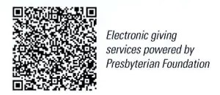

First Presbyterian Church
In the heart of Gardner since 1866 ~ Serving from the heart of God

Sunday, December 21st, 2025
Fourth Sunday of Advent
10:00 AM

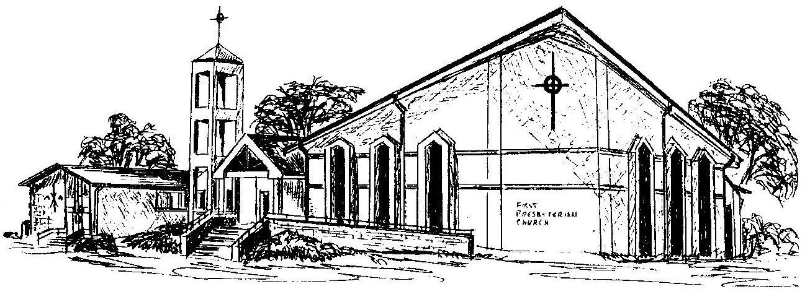

Welcome - Thank you for joining us for worship today. Please fill out a visitor information card found in the pew racks and place those in the offering plate so that we may follow up with you in the future. Your presence with us today has been a blessing to us, we hope that you have felt the presence of God and the welcome of this congregation.

