Welcome
Prelude
Let us prepare our hearts and minds for worship.

Call to Worship (Psalm 24 adapted)
Leader: All that we are is a gift from God.
People: The earth is the Lord’s and all that is in it,
Leader: All that we have is a gift from God.
People: The world, and those who dwell therein;
Leader: There are no words to describe the wonders of God’s creation.
People: For God has founded it on the seas; God has established it upon the rivers.
Leader: Who shall stand in God’s holy place? Who shall approach God with confidence?
People: All shall receive blessing from the Lord, and righteousness from the God of our salvation.

*Opening Hymn: “Now Thank We All Our God” Red Hymnal, #556

*Prayer of Confession (Unison) adapted from by Sarah E. Weaver, Preaching in Pumps
God of amazing grace, you have asked us to give of ourselves, wholly and completely. We have heard your call and have responded with great affirmation and joy. Yet there are times when we fall short. Times when we forget. Times when we focus on the wrong things. Help us to have faith, O God. Help us to give and serve through that faith. Help us to be blessed by that faith. Help us to renew that faith. Help us to share that faith with others. We pray in Jesus name. Amen.

* Silent Reflection

* Assurance of Pardon

* Gloria Patri (Glory Be to the Father…) Red Hymnal, #623

Children’s Time

Scripture “ Jeremiah 29:11-13” (page 1221)
“Mark 12:28-31” (page 1575)
“Mark12:38-44” (page 1576)
Leader: The word of the Lord.
People: Thanks be to God.

Music “Here, I Am Lord”
Daniel Schutte, arr. Arnold B. Sherman

Sermon “Put Your Whole Self In” Rev. Kimby Young

*Stewardship Pledge Dedication Litany of Gratitude (from M.Tirabassi, 2009)
Leader: For the grace upon grace which is this community of faith – sanctuary and sermon, music and mission, practices of hospitality, of education, of discernment.
People: We give you thanks, Generous God.
Leader: For the grace we each bring to add to others’ graces – our personal hopes and skills, the time we can share, the experiences from which we offer tenderness, our willingness to take responsibility or expose vulnerability.
People: We give you thanks, Generous God.
Leader: For unexpected grace in trouble’s face that sustains us in hard times – diagnosis, discouragement, downturn or despair – and the way community granites that grace so that it is strong enough for any situation.
People: We give you thanks, Generous God.
Leader: For grace in the spaces – all those possibilities of next year – the new people who will sit in these pews, the new programs through which we will reach out, the transitions completed and the transitions begun.
People: We give you thanks, Generous God.
Leader: For the grace of prayer, the grace of scripture, the grace of forgiveness, the grace of the resurrection promise, the grace of a single cup of cold water for a child, a stranger or a friend.
People: We give you thanks, Generous God.
Leader: All these we have and do and will receive through Jesus Christ who opens our hearts and hands so that grace may flow through us to all the world.
People: For so many blessings we give you thanks and praise, Our Generous and Gracious God. Amen.

*Hymn “Take My Life and Let It Be” Red Hymnal, #379 vs. 1, 2, 6

Pastoral Prayer & Lord’s Prayer

Offertory Meditation:

*Doxology

*Prayer of Dedication

*Closing Hymn: “Come, All Christians, Be Committed” Red Hymnal, #455

*Benediction

Postlude
*Those who are comfortably able will please stand.

Rev. Kimby Young, Pastor; Randy Rieger, Worship Assistant; Bell Choir
Dean Faulk, Music Ministries; Robyn Forkner, Pianist; Harlan Plunkett, Organist
Mike McGuire and Brad Cornell, Slide Production; Kim Liu, Sound
Childcare is always available in the nursery (off the hall to the west of the sanctuary). Children are welcome to stay in the sanctuary thru the whole service, or to leave at any time. Allison Perry is our primary childcare attendant.

Worship Bags for Children are available outside the north door to the sanctuary. Choose books,
crayons, pencils, Legos, stuffed toys and other items to fill your bag to use during worship.

Offering Plates are at the entrance of each aisle for your contributions to the work of the church.

Gardner Multi Service Center collection is ongoing every week and is always in need of any non-perishable food. Bring something every week or once a month.

Fair Trade Products for Sale on Sundays Coffee, tea, chocolate, nuts, olive oil, dried fruit, baking products, and a few other items are for sale each Sunday at church.

Joy Closet – Our mission center thrift store provides free clothing to a variety of needs. Our church provides all volunteers on the fourth Saturday of each month.

Remember, Each One, Bring One collecting food, basket in the narthex. Food goes to Hope Market Food Pantry.

YABS – Young Adult Bible Study 18-25 yrs Sundays 3p.m. Join us. Invite a friend.
Youngaddultbiblestudy47@gmail.com.

Operation Christmas Child Shoebox Packing Party, Nov. 16, 9:45–11:00 a.m. Bring a gift any time. A gift suggestion list is in the narthex. No liquids, fragrances, sharp or breakable objects.

Men’s Breakfast on Tuesday, November 11 at 7:00 a.m. Perkins. Come and enjoy fellowship.

Pastor Kimby on vacation November 11-17 including Sunday, November 16. Guest preacher will be Kirk Perucca. Plan to be here to welcome Kirk during both services.

Presbyterian Women Mitten Tree. Please bring scarves, gloves, mittens, winter items. They will be delivered to different Gardner schools.

Chocolate Tasting, Sunday, November 23 at 9:45 – 11:00 a.m.

Presbyterian Woman Thank Offering received on Sunday, November 23.
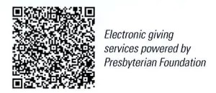

First Presbyterian Church
In the heart of Gardner since 1866 ~ Serving from the heart of God

Sunday, November 9, 2025
Stewardship Dedication Sunday
8:45 AM

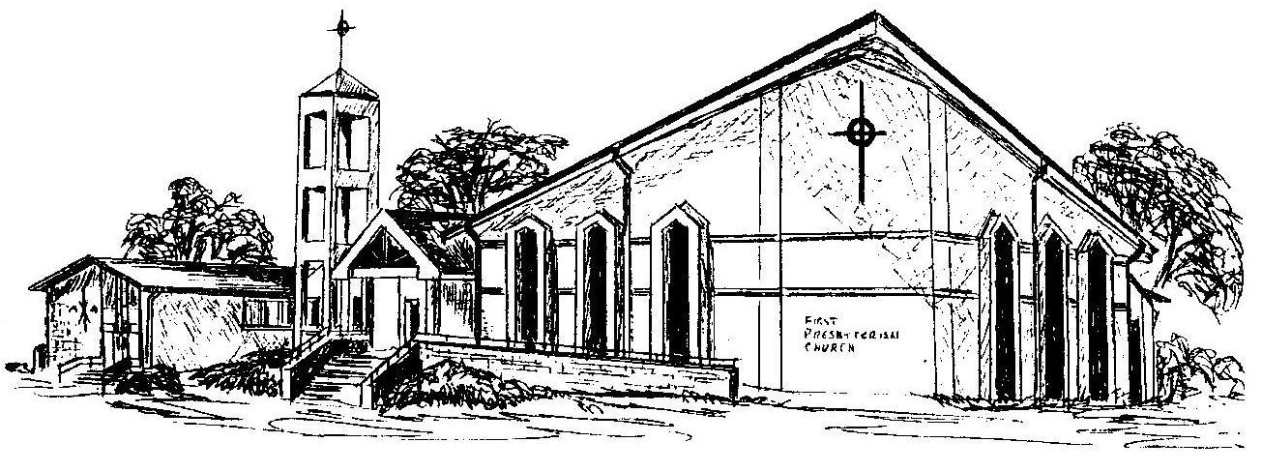

Welcome - Thank you for joining us for worship today. Please fill out a visitor information card found in the pew racks and place those in the offering plate so that we may follow up with you in the future. Your presence with us today has been a blessing to us, we hope that you have felt the presence of God and the welcome of this congregation.

