Welcome
Prelude
Let us prepare our hearts and minds for worship.

Call to Worship
Leader: Come to worship Jesus Christ, Alpha and Omega, the one who is, who was, and who is to come.
People: We come to worship Jesus Christ, the faithful witness, the firstborn of the dead, the ruler of the kings of the earth!
Leader: We worship Jesus Christ, Bread of Heaven, God with us, Good Shepherd, True Vine!
People: We praise Jesus Christ the Eternal Word, the Great I AM, Wonderful Counselor, Prince of Peace!
Leader: We come to worship Jesus Christ, King of kings and Lord of lords!
People: To Jesus Christ be glory and dominion forever and ever! Amen.

*Opening Hymn: “We Gather Together” Red Hymnal, #561

*Prayer of Confession (Unison)
King of Kings, Lord of Lords, God of all our days, you have blessed us in so many ways and we are grateful. Sometimes we forget your love and presence all around us, and we dwell on the difficulties and darkness. Shine your light of grace that we may see your bounty. Inspire us again that we may share your blessing in the world. Return us to you that we may live to your glory, through Jesus Christ our Lord. Amen.

* Silent Reflection

* Assurance of Pardon

* Gloria Patri (Glory Be to the Father…) Red Hymnal, #623

Children’s Choir “This Little Light of Mine”

Children’s Time

Scripture “Colossians 1:11-20” (page 1832)
Leader: The word of the Lord.
People: Thanks be to God.

Music “Every Day My Thanks to You”
Words and Music by Penny Folsom, arr. by Ralph Manuel
Sermon “Son of God and Son of Man” Rev. Kimby Young

*Profession of Faith The Apostle's Creed The Hymnal, inside back cover
I Believe in God the Father Almighty, Maker of heaven and earth, And in Jesus Christ his only Son our Lord; who was conceived by the Holy Ghost, born of the Virgin Mary, suffered under Pontius Pilate, was crucified, dead, and buried; he descended into hell; the third day he rose again from the dead; he ascended into heaven, and sitteth on the right hand of God the Father Almighty; from thence he shall come to judge the quick and the dead. I believe in the Holy Ghost; the holy catholic Church; the communion of saints; the forgiveness of sins; the resurrection of the body; and the life everlasting. Amen

*Hymn “Crown Him With Many Crowns” Red Hymnal, #234

Pastoral Prayer & Lord’s Prayer

Offertory Meditation:

*Doxology

*Prayer of Dedication

*Closing Hymn: “Rejoice, Ye Pure In Heart” Red Hymnal, #562

*Benediction

Postlude
*Those who are comfortably able will please stand.

Rev. Kimby Young, Pastor; Connie Neneman, Worship Assistant
Chancel Choir; Dean Faulk, Music Ministries; Children’s Choir
Robyn Forkner, Pianist; Harlan Plunkett, Organist
Mike McGuire and Brad Cornell, Slide Production; Kim Liu, Sound

Childcare is always available in the nursery (off the hall to the west of the sanctuary). Children are welcome to stay in the sanctuary thru the whole service, or to leave at any time. Allison Perry is our primary childcare attendant.

Worship Bags for Children are available outside the north door to the sanctuary. Choose books,
crayons, pencils, Legos, stuffed toys and other items to fill your bag to use during worship.

Offering Plates are at the entrance of each aisle for your contributions to the work of the church.

Gardner Multi Service Center collection is ongoing every week and is always in need of any non-perishable food. Bring something every week or once a month.

Fair Trade Products for Sale on Sundays Coffee, tea, chocolate, nuts, olive oil, dried fruit, baking products, and a few other items are for sale each Sunday at church.

Harvesters Food Distribution is always seeking volunteers. Every 3rd Saturday at Trade Net Parking lot and every 2nd Thursday at Divine Mercy Parish. Distribution begins at 1 p.m.

Joy Closet – Our mission center thrift store provides free clothing to a variety of needs. Our church provides all volunteers on the fourth Saturday of each month.

A "Suggestion Box" is outside the office for ideas, comments, questions and thoughts. Contents will be reviewed at session meetings on the 2nd Monday of each month.

Remember, Each One, Bring One collecting food, basket in the narthex. Food goes to Hope Market Food Pantry.

YABS – Young Adult Bible Study 18-25 yrs Sundays 3p.m. Join us. Invite a friend.
Youngaddultbiblestudy47@gmail.com.

Presbyterian Women Mitten Tree. Please bring scarves, gloves, mittens, winter items. They will be delivered to different Gardner schools.

Presbyterian Youth Fellowship – Fundraiser Brunch – December 7 –9:30-11:00 a.m.

Gardner Christmas Project Tags gift request are in. Take a tag from the tree in the narthex and return the gift by December 7.

Christmas Poinsettias for Sanctuary cost $13.00 in memory of or in honor of someone special
due by Monday, December 8th.
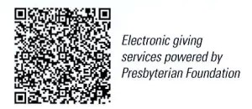

First Presbyterian Church
In the heart of Gardner since 1866 ~ Serving from the heart of God

Sunday, November 23, 2025
Christ the King Sunday
8:45 AM

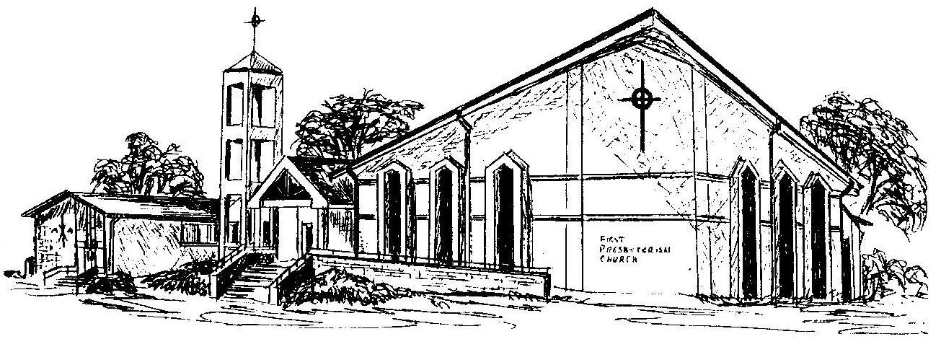

Welcome - Thank you for joining us for worship today. Please fill out a visitor information card found in the pew racks and place those in the offering plate so that we may follow up with you in the future. Your presence with us today has been a blessing to us, we hope that you have felt the presence of God and the welcome of this congregation.

