First Presbyterian Newsletter December 2025
Advent – by Kimby Young
I love the season of Advent. It is a time of preparation and celebration. It is an intentional season of turning to God and listening for God’s message and meaning. Sometimes we get distracted by the busy-ness and bustle. But I hope you enjoy many moments of delight as you turn toward Jesus during this season.
Each Sunday of Advent has a particular traditional meaning. We don’t always explore all the themes of Advent because of our other traditions and activities. See all of the events listed in the following pages of this newsletter. Mark your calendars and plan to join us.
Themes of Advent
The first week is often called "Prophecy." It stands for the long expectation, the long wait, for both the first and the second coming of Christ. We remember the prophets, including John the Baptist, who pointed the way to the Messiah, and we look forward to the future fulfillment of all God’s promises. The theme is often about “Hope.”
The second week is named for "Bethlehem," and reminds us that Jesus Christ was wholly human, descendant of the earthly King David. We remember Mary and Joseph who made a home for the Christ child, and nurtured him in love, creating a place of peace in which to grow. We too are challenged to make ready, to prepare a place of peace for others to be nurtured by God’s grace, to work to make the whole world a place of peace. The theme is often “Peace.”
The third week is set aside for "Angels," to remember that Jesus was also wholly divine, son of the Heavenly Holy One. We remember those who announce Christ’s birth, and we are called to proclaim that good news in our lives and in our world. The theme is often about “joy.”
The fourth week is for "Shepherds,” (and wisemen) reminding us of those for whom Christ came to the world - those ordinary people, like you and me - whom Christ came to love and teach and touch and save. We remember the love of God fully expressed in the birth, life, death and resurrection of Jesus Christ – love incarnate. We remember our call to follow this Jesus in service to the world, sharing Christ's love wherever we go. The theme is often about “Love.”
May you experience this season, the Hope, Peace, Joy and Love of Christ. And may you be blessed as you share these gifts of God with others.

Worship Schedule
November 30 – First Sunday of Advent – “Watch” – Mark 13:24-37; Revelations 21:1-7.
December 7 – Second Sunday of Advent – “Prepare” – Isaiah 40:1-11; Mark 1:1-8
December 14 – one service -10a.m. – Cantata
December 21 – one service – 10a.m. “God with us!” - Isaiah 7:14; 35:3-10; Matthew 1:18-25
December 24 – 4:30 p.m. – Christmas Eve Worship
December 28 – one service -10a.m. – “Pondering” - Luke 2:19-40
January 4 – two services – Epiphany

One Worship Service at 10:00 a.m. for Three Weeks –
December 14, December 21 and December 28
On December 14, we will share the music of our Cantata.
On December 21, we will have a casual Christmas program including carols.
On December 28, we will celebrate the Christmas season and our church together.
Join us all three Sundays at 10 a.m. if you are able.

Christmas Eve Service, Wednesday, December 24, 4:30 p.m.
Communion and Candlelight Worship
Join us for worship on Christmas eve at 4:30 p.m.
Remember to invite family, friends, neighbors, and coworkers.

Advent Devotional booklets are available for all ages. Advent readings Start November 30 or December 1. A variety of Advent devotional booklets are available in the narthex to follow along through the advent season. Some are for adults, some youth, some families.
Monthly Financial Report
At the end of October 2025 our records indicate:
total income this month is $ 26,031.21
total expenses this month is $ 31,371.31
The session and finance/operations pillar thank each of you for your contributions to the church – financial or any other contribution. A complete line-by-line expense report is available upon request. We will close finances for November after December 8. We will also have a budget for 2026 after December 8.

Sunday Treats for Fellowship from 9:45-11a.m. You can help!
On Sunday mornings a variety of individuals and groups provide coffee and refreshments on a rotating basis. Some people have asked how they can help. There are a couple of options. You could volunteer to be responsible for all coffee and treats on a regular rotating basis, or you could help provide some of the treats every once in a while with one of the other groups. Judy and Phil Lenahan offer treats one Sunday of every month. (Thank you!) Other groups in the church offer treats about once every two months. If you (or your group) would like to join this regular rotation, please talk to Pastor Kimby. We are now working on the rotation for 2026. If you would like to help out occasionally, you may work with any pillar on their assigned Sunday. You may speak to the elders for that pillar to volunteer. In 2026 that will be Karl Allen for Worship; Ginger Crist for Discipleship; Lynn Moldrup for Mission; and Larry Schick for Finance/Operations.

Mrs. Claus will visit during the brunch on Sunday, December 7, 10 a.m. Narthex
Mrs. Claus is coming to read to our children and youth. Mrs. Claus is a dear friend of deacon Barbara Sue Sweetwood. She visits area schools and libraries and has agreed to work us into her schedule. Adults are welcome to listen in as well and take pictures. Guests are welcome.

Sunday Potluck Brunch, December 14, 11:00 a.m.
or at the end of the Cantata and Worship Service
After the cantata on December 14, our deacons are sponsoring a congregational brunch. Bring a main dish, side dish, salad or dessert to share. It is a wonderful way to celebrate the season and to enjoy the gifts of our congregation. Bring a friend or family member to worship and brunch. Everyone is welcome.

Christmas Caroling with the Deacons
Sunday December 21, 4-6 p.m. with hot chocolate following at 6 in fellowship hall
Join us on Sunday afternoon for caroling to some of our homebound members and friends. We can’t reach everyone, but will have a great visit with a few people. We are working on getting a “party bus” so we can all ride together. We would love an estimate of people coming so we know we have enough transportation. Please sign up in the narthex. If we need extra drivers, please indicate if you can drive.

Gardner Christmas Project
For years we have supported the local volunteer program to provide gifts for children and families in need over the holidays. Each person receives 4 gifts. The children’s gifts are - Something You Want; Something You Need; Something To Wear; Something to Read and sometimes one extra. You may select names off our list. Please return gifts for children and families in our area by December 7. Mission Pillar will sort them and deliver to the drop off point. You may also include cash (checks to FPC Gardner) for gifts cards or committee purchases.

JOY offering – PCUSA
By giving to the Christmas Joy Offering, one of the four offerings of the Presbyterian Church, USA, you honor God’s gift of Jesus Christ by providing assistance to current and retired church workers in their time of need (ministers, educators, musicians and administrators) and by developing our future leaders at Presbyterian-related schools and colleges equipping communities of color. At First Presbyterian Church we will receive the Joy offering at any time in December including Christmas Eve. Mark your checks with the designation “PCUSA JOY offering.”

Weather Cancellation Policy
Usually, we try to worship if possible. We may modify worship or cancel Sunday school. Even if we don’t cancel. Be smart. Be cautious. Don't take any chances. Even if a church event is not cancelled, if you do not feel comfortable getting out, you are excused. If you have a duty, we will find someone to cover for you.
Generally, midweek if school is cancelled, events are cancelled. But discretion is given to event leaders to cancel if needed. Check with the event leader to be sure.
Check emails, Facebook or the website (www.fpcgardner.church) for announcements about cancellation. Also check KMBC-TV notices.
Call Kimby 913-481-7076, or Connie 913-244-8185.

Storage Cleaning and Purging
We are trying to clean out our many storage spaces and areas in the church. We have made some progress, but there is more work to be done. If you are responsible for any storage area, please do some deep cleaning as soon as possible. Please identify any items in storage that you want to be sure to keep. If you have donated something to the church that you want to be certain to save, let Pastor Kimby or Phil Lenahan know.
The reason for this deep clean is a good one. We have expanding areas of ministry and are needing more space for groups and programs. We also expect new staff in the summer and would like to have any messes cleaned before new staff arrives, so they don’t have to deal with it. It is a mark of growth that we need to prioritize our space more wisely. Help us to be good stewards of our building, grounds and property.


CHRISTMAS POINSETTIAS FOR SANCTUARY COST $13.00
Poinsettias for the sanctuary may be purchased in memory of or in honor of someone special, just place your order by Monday, December 8th, using the forms provided in the bulletins or call it in (856-4099). The poinsettias are $13.00 each and will be used for Sunday, December 21st and the Christmas Eve service. You may take them home after the Christmas Eve service if you wish.
Quantity: ______
Name: __________________________________________________________
Phone number: ____________________________________________________
In Memory________________________________________________________
In Honor__________________________________________________________

Note of Thanks
We want to thank you all for keeping Darius Crist in your prayers, been a very long 13 weeks with a fractured C2 (neck), we know how lucky he is and could have been much worse, but prayers have been answered!!! He can drive and do most normal activities, praise God. Again, Thank you for all your prayers.
Darius & Ginger Crist
The PYF will host their annual brunch on Sunday, December 7th. Food will be served 9:30-11:00am. Come down to Fellowship Hall between worship services for a good meal and great fellowship. We'll have biscuits and gravy, pancakes and sausage, bacon and eggs, and more. Enjoy a little of everything and support the youth group in the of their next mission trip. As always, there is no set cost for the meal, but donations will be accepted to help fund the 2027 trip.

Suggestion Box Responses –
The preferred way to talk to session members is to speak to session members face to face. You may also write a letter or email to the clerk of session to be addressed to the whole session. This way of communicating helps the session to be able to respond to specific concerns. However, we also have a suggestion box by the office which is checked before each session meeting on the 2nd Monday of each month. All notes are discussed and included in session minutes. It is preferred that notes are signed so that we can respond to individuals. When notes are anonymous and we have an answer, we don’t know how to let the person know our response.
The following anonymous notes were received for the November session meeting.
“Need fall programs in evenings for all ages to help build up congregation.”
Session discussed and agreed, but would appreciate more specific ideas and volunteers to plan these programs year round. If you are interested, in serving on the fellowship committee please volunteer to Kimby or any session member.
“Where is the ‘elder on call’ at coffee on Sundays?”
After several months of having an elder on call, session decided to discontinue the program. We were not seeing any meaningful conversations or questions at that time. It was pleasant and fun to share fellowship, but it did not serve a purpose of increasing communication and accessibility. Elders names are posted in the print directory and on the bulletin board by the office. Feel free to speak to any elder at any time.
“For all the God given talent, could we praise the Lord by saying ‘Amen’ after our wonderful organ music, solos or full choir anthems. Instead of applauding like we just heard a performance. Thank you.”
The applause argument has been a debate for 50-60 years in churches. Many believe their applause is indeed an expression of gratitude to God in a culturally understood way. Many find applause an interruption to worship (as expressed in this note). No congregation has ever found a satisfying solution to this issue. Restricting personal expression, or trying to reinterpret that expression, is not easily accomplished. Our suggestion is to offer grace. Allow people to use the form of expression they prefer and don’t make assumptions about their motivation. If you like applause, be aware that some people do not. If you don’t like applause, try to receive the applause as an expression of gratitude, a different form of “AMEN.” In either case, try to keep the focus in worship on God. Believe the best of others. Try to love people around you who may think or act differently than you do. May you be blessed in worship and community.
Prayer Request
Please Pray for Mark Perry, Joyce Pattrick, Brenda Jones, Michael Chase, Martha Samuels, Mikel Walter, Amy Foster, San Juanita Leal, Family of Barb Tropansky, Campbell Moldrup, Lois Barber, Will Biggs Jim Summers, Randy, Bill Stone, Nick McSwane, Karen Elliott, Nancy Falkner, Lenore Chambers, Cliff Schick, Rhonda Krehbiel, the family of Ray Haberstroh, Robert Mashburn, Susan Gash, Susan Wilson-Dierksen, Alice Christensen, Janice Bacon, Lin Swartz’s Uncle Tom, Ronnie DuChene, Sharon Frahme, Jon Deiley, Abe Portenier, Rex and Karen Roney, Amanda Allen, LeMoyne Zimmerman, Dozer Reed, Trinity D’Autorio, Skyla D’Autorio, Jackson Tijerina, Reagan Barnadt.

Ushers for December 2025
Phil Lenahan, John Forkner, Gary Richardson, Derrek & Amy Hittle

Presbyterian Women’s Christmas Luncheon will be Saturday, December 6th at 12:00, noon, at Fellowship Hall. It will be Potluck with a short program, devotion, with a White Elephant Gift Exchange to finish our gathering. Join us for the Fun and Fellowship!

Women’s Fellowship Group will take part in the Women’s Christmas lunch on Saturday, December 6th. Please plan to attend. The women’s Fellowship Group meets on the first Wednesday of each month, from March through November, in Fellowship Hall. The Fellowship Group is open to all women of the church.

Men’s Breakfast on Tuesday, December 9th, Perkins, at 7:00 a.m. Come and enjoy fellowship.
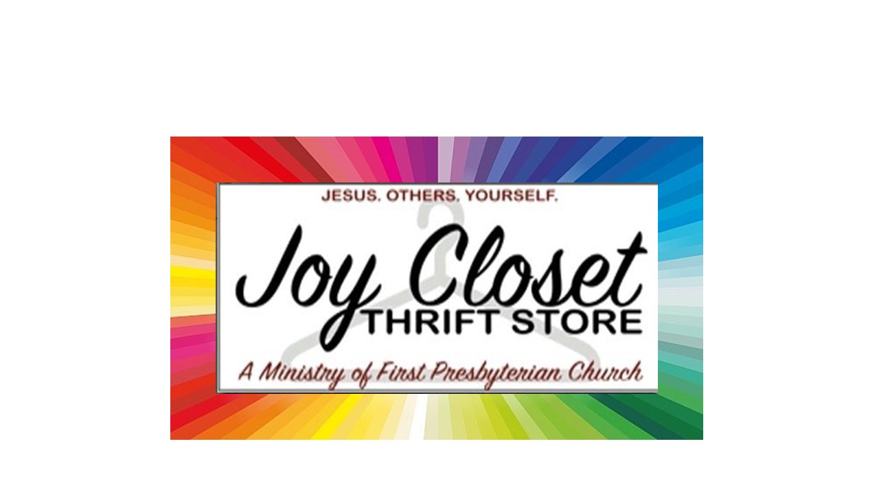
Store Hours
MONDAY 10 – 7
TUESDAY` 10 – 7
WEDNESDAY 10 – 4
THURSDAY 10 – 7
SATURDAY 10 – 2

  2025 |  | We’re busy wrapping up another year filled with blessings at JOY Closet. We are blessed with plentiful donations, the finest volunteers, and friendly shoppers who also tell their neighbors about us.  We are especially thankful for the opportunity to help others. We’re changing lives for the better and saving the environment through the recycling of needed items.  God has blessed our mission greatly.
Designated Donations – Helping other non-profits through ‘tips’ and donations at the register:

During October, our Designated Donations at the checkout register raised $1,125.00 for ReStart of Kansas City. It is the only homeless shelter in downtown KCMO serving children, families, singles, and veterans.
More information about this non-profit can be found at: HOME | reStart 2025


Designated Donations for November will go to the Wounded Warrior Project. WWP is the natiion’s leading veterans service organization, dedicated to improving the total well-being of post 9/11 wounded, ill, and injured veterans, service members, and their families. More information about this non-profit can be found at: Veterans Charity - Non Profit Organization for Veterans

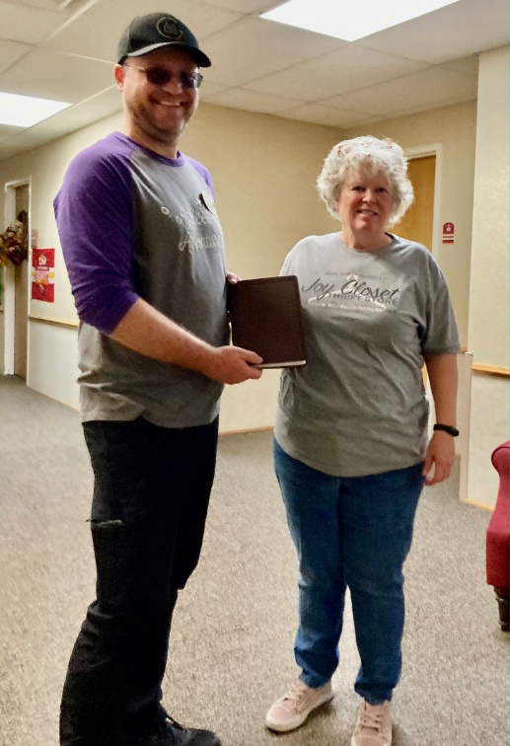
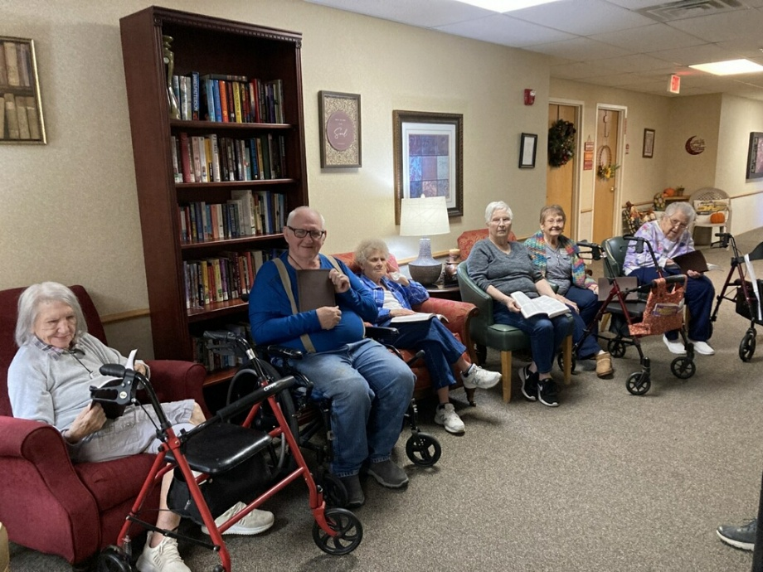
New Bibles to Vintage Park Residents

JOY Closet is fortunate to help in other ways beyond the merchandise at our thrift store/closet. This last month we ordered new large-print Bibles for residents at Vintage Park to help with their Bible Studies. The residents were very pleased and a beautiful thank you has been received. We are pleased to help spread the word of God to our friends at Vintage Park!
Helping Our Community
As the holidays approach, and especially during this time of economic need, JOY Closet will assist the following civic groups monetarily:
Wellsville Secret Santa
Edgerton Mayor Fund
Edgerton Food Pantry
Hope Market
Christmas For Children Program
Joy Closet will also continue to offer support for Laundry Love, which is serving a very specific need: the blessing of clean laundry. The participants load/unload all of their clothing. The volunteers are there to assist with handling money to run the machines and to visit with the adults and their children.
Expanding Our Voucher Program to include
the Spring Hill School District

JOY Closet is in the process of helping to organize vouchers to include the 10 schools in the Spring Hill District. Our neighbors have reached out to us through their Social Workers and will pick up vouchers from us. All of our vouchers are marked letting us know how much they are shared in various buildings as well as the other social agencies that are provided vouchers.

We welcome Spring Hill families!

Heartland Camps
JOY Closet has made a donation to Heartland Camp in Parkville, Missouri. They have long been a provider of a place of learning about God while finding joy and recreation. Their core values include: Love for God, Love for Kids, Love for Joy, and Love for Service. Our donation will assist in their swimming pool project completion.

Many of our congregation have benefitted from their time at the beautiful acres at Heartland. They welcome all to their camp. Everyone is a child of God.
This link will tell you more about their mission and ministry:
Core Values — Heartland Christian Camps
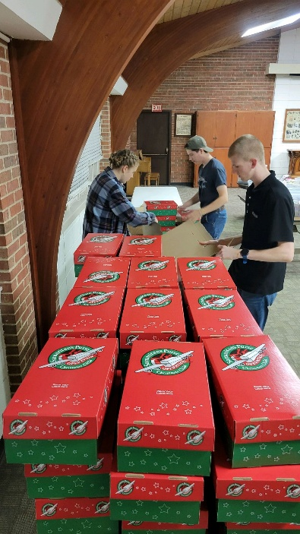
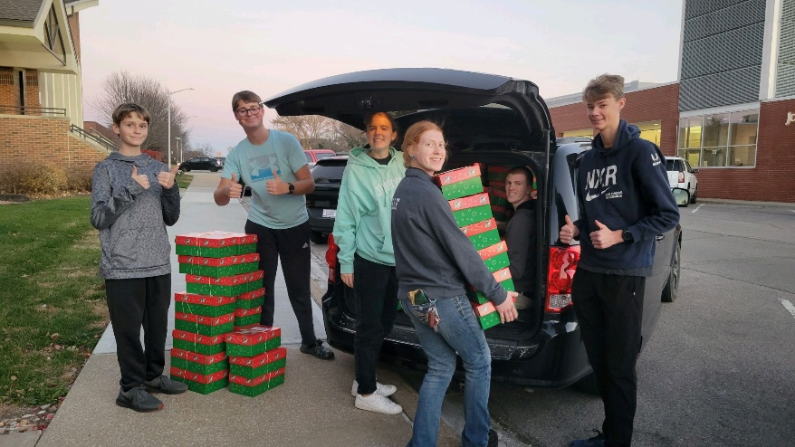
Operation Christmas Child JOY Closet volunteers joined in the packing of Operation Christmas Child boxes at FPC. This year, 180 boxes will be sent… spreading the JOY of Christ’s love!
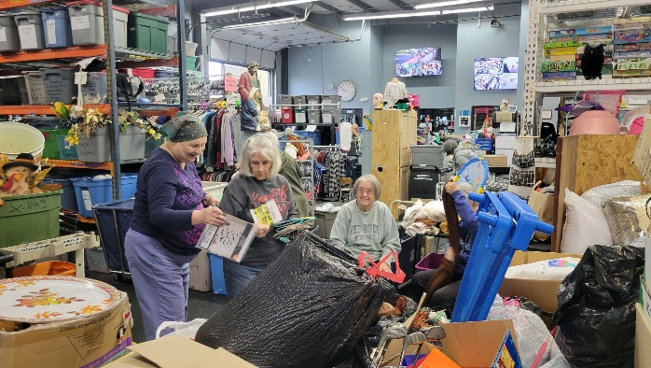
Busy times at JOY Closet! Included are pictures of helpers from across the community:
New Life
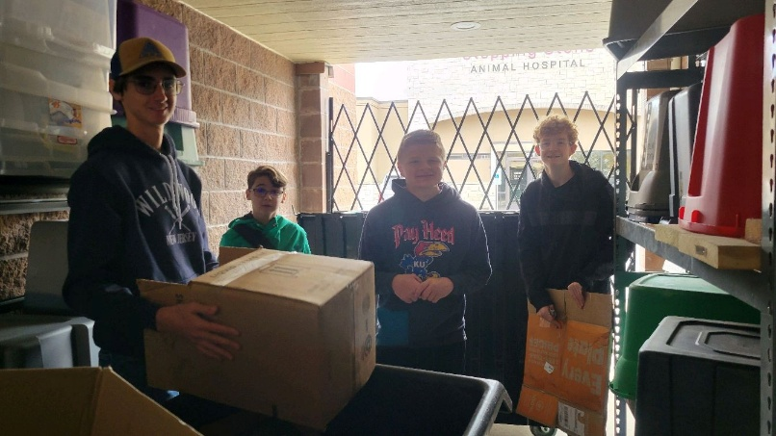
Divine Mercy Catholic Church
Cross Country helpers
Regular volunteers


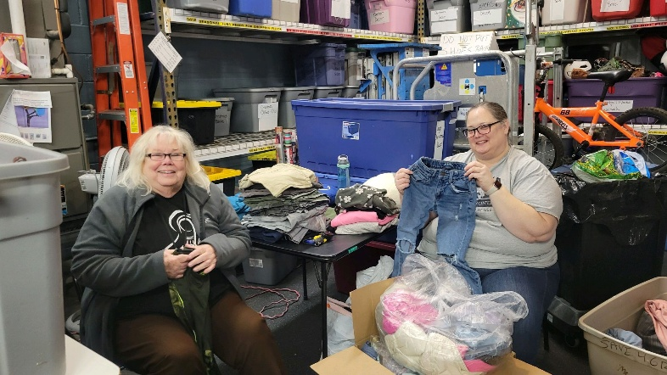


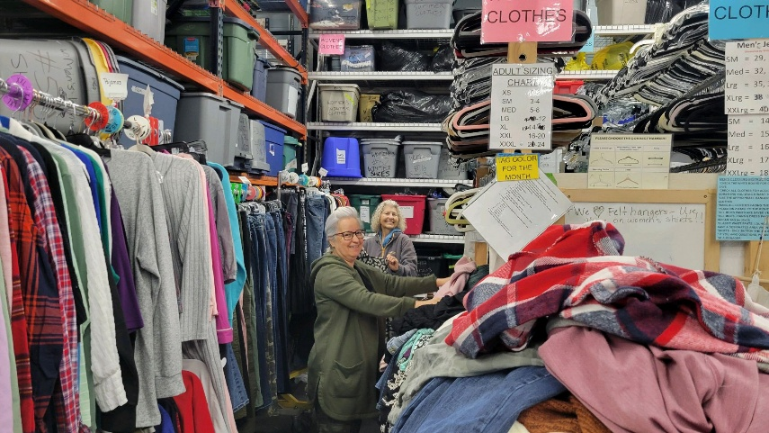

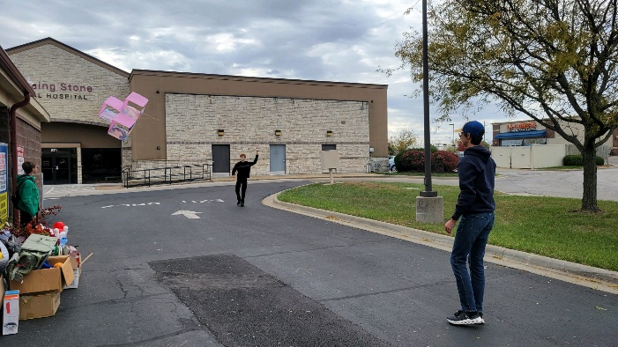
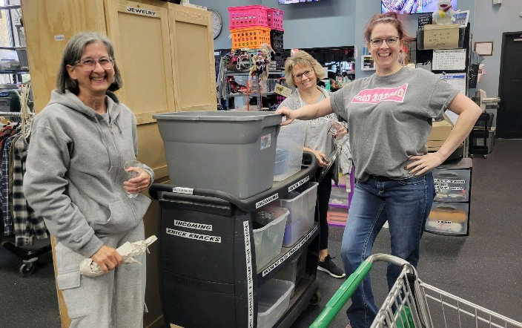

Thanks for making a difference!
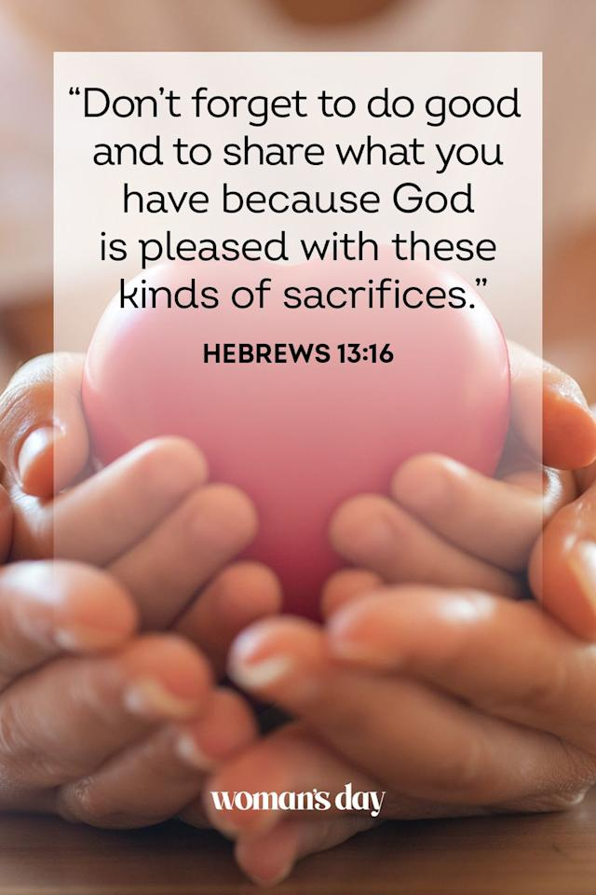 |   We need volunteers! Bring your skills and a smile. You’ll love the people at  JOY Closet and also the people we serve!  If you are interested in becoming a volunteer,talk with Cindy, Ginger, Cathy, or Margaret.
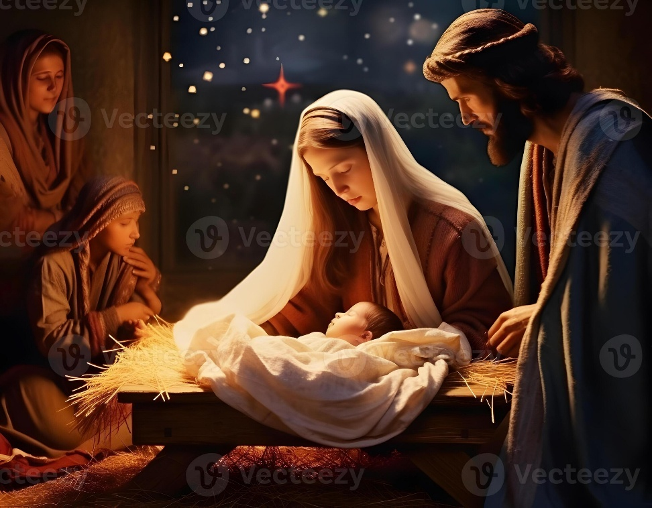
Amidst all of the lights and sounds of the season,
listen for God.

Seek him.
He loves you.

For God so loved the world, that he gave his one and only son that whosoever believes in Him shall not perish, but have everlasting life. John 3:16

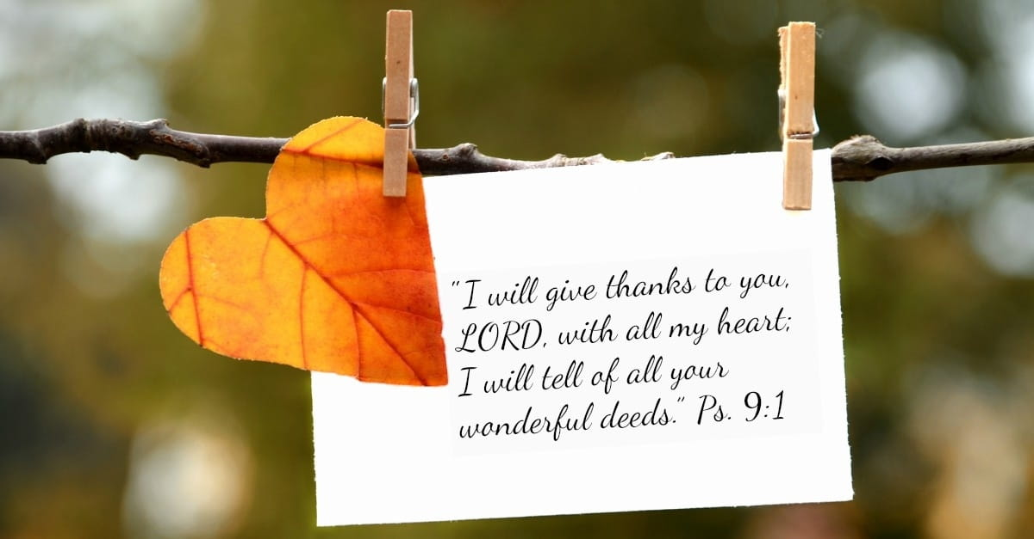
For I was hungry, and you gave me something to eat, I was thirsty, and you gave me something to drink, I was a stranger and you invited me in, I needed clothes, and you clothed me.

Matthew 25:35-36 NIV

JOY Closet Is a ministry of

First Presbyterian Church of Gardner, KS

Serving our comunity since 2013

