First Presbyterian Newsletter October 2025

Great Transitions – by Pastor Kimby
Wonderful things are happening at church. We just hired a new part time children’s ministry coordinator. This is the job previously held by Marsha Cooper to manage Sunday school and special events for children. Amanda Rooney joined the staff officially on October 1. Be sure to welcome and introduce yourself when you are able.
Meanwhile the Associate Pastor Nominating Committee is hard at work. Because of the confidential nature of their work, we won’t hear the details. But the Spirit of God is moving among this group of volunteers and they are doing an excellent job for this congregation. Thank the members of this committee when you see them, and don’t press for too many details. They will share as soon as they are able. For now we trust these members we have elected and know that they are seeking God’s will.
Session has just about completed annual reviews for existing staff. In my interview, I was able to share some of the hopeful energy I feel around this place. God is working among us, as God always has worked. I am more aware of the vision for the future that is taking place by God’s grace. We are looking toward growth in the community, reaching out in love and service in new ways.
Please continue to pray for this congregation in the weeks and months ahead, that we will continue to serve God well as we follow Jesus Christ in the way of love.

Worship Schedule
October 19 - Children's Sabbath - Let the Children Come - 1 Sam 3:1-10; Mt.19:13-15
October 26 - Reformation Sunday – Reforming: Who Are We? - Heb.1:1-3; Eph.2:4-10

Daylight Saving Time ends on the first Sunday in November, November 2 which is also All Saints Day. Don’t forget to change your clocks.

Monthly Financial Report
At the end of August 2025 our records indicate:
total income this month is $ 24,042.78
total expenses this month is $ 27,701.26
The session and finance/operations pillar thank each of you for your contributions to the church – financial or any other contribution. A complete line-by-line expense report is available upon request. We will close finances for September after October 9.

Childcare Nursery Available on Request
The Discipleship Pillar and session approved a request last year to have child care available for evening and special meetings upon request. There is a form available in the nursery and in the office to make a request. Our regular child care provider Allison Perry may be available. If not substitute care givers will be contacted. Amy Hittle will help coordinate requests. All requests must be made 2 days or 48 hours in advance of the event to insure availability. Some groups may be asked to pay for child care to cover costs if possible.

Children’s Music – Well Begun, Lots of Fun!
Each Sunday just before Sunday school from 9:45 to 10 a.m., Ella Falkner and Dean Faulk are leading a children’s music group. We are squeezing the program between 1st worship and Sunday School, to try to reach the most people who are already here. All children and youth are welcome. We know we have some great young singers and musicians. This is a chance to get together to praise God in song. If you would like to assist with crowd control or in any other way, please speak to Dean or Ella.

Men’s Breakfast on Tuesday, October 14 at 7:00 a.m. Come enjoy fellowship.

Trunk or Treat and Chili Supper! October 26
Halloween All Church Celebration – Sunday, October 26
5-5:45 p.m. – Trick-or-treat and Games – North Parking Lot
5:45-6 p.m. – Costume Parade and Celebration
5:45-7 p.m. – Chili Supper – Fellowship Hall
Mark your calendar! Save the date! Added “photo booth!”
Look for sign up sheets soon to help with planning and set up, to decorate, to offer your trunk, to lead games, to bring chili or fixin’s, and to help in any other way you imagine.
If you would like to help in planning please contact Pastor Kimby.
Right now we need more TRUNKS and we need more candy!

Congregational Meeting - Sunday October 26 at 9:45a.m.
The session has called a congregational meeting for Sunday October 26 at 9:45a.m. The purpose of the meeting is to receive the report of the nominating committee and to elect officers for the coming year.
The slate proposed by the nominating committee is
for the class of 2028 to serve as Elders
Tony Waites, Devon Mason, Bob McVey and Patricia Pacey.
For the class of 2027 to serve an unexpired 2 year term - Vera Beach.
For the class of 2028 to serve as Deacons
Alice Rollf, Holly Applegarth, Connie Neneman, Joe Neneman and Merle Schick.
For the nominating committee for a one year term 2026 –
Lois Barber, Paula Waters.

Operation Christmas Child - Shoebox Packing Party
Sunday, November 16 9:45-11 a.m.
Mark your calendars to join us for our annual packing party. Come put together a box for a child somewhere in the world. Before then, please bring in items to add to a box. A long list of items is available in the church narthex. We are concentrating. You can bring in a one great gift, or order in bulk and bring in several items. We usually try to fill about 100 boxes which includes all age groups.

Prayer Request
Bill Stone, Ruth Hailey, Charlie Hildreth, Nick McSwane, Gregg Plank, Bea Judah, Karl Allen, Mark Perry, Breanne Francis, Alice Christnger, Karen Elliott, Nancy Falkner, Janice Bacon, Darius Crist, Sharon Frahme, Bob Knoche, Rhonda Krehbiel, Uncle Tom, Ronnie DeChene, Martha Samuels, Tom Patton, Beau Foster, Robert Mashburn, Susan Gash, Susan Wilson-Dierksen, Abe Portenier, LeMoyne Zimmerman, Jerry Lane, Jon Deiley, Amanda Allen, Dozer Reed.


REMEMBER OUR DEPARTED LOVED ONES
ALL SAINTS’ SUNDAY, NOVEMBER 2nd, 2025
We will honor the memory of our recently departed loved ones during the worship service. Please send in the names of your departed loved ones by email, phone, or use this form due by Monday, October 27th.
Name of Departed ____________________________________
Given by____________________________________________

Music Ministries
The music team has resumed rehearsals for the next season, and I must say it is good to be back in full swing. The vocal choir has resumed presenting special anthems each Sunday for the 8:45 service. The vocal choir has started rehearsing for the Christmas Cantata ‘A Song, A Son and A Savior’ which will be presented on Sunday December 14, 2025, at 10:00 a.m.
I would like to put out a special thank you to those individuals who presented special music over the summer months: Rhonda Atwater, Shana Devlin, Ella Falkner, Robyn Forkner, Chesley Jones, John Kunkel, Mike McGuire, Mark Perry, Harlan Plunkett, Larry Schick, and Oliver Schwab. Thank you for your willing service to our Lord and our church.
The bell choir has also resumed their season as well. It is good to have most members returning for another year. The group continues to rehearse around busy schedules and will be presenting to the congregation soon. The bell choir gives a different perspective on the music. If anyone is interested in learning more about the bell choir, I encourage you to stop by at 6:00 p.m. on Wednesday evenings and take a listen.
Since I have been at First Presbyterian Church, I have always had the dream of starting a children’s choir. With the help of others the process has begun. Each Sunday from 9:45 to 10:05 a.m. the children are meeting in the social hall to rehearse numbers to be presented to the congregation. At this time there are around 10 children that make up the choir. It is so wonderful to hear their young voices and to know that they are serving the Lord. The children will not be presenting every Sunday but will be bringing special numbers throughout the year.
The Praise Team continues to bring music to the 11:00 a.m. service. Doug and Bea Judah are on an extended sabbatical, and we thank them for their service to the Lord and our church. We pray for them and their family and welcome them back anytime. The Praise Team has realigned, and as God has brought to us a new drummer Paul Chedda. We welcome Paul and his wife Robyn to our team. Thank you for giving your time and talent to our Lord and our congregation.
The music ministry is always part of my heart. God continues to use so many people to further his kingdom, and I am blessed to be a part of it. Thank you to everyone for all you do and being a vessel for our Lord, our Church and our community.
Many Blessings To All, Dean

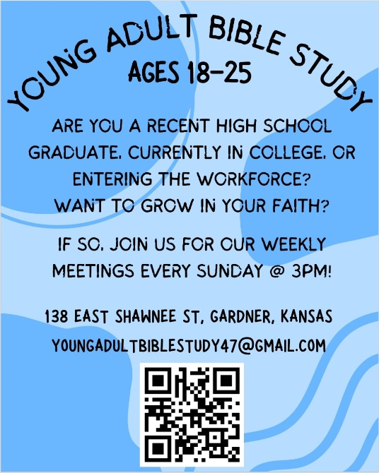

Store Hours
MONDAY 10 – 7
TUESDAY` 10 – 7
WEDNESDAY 10 – 4
THURSDAY 10 – 7
SATURDAY 10 – 2
2025 Designated Donations

August designated donations at the register helped support Gardner Gold. Amount collected was $1,500.00. September donations were collected for the non-profit, 911 Answering the Call, which serves families of first responders during times of crisis. More information on that group can be found at the link below: Charity for First Responders - Answering the Call 911
October Designated Donations will be for ReStart, the only homeless shelter in KC area for kids, singles, families, and veterans. www.restartinc.org

JOY Closet is in need of more sectional help. We have a variety of sections: Women’s, Men’s, Kids clothing, Shoes, Bedding, Purses, Jewelry, Glasses, Seasonal. Preparation of donations for the shopping floor is the emphasis. Our shoppers enjoy the consistency of how things are displayed, making shopping easier and more enjoyable.
Find an area of interest and your knowledge will be put to great use for others! Come and join us!
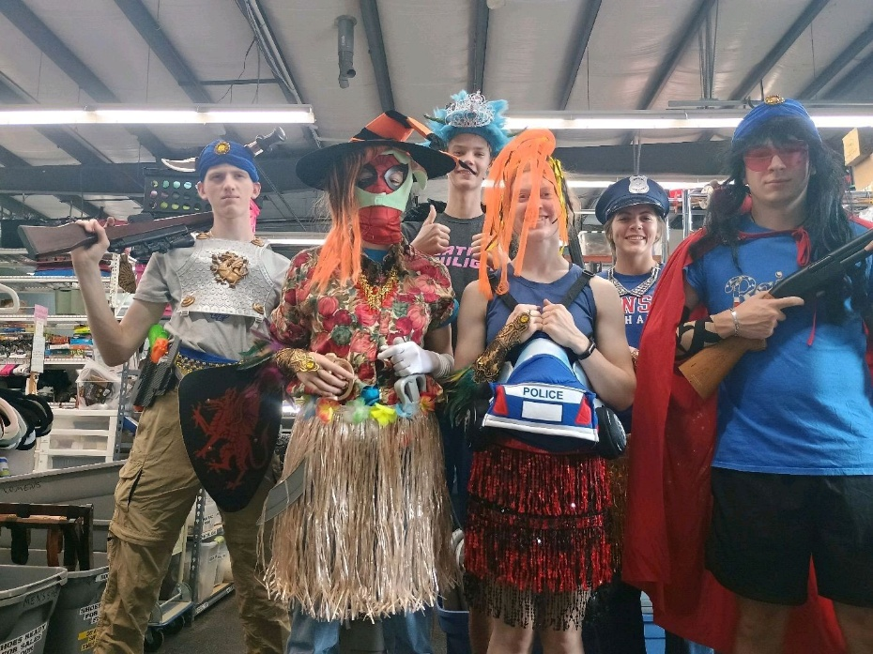
The Young Adult Bible Study group had a great time preparing our Halloween costumes.

We appreciate their help!
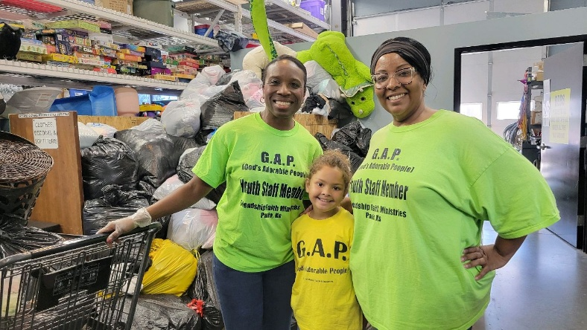
A small, but mighty, group from Paola had a great time making a difference at JOY Closet.
Thank you!

In October, JOY Closet
celebrates our 12th anniversary!

As of September 30th, we have helped 1,226 families with vouchers for free clothing and other items in 2025.

God has blessed this ministry beyond our hopes and dreams. For each of you that volunteer, donate, or pray for JOY Closet and the people we serve, we give thanks.
God is good…all the time!
If you are interested in becoming a volunteer,
talk with Cindy, Ginger, Cathy, or Margaret.
We love our volunteers!

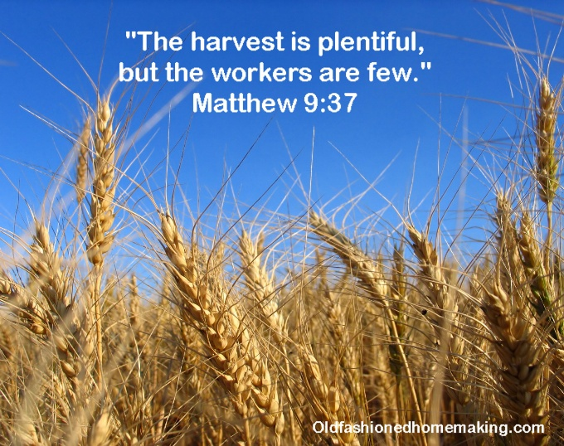
For I was hungry, and you gave me something to eat, I was thirsty, and you gave me something to drink, I was a stranger and you invited me in, I needed clothes and you clothed me.

Matthew 25:35-36 NIV

JOY Closet Is a ministry of

First Presbyterian Church of Gardner, KS

Serving our comunity since 2013

