Welcome

“You Can Make a Difference” Discipleship Pillar

Prelude
Let us prepare our hearts and minds for worship.

Call to Worship (from Deuteronomy 6:4-8)
Leader: Hear this, People of God. The Lord is our God, the Lord alone.
People: We shall love the Lord our God with all our hearts, all our souls, and all our strength.
Leader: Keep these promises in your hearts, recite them to your children, and talk about these promises wherever you go.
People: We shall love the Lord our God. We shall worship and sing our praise.

*Opening Hymn: “Praise the Lord! Ye Heavens, Adore Him” Red Hymnal, #9

*Prayer of Confession (Unison)
God of Covenant Grace, we know that you have always kept your promises. You have loved us and provided for us, you have shown us the way to eternal life and joy in each present moment. We also know that we have often failed to respond as you have called us. We have broken your covenant. We have left your people suffering. Forgive us we pray. Renew us again. Inspire us to hear you again and to respond in loving commitment, through Jesus Christ our Redeemer. Amen.

* Silent Reflection

* Assurance of Pardon

* Gloria Patri (Glory Be to the Father…) Red Hymnal, #623

Children’s Time

Scripture “Deuteronomy 6:4-7” (page 284)
“1 Samuel 3:1-10” (page 423)
“Matthew 18:1-5” (page 1526)
“Matthew 19:13-15” (page 1528)
Leader: The word of the Lord.
People: Thanks be to God.
Music “Jesus Loves Me” “Deep and Wide”

Sermon “Let the Children Come” Rev. Kimby Young

*Profession of Faith The Apostle's Creed Red Hymnal, inside back cover
I Believe in God the Father Almighty, Maker of heaven and earth, And in Jesus Christ his only Son our Lord; who was conceived by the Holy Ghost, born of the Virgin Mary, suffered under Pontius Pilate, was crucified, dead, and buried; he descended into hell; the third day he rose again from the dead; he ascended into heaven, and sitteth on the right hand of God the Father Almighty; from thence he shall come to judge the quick and the dead. I believe in the Holy Ghost; the holy catholic Church; the communion of saints; the forgiveness of sins; the resurrection of the body; and the life everlasting. Amen

*Hymn “Here I Am Lord” Insert

Pastoral Prayer & Lord’s Prayer

Offertory Meditation:

*Doxology

*Prayer of Dedication

*Closing Hymn: “Standing on the Promises of God” Red Hymnal, #271

*Benediction

Postlude
*Those who are comfortably able will please stand.

Rev. Kimby Young, Pastor; Lynn Moldrup, Worship Assistant
Dean Faulk, Music Ministries; Children’s Choir
Harlan Plunkett, Organist; Robyn Forkner, Pianist
Mike McGuire and Brad Cornell, Slide Production; Kim Liu, Sound

Childcare is always available in the nursery (off the hall to the west of the sanctuary). Children are welcome to stay in the sanctuary thru the whole service, or to leave at any time. Allison Perry is our primary childcare attendant.

Worship Bags for Children are available outside the north door to the sanctuary. Choose books,
crayons, pencils, Legos, stuffed toys and other items to fill your bag to use during worship.

Offering Plates are at the entrance of each aisle for your contributions to the work of the church.

Gardner Multi Service Center collection is ongoing every week and is always in need of any non-perishable food. Bring something every week or once a month.

Fair Trade Products for Sale on Sundays Coffee, tea, chocolate, nuts, olive oil, dried fruit, baking products, and a few other items are for sale each Sunday at church.

Harvesters Food Distribution is always seeking volunteers. Every 3rd Saturday at Trade Net Parking lot and every 2nd Thursday at Divine Mercy Parish. Distribution begins at 1 p.m.

Joy Closet – Our mission center thrift store provides free clothing to a variety of needs. Our church provides all volunteers on the fourth Saturday of each month.

A "Suggestion Box" is outside the office for ideas, comments, questions and thoughts. Contents will be reviewed at session meetings on the 2nd Monday of each month.

Remember, Each One, Bring One collecting food, basket in the narthex. Joy Closet food box.

Presbyterian Women Bible study Oct. 23, 6:30 p.m. “Jesus Through the Eyes of Women”. All women welcome!

YABS – Young Adult Bible Study 18-25 yrs Sundays ay 3p.m. Join us. Invite a friend.
Youngaddultbiblestudy47@gmail.com.

Congregational Meeting – Sunday, October 26 – 9:5 a.m. – to nominate officers for 2026.

Trunk or Treat and Chili Supper! October 26 – 5-7 p.m.

Daylight Saving Time ends on the first Sunday, Nov. 2, which is also All Saints Day.

Operation Christmas Child Shoebox Packing Party, Nov. 16, 9:45–11:00 a.m. Bring a gift any time. A gift suggestion list is in the narthex. No liquids, fragrances, sharp or breakable objects.

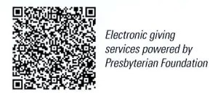
First Presbyterian Church
In the heart of Gardner since 1866 ~ Serving from the heart of God

Sunday, October 19, 2025
8:45 AM

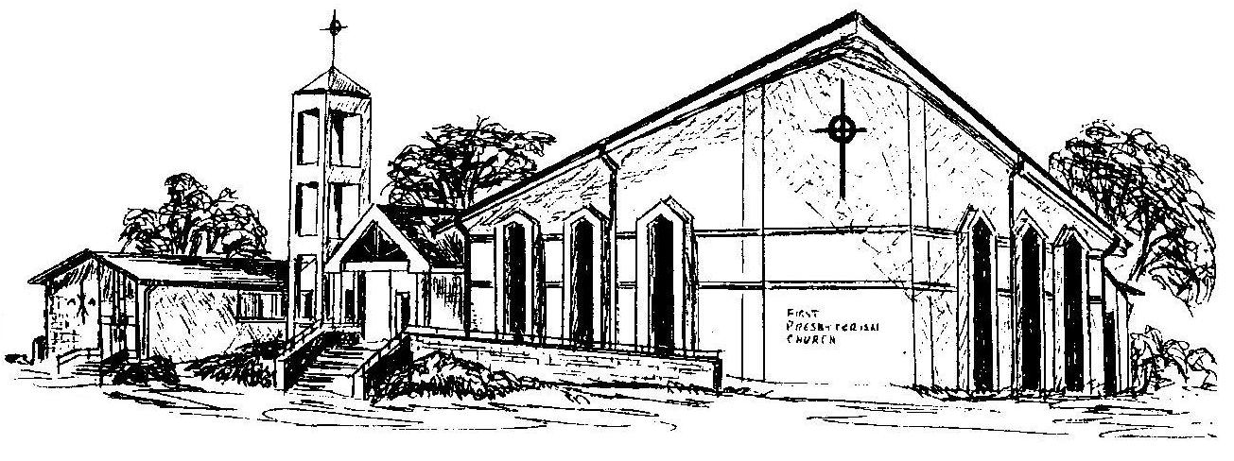

Welcome - Thank you for joining us for worship today. Please fill out a visitor information card found in the pew racks and place those in the offering plate so that we may follow up with you in the future. Your presence with us today has been a blessing to us, we hope that you have felt the presence of God and the welcome of this congregation.

