Welcome

“You Can Make a Difference” Mission Pillar

Prelude
Let us prepare our hearts and minds for worship.

Call to Worship
Leader: Come, let us worship the God who came to seek and save the lost!
People: Jesus welcomes all and calls us to do the same.
Leader: Let us welcome God into our homes, our hearts, our lives, our world.
People: Let us joyfully worship God! Let us lift our voices in praise!

*Opening Hymn: “Praise to the Lord, the Almighty” Red Hymnal, #8

*Prayer of Confession (Unison) (Waiting for Water: Liturgy for The Journey)
O God, sometimes we cannot see you. We search for you and have to strain to hear your voice. And yet you come to us where we are, in our sinful lives. You forgive us and change our hearts through the grace of your son, Jesus, and his liberating love. Forgive us again, as we thank you for your presence in our lives. In Jesus’ name we pray. Amen.

* Silent Reflection

* Assurance of Pardon

* Gloria Patri (Glory Be to the Father…) Red Hymnal, #623

Children’s Time

Scripture “Luke 19:1-10” (page 1630)
Leader: The word of the Lord.
People: Thanks be to God.

Music “Missions and Evangelism” Arr. by Dennis Allen
Mighty to Save; People Need the Lord; and Jesus, Hope of the World

Sermon “Zacchaeus” Rev. Kimby Young

*Profession of Faith The Apostle's Creed Red Hymnal, inside back cover
I Believe in God the Father Almighty, Maker of heaven and earth, And in Jesus Christ his only Son our Lord; who was conceived by the Holy Ghost, born of the Virgin Mary, suffered under Pontius Pilate, was crucified, dead, and buried; he descended into hell; the third day he rose again from the dead; he ascended into heaven, and sitteth on the right hand of God the Father Almighty; from thence he shall come to judge the quick and the dead. I believe in the Holy Ghost; the holy catholic Church; the communion of saints; the forgiveness of sins; the resurrection of the body; and the life everlasting. Amen

*Hymn “Amazing Grace” Red Hymnal, #202

*Pastoral Prayer & Lord’s Prayer

Offertory Meditation:

*Doxology

Prayer of Dedication

*Closing Hymn: “Just As I Am” Red Hymnal, #342

*Benediction

Postlude
*Those who are comfortably able will please stand.

Rev. Kimby Young, Pastor; Alice Rollf, Worship Assistant
Dean Faulk, Music Ministries; Chancel Choir
Harlan Plunkett, Organist; Robyn Forkner, Pianist
Mike McGuire and Brad Cornell, Slide Production; Kim Liu, Sound

Childcare is always available in the nursery (off the hall to the west of the sanctuary). Children are welcome to stay in the sanctuary thru the whole service, or to leave at any time. Allison Perry is our primary childcare attendant.

Worship Bags for Children are available outside the north door to the sanctuary. Choose books,
crayons, pencils, Legos, stuffed toys and other items to fill your bag to use during worship.

Offering Plates are at the entrance of each aisle for your contributions to the work of the church.

Gardner Multi Service Center collection is ongoing every week and is always in need of any non-perishable food. Bring something every week or once a month.

Fair Trade Products for Sale on Sundays Coffee, tea, chocolate, nuts, olive oil, dried fruit, baking products, and a few other items are for sale each Sunday at church.

Harvesters Food Distribution is always seeking volunteers. Every 3rd Saturday at Trade Net Parking lot and every 2nd Thursday at Divine Mercy Parish. Distribution begins at 1 p.m.

Joy Closet – Our mission center thrift store provides free clothing to a variety of needs. Our church provides all volunteers on the fourth Saturday of each month.

A "Suggestion Box" is outside the office for ideas, comments, questions and thoughts. Contents will be reviewed at session meetings on the 2nd Monday of each month.

Trunk or Treat and Chili Supper! October 26 - 5-7 p.m. - Save the date.

Remember, Each One, Bring One collecting food, basket in the narthex. Joy Closet food box.

Presbyterian Women Bible study starts Thurs., Sept. 18 – Oct. 23, 6:30 p.m. Book “Jesus
Through the Eyes of Women”. All women welcome!

Men’s Breakfast Tuesday, October 14, 7:00 a.m. at Perkins. Come and join the fellowship.

The session has called a congregational meeting for Sunday, October 26 at 9:45a.m. The purpose of the meeting is to receive the report of the nominating committee and to elect officers.

Daylight Saving Time ends on the first Sunday, Nov. 2, which is also All Saints Day.

Young Adult Bible Study ages 18-25 meetings Sun. 3:00 youngadultbiblestudy47@gmail.com.

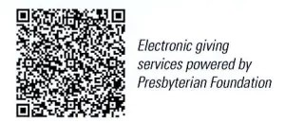

First Presbyterian Church
In the heart of Gardner since 1866 ~ Serving from the heart of God

Sunday, October 12, 2025
8:45 AM

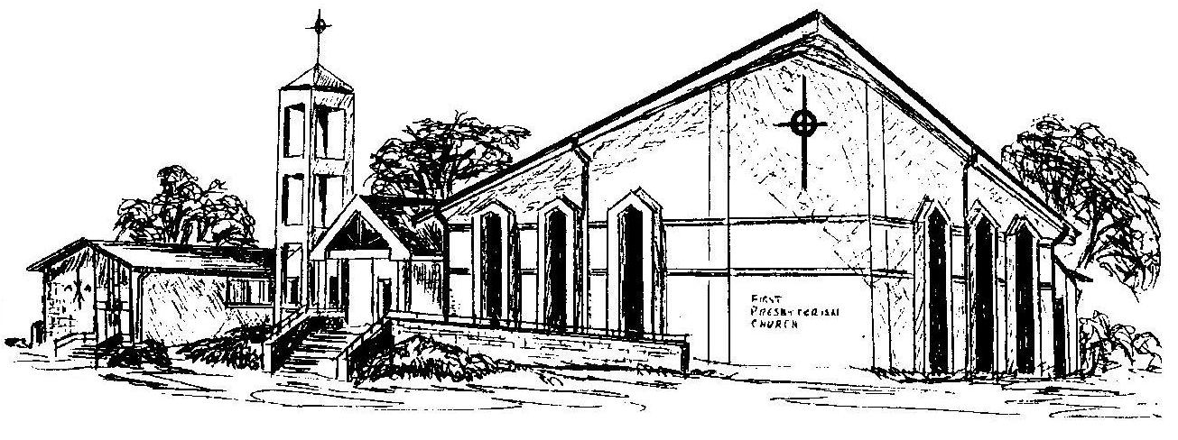

Welcome - Thank you for joining us for worship today. Please fill out a visitor information card found in the pew racks and place those in the offering plate so that we may follow up with you in the future. Your presence with us today has been a blessing to us, we hope that you have felt the presence of God and the welcome of this congregation.

