First Presbyterian Newsletter November 2025

Pastor Transition Process – by Kimby Young
I have announced and most of you know, I will be retiring at the end of May 2026, just after I turn 65. This is still 7 months away – so a great deal will happen between now and May. However, I recognize some signs of anxiety in the congregation because of so many unknowns in the year ahead. I have also heard some strange rumors about the process. I decided to try to clarify a few things.

First, you cannot start searching for a new pastor until I leave. This is an old rule that seems frustrating, but it is in place to prevent abuse of power by pastors. I should not influence your decisions in future pastoral leadership. That is the same reason for a rule that says I will not be able to do anything “pastoral” for at least a year after I leave, and after that only by invitation of your pastors and session. This is so that you will trust and depend on new leadership, not me. It is a healthy step toward a good transition.

Second, there will be preachers and pastors available to help during the transition. We don’t know who yet, but there will be someone. We all know there are some churches in our area who have not had pastors after someone left. That will not happen here. This church is large enough, healthy enough and financially stable. In fact you are in the top third in size of all churches in this Presbytery. This Presbytery wants you to be strong and healthy, as you are. This Presbytery will do everything possible to help this church remain vital and vibrant, even during the transition. There will be preachers every Sunday and pastors to offer care during the week. What is most likely to happen is that your session will hire someone called a “Bridge Pastor” who will be here for 3-6 months. Or they may choose to hire an “Interim Pastor” who will be here for a year or more. That decision has not been made, and a lot depends on what happens in the next 7 months while I am still here. If we are able to find an associate pastor before I leave that person will help in the transition. There will still be a need for a Bridge or Interim pastor, but there will be less pressure and more flexibility for the transition. If we are not able to find an associate pastor before I leave, session may consider hiring other part time staff for pastoral care to support the Bridge or Interim pastor, and to provide for your needs during the transition.

Third, a long transition is not a new thing. In the Presbyterian Church, there have always been breaks between pastors – usually of a year to three years. (An interim period.) In some other traditions (Methodist, Catholic, Episcopal), a pastor is appointed so there is no break between pastors. The disadvantage of that system is that the congregation has very little choice in who is appointed to the church. In the Presbyterian Church members choose the next pastor through a committee process, which takes time and careful discernment. If we try to go too fast, we often make mistakes. This is a challenge and a frustration in our fast-paced world today. We are encouraged to trust God, trust the process, and know that God will provide for us and sustain us during the transition, as God sustains us always.

And finally, I know this is anxiety producing - to not know the future, to worry about who will be with you next year, and how the church might change. However, only one person is leaving – only me. The leadership of the church is you - the session, the deacons, the committees, the members, the participants, the rest of staff. Most importantly, God is with you and always will be. Jesus Christ is the head of the church and will continue to guide you as you follow. Trust God. Trust, and see how the plan of God unfolds in the life of this wonderful congregation.

Worship Schedule
November 2 – All Saint’s Sunday – Hebrews 11 and 12
November 9 – Stewardship Dedication Sunday – Mark 12:38-44
November 16 – Guest Preacher, Kirk Perucca
November 23 – Christ the King Sunday and Thanksgiving Celebration – Colossians 1:9-20
November 30 – First Sunday of Advent – “Watch” – Mark 13:24-37; Revelations 21:1-7.

Daylight Saving Time ends on the first Sunday in November, November 2 which is also All Saints Day. Don’t forget to change your clocks.

Vacation and Guest Preacher
Pastor Kimby will be on vacation from November 11 through November 17 including Sunday, November 16. On that Sunday our Guest preacher will be Kirk Perucca, who is a retired pastor in our Presbytery. Kirk served as pastor of Covenant Presbyterian Church (KC, MO) for many years. He was active in urban ministry for the poor in Kansas City. Kirk has served on the Mission and Social Justice Committee of Heartland Presbytery, off and on for many years. Plan to be here on Sunday November 16 to welcome Kirk to lead worship in both services.

Monthly Financial Report
At the end of September 2025 our records indicate:
total income this month is $ 24,756.68
total expenses this month is $ 22,216.85
The session and finance/operations pillar thank each of you for your contributions to the church – financial or any other contribution. A complete line-by-line expense report is available upon request. We will close finances for October after November 3.

Stewardship Dedication
On November 9 we dedicate our pledge offerings for 2026. We give thanks for our church and all the ways we are able to connect with God and others. If you are able, bring your pledge cards on November 9. If you are not able to come that day, you may send your pledge card in at any time.

Operation Christmas Child - Shoebox Packing Party
Sunday, November 16 9:45-11 a.m.
Mark your calendars to join us for our annual packing party. Come put together a box for a child somewhere in the world. Before then, please bring in items to add to a box. A long list of items is available in the church narthex. You can bring in one great gift, or order in bulk and bring in several items. We usually try to fill about 150 boxes which includes all age groups.

One Worship Service at 10:00 a.m. for Three Weeks –
December 14, December 21 and December 28
On December 14, we will have one worship service at 10 to share the music of our Cantata.
On December 21, we will have a casual Christmas program including carols.
On December 28, we will celebrate the Christmas season and our church together.
Join us all three Sundays at 10 a.m. if you are able.

Christmas Eve Service, Wednesday, December 24, 4:30 p.m.
Communion and Candlelight Worship
Join us for worship on Christmas eve at 4:30 p.m.
Remember to invite family, friends, neighbors, and coworkers.

Prayer Request
Lois Barber, Cliff Schick, Jim Summers, Will Biggs, Martha Samuels, Randy, Bill Stone, Charlie Hildreth, Nick McSwane, the family of Gregg Plank, Bea Judah, Karl Allen, Mark Perry, Breanne Francis, Alice Christnger, Karen Elliott, Nancy Falkner, Janice Bacon, Darius Crist, Sharon Frahme, Bob Knoche, Rhonda Krehbiel, Uncle Tom, Ronnie DeChene, Tom Patton, Beau Foster, Robert Mashburn, Susan Gash, Susan Wilson-Dierksen, Abe Portenier, LeMoyne Zimmerman, Jerry Lane, Jon Deiley, Amanda Allen, Dozer Reed.

Ushers 8:45 a.m. Service
Ron Rushing, Jamie Bovitz, Karl & Kim Allen

Worship Assistant 8:45 a.m.
November 2 Tina Fraser
November 9 Randy Rieger
November 16
November 23 Connie Neneman
November 30 Maureen Allinder
Worship Assistant 11:00 a.m.
November 2 Seth Cooper
November 9 Heather Shutt
November 16
November 23 Carl Frahme
November 30 Jennifer Waites
Women Fellowship Group will meet on Wednesday, November 5 at 10:00 a.m. in Fellowship Hall. We will enjoy a morning of fellowship, including devotions by Vera Beach, refreshments will be provided by Glenda Bloomquist. The women’s Fellowship Group meets from March through November in Fellowship Hall. This will be our last Fellowship meeting for 2025. On December 6 we will join the Presbyterian Women for the Annual Christmas Luncheon. This group is open to ALL women of the church. Our purpose is to provide care and support for the mission and service projects of the church.

Ladies Night: Thursday, November 6, Presbyterian Women Group is having Ladies Night on Thursday, November 6th at 6:30pm in Fellowship Hall. Everyone is encouraged to bring a salad to share and dessert will be provided. Come join us! There is a Signup Sheet in the Narthex.

Ladies Christmas Luncheon: Stay tuned for more information to come on the Annual Christmas Luncheon to be held on Saturday December 6th at 12:00 noon. Mark your calendars!

Men’s Breakfast on Tuesday, November 11 at 7:00 a.m. Perkins. Come and enjoy fellowship.

Update from the APNC
The Associate Pastor Nominating committee has been hard at work. We have reviewed quite a few applications and interviewed a couple of individuals. Unfortunately, through our interview process, none of them were a good fit for our congregation. Therefore, we will continue to accept applications and move forward in our process.
On a separate matter – Individuals have asked about coverage when Kimby retires, Presbytery has assured us a Pastor will be available to preach and available for Pastoral cares or concerns.
Thank you!
Sandy Rieger

Store Hours
MONDAY 10 – 7
TUESDAY` 10 – 7
WEDNESDAY 10 – 4
THURSDAY 10 – 7
SATURDAY 10 – 2


2025
Celebrating 12 years!
We are thankful for:
abundant donations, amazing volunteers, generous shoppers who donate to our various non-profits that we help support, and especially for the people that God sends our way to be served. Our ministry continues to grow and provides our community with a great resource. We are humbled by the response of everyone involved. Thank you.
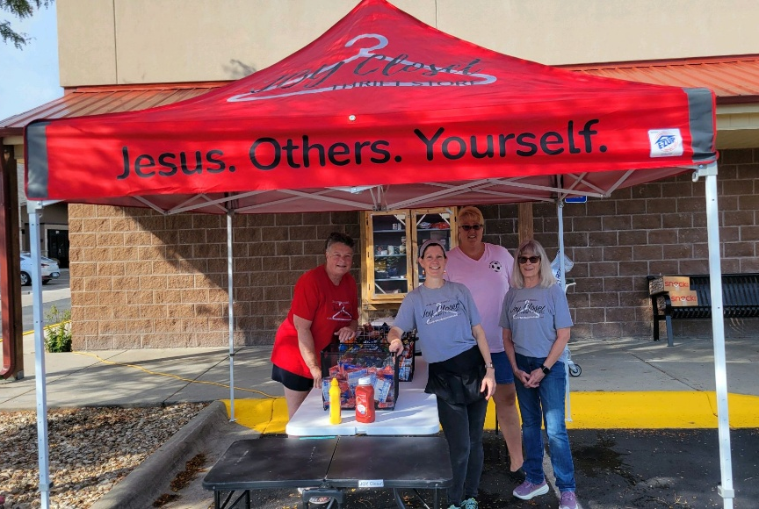
Our managers: Margaret Drovetta, Cindy Rollf, Ginger Crist, and Cathy Cochran.

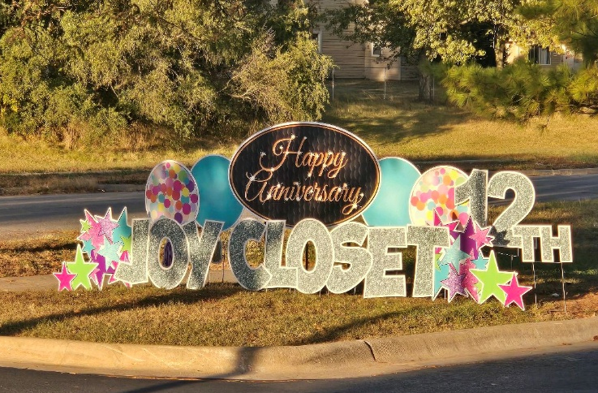

Shoppers enjoyed the Customer Appreciation Lunch Day.
We received lots of ‘thank you’s!

October designated donations at the register are going to reStart, an organization in Kansas City whose purpose is to address homelessness. ReStart is the only homeless shelter in downtown KCMO serving children, families, singles, and veterans.
More information about this non-profit can be found at: HOME | reStart 2025

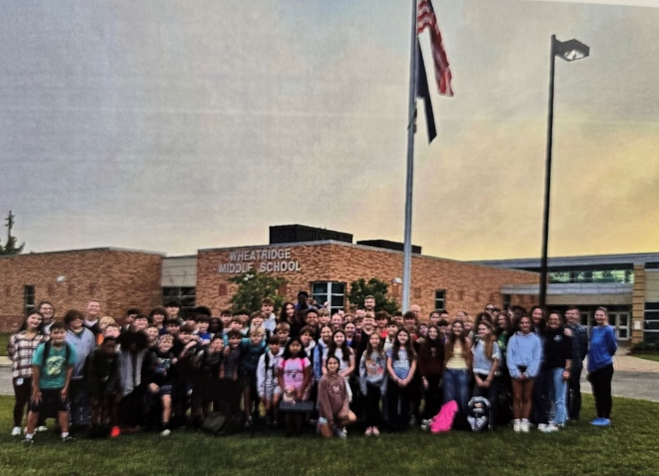
JOY Closet has received a beautiful thank you note from Fellowship of Christian Students at WheatRidge for our donation of $500 to provide donuts for 2025-2026 for their organization.

We are glad to help provide a welcoming space for students to grow their faith. The group is pictured here at the flagpole.

JOY Closet is in need of more sectional help. We have a variety of sections: Women’s, Men’s, Kids’ Clothing, Shoes, Bedding, Purses, Glasses, Seasonal.
Help us make donations ready for display! Come join us!


JOY Closet supports the Gardner Edgerton Schools Foundation, a non-profit that supports students and teachers in our district to assist in student learning.


JOY Closet board members represented our organization at the Prize Patrol presentations of teacher grants recently. Teachers submit proposals for specific learning activities to better instruct students.

What a JOY it was to see the students’ faces and the very happy teachers!
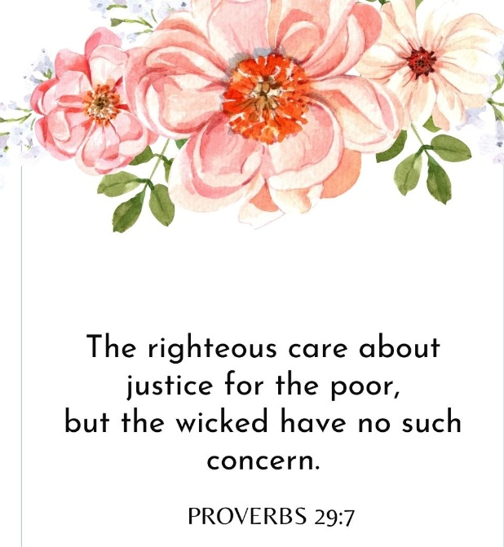
If you are interested in becoming a volunteer,
talk with Cindy, Ginger, Cathy, or Margaret.

You will meet some amazing people who enjoy helping others.
It is through helping others that we truly help ourselves.


Some of our volunteers being incognito…but having a great time! We appreciate your help!

Our Young Adult Bible Study group have received some start-up funds from JOY Closet as they begin meeting and serving. We want to support them as they transition from high school / college into their chosen careers. There is a need for fellowship to further nurture their faith and service in Christ.
If you are interested in becoming a volunteer,
talk with Cindy, Ginger, Cathy, or Margaret.
Volunteering is a great way to give back to a wonderful community and to meet new people who also enjoy helping others.
It is through helping others that we truly help ourselves.
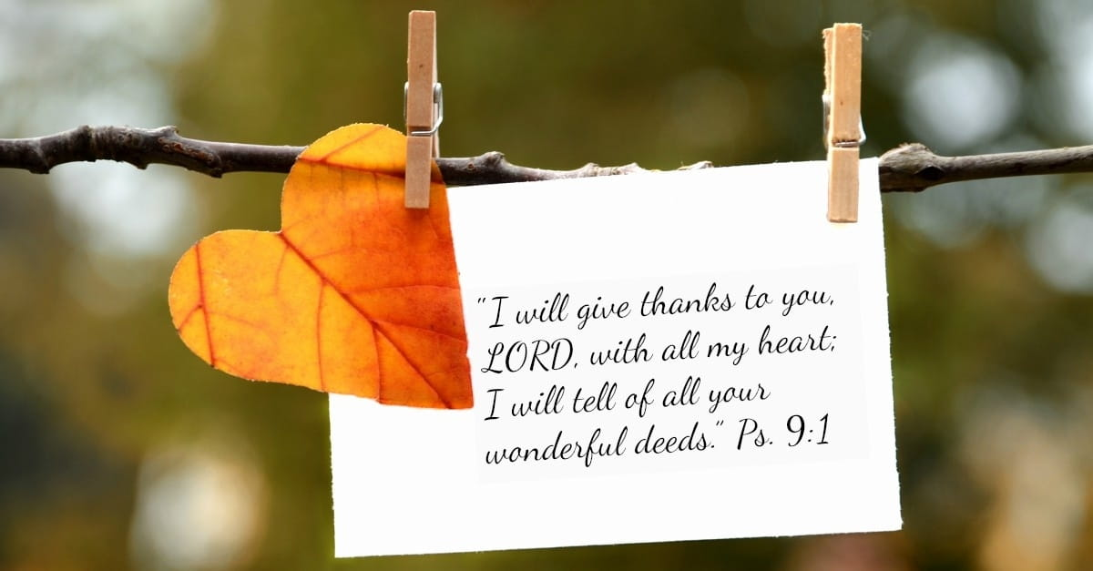
For I was hungry, and you gave me something to eat, I was thirsty, and you gave me something to drink, I was a stranger and you invited me in, I needed clothes, and you clothed me.

Matthew 25:35-36 NIV

JOY Closet Is a ministry of

First Presbyterian Church of Gardner, KS

Serving our comunity since 2013

