Welcome

Prelude “Surely the Presence of the Lord” Piano Duet
Let us prepare our hearts and minds for worship.

Call to Worship
Leader: This is the day that the Lord has made.
People: We will rejoice and be glad in it.
Leader: Christ calls us into service and worship.
People: We will praise our God with hearts and hands and voices.

*Opening Hymn: “Holy, Holy, Holy” Red Hymnal, #262

*Prayer of Confession (Unison) ~ PCUSA website.
Almighty God, you poured your Spirit upon gathered disciples creating bold tongues, open ears, and a new community of faith. We confess that we hold back the force of your Spirit among us. We do not listen for your word of grace, speak the good news of your love, or live as a people made one in Christ. Have mercy on us, O God. Transform our timid lives by the power of your Spirit, and fill us with a flaming desire to be your faithful people, doing your will for the sake of Jesus Christ our Lord. Amen.

* Silent Reflection

* Assurance of Pardon

* Gloria Patri (Glory Be to the Father…) Red Hymnal, #623

Children’s Time

Scripture “Psalm 96” (page 934)
“Psalm 100” (page 937)
“Colossians 3:14-17” (page 1835)
Leader: The word of the Lord.
People: Thanks be to God.

Music “Cares Chorus” Piano Duet
Sermon “Rally Day – Joyful Noise” Rev. Kimby Young

*Profession of Faith The Apostle's Creed Red Hymnal, inside back cover
I Believe in God the Father Almighty, Maker of heaven and earth, And in Jesus Christ his only Son our Lord; who was conceived by the Holy Ghost, born of the Virgin Mary, suffered under Pontius Pilate, was crucified, dead, and buried; he descended into hell; the third day he rose again from the dead; he ascended into heaven, and sitteth on the right hand of God the Father Almighty; from thence he shall come to judge the quick and the dead. I believe in the Holy Ghost; the holy catholic Church; the communion of saints; the forgiveness of sins; the resurrection of the body; and the life everlasting. Amen

*Hymn “Break Thou the Bread of Life” Red Hymnal, #274

Offertory Meditation

*Doxology

The Sacrament of Holy Communion
(All bread is gluten free. Prepacked elements are available in the back.)
Invitation
Great Prayer and The Lord’s Prayer
Words of Institution – Breaking of Bread
Communion of the People
Prayer of Thanksgiving

*Closing Hymn: “He’s Got the Whole World in His Hands” Red Hymnal, #344

*Benediction

Postlude
*Those who are comfortably able will please stand.

Rev. Kimby Young, Pastor; Larry Schick, Worship Assistant
Dean Faulk, Music Ministries
Vanessa Marriott and Robyn Forkner, Piano Duet
Harlan Plunkett, Organist; Robyn Forkner, Pianist
Mike McGuire and Brad Cornell, Slide Production; Kim Liu, Sound
Childcare is always available in the nursery (off the hall to the west of the sanctuary). Children are welcome to stay in the sanctuary thru the whole service, or to leave at any time. Allison Perry is our primary childcare attendant.

Worship Bags for Children are available outside the north door to the sanctuary. Choose books,
crayons, pencils, Legos, stuffed toys and other items to fill your bag to use during worship.

Offering Plates are at the entrance of each aisle for your contributions to the work of the church.

Gardner Multi Service Center collection is ongoing every week and is always in need of any non-perishable food. Bring something every week or once a month.

Fair Trade Products for Sale on Sundays Coffee, tea, chocolate, nuts, olive oil, dried fruit, baking products, and a few other items are for sale each Sunday at church.

Harvesters Food Distribution is always seeking volunteers. Every 3rd Saturday at Trade Net Parking lot and every 2nd Thursday at Divine Mercy Parish. Distribution begins at 1 p.m.

Joy Closet – Our mission center thrift store provides free clothing to a variety of needs. Our church provides all volunteers on the fourth Saturday of each month.

Men’s Breakfast on Tuesday, September 9, 7:00 a.m. at Perkins

Bells 6:00 p.m., Cantata 7:00 p.m., Chancel Choir 8:00 p.m. starts on Wed., Sept. 10.

Middle school teacher or team needed for Sunday School. Experienced helper in place. Contact Kimby for more information.

Bible Study – Romans – Thursdays beginning Sept. 11, 10-11:30 a.m. - Pastor Kimby teaching.

Holy Smokes, Sat., September 27, 5:00 – 7:30 p.m. BBQ Potluck & Music Community Event.

Trunk or Treat and Chili Supper! October 26 - 5-7 p.m. - Save the date.

Nominating Committee is seeking elders and deacons to begin serving in January 2026. If you have a name to suggest, or if you would be interested let Karen Elliott or Lynn Moldrup know.

Remember, Each One, Bring One collecting food, basket in the narthex. Joy Closet food box.

Presbyterian Women Bible study starts Thursday, September 11, 6:30 p.m. Bring sack lunch. Book “Jesus Through the Eyes of Women”. Paula Waters collecting. $10.00 ordering book.

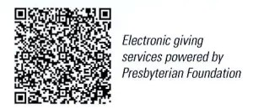
First Presbyterian Church
In the heart of Gardner since 1866 ~ Serving from the heart of God

Sunday, September 7, 2025
8:45 AM

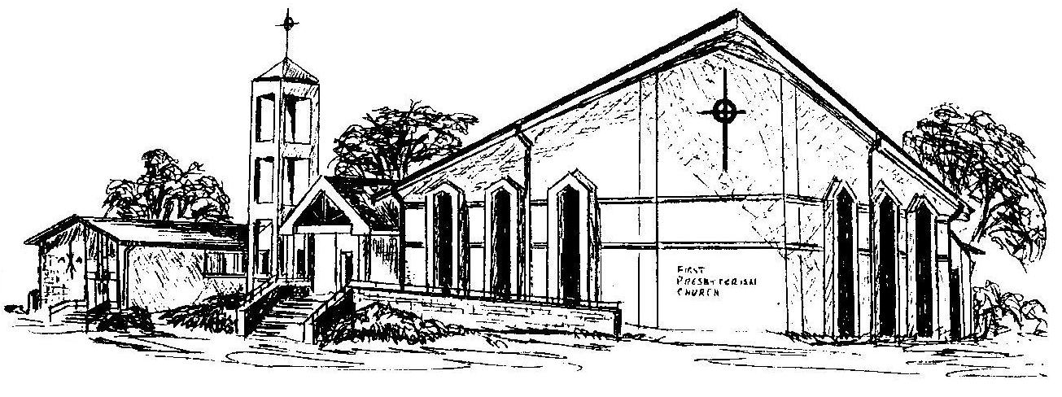

Welcome - Thank you for joining us for worship today. Please fill out a visitor information card found in the pew racks and place those in the offering plate so that we may follow up with you in the future. Your presence with us today has been a blessing to us, we hope that you have felt the presence of God and the welcome of this congregation.

