Welcome

Prelude
Let us prepare our hearts and minds for worship.

Call to Worship: (inspired by 1 Corinthians 12)
Leader: There are varieties of gifts, but the same Spirit who gives them.
People: There are varieties of service, but the same Lord who is served.
Leader: To each is given the manifestation of the Spirit for the common good.
People: All are empowered by our one God, to offer the best that we are able to give.

*Opening Hymn: “Sing Praise to God Who Reigns Above” Red Hymnal, #6

*Prayer of the Confession (Unison) (from Rev Gord’s Worship Offerings)
Gracious God, You have given each of us many gifts, but sometimes we cannot recognize what gift we have to share, so we hide it under a bushel. You remind us that all gifts are needed, but sometimes we let ourselves be convinced that some gifts are more special than others. You call us to work, to live, to love together as parts of one body, but sometimes we exclude others. Forgive us, God, and speak to us again of Your love and mercy, that we may share Your gifts fully and freely in the world. Amen.

*Silent Reflection

*Assurance of Pardon

*Gloria Patri (Glory Be to the Father…) Red Hymnal, #623

Children’s Time

Scripture “Luke 10:38-42” (page 1613)
“Romans 12:3-13” (page 1763)
Leader: The word of the Lord.
People: Thanks be to God.

Music

Sermon “Mary and Martha” Rev. Kimby Young

*Profession of Faith The Apostle's Creed Red Hymnal, inside back cover
I Believe in God the Father Almighty, Maker of heaven and earth, And in Jesus Christ his only Son our Lord; who was conceived by the Holy Ghost, born of the Virgin Mary, suffered under Pontius Pilate, was crucified, dead, and buried; he descended into hell; the third day he rose again from the dead; he ascended into heaven, and sitteth on the right hand of God the Father Almighty; from thence he shall come to judge the quick and the dead. I believe in the Holy Ghost; the holy catholic Church; the communion of saints; the forgiveness of sins; the resurrection of the body; and the life everlasting. Amen

*Hymn “O Master, Let Me Walk With Thee” Red Hymnal, #451

Pastoral Prayer & Lord’s Prayer

Offertory Meditation

*Doxology

*Prayer of Dedication

*Closing Hymn: “They’ll Know We Are Christians” Red Hymnal, #284

*Benediction

Postlude
*Those who are comfortably able will please stand.

Rev. Kimby Young, Pastor; Harlan Plunkett, Worship Assistant
Dean Faulk, Music Ministries
Harlan Plunkett, Organist; Robyn Forkner, Pianist
Mike McGuire and Brad Cornell, Slide Production; Kim Liu, Sound

Childcare is always available in the nursery (off the hall to the west of the sanctuary). Children are welcome to stay in the sanctuary thru the whole service, or to leave at any time. Allison Perry is our primary childcare attendant.

Worship Bags for Children are available outside the north door to the sanctuary. Choose books,
crayons, pencils, Legos, stuffed toys and other items to fill your bag to use during worship.

Offering Plates are at the entrance of each aisle for your contributions to the work of the church.

Gardner Multi Service Center collection is ongoing every week and is always in need of any non-perishable food. Bring something every week or once a month.

Remember, Each One, Bring One collecting food, basket in the narthex. Joy Closet food box.

Joy Closet – Our mission center thrift store provides free clothing to a variety of needs. Our church provides all volunteers on the fourth Saturday of each month.

Harvesters Food Distribution is always seeking volunteers. Every 3rd Saturday at Trade Net Parking lot and every 2nd Thursday at Divine Mercy Parish. Distribution begins at 1 p.m.

Fair Trade Products for Sale on Sundays Coffee, tea, chocolate, nuts, olive oil, dried fruit, baking products, and a few other items are for sale each Sunday at church.

Bells 6:00 p.m., Cantata 7:00 p.m., Chancel Choir 8:00 p.m. New participants welcome.

Trunk or Treat and Chili Supper! October 26 - 5-7 p.m. – Sign up in the narthex

Presbyterian Women Bible study - Thursdays, thru Oct.23, 6:30 p.m. Book “Jesus Through the Eyes of Women.” Paula Waters collecting. $10.00 ordering book. All women can come.

Women Fellowship Group will meet on Wednesday, October 1, 10:00 a.m. All Women welcome.

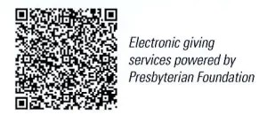
First Presbyterian Church
In the heart of Gardner since 1866 ~ Serving from the heart of God
Sunday, September 28, 2025
8:45 AM
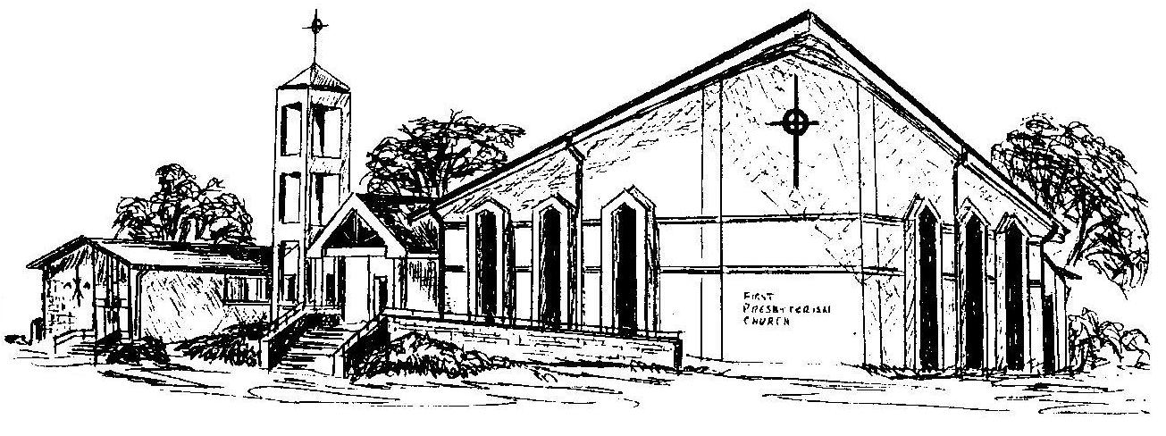

Welcome - Thank you for joining us for worship today. Please fill out a visitor information card found in the pew racks and place those in the offering plate so that we may follow up with you in the future. Your presence with us today has been a blessing to us, we hope that you have felt the presence of God and the welcome of this congregation.

