Welcome

Prelude
Let us prepare our hearts and minds for worship.

Call to Worship: (adapted from Katherine Hawker. Liturgy Outside the Box.)
Leader: Listen to The Voice calling long ago. The Voice calling today.
People: The Voice compelling Jonah to go. The Voice calling us to follow.
Leader: Compelling us to share the good news of God's redemptive love.
People: Calling us to love even our enemies. Give us grace to respond.

*Opening Hymn: “O Worship the King” Red Hymnal, #10

*Prayer of the Confession (Unison)
(adapted from Rev. Madison Shockley, Reluctant Evangelists)
Holy One, what a blessing we share here among this loving community. Like Jonah, we sometimes guard what we have here. We know that others are longing for what we know and experience of your love. Forgive us our reluctance to open our doors, and open our hearts to others. We repent of our hesitations and unwillingness to witness to others for fear that we might lose something. By your grace, as we share, we will receive only more and more blessing. Help us to live your grace, in Jesus name. Amen.

*Silent Reflection

*Assurance of Pardon

*Gloria Patri (Glory Be to the Father…) Red Hymnal, #623

Children’s Time

Scripture “Jonah 1:1-4” (page 1436)
“Jonah 1:11-17” (page1437)
Leader: The word of the Lord.
People: Thanks be to God.

Mixed Choir “Hope” Medley arr. By Dennis Allen

Sermon “Jonah” Rev. Kimby Young

*Profession of Faith The Apostle's Creed Red Hymnal, inside back cover
I Believe in God the Father Almighty, Maker of heaven and earth, And in Jesus Christ his only Son our Lord; who was conceived by the Holy Ghost, born of the Virgin Mary, suffered under Pontius Pilate, was crucified, dead, and buried; he descended into hell; the third day he rose again from the dead; he ascended into heaven, and sitteth on the right hand of God the Father Almighty; from thence he shall come to judge the quick and the dead. I believe in the Holy Ghost; the holy catholic Church; the communion of saints; the forgiveness of sins; the resurrection of the body; and the life everlasting. Amen

*Hymn “Jesus Calls Us” Red Hymnal, #375

Pastoral Prayer & Lord’s Prayer

Offertory Meditation

*Doxology

*Prayer of Dedication

*Closing Hymn: “We’ve a Story to Tell to the Nations” Red Hymnal, #296

*Benediction

Postlude
*Those who are comfortably able will please stand.

Rev. Kimby Young, Pastor; Mitch McSwane, Worship Assistant
Dean Faulk, Music Ministries
Harlan Plunkett, Organist; Robyn Forkner, Pianist
Mike McGuire and Brad Cornell, Slide Production; Kim Liu, Sound

Childcare is always available in the nursery (off the hall to the west of the sanctuary). Children are welcome to stay in the sanctuary thru the whole service, or to leave at any time. Allison Perry is our primary childcare attendant.

Worship Bags for Children are available outside the north door to the sanctuary. Choose books,
crayons, pencils, Legos, stuffed toys and other items to fill your bag to use during worship.

Offering Plates are at the entrance of each aisle for your contributions to the work of the church.

Gardner Multi Service Center collection is ongoing every week and is always in need of any non-perishable food. Bring something every week or once a month.

Remember, Each One, Bring One collecting food, basket in the narthex. Joy Closet food box.

Joy Closet – Our mission center thrift store provides free clothing to a variety of needs. Our church provides all volunteers on the fourth Saturday of each month.

Harvesters Food Distribution is always seeking volunteers. Every 3rd Saturday at Trade Net Parking lot and every 2nd Thursday at Divine Mercy Parish. Distribution begins at 1 p.m.

Fair Trade Products for Sale on Sundays Coffee, tea, chocolate, nuts, olive oil, dried fruit, baking products, and a few other items are for sale each Sunday at church.

Bells 6:00 p.m., Cantata 7:00 p.m., Chancel Choir 8:00 p.m. New participants welcome.

Holy Smokes, Sat., September 27, 5:00 – 7:30 p.m. BBQ Potluck & Music Community Event.

Trunk or Treat and Chili Supper! October 26 - 5-7 p.m. – Sign up in the narthex

Presbyterian Women Bible study - Thursdays, Sept.18 – Oct.23, 6:30 p.m. Book “Jesus Through the Eyes of Women.” Paula Waters collecting. $10.00 ordering book. All women can come.

Women Fellowship Group will meet on Wednesday, October 1, 10:00 a.m. All Women welcome.

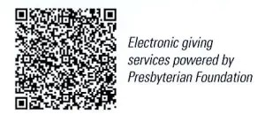
First Presbyterian Church
In the heart of Gardner since 1866 ~ Serving from the heart of God
Sunday, September 21, 2025
8:45 AM
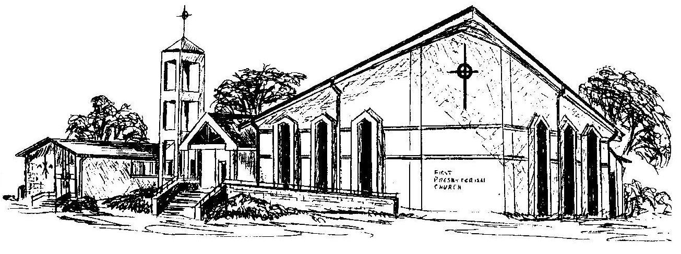

Welcome - Thank you for joining us for worship today. Please fill out a visitor information card found in the pew racks and place those in the offering plate so that we may follow up with you in the future. Your presence with us today has been a blessing to us, we hope that you have felt the presence of God and the welcome of this congregation.

