Welcome

Prelude
Let us prepare our hearts and minds for worship.

Call to Worship: (inspired by Psalm 145)
Leader: Great is the Lord and greatly to be praised; God’s greatness is unsearchable.
People: The Lord is gracious and merciful, slow to anger and abounding in steadfast love.
Leader: The Lord is good to all, and God’s compassion is over all that God has made.
People: The Lord is faithful in all words and gracious in all deeds.
Leader: The Lord is just in all ways and kind in all God does.
People: The Lord is near to all who call on God in truth. Let us worship God.

*Opening Hymn: “Immoral, Invisible” Red Hymnal, #25

*Prayer of the Confession (Unison) (adapted from RE-Worship blogspot)
God, we confess that we do not always understand Your ways. We are easily discouraged when life takes unexpected turns and our carefully laid plans come to nothing. Forgive us. Grant us patience to wait for Your good timing. Open our eyes to recognize Your leading in our lives - to listen for Your gentle whisper when we least expect it. And then give us courage to step out in faith, trusting in Your leading even when we cannot yet see the outcome. We pray that You would make us worthy to bear Your name. Amen.

*Silent Reflection

*Assurance of Pardon

* Gloria Patri (Glory Be to the Father…) Red Hymnal, #623

Children’s Time

Scripture “1 Kings 18: 17-39” (page 557)
Leader: The word of the Lord.
People: Thanks be to God.

Music “Heaven” by Dennis Allen
Sermon “Elijah and Fire” Rev. Kimby Young

*Profession of Faith The Apostle's Creed Red Hymnal, inside back cover
I Believe in God the Father Almighty, Maker of heaven and earth, And in Jesus Christ his only Son our Lord; who was conceived by the Holy Ghost, born of the Virgin Mary, suffered under Pontius Pilate, was crucified, dead, and buried; he descended into hell; the third day he rose again from the dead; he ascended into heaven, and sitteth on the right hand of God the Father Almighty; from thence he shall come to judge the quick and the dead. I believe in the Holy Ghost; the holy catholic Church; the communion of saints; the forgiveness of sins; the resurrection of the body; and the life everlasting. Amen

*Hymn “Dear Lord and Father of Mankind” Red Hymnal, #427

Pastoral Prayer & Lord’s Prayer

Offertory Meditation

*Doxology

*Prayer of Dedication

*Closing Hymn: “Abide With Me” Red Hymnal, #419 vs 1, 3, 5

*Benediction

Postlude
*Those who are comfortably able will please stand.

Rev. Kimby Young, Pastor; Dean Faulk, Worship Assistant
Dean Faulk, Music Ministries; Chancel Choir
Harlan Plunkett, Organist; Robyn Forkner, Pianist
Mike McGuire and Brad Cornell, Slide Production; Kim Liu, Sound

Childcare is always available in the nursery (off the hall to the west of the sanctuary). Children are welcome to stay in the sanctuary thru the whole service, or to leave at any time. Allison Perry is our primary childcare attendant.

Worship Bags for Children are available outside the north door to the sanctuary. Choose books,
crayons, pencils, Legos, stuffed toys and other items to fill your bag to use during worship.

Offering Plates are at the entrance of each aisle for your contributions to the work of the church.

Gardner Multi Service Center collection is ongoing every week and is always in need of any non-perishable food. Bring something every week or once a month.

Fair Trade Products for Sale on Sundays Coffee, tea, chocolate, nuts, olive oil, dried fruit, baking products, and a few other items are for sale each Sunday at church.

Harvesters Food Distribution is always seeking volunteers. Every 3rd Saturday at Trade Net Parking lot and every 2nd Thursday at Divine Mercy Parish. Distribution begins at 1 p.m.

Joy Closet – Our mission center thrift store provides free clothing to a variety of needs. Our church provides all volunteers on the fourth Saturday of each month.

Bells 6:00 p.m., Cantata 7:00 p.m., Chancel Choir 8:00 p.m. New participants welcome.

Bible Study – Romans – Thursdays, 10-11:30 a.m. - Pastor Kimby teaching.

Holy Smokes, Sat., September 27, 5:00 – 7:30 p.m. BBQ Potluck & Music Community Event.

Trunk or Treat and Chili Supper! October 26 - 5-7 p.m. - Save the date.

Nominating Committee is seeking elders to begin serving in January 2026. If you have a name to suggest, or if you would be interested let Karen Elliott or Lynn Moldrup know.

Remember, Each One, Bring One collecting food, basket in the narthex. Joy Closet food box.

Presbyterian Women Bible study starts Thurs., Sept.18 – Oct.23, 6:30 p.m. Book “Jesus Through the Eyes of Women”. Paula Waters collecting. $10.00 ordering book. All women are welcome!

Women’s Fellowship Group will meet on Wed., Oct. 1, at 10:00 a.m. All Women are welcome!



First Presbyterian Church
In the heart of Gardner since 1866 ~ Serving from the heart of God
Sunday, September 14, 2025
8:45 AM
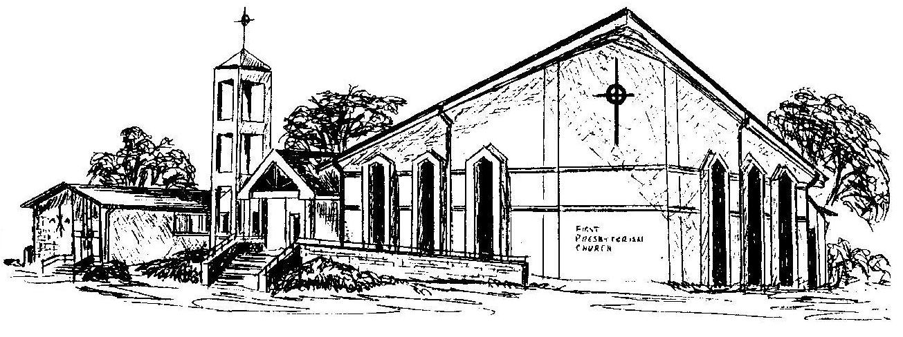

Welcome - Thank you for joining us for worship today. Please fill out a visitor information card found in the pew racks and place those in the offering plate so that we may follow up with you in the future. Your presence with us today has been a blessing to us, we hope that you have felt the presence of God and the welcome of this congregation.

