Welcome

Prelude
Let us prepare our hearts and minds for worship.

Call to Worship
Leader: Today we gather around God's table from every corner of the earth.
People: We are the People of God!
Leader: Though we differ in many ways, we come together to worship a God who knows and loves us all.
People: We are brothers and sisters in Christ!
Leader: For there is one Lord, one faith, and one baptism.
People: One God and Savior of us all! Let us worship God.

*Opening Hymn: “The Church’s One Foundation” Red Hymnal, #277

*Prayer of Confession (Unison)
Great God of all the world, we know that you call us to be one world community, inviting all people into your love and abundance. Help us on this Worldwide Communion Sunday to hear your call to unity and to respond. Help us to be open to your world in all its diversity, and to share generously the gifts you have given, that all may know your mercy and grace, through Jesus Christ our Lord. Amen.

* Silent Reflection

* Assurance of Pardon

* Gloria Patri (Glory Be to the Father…) Red Hymnal, #623

Children’s Time

Sacrament of Baptism - Robin Gilmore

Scripture “Matthew 28:18-20” (page 1550)
“Ephesians 4:1-7; 11-16 ” (page 1821)
Leader: The word of the Lord.
People: Thanks be to God.

Choir Anthem “The Lord’s Supper (Communion)” arr. By Dennis Allen

Sermon “Sacraments and Unity” Rev. Kimby Young

*Profession of Faith The Apostle's Creed Red Hymnal, inside back cover
I Believe in God the Father Almighty, Maker of heaven and earth, And in Jesus Christ his only Son our Lord; who was conceived by the Holy Ghost, born of the Virgin Mary, suffered under Pontius Pilate, was crucified, dead, and buried; he descended into hell; the third day he rose again from the dead; he ascended into heaven, and sitteth on the right hand of God the Father Almighty; from thence he shall come to judge the quick and the dead. I believe in the Holy Ghost; the holy catholic Church; the communion of saints; the forgiveness of sins; the resurrection of the body; and the life everlasting. Amen

*Hymn “In Christ There is No East or West” Red Hymnal, #285

Offertory Meditation

*Doxology

The Sacrament of Holy Communion
(All bread is gluten free. Prepacked elements are available in the back.)
Invitation
Great Prayer and The Lord’s Prayer
Words of Institution – Breaking of Bread
Communion of the People
Prayer of Thanksgiving

*Closing Hymn: “Let Us Break Bread Together” Red Hymnal, #323

*Benediction

Postlude
*Those who are comfortably able will please stand.

Rev. Kimby Young, Pastor; Sandy Rieger, Worship Assistant
Dean Faulk, Music Ministries; Chancel Choir
Harlan Plunkett, Organist; Robyn Forkner, Pianist
Mike McGuire and Brad Cornell, Slide Production; Kim Liu, Sound

Childcare is always available in the nursery (off the hall to the west of the sanctuary). Children are welcome to stay in the sanctuary thru the whole service, or to leave at any time. Allison Perry is our primary childcare attendant.

Worship Bags for Children are available outside the north door to the sanctuary. Choose books,
crayons, pencils, Legos, stuffed toys and other items to fill your bag to use during worship.

Offering Plates are at the entrance of each aisle for your contributions to the work of the church.

Gardner Multi Service Center collection is ongoing every week and is always in need of any non-perishable food. Bring something every week or once a month.

Remember, Each One, Bring One collecting food, basket in the narthex. Joy Closet food box.

Joy Closet – Our mission center thrift store provides free clothing to a variety of needs. Our church provides all volunteers on the fourth Saturday of each month.

Harvesters Food Distribution is always seeking volunteers. Every 3rd Saturday at Trade Net Parking lot and every 2nd Thursday at Divine Mercy Parish. Distribution begins at 1 p.m.

Fair Trade Products for Sale on Sundays Coffee, tea, chocolate, nuts, olive oil, dried fruit, baking products, and a few other items are for sale each Sunday at church.

Faith and Blue Open House at the Gardner Justice Center on October 11th from 10 AM to 12PM.

Trunk or Treat and Chili Supper! October 26 - 5-7 p.m. – Sign up in the narthex

Presbyterian Women Bible study - Thursdays, thru Oct.23, 6:30 p.m. Book “Jesus Through the Eyes of Women.” Paula Waters collecting. $10.00 ordering book. All women can come.

Women Fellowship Group will meet on Wednesday, October 1, 10:00 a.m. All Women welcome.

Operation Christmas Child – Shoebox Packing Party – November 16 – Bring a gift any time. A gift suggestion list is in the narthex – no liquids, fragrances, sharp or breakable objects.

Congregational Meeting – Sunday, October 26 – 9:45a.m. – to nominate officers for 2026.

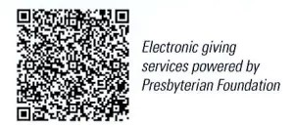

First Presbyterian Church
In the heart of Gardner since 1866 ~ Serving from the heart of God

Sunday, October 5, 2025
World Communion Sunday
8:45 AM

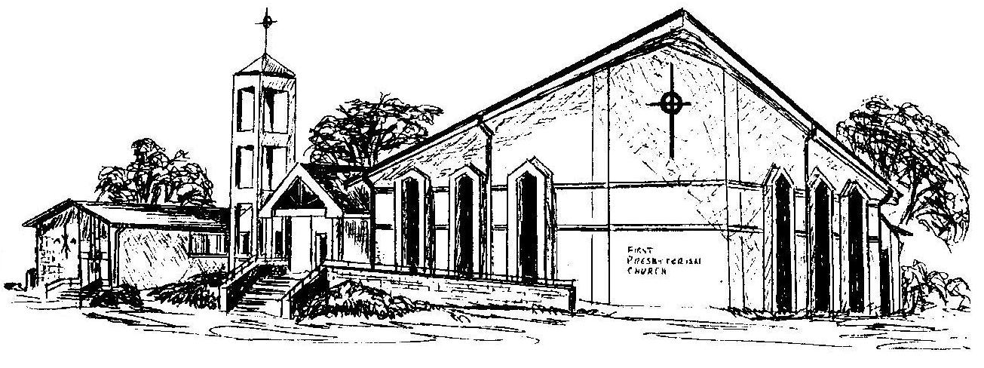

Welcome - Thank you for joining us for worship today. Please fill out a visitor information card found in the pew racks and place those in the offering plate so that we may follow up with you in the future. Your presence with us today has been a blessing to us, we hope that you have felt the presence of God and the welcome of this congregation.

