First Presbyterian Newsletter September 2025

September Start Ups – by Pastor Kimby
It’s time! Everything is coming back together after summer scattering. Join something new or return to your old programs regularly. Choir and Bell choir resume September 3. Children’s Sunday School starts September 7. Cantata Choir starts September 10. Bible Studies begin September 11 – morning and evening. PYF has already shifted and kicks off another wonderful year of youth activities. Women’s groups, Men’s groups, Committees and Pillars continue. See below that we are starting a few new programs and projects. Thank you to all those who have stepped up to lead in any way. You are appreciated.
I do love September – change of seasons, change of routines. The mad rush of planning is passed, and we slip into regular wonderful ordinary days. It is a great time to try something new. We have 3-4 months before us with fairly predictable patterns. We have a few holidays and special occasions to look forward to in those months. See below for “Holy Smokes BBQ” and “Trunk or Treat” details. It should be a terrific fall season with lots of opportunities. Join us. And invite friends.

Worship Schedule
September 7 – Psalm 96 and 100 - Rally Day – Joyful Noise
September 14 - 1 Kings 18:17-39 - Elijah & Fire
September 21 - Jonah 1 & 2:10 - Jonah & the Whale
September 28 - Luke 10:38-42 - Mary & Martha

Monthly Financial Report
At the end of July 2025 our records indicate:
total income this month is $ 20,577.37
total expenses this month is $ 28,038.48
The session and finance/operations pillar thank each of you for your contributions to the church – financial or any other contribution. A complete line-by-line expense report is available upon request. We will close finances for August after September 3.

Thank you – Video Upgrades in the Sanctuary
Worship Pillar completed upgrades to the monitors, transmitters and other video equipment in the sanctuary. The screens are now 86 inches wide and we added a screen in the back for Pastor, Choirs and Praise Team to follow. Thank you to all of the volunteers who worked on this project. Seth, Chris, Henry and Marsha Cooper, Oliver Schwab, Dean Faulk, and Karl Allen. Thank you also to Joy Closet for lending us the scissor lift for the week. Also thank you to Brad Cornell and Mike McGuire for ongoing slide production each week and for making adjustments to the new format. This was a huge project that will enhance worship for some time.

Childcare Nursery Available on Request
The Discipleship Pillar and session approved a request last year to have child care available for evening and special meetings upon request. There is a form available in the nursery and in the office to make a request. Our regular child care provider Alison Perry may be available. If not substitute care givers will be contacted. Amy Hittle will help coordinate requests. All requests must be made 2 days or 48 hours in advance of the event to insure availability. Some groups may be asked to pay for child care to cover costs if possible.

Children’s Music – Starting Something New, Returning to Something Old
We are beginning a new children’s choir and music program. Each Sunday just before Sunday school from 9:45 to 10 a.m., Ella Falkner and Dean Faulk will lead a children’s music group. We are squeezing the program between 1st worship and Sunday School, to try to reach the most people who are already here. All children and youth are welcome. We know we have some great young singers and musicians. This is a chance to get together to praise God in song. If all goes well, we may see the group in worship around Christmas. If you would like to assist with crowd control or in any other way, please speak to Dean or Ella. Tom Dean on guitar, Amy Hittle crowd control.
Sunday School resumes - Sunday, September 7, 10 a.m.
Between services on Sunday, September 7, church school classes for all ages will begin again for the school year. It's a great time to start anew. Children's classes are held downstairs below the fellowship hall.

There are three adult study options.
Seekers and Servants – led by Alice Rollf and Paula Waters - will continue to meet in the library.
Young Adults Class - led by Cindy Rollf in PYF room downstairs.
Devotional Discussion – led by Phil Lenahan - conference room off the office (Calvin Room).

Please pray for and thank the following leaders and teachers:
Nursery - Allison and Joni Perry
Early Children – Marsha Cooper and Judy Mason
Elementary – Tracy McCabe and Blake McSwane
Middle School – _______________ and Maureen Allinder

We could use several more substitutes. If you would be willing to assist or substitute teach in any of the classes, speak to Pastor Kimby Young or to the teacher.
Everyone is welcome. Invite family, neighbors and friends and let us grow together in our faith. Join us on Sunday, September 7 for worship and classes.

Pastor Kimby's Bible Study – Romans
- each Thursday beginning September 11, 10-11:30 a.m.
Join us each week, or any week you are able, for a study of the book of Romans – Paul’s letter to the Christians living in the capital city of the world. It is a comprehensive overview of the belief system of the early church, and an inspiration to Christians throughout generations. Pastor Kimby Young will be teaching. The only book or curriculum is the Bible in any version. Participants are encouraged to bring commentaries and study Bibles. We usually study the book chapter by chapter, or verse by verse. We have great discussions on a wide range of faith topics. The class will last till Spring with breaks for holidays and other events. The first week (Sept.11) will be an introduction or overview. It’s a good week to sit in to see if you like the class. You can miss some sessions. Friends, members and guests are welcome. Men and women, singles and couples. All ages. Everyone may join us. Invite a friend. All are welcome.

BBQ Potluck and Music Community Event
Saturday, September 27 – 5-7:30 p.m.
Our “Holy Smokes” event will continue this year, with a few changes. The BBQ and Potluck will begin at 5 p.m. with food served inside, and seating both indoors and out. Games on the lawn will continue. This year we are adding bounce houses. Derrek Hittle will BBQ pork, beef and a few other meats. At 6:30p.m. we will move to the sanctuary for music and entertainment. The plan is to invite all the area churches to bring musicians, so we can enjoy and praise God together. Bring potluck sides, chairs and lots of friends.
If you would like to offer some of the entertainment, please contact Dean Faulk.
If you would be willing to help set up or organize the games, contact Pastor Kimby.
If you would be willing to cook hamburgers and hot dogs (on site or at home), contact Kimby.
If you would like to contribute meat or money for meat, contact Amy or Derrek Hittle.
If you would like to help with kitchen and table set up, contact Kelly Johnson.
If you have other questions or ideas, contact Karen Elliott or Kimby Young.

Nominating Committee
Nominating Committee has started the process of looking for elders and deacons for the class of 2028 to begin serving in January 2026. If you have a name to suggest, if you would be interested in serving, or if you would like more information about what is involved in these service positions, please contact the church office or anyone on nominating committee. This year’s committee includes Karen Elliott, Lynn Moldrup, Carl Frahme. Paula Waters, Larry Atwater, Robin Tropansky, Phil Lenahan, Lois Barber, and Pastor Kimby Young.
Trunk or Treat and Chili Supper! October 26
Halloween All Church Celebration – Sunday, October 26
5-5:45 p.m. – Trick-or-treat and Games – North Parking Lot
5:45-6 p.m. – Costume Parade and Celebration
5:45-7 p.m. – Chili Supper – Fellowship Hall
Mark your calendar! Save the date! Added “photo booth!”
Look for sign up sheets soon to help with planning and set up, to decorate, to offer your trunk, to lead games, to bring chili or fixin’s, and to help in any other way you imagine.
If you would like to help in planning, please contact Pastor Kimby.

Choir, Bells and Cantata Choir Start Ups
All of our music groups are welcoming new participants and returning volunteers. Praise band continues year-round, but they always welcome new talent - vocal or instrumental. Talk to Dean Faulk to volunteer or to know more. Choir and Bell choir begin again on September 3. 6 p.m. for bells. 7 for choir. Cantata Choir will start on September 10 at 7 and Chancel choir moves to 8p.m.
Online Picture Directory
The deacons are trying to set up an online picture directory for our church. We are using Instant Church Directory. It will be available to print or to access on line. We can edit, add or delete at any time. The set up is the most difficult part. You must set up your initial profile. We are pushing in September to have as many people enter their information as possible. Carl Frahme is in charge of the project. You will receive an email from Carl or from Instant Church directory (many of you have already received that email.) The emails are going out in batches by alphabet, so you may not have received yours yet. You must click on that email, create your own personal password, and then have access to the system. Then you may enter your profile. You may include as much or as little information as you wish – family names, phone, address, email, pictures, birthday, anniversary, etc. Even if we have this information already, we cannot enter it initially. On September 21 during the fellowship time between services we will have volunteers available to help you set up your initial profile. But feel free to set it up ahead of time if you are able. If you do not have an email address or we do not know your email address, we will help you set up your profile on September 21 or you can contact Carl to help you set it up. After September we will check to see who is not yet entered and will follow up with personal contact. The goal is to have a complete directory by the end of the year.

Prayer Request
Karen Elliott, Nancy Falkner, family of Diane Patton, family of Jim Applegarth, Janice Bacon, family of Bethany and children, Darius Crist, Sharon Frahme, Bob Knoche, Rhonda Krehbiel, family of Steve Ferk, family of Laurie Holben, family of Mike Judah, Uncle Tom, Ronnie DeChene, Martha Samuels, Tom Patton, Beau Foster, Ruth (Talbot) Hailey, Robert Mashburn, Susan Gash, Susan Wilson-Dierksen, Abe Portenier, LeMoyne Zimmerman, Jerry Lane, Jon Deiley, Amanda Allen, Dozer Reed.

Men’s Breakfast on Tuesday, September 9, 7:00 a.m. at Perkins. Come and Join in the Fellowship. It is an opportunity to get to know one another and to build a stronger community of faith. Call or text a friend the night before as a reminder.

Johnson County Fair Association our church float won 1st place non - profit judged.

Members of First Presbyterian
Thank you for your generous donation of school supplies to our district. Your support will make a meaningful difference in the lives of our students.
From USD 231 Staff.

Remember, Each One, Bring One nonperishable food item for Joy Closet Food Box.

Women Fellowship Group will meet on Wednesday, September 3 at 10:00 a.m. in Fellowship Hall. We will enjoy a morning of fellowship, including devotions by Elaine Grapengater, refreshments will be provided by Sandy McVey. The women’s Fellowship Group meets from March through November in Fellowship Hall. This group is open to ALL women of the church. Our purpose is to provide care and support for the mission and service projects of the church.

Presbyterian Women’s Bible Study will be Thursdays, September 18th - October 23rd, at 6:30pm. An introduction session will be Thursday, September 11th at 6:30pm. Bring a Sack Supper with beverages provided. The book will be “Jesus Through the Eyes of Women” by Rebecca McLaughlin. Contact Paula Waters for the book, $10.00.

Our Presbyterian Woman’s Group would like our membership to grow and would love for more women to join our mission for the church. We do so many things, to share a few, we have:
* Bible Studies
* Mitten Tree
* Ladies Night
* Spring Brunch
* Christmas Luncheon
* Thank Offering
* Birthday Offering
* Gift of Women
* Blankets for New Parents
* Lap Robes for Elderly
We usually meet on the 3rd Monday of each month for one hour, except in June and July. Please join us at our next meeting on Monday, September 15th, at 6:30 pm.


Store Hours
MONDAY 10 – 7
TUESDAY` 10 – 7
WEDNESDAY 10 – 4
THURSDAY 10 – 7
SATURDAY 10 - 2

2025

SALE – 50% OFF
SUMMER MERCHANDISE!

WINTER APPAREL ADDED TO THE SHOPPING FLOOR DURING SEPTEMBER
Note from volunteer, Marilou Simmons:
I needed clothes and you clothed me,” part of what’s on my JOY Closet t-shirt.
Today a man came in who had just lost his job. He was trying to decide what he could afford when the woman at the counter said, “Put it on my tab.”
Right there, someone being the hands and feet of Jesus. God bless her!

Volunteer, Kim Allen, reported:
Just had a customer that came in and he drives from Lawrence to shop here. He purchased nothing, but did leave a $10 donation for Gardner Gold. His comment was he hopes the community appreciates us.
July designatged donations at the register raised $950.28 for My Father’s House in Paola. This nonprofit serves homeless and low income families in Linn and Miami counties.
The name of their organization comes from John 14:2 “My Father’s house has many rooms; if that were not so, would I have told you that I am going to prepare a place for you?”

JOY Closet Parking Lot Closed for Asphalt work on the following dates – Depending on Weather!
Friday, Aug 29th Asphalt work
Friday, September 5th sealant applied to asphalt
Saturday, September 6th store and lot closed
Sunday, September 7th lot is closed while sealant completes curing process.
Friday, September 12th, lot is closed to stripe parking spots
JOY Closet contributed to SuperKidsKC to help support special needs kids and their families attending a preseason KC Chiefs game. This organization provides support to helps families of children with sensory needs to get more enjoyment of the game day experience.
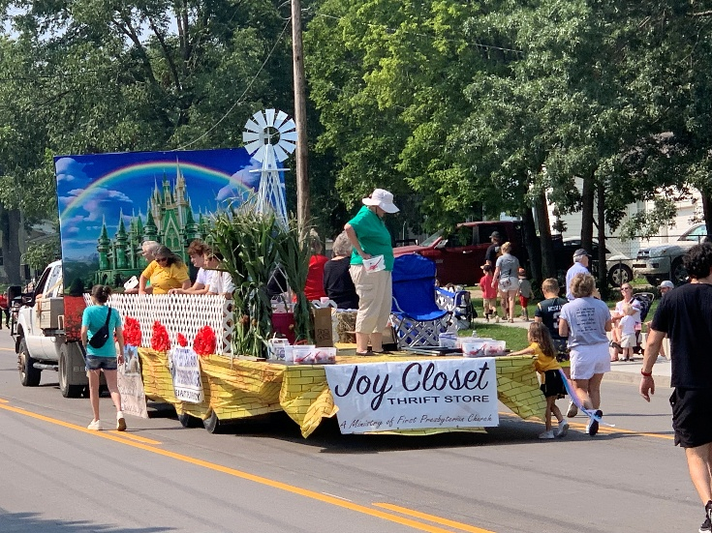
JOY Closet volunteers joined in the parade at Johnson County Fair 2025.

JOY Closet was represented at the USD 231 Convocation this year by Ginger Crist, Margaret Drovetta, Karen Elliott and Vera Beach. JOY Closet participates at the Platinum Level of giving to the Gardner Edgerton Foundation.
It is an honor to be able to help the students and staff in our community as they begin another year of education. Investing in education helps the entire community and helping the community is what JOY Closet is about.
If you are interested in becoming a volunteer,
talk with Cindy, Ginger, Cathy, or Margaret.
We love our volunteers!


For I was hungry and you gave me something to eat, I was thirsty and you gave me something to drink, I was a stranger and you invited me in, I needed clothes and you clothed me.

Matthew 25:35-36 NIV
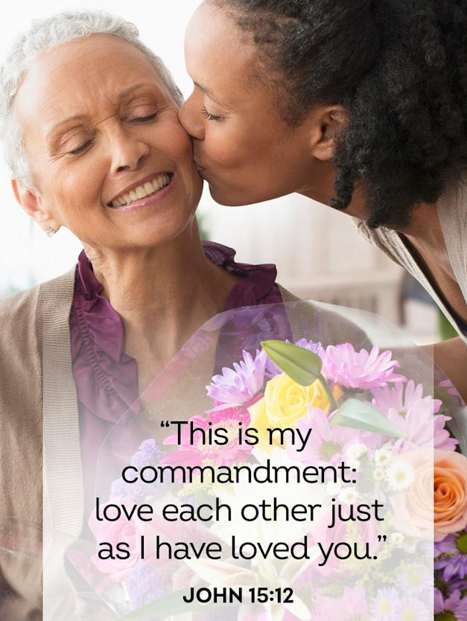

JOY Closet Is a ministry of

First Presbyterian Church of Gardner, KS
Serving our comunity since 2013

