FIRST PRESBYTERIAN NEWSLETTER AUGUST 2025

Big Bible Stories Sermon Series – by Pastor Kimby
We will be revisiting many of the great Bible stories we heard in childhood for a sermon series this summer and fall. (There are a lot of memorable stories.) You remember all those wonderful splashy stories from childhood that point toward faithfulness and the power of God. We used to act them out and draw pictures and make crafts. When I was looking back through 35 years of sermons, I realized I have preached very few times about any of these big stories. Maybe, because we think we know all about them. Maybe because we think of them as children’s stories. Actually, these stories are timeless because they have so many layers of meaning. We will dig a little deeper into some of these profound memorable stories of our faith to explore richer understanding and inspiration. There are so many great stories that unfortunately I had to leave out quite a few. Earlier this summer, I dipped into a couple of these great big Bible stories – Noah in July, Crossing the Red Sea in June. Beginning in August we will look at story after story, as we dig into the Bible’s wonderful timeless epic drama. Feel free to read ahead.

Worship Schedule
August 3- Genesis 37-50 - Joseph & Brothers
August 10 - Exodus 2:1-10 - Moses - Baby in the Bushes
August 17 - Joshua 6 - Joshua & Wall of Jerrico
August 24 - Ruth 1-4 - Naomi & Ruth
August 31 - 1 Samuel 17 - David & Goliath
September 7 – Psalm 96 and 100 - Rally Day – Joyful Noise
September 14 - 1 Kings 18:17-39 - Elijah & Fire
September 21 - Jonah 1 & 2:10 - Jonah & the Whale
September 28 - Luke 10:38-42 - Mary & Martha

Extra Expenses
This has been a very expensive summer for the church. Fortunately, we knew some of those expenses would be coming and we had special savings to cover the expenses. However, our building repair fund is severely depleted. Any extra donations would be welcome. Expenses this summer have included parking lot re-paving, fence repair off the north lot, replacement of one air conditioner unit and two related furnaces, and some video upgrades for the sanctuary.

Teachers for Fall – New Teachers and Helpers Needed
We need a new lead teacher or team of co-teachers for our Middle School Sunday School class. We welcome occasional substitutes for all of our classes. If you would be willing to teach, to assist, or to substitute, please speak to Pastor Kimby Young, or to anyone on the Discipleship Pillar to volunteer.

Children’s Music
We are looking for someone or a small team who would be willing to help lead songs for children or perhaps lead a children’s choir. The goal is to get children singing some of their favorite old children’s songs. A benefit might be sharing during worship if the children are comfortable. We are open to the age range and music choices. We are flexible about timing of practice. Contact Pastor Kimby or Dean Faulk if you are interested.

Nominating Committee
Nominating Committee has started the process of looking for elders and deacons for the class of 2028 to begin serving in January 2026. If you have a name to suggest, if you would be interested in serving, or if you would like more information about what is involved in these service positions, please contact the church office or anyone on nominating committee. This year’s committee includes Karen Elliott, Lynn Moldrup, Carl Frahme. Paula Waters, Larry Atwater, Robin Tropansky, Phil Lenahan, Lois Barber, and Pastor Kimby Young.

Johnson County Fair Parade – August 2 10am-noon
We will again have a float entry in the Johnson County Fair Parade on Saturday, August 2. Plan to join us walking or riding bikes/scooters/wagons in the parade. We will have a few seats for riders and small children on the float. Wear any church t-shirt or any faith t-shirt. Meet us at the high school parking lot on Saturday, August 2 between 8 and 10 a.m. We want to be represented again, sharing goodwill in our neighborhood. It is a great way to get our name out in town. We are still receiving candy to add to our handouts. Bring candy to the float or contact pastor Kimby to transport.

BBQ Potluck and Music Community Event
Saturday, September 27 – 5-7:30 p.m.
Our “Holy Smokes” event will continue this year, with a few changes. The BBQ and Potluck will begin at 5 p.m. with food served inside, and seating both indoors and out. Games on the lawn will continue. This year we are adding bounce houses. Derrek Hittle will BBQ pork, beef and a few other meats. At 6:30 p.m. we will move to the sanctuary for music and entertainment. The plan is to invite all the area churches to bring musicians, so we can enjoy and praise God together.
If you would like to offer some of the entertainment, please contact Dean Faulk.
If you would be willing to help set up or organize the games, contact Pastor Kimby.
If you would be willing to cook hamburgers and hot dogs (on site or at home), contact Kimby.
If you would like to contribute meat or money for meat, contact Amy or Derrek Hittle.
If you would like to help with the kitchen and table set up, contact Kelly Johnson.
If you have other questions or ideas, contact Karen Elliott or Kimby Young.
Bring potluck sides, chairs and lots of friends.

Blessing of the Backpacks – School Year Blessing
August 17– during worship – either service.
On August 17 during both worship services, we will share a special time of blessing for all students, teachers and school workers of all ages. You are invited to bring your backpack, calendar, or any other school item to bring forward during a time of blessing and prayer. We will remember that God is with you wherever you go. We will pray that God blesses the year ahead for everyone.

School Supply Donations
During the first two weeks of August, we are receiving donations of school supplies of any kind to be shared with the Gardner School District or with Operation Christmas Child.

Prayer Requests
Mark Welch, Nancy Falkner, Pat Clark, Steve and Sue Clark, Justin Cox, Sharon Frahme, Larry Atwater, Pat Revey, Kim Liu, Bob Knoche, Rhonda Krehbiel, family of Laurie Holben, Jennette, family of Mike Judah, Uncle Tom, Gary Allen, Ronnie DeChene, Martha Samuels, Lance Schramm, Tom Patton, Beau Foster, Ruth (Talbot) Hailey, Friend of Carl & Sharon Frahme, Robert Mashburn, Susan Gash, Susan Wilson-Dierksen, Abe Portenier, LeMoyne Zimmerman, Jim Applegarth, Jerry Lane, Jon Deiley, Amanda Allen, Dozer Reed.
Note of Thanks
Thank you all for the many prayers, cards and visits, I am feeling good and hopefully on the road to full recovery after my surgery to remove the large pulmonary embolus. Thank you all. Pat Clark
Women Fellowship Group will meet on Wednesday, August 6 at 10:00 a.m. in Fellowship Hall. We will enjoy a morning of fellowship. The women’s Fellowship Group meets from March through November in Fellowship Hall. This group is open to ALL women of the church. Our purpose is to provide care and support for the mission and service projects of the church.
Re-Scheduled Women of Faith Book Club will be held on Thursday, August 21, at 6:30 p.m. at Heather Rutler’s house, 17767 S. Laverty St., Olathe, KS. Anyone is welcome to join.


Store Hours
MONDAY 10 – 7
TUESDAY` 10 – 7
WEDNESDAY 10 – 4
THURSDAY 10 – 7
SATURDAY 10 - 2
  2025 |   Back-to-School Shopping! It is definitely that time of year, and JOY Closet is a great place for thrifty shoppers to complete a big portion of the school supply list plus clothing and shoes. Our big backpack display was awesome with a variety of backpacks in great condition. That’s a definite money-saved item!
“Effective Teamwork begins and ends with Communication.”
The above headline was in a recent communication on our JOY Closet group chat. Our volunteers receive their information through an app on their phones as well as monthly email updates. An information board also gives some of the fine details.
Coordinating the efforts efficiently with the large amount of donations received and preparations for display, it is important that we read them. Volunteers will help answer each other’s questions or know how to find the answers.

Just as importantly, a text on the app will often be of a more personal nature. People have moments when they need encouragement, are hurt or ill, and ask for prayer. Sometimes a volunteer texts that they cannot come in and invariably another volunteer says, “I’ll be there!” How wonderful to know that we can lift each other up in prayer and support our common cause together.

JOY Closet is a wonderful place to volunteer. If you have hesitated because you are worried that it will tie you down, please talk to one of the managers and consider signing up. Several jobs are ‘take home,’ or as needed.

You’ll be welcomed into this wonderful ministry!

Volunteer Opportunities:
If you’ve been considering joining us, come on in and find just the job that fits your needs and schedule.
Training will be provided.

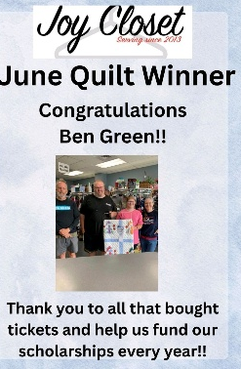
We love it when a beautiful quilt is donated as it becomes the feature of a monthly drawing! Many of our shoppers appreciate a great quilt and proceeds go into our Scholarship Fund.

Quilts don’t just make great gifts and warm our homes, they help build funds to give to deserving high school seniors!

Our thanks to the GEHS Cross Country team plus other volunteer friends who conducted a group sort recently!
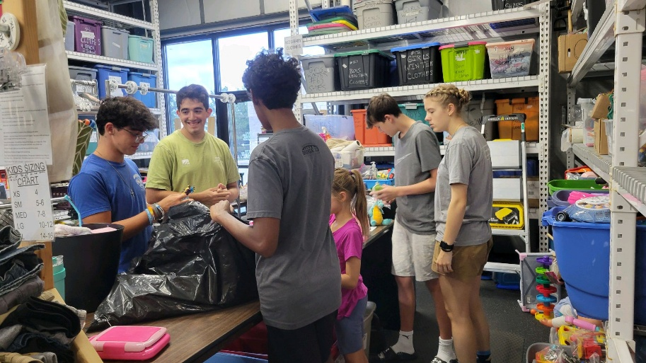

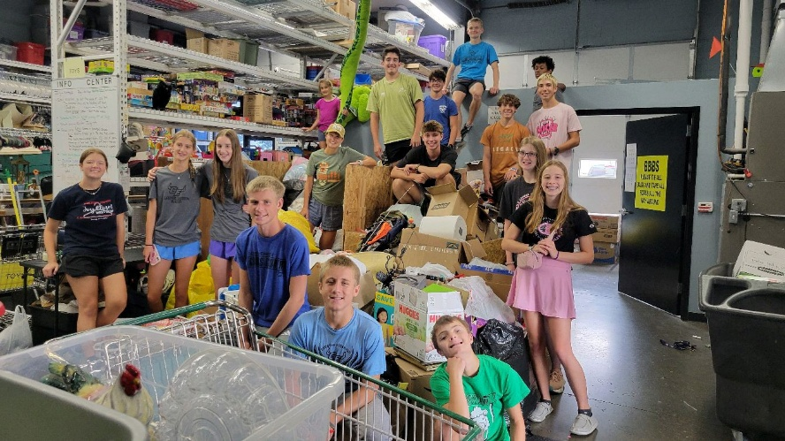
If you are interested in becoming a volunteer,
talk with Cindy, Ginger, Cathy, or Margaret.
For I was hungry and you gave me something to eat, I was thirsty and you gave me something to drink, I was a stranger and you invited me in, I needed clothes and you clothed me.

Matthew 25:35-36 NIV

JOY Closet Is a ministry of

First Presbyterian Church of Gardner, KS
Serving our community since 2013

