Welcome

Prelude
Let us prepare our hearts and minds for worship.

Call to Worship: (inspired by Psalm 95)
Leader: Come, let us sing to the Lord; let us make a joyful noise to the rock of our salvation!
People: Let us come into God’s presence with thanksgiving; let us make a joyful noise with songs of praise!
Leader: For the Lord is a great God and a great King above all others.
People: O come, let us worship and bow down; let us kneel before the Lord, our Maker!

*Opening Hymn: “Eternal Father, Strong to Save” Red Hymnal, #575

*Prayer of the Confession (Unison)
Sovereign God, Creator, Redeemer, Sustainer, We confess we have fallen into the ways of this world and have forgotten your will and your way. We have become distracted by the many challenges and we have given up on the peace you promise. We have lost sight of your power, your provision, and your purpose. Forgive us. Reshape us. Send us out to serve to your glory, in the name of Christ Jesus our Lord. Amen.

*Silent Reflection

*Assurance of Pardon

* Gloria Patri (Glory Be to the Father…) Red Hymnal, #623

Children’s Time

Scripture “1 Samuel 17:4-11” (page 445)
“1 Samuel 17: 32-40” (page 447)
“1 Samuel 17:48-51” (page 447)
Leader: The word of the Lord.
People: Thanks be to God.

Music “Prelude et Scherzo” Henri Busser
Sermon “David and Goliath” Rev. Kimby Young

*Profession of Faith The Apostle's Creed Red Hymnal, inside back cover
I Believe in God the Father Almighty, Maker of heaven and earth, And in Jesus Christ his only Son our Lord; who was conceived by the Holy Ghost, born of the Virgin Mary, suffered under Pontius Pilate, was crucified, dead, and buried; he descended into hell; the third day he rose again from the dead; he ascended into heaven, and sitteth on the right hand of God the Father Almighty; from thence he shall come to judge the quick and the dead. I believe in the Holy Ghost; the holy catholic Church; the communion of saints; the forgiveness of sins; the resurrection of the body; and the life everlasting. Amen

*Hymn “Savior, Like a Shepherd Lead Us” Red Hymnal, #462

Pastoral Prayer & Lord’s Prayer

Offertory Meditation

*Doxology

*Prayer of Dedication

*Closing Hymn: “Battle Hymn of the Republic” Red Hymnal, #569

*Benediction

Postlude
*Those who are comfortably able will please stand.

Rev. Kimby Young, Pastor; Tina Fraser, Worship Assistant
Dean Faulk, Music Ministries; Ella Falkner, Flute Solo
Harlan Plunkett, Organist; Robyn Forkner, Pianist
Mike McGuire and Brad Cornell, Slide Production; Kim Liu, Sound

Childcare is always available in the nursery (off the hall to the west of the sanctuary). Children are welcome to stay in the sanctuary thru the whole service, or to leave at any time. Allison Perry is our primary childcare attendant.

Worship Bags for Children are available outside the north door to the sanctuary. Choose books,
crayons, pencils, Legos, stuffed toys and other items to fill your bag to use during worship.

Offering Plates are at the entrance of each aisle for your contributions to the work of the church.

Gardner Multi Service Center collection is ongoing every week and is always in need of any non-perishable food. Bring something every week or once a month.

Fair Trade Products for Sale on Sundays Coffee, tea, chocolate, nuts, olive oil, dried fruit, baking products, and a few other items are for sale each Sunday at church.

Harvesters Food Distribution is always seeking volunteers. Every 3rd Saturday at Trade Net Parking lot and every 2nd Thursday at Divine Mercy Parish. Distribution begins at 1 p.m.

Children’s Sunday School starts next Sunday, September 7, 10:00 a.m.

Bells 6:00 p.m. Chancel Choir 7:00 p.m. starts on Wed., Sept. 3, Cantata starts September 10.

Joy Closet – Our mission center thrift store provides free clothing to a variety of needs. Our church provides all volunteers on the fourth Saturday of each month.

Middle school teacher or team needed for Sunday School. Experienced helper in place. Contact Kimby for more information.

Bible Study – Romans – Thursdays beginning Sept. 11, 10-11:30 a.m. - Pastor Kimby teaching.

Holy Smokes, Sat., September 27, 5:00 – 7:30 p.m. BBQ Potluck & Music Community Event.

Trunk or Treat and Chili Supper! October 26 - 5-7 p.m. - Save the date.

Nominating Committee is seeking elders and deacons to begin serving in January 2026. If you have a name to suggest, or if you would be interested let Karen Elliott or Lynn Moldrup know.

Remember, Each One, Bring One collecting food, basket in the narthex. Joy Closet food box.

Presbyterian Women’s Group meets Wednesday, Sept. 3, at 10:00 a.m. in Fellowship Hall.

Presbyterian Women Bible study starts Thursday, September 11, 6:30 p.m. Bring sack lunch. Book “Jesus Through the Eyes of Women”. Paula Waters collecting. $10.00 ordering book.

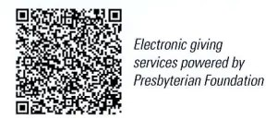
First Presbyterian Church
In the heart of Gardner since 1866 ~ Serving from the heart of God
Sunday, August 31, 2025
8:45 AM

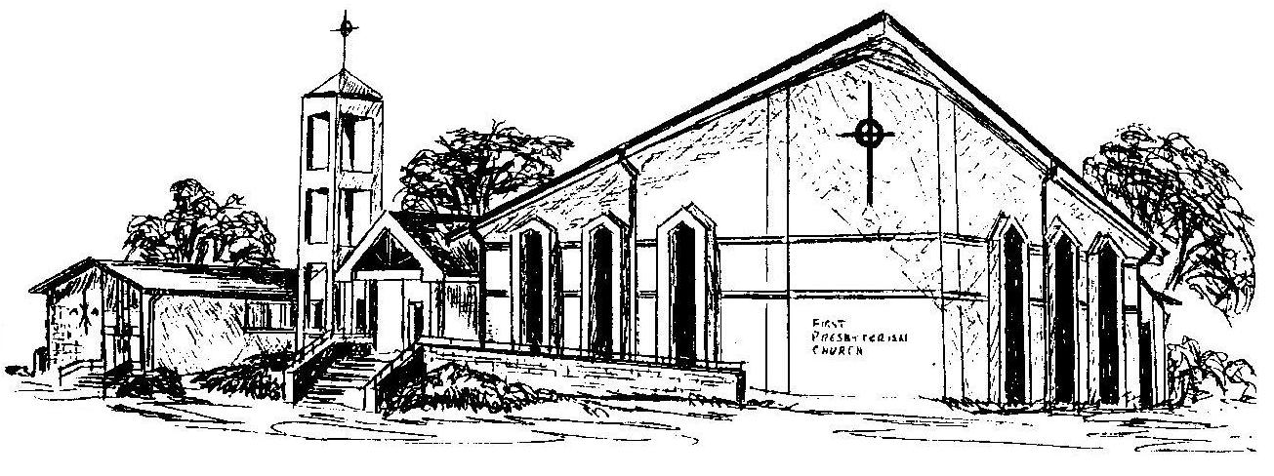

Welcome - Thank you for joining us for worship today. Please fill out a visitor information card found in the pew racks and place those in the offering plate so that we may follow up with you in the future. Your presence with us today has been a blessing to us, we hope that you have felt the presence of God and the welcome of this congregation.

