Welcome

Prelude
Let us prepare our hearts and minds for worship.

Call to Worship:
Leader: Throughout life’s journey we search for a place to belong and call home.
People: God has created a home for us in this community. God welcomes everyone.
Leader: Here we seek to serve God with faithfulness and joy.
People: We belong together. We belong to God. Let us worship and serve.

*Opening Hymn: “Joyful, Joyful, We Adore Thee” Red Hymnal, #1

*Prayer of the Confession (Unison)
God of Love, we hear these stories from the Bible, and we wonder if we are as faithful as our ancestors in faith. We trace our own life stories and notice the times we have failed. Still, you love us, you forgive us, and you call us to be all that you have created us to be. Help us to do our best. Help us to serve you as you know we are able. We pray in the name of Jesus our Savior. Amen.

*Silent Reflection

*Assurance of Pardon

* Gloria Patri (Glory Be to the Father…) Red Hymnal, #623

Children’s Time

Scripture “Ruth 1:8-17” (page 412)
“Ruth 2:1-2, 8-13” (page 413)
“Ruth 4:13-17” (page 416)
Leader: The word of the Lord.
People: Thanks be to God.

Music “I Love You, Lord”
Words and Music by Laurie Klein

Sermon “Naomi and Ruth” Rev. Kimby Young

*Profession of Faith The Apostle's Creed Red Hymnal, inside back cover
I Believe in God the Father Almighty, Maker of heaven and earth, And in Jesus Christ his only Son our Lord; who was conceived by the Holy Ghost, born of the Virgin Mary, suffered under Pontius Pilate, was crucified, dead, and buried; he descended into hell; the third day he rose again from the dead; he ascended into heaven, and sitteth on the right hand of God the Father Almighty; from thence he shall come to judge the quick and the dead. I believe in the Holy Ghost; the holy catholic Church; the communion of saints; the forgiveness of sins; the resurrection of the body; and the life everlasting. Amen

*Hymn “O Love That Will Not Let Me Go” Red Hymnal, #374

Pastoral Prayer & Lord’s Prayer

Offertory Meditation

*Doxology

*Prayer of Dedication

*Closing Hymn: “Leaning on the Everlasting Arms” Red Hymnal, #354

*Benediction

Postlude
*Those who are comfortably able will please stand.

Rev. Kimby Young, Pastor; Poppy Zurcher, Worship Assistant
Dean Faulk, Music Ministries
Men’s Group Special Music; John Kunkel, Chesley Jones
Harlan Plunkett, Mark Perry, Karl Allen, Carl Frahme
Oliver Schwab, August Westlund, Larry Schick, Dean Faulk
Harlan Plunkett, Organist; Robyn Forkner, Pianist
Mike McGuire and Brad Cornell, Slide Production; Kim Liu, Sound

Childcare is always available in the nursery (off the hall to the west of the sanctuary). Children are welcome to stay in the sanctuary thru the whole service, or to leave at any time. Allison Perry is our primary childcare attendant.

Worship Bags for Children are available outside the north door to the sanctuary. Choose books,
crayons, pencils, Legos, stuffed toys and other items to fill your bag to use during worship.

Offering Plates are at the entrance of each aisle for your contributions to the work of the church.

Gardner Multi Service Center collection is ongoing every week and is always in need of any non-perishable food. Bring something every week or once a month.

Fair Trade Products for Sale on Sundays Coffee, tea, chocolate, nuts, olive oil, dried fruit, baking products, and a few other items are for sale each Sunday at church.

Harvesters Food Distribution is always seeking volunteers. Every 3rd Saturday at Trade Net Parking lot and every 2nd Thursday at Divine Mercy Parish. Distribution begins at 1 p.m.

Joy Closet – Our mission center thrift store provides free clothing to a variety of needs. Our church provides all volunteers on the fourth Saturday of each month.

Bells 6:00 p.m., Chancel Choir 7:00 p.m. starts on Wednesday, September 3.

Middle school teacher or team needed for Sunday School. Experienced helper in place. Contact Kimby for more information.

Bible Study – Romans – Thursdays beginning Sept. 11, 10-11:30 a.m. - Pastor Kimby teaching.

Holy Smokes, Sat., September 27, 5:00 – 7:30 p.m. BBQ Potluck & Music Community Event.

Trunk or Treat and Chili Supper! October 26 - 5-7 p.m. - Save the date.

Nominating Committee is seeking elders and deacons to begin serving in January 2026. If you have a name to suggest, or if you would be interested let Karen Elliott or Lynn Moldrup know.

Remember, Each One, Bring One collecting food, basket in the narthex. Joy Closet food box.

Presbyterian Women Group meets on Wednesday, September 3 at 10:00 a.m. in Fellowship Hall.

Presbyterian Women Bible study starts Thursday, September 11, 6:30 p.m. Bring sack lunch. Book “Jesus Through the Eyes of Women”. Paula Waters collecting. $10.00 ordering book.


First Presbyterian Church
In the heart of Gardner since 1866 ~ Serving from the heart of God

Sunday, August 24, 2025
8:45 AM
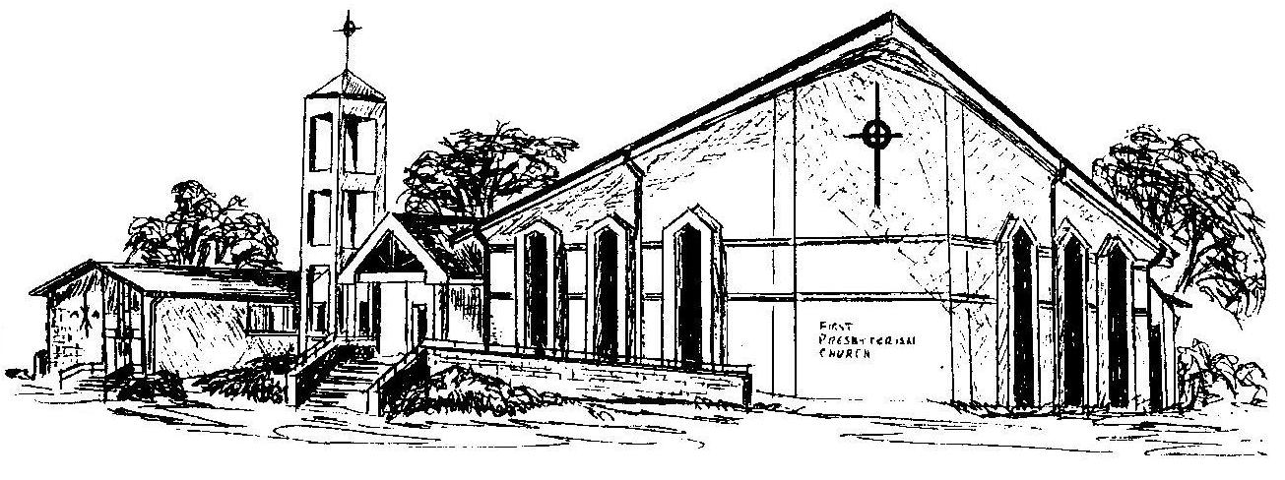

Welcome - Thank you for joining us for worship today. Please fill out a visitor information card found in the pew racks and place those in the offering plate so that we may follow up with you in the future. Your presence with us today has been a blessing to us, we hope that you have felt the presence of God and the welcome of this congregation.

