Welcome

Prelude
Let us prepare our hearts and minds for worship.

Call to Worship (Rev. Mindi; Rev-o-lution blog) (Inspired by Isaiah 43:2)
Leader: When we pass through the waters, God is there with us.
People: When we are joyful and blessed, God is there with us.
Leader: Whether we feel triumphant or defeated, God is there with us, always.
People: Come, let us worship together for God is right here with us.

*Opening Hymn: “Come Christian Join to Sing” Red Hymnal, #108

*Prayer of Confession (Unison)
God who is the Great I Am, we are grateful that our children have had a good week. We are grateful for the ways you bless us and call us to be your people. Guide us through the days ahead, to remember your presence and to follow where you lead. We pray in the name of Jessus who loves us. We promise to share that love in the world. Amen

*Gloria Patri (Glory Be to the Father…) Red Hymnal, #623

Children’s Time

Scripture “Exodus 14:19-29” (page 109)
“Ephesians 2:4-10” (page 1819)
Leader: The word of the Lord.
People: Thanks be to God.

Special Music “Great Is Thy Faithfulness” Arr. by William M. Runyan

Sermon “Pass Through the Waters” Rev. Kimby Young

*Profession of Faith The Apostle's Creed Red Hymnal, inside back cover
I Believe in God the Father Almighty, Maker of heaven and earth, And in Jesus Christ his only Son our Lord; who was conceived by the Holy Ghost, born of the Virgin Mary, suffered under Pontius Pilate, was crucified, dead, and buried; he descended into hell; the third day he rose again from the dead; he ascended into heaven, and sitteth on the right hand of God the Father Almighty; from thence he shall come to judge the quick and the dead. I believe in the Holy Ghost; the holy catholic Church; the communion of saints; the forgiveness of sins; the resurrection of the body; and the life everlasting. Amen

*Hymn “He’s Got the Whole World in His Hands” Red Hymnal, #344

Pastoral Prayer & Lord’s Prayer

Offertory Meditation:

*Doxology

*Prayer of Dedication

*Closing Hymn: “Jesus Loves Me” Red Hymnal, #579

*Benediction

Postlude
*Those who are comfortably able will please stand.

Rev. Kimby Young, Pastor; Lynn Moldrup, Worship Assistant
Amber Hildreth, Bell Solo; Dean Faulk, Music Ministries
Harlan Plunkett, Organist; Robyn Forkner, Pianist
Mike McGuire and Brad Cornell, Slide Production; Kim Liu, Sound

Childcare is always available in the nursery (off the hall to the west of the sanctuary). Children are welcome to stay in the sanctuary thru the whole service, or to leave at any time. Allison Perry is our primary childcare attendant.

Worship Bags for Children are available outside the north door to the sanctuary. Choose books,
crayons, pencils, Legos, stuffed toys and other items to fill your bag to use during worship.

Offering Plates are at the entrance of each aisle for your contributions to the work of the church.

Gardner Multi Service Center collection is ongoing every week and is always in need of any non-perishable food. Bring something every week or once a month.

Fair Trade Products for Sale on Sundays Coffee, tea, chocolate, nuts, olive oil, dried fruit, baking products, and a few other items are for sale each Sunday at church.

Harvesters Food Distribution is always seeking volunteers. Every 3rd Saturday at Trade Net Parking lot and every 2nd Thursday at Divine Mercy Parish. Distribution begins at 1 p.m.

Joy Closet – Our mission center thrift store provides free clothing to a variety of needs. Our church provides all volunteers on the fourth Saturday of each month.

A "Suggestion Box" is outside the office for ideas, comments, questions and thoughts. Contents will be reviewed at session meetings on the 2nd Monday of each month.

Mission Pillar Hygiene Kits - raising funds now $5 per kit - goal of over 200 kits. Assemble kits on Saturday July 12 (time TBD) at Heart to Heart International warehouse. Please mark your donations to "FPC" for "Mission Kits."

St. Johns’ Sunday - We offer a welcome today to our friends from Gardner Masonic Lodge #65. Today is St. Johns’ Sunday, commemorating the faith and spiritual legacy of St. John the Baptist and St. John the Evangelist, who are the patron saints of the Masons. Freemasonry is a fraternal organization that arose during the late 16 to early 17 century, Freemasonry now exists in various forms all over the world, with a membership estimated at around five million, including just under two million in the United States and around 480,000 in England, Scotland and Ireland.
Freemasonry uses the metaphors of the stonemasons’ tools, set against the backdrop of King Solomon’s Temple, to convey lessons of morality illustrated by symbols.

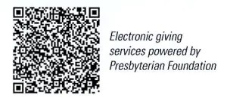
First Presbyterian Church
In the heart of Gardner since 1866 ~ Serving from the heart of God

Sunday, June 22, 2025
8:45 AM

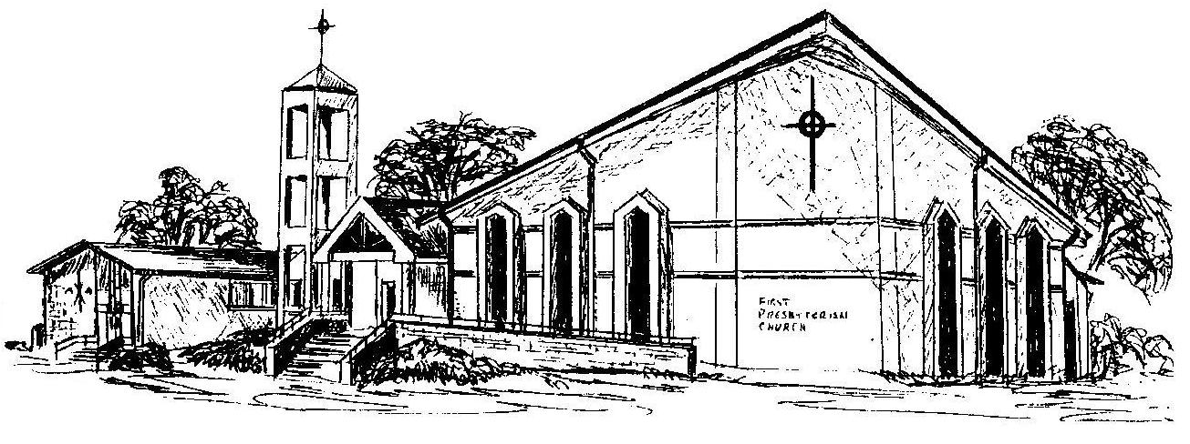

Welcome - Thank you for joining us for worship today. Please fill out a visitor information card found in the pew racks and place those in the offering plate so that we may follow up with you in the future. Your presence with us today has been a blessing to us, we hope that you have felt the presence of God and the welcome of this congregation.

