Welcome

Prelude
Let us prepare our hearts and minds for worship.

Call to Worship
Leader: On this Father’s day, we come to worship the Lord and Father of us all.
People: God nurtures and protects us, welcomes and forgives us.
Leader:
We come to worship our heavenly Father who has created us and creates us anew.
People:
We give thanks for earthly fathers who love in the image of our Creator God.

*Opening Hymn: “God of Our Fathers” Red Hymnal, #573

*Prayer of Confession (Unison) (adapted from Words for Worship)
O God, even as we celebrate your unity, we know that sometimes we forget the beauty of your three persons. Holy Trinity, if we are tempted to think that we know all that there is to know, closing ourselves off from ideas which others offer and neglecting to search for even deeper truths: Forgive us, Jesus Christ. Guide and guard us, Holy Spirit. Continue creating within us, Creator God. This we pray in your Triune name. Amen.

*Silent Reflection

*Assurance of Pardon

*Gloria Patri (Glory Be to the Father…) Red Hymnal, #623

Children’s Time

Scripture “John 14:8-14” (page 1675)
“Galatians 3:23-29” (page 1813)
“Galatians 4:1-7” (page 1813)
“2 Corinthians 13:13” (page 1808)
Leader: The word of the Lord.
People: Thanks be to God.

Special Music

Sermon “Our Father” Rev. Kimby Young

*Profession of Faith The Apostle's Creed Red Hymnal, inside back cover
I Believe in God the Father Almighty, Maker of heaven and earth, And in Jesus Christ his only Son our Lord; who was conceived by the Holy Ghost, born of the Virgin Mary, suffered under Pontius Pilate, was crucified, dead, and buried; he descended into hell; the third day he rose again from the dead; he ascended into heaven, and sitteth on the right hand of God the Father Almighty; from thence he shall come to judge the quick and the dead. I believe in the Holy Ghost; the holy catholic Church; the communion of saints; the forgiveness of sins; the resurrection of the body; and the life everlasting. Amen

*Hymn “Faith of Our Fathers” Red Hymnal, #279

Pastoral Prayer & Lord’s Prayer

Offertory Meditation:

*Doxology

*Prayer of Dedication

*Closing Hymn: “Holy, Holy, Holy” Red Hymnal, #262

*Benediction

Postlude
*Those who are comfortably able will please stand.

Rev. Kimby Young, Pastor; Wayne Rollf, Worship Assistant;
Dean Faulk, Music Ministries; Harlan Plunkett, Organist; Robyn Forkner, Pianist
Mike McGuire and Brad Cornell, Slide Production; Kim Liu, Sound

Childcare is always available in the nursery (off the hall to the west of the sanctuary). Children are welcome to stay in the sanctuary thru the whole service, or to leave at any time. Allison Perry is our primary childcare attendant.

Worship Bags for Children are available outside the north door to the sanctuary. Choose books,
crayons, pencils, Legos, stuffed toys and other items to fill your bag to use during worship.

Offering Plates are at the entrance of each aisle for your contributions to the work of the church.

Gardner Multi Service Center collection is ongoing every week and is always in need of any non-perishable food. Bring something every week or once a month.

Fair Trade Products for Sale on Sundays Coffee, tea, chocolate, nuts, olive oil, dried fruit, baking products, and a few other items are for sale each Sunday at church.

Harvesters Food Distribution is always seeking volunteers. Every 3rd Saturday at Trade Net Parking lot and every 2nd Thursday at Divine Mercy Parish. Distribution begins at 1 p.m.

Joy Closet – Our mission center thrift store provides free clothing to a variety of needs. Our church provides all volunteers on the fourth Saturday of each month.

A "Suggestion Box" is outside the office for ideas, comments, questions and thoughts. Contents will be reviewed at session meetings on the 2nd Monday of each month.

Mission Pillar Hygiene Kits - raising funds now $5 per kit - goal of over 200 kits. Assemble kits on Saturday July 12 (time TBD) at Heart to Heart International warehouse. Please mark your donations to "FPC" for "Mission Kits."

Multi-Church School Supply Drive you may contribute financial donations.

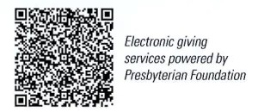

First Presbyterian Church
In the heart of Gardner since 1866 ~ Serving from the heart of God

Sunday, June 15, 2025
Trinity Sunday & Father’s Day
8:45 AM

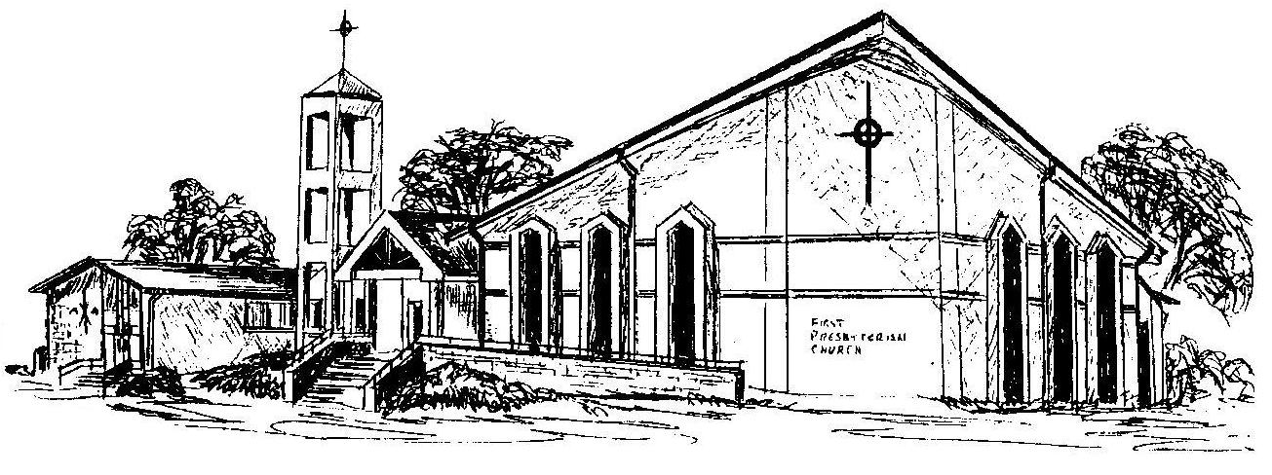

Welcome - Thank you for joining us for worship today. Please fill out a visitor information card found in the pew racks and place those in the offering plate so that we may follow up with you in the future. Your presence with us today has been a blessing to us, we hope that you have felt the presence of God and the welcome of this congregation.

