Welcome
Prelude
Let us prepare our hearts and minds for worship.

Call to Worship (based on Psalm 47)
Leader: Our God has ascended with a mighty shout.
The Lord has ascended with trumpets blaring!
People: Come, let us sing praise to God together,
for our God is sovereign over all the earth!
Leader: Jesus reigns! Robed with majesty and armed with strength,
God holds our world and our lives securely.
People: This is Jesus to whom we have given our lives—
the God who deserves our worship and our praise!

*Opening Hymn: “Hail the Day that Sees Him Rise ” Red Hymnal, #232

*Prayer of Confession (Unison) (adapted from Calvin Institute of Christian Worship)
On this day in which we celebrate the ascension of Jesus into heaven, We come to confess our lack of trust. While we sing of your lordship over all creation, we have too often acted as though you are powerless in the face of today's events. We must remember that you can do everything. Help us to live with confidence in your presence today and in hope for life with you forever. Amen.

* Silent Reflection

* Assurance of Pardon

* Gloria Patri (Glory Be to the Father…) Red Hymnal, #623

Children’s Time

Commissioning of PYF Mission Trip 2025

Scripture “Matthew 28:16-20” (page 1550)
“Luke 24:44-53” (page 1644)
“Acts 1:1-9” (page 1690)
Leader: The word of the Lord.
People: Thanks be to God.

Special Music “How Deep the Father’s Love for Us” by Stuart Townend

Sermon “Commissioned: Show God’s Love” Rev. Kimby Young

*Profession of Faith The Apostle's Creed Red Hymnal, inside back cover
I Believe in God the Father Almighty, Maker of heaven and earth, And in Jesus Christ his only Son our Lord; who was conceived by the Holy Ghost, born of the Virgin Mary, suffered under Pontius Pilate, was crucified, dead, and buried; he descended into hell; the third day he rose again from the dead; he ascended into heaven, and sitteth on the right hand of God the Father Almighty; from thence he shall come to judge the quick and the dead. I believe in the Holy Ghost; the holy catholic Church; the communion of saints; the forgiveness of sins; the resurrection of the body; and the life everlasting. Amen

*Hymn “They’ll Know We Are Christians By Our Love” Red Hymnal, #284

Offertory Meditation

*Doxology

The Sacrament of Holy Communion
(All bread is gluten free. Prepacked elements are available in the back.)
Invitation
Great Prayer and The Lord’s Prayer
Words of Institution – Breaking of Bread
Communion of the People
Prayer of Thanksgiving

*Closing Hymn: “Blest Be the Tie That Binds” Red Hymnal, #286

*Benediction

Postlude
*Those who are comfortably able will please stand.

Rev. Kimby Young, Pastor; Sandy Rieger, Worship Assistant
Dean Faulk, Music Ministries; Chesley Jones, Soloist
Harland Plunkett, Organist; Robyn Forkner, Pianist
Mike McGuire and Brad Cornell, Slide Production; Kim Liu, Sound

Childcare is always available in the nursery (off the hall to the west of the sanctuary). Children are welcome to stay in the sanctuary thru the whole service, or to leave at any time. Allison Perry is our primary childcare attendant.

Worship Bags for Children are available outside the north door to the sanctuary. Choose books,
crayons, pencils, Legos, stuffed toys and other items to fill your bag to use during worship.

Offering Plates are at the entrance of each aisle for your contributions to the work of the church.

Gardner Multi Service Center collection is ongoing every week and is always in need of any non-perishable food. Bring something every week or once a month.

Fair Trade Products for Sale on Sundays Coffee, tea, chocolate, nuts, olive oil, dried fruit, baking products, and a few other items are for sale each Sunday at church.

Harvesters Food Distribution is always seeking volunteers. Every 3rd Saturday at Trade Net Parking lot and every 2nd Thursday at Divine Mercy Parish. Distribution begins at 1 p.m.

Joy Closet – Our mission center thrift store provides free clothing to a variety of needs. Our church provides all volunteers on the fourth Saturday of each month.

A "Suggestion Box" is outside the office for ideas, comments, questions and thoughts. Contents will be reviewed at session meetings on the 2nd Monday of each month.

Mission Pillar Hygiene Kits - raising funds now $5 per kit - goal of over 200 kits. Assemble kits on Saturday July 12 (time TBD) at Heart to Heart International warehouse. Please mark your donations to "FPC" for "Mission Kits."

Today, June 1 Ice cream social between services.

Women Fellowship Group will meet on Wednesday, June 4 at 10:00 a.m. in Fellowship Hall. Please bring 2 dozen cookies for Traveling Day Camp. No Peanut butter and No nuts.

Sunday, June 8, remember to wear red in celebration of Pentecost.

Ladies Community Luncheon at Divine Mercy Parish on Saturday, June 14, 2025, 11:30 a.m., 555 W Main St. RSVP by calling the Parish Office (913) 856-7781. Come for fun and fellowship.

Office Closed Monday, June 9 – Friday, June 13. Call Kimby if you need anything.

Multi-Church School Supply Drive you may contribute financial donations.

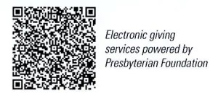
First Presbyterian Church
In the heart of Gardner since 1866 ~ Serving from the heart of God

Sunday, June 1, 2025
Ascension Sunday
8:45 AM

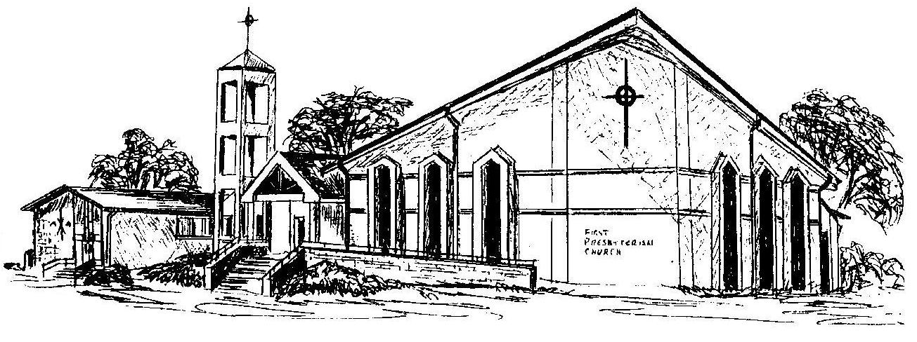

Welcome - Thank you for joining us for worship today. Please fill out a visitor information card found in the pew racks and place those in the offering plate so that we may follow up with you in the future. Your presence with us today has been a blessing to us, we hope that you have felt the presence of God and the welcome of this congregation.

