Welcome

Prelude “Largo in G” G.F. Handel
Let us prepare our hearts and minds for worship.

Call to Worship (adapted from Lutheran Retreats, Camps, and Conferences.)
Leader: Come and see, come and see!
People: We come to see for ourselves who this Jesus is.
Leader: We come with open hearts to experience Jesus
People: Come and see, come and see! We come to follow Jesus.

*Opening Hymn: “Be Thou My Vision” Red Hymnal, # 382

*Prayer of Confession (Unison) (adapted from Susan Durber, Christian Aid website)
Open our eyes, Lord Jesus, to the world around us, to the people we fail to notice. Show us what we should see. Give us courage to do what you ask. Help us to see with your eyes, your vision, your wisdom. Give us courage to be where you are and to 'Come and see' as your true disciples. Amen.

*Silent Reflection

*Assurance of Pardon

*Gloria Patri (Glory Be to the Father…) Red Hymnal, #623

Children’s Time

Scripture “Job 42:5” (page 841)
“Mark 8:22-26” (page 1566)
“John 1:5” (page 1645)
“John 8:12” (page 1662)
“John 9:1-7” (page 1664)
“John 9:39” (page 1666)
“1 Corinthians 13:12” (page 1787)
Leader: The word of the Lord.
People: Thanks be to God.

Anthem “

Sermon “Seeing God” Rev. Kimby Young

*Profession of Faith The Apostle's Creed Red Hymnal, inside back cover
I Believe in God the Father Almighty, Maker of heaven and earth, And in Jesus Christ his only Son our Lord; who was conceived by the Holy Ghost, born of the Virgin Mary, suffered under Pontius Pilate, was crucified, dead, and buried; he descended into hell; the third day he rose again from the dead; he ascended into heaven, and sitteth on the right hand of God the Father Almighty; from thence he shall come to judge the quick and the dead. I believe in the Holy Ghost; the holy catholic Church; the communion of saints; the forgiveness of sins; the resurrection of the body; and the life everlasting. Amen

*Hymn “O Jesus I Have Promised” Red Hymnal, # 369

Pastoral Prayer & Lord’s Prayer

Offertory Meditation: “How Firm A Foundation” Arr. Terry Baldridge

*Doxology

*Prayer of Dedication

*Closing Hymn: “Amazing Grace” Red Hymnal, # 202

*Benediction

*Postlude “Jubilation” Gordon Young

*Those who are comfortably able will please stand.

Rev. Kimby Young, Pastor; Shana Devlin, Worship Assistant
Chancel Choir; Dean Faulk, Music Ministries
Harlan Plunkett, Organist; Robyn Forkner, Pianist
Mike McGuire and Brad Cornell, Slide Production; Kim Liu, Sound

Childcare is always available in the nursery (off the hall to the west of the sanctuary). Children are welcome to stay in the sanctuary thru the whole service, or to leave at any time. Allison Perry is our primary childcare attendant.

Worship Bags for Children are available outside the north door to the sanctuary. Choose books, crayons, pencils, Legos, stuffed toys and other items to fill your bag to use during worship.

Offering Plates are at the entrance of each aisle for your contributions to the work of the church.

Gardner Multi Service Center collection is ongoing every week and is always in need of any non-perishable food. Bring something every week or once a month.

Fair Trade Products for Sale on Sundays Coffee, tea, chocolate, nuts, olive oil, dried fruit, baking products, and a few other items are for sale each Sunday at church.

Harvesters Food Distribution is always seeking volunteers. Every 3rd Saturday at Trade Net Parking lot and every 4th Wednesday at Divine Mercy Parish. Distribution begins at 1 p.m.

A "Suggestion Box" is outside the office for ideas, comments, questions, and thoughts. Contents will be reviewed at session meetings on the 2nd Monday of each month.

Joy Closet – Our mission center thrift store provides free clothing to a variety of needs. Our church provides all volunteers on the fourth Saturday of each month.

Presbyterian Women’s Bible Study meets each Thursday in Fellowship Hall at 6:30 p.m. All women welcome.

The congregation is invited to a 95th birthday cake Celebration for Mary Barbara Allen on March 9th from 2-4 pm in Fellowship Hall. No gifts please.

Black Out Drapes - For Lent each year we raise curtains over the stained glass windows as reminders of the deepening season. As a Lenten discipline we are called to awareness of light and darkness in the world as we seek God's presence in our daily lives, and as we look forward in hope to the celebration of the resurrection of Jesus Christ.

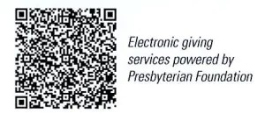
First Presbyterian Church
In the heart of Gardner since 1866 ~ Serving from the heart of God

Sunday, March 9, 2025
First Sunday of Lent
8:45 AM
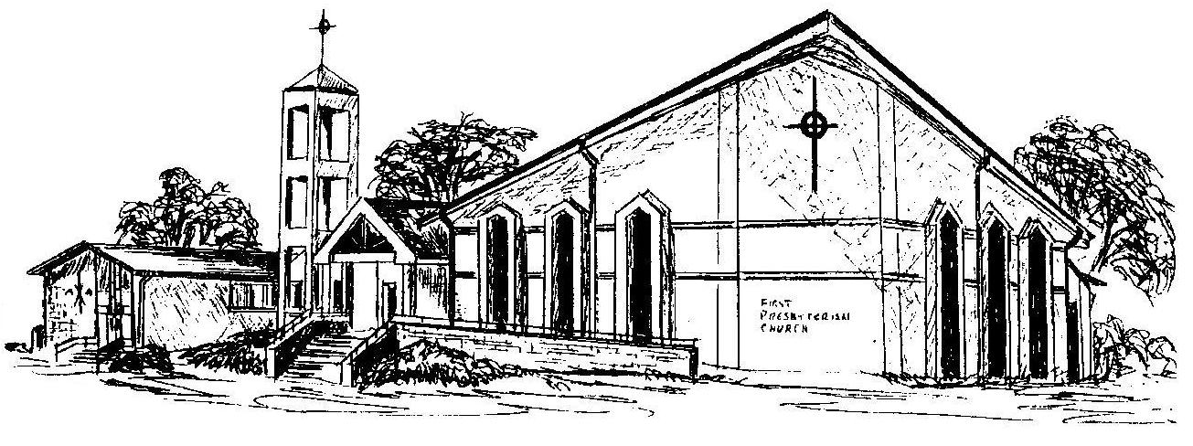

Welcome - Thank you for joining us for worship today. Please fill out a visitor may follow up with you in the future. Your presence with us today has been a blessing to us, we hope that you have felt the presence of God and the welcome of this congregation.

