Welcome

Prelude “Fairest Lord Jesus”
Piano/Organ Duet Guest Pianist Nancie Dalke Arr. Hayes/Gaspard
Let us prepare our hearts and minds for worship.

Call to Worship
Leader: The Word became flesh and blood and came to live among us in Jesus Christ.
People: Throughout his life Jesus pointed to God, showing us the way.
Leader: We sense the presence of God all around us, everywhere we go.
People: We give thanks for the life of Jesus and praise God together.

*Opening Hymn: “We Three Kings” Red Hymnal, #166 vs1-4

*Prayer of Confession (Unison)
Anointed and Appointed One, Jesus of Nazareth, You poured God’s love over everyone. You lived a life of care and creativity. You call us to do the same. We confess that we hold back. We fear loss or suffering. We wait to see if others will move first. We fail to love as You loved. Forgive us. Pour your Spirit over us and into us again. Remind us how much Your great love can do. Empower us to serve in the name of Jesus. Amen.

*Silent Reflection

*Assurance of Pardon

*Gloria Patri (Glory Be to the Father…) Red Hymnal, #623

Children’s Time

Scripture “Matthew 2:9-11” (page 1498)
“John 12:1-8” (page 1670)
Leader: The word of the Lord.
People: Thanks be to God.

Bell Choir “Be Still and Know”
Steven Curtis Chapman/arr. Douglas E. Wagner

Sermon “Smell” Rev. Kimby Young

*Profession of Faith The Apostle's Creed Red Hymnal, inside back cover
I Believe in God the Father Almighty, Maker of heaven and earth, And in Jesus Christ his only Son our Lord; who was conceived by the Holy Ghost, born of the Virgin Mary, suffered under Pontius Pilate, was crucified, dead, and buried; he descended into hell; the third day he rose again from the dead; he ascended into heaven, and sitteth on the right hand of God the Father Almighty; from thence he shall come to judge the quick and the dead. I believe in the Holy Ghost; the holy catholic Church; the communion of saints; the forgiveness of sins; the resurrection of the body; and the life everlasting. Amen

*Hymn “O Sacred Head, Now Wounded” Red Hymnal, #178

Pastoral Prayer & Lord’s Prayer

Offertory Meditation “Amazing Grace”
Piano/Organ Duet Guest Pianist Nancie Dalke Arr. Hayes/Gaspard

*Doxology

*Prayer of Dedication

*Closing Hymn: “O Love That Will Not Let Me Go” Red Hymnal, #374

*Benediction

Postlude “How Firm a Foundation”
Piano/Organ Duet Guest Pianist Nancie Dalke Arr. Hayes/Gaspard
*Those who are comfortably able will please stand.

Rev. Kimby Young, Pastor; Paula Waters, Worship Assistant
Dean Faulk, Music Ministries; Bell Choir
Harlan Plunkett, Organist; Robyn Forkner, Pianist
Mike McGuire and Brad Cornell, Slide Production, Kim Liu Sound

Childcare is always available in the nursery (off the hall to the west of the sanctuary). Children are welcome to stay in the sanctuary thru the whole service, or to leave at any time. Allison Perry is our primary childcare attendant.

Worship Bags for Children are available outside the north door to the sanctuary. Choose books,
crayons, pencils, Legos, stuffed toys and other items to fill your bag to use during worship.

Offering Plates are at the entrance of each aisle for your contributions to the work of the church.

Gardner Multi Service Center collection is ongoing every week and is always in need of any non-perishable food. Bring something every week or once a month.

Fair Trade Products for Sale on Sundays Coffee, tea, chocolate, nuts, olive oil, dried fruit, baking products, and a few other items are for sale each Sunday at church.

Harvesters Food Distribution is always seeking volunteers. Every 3rd Saturday at Trade Net Parking lot and every 2nd Thursday at Divine Mercy Parish. Distribution begins at 1 p.m.
Note Harvesters has changed the regular distribution day.

A "Suggestion Box" is outside the office for ideas, comments, questions and thoughts. Contents will be reviewed at session meetings on the 2nd Monday of each month.

Joy Closet – Our mission center thrift store provides free clothing to a variety of needs. Our church provides all volunteers on the fourth Saturday of each month.

Presbyterian Women’s Bible Study meets each Thursday in Fellowship Hall at 6:30 p.m. All women welcome.

Black Out Drapes - For Lent each year we raise curtains over the stained glass windows as reminders of the deepening season. As a Lenten discipline we are called to awareness of light and darkness in the world as we seek God's presence in our daily lives, and as we look forward in hope to the celebration of the resurrection of Jesus Christ

Women’s Fellowship Group, Wednesday, April 2 at 10:00 a.m. All Ladies welcome.

Work Day at the Church, Building and Grounds on April 5 8:00 a.m. Signup sheet in the Narthex.

April 13 – Palm Sunday – Schedule
10 a.m. – One Service with Cantata
11 a.m. – Potluck Brunch
6 p.m. – KC Gospel Big Band Concert

PW Annual Spring Brunch, Saturday, April 26 at 9:30 a.m. Signup sheet in the Narthex.

Presbyterian Youth Fellowship Chicken & Noodle dinner April 27 food served 11:30–1:00 p.m.
First Presbyterian Church
In the heart of Gardner since 1866 ~ Serving from the heart of God

Sunday, March 30, 2025
Fourth Sunday of Lent
8:45 AM
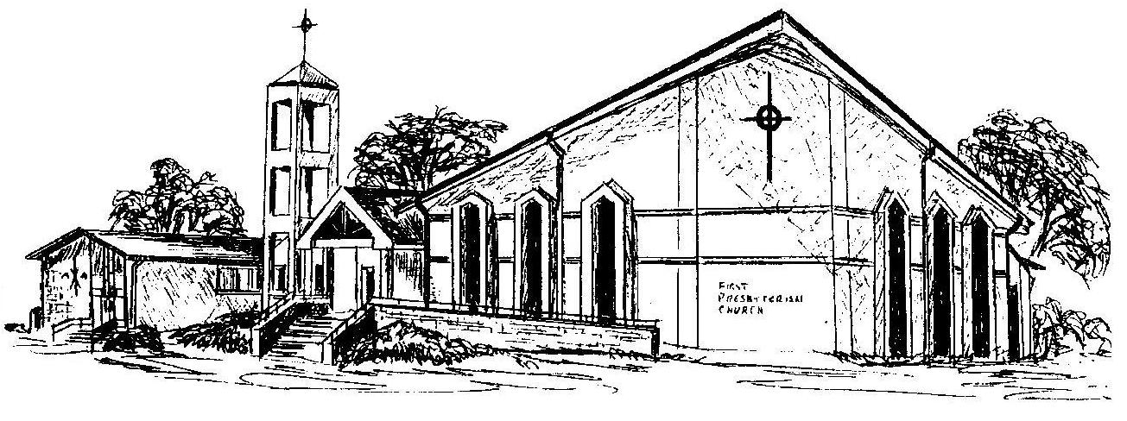

Welcome - Thank you for joining us for worship today. Please fill out a visitor information card found in the pew racks and place those in the offering plate so that we may follow up with you in the future. Your presence with us today has been a blessing to us, we hope that you have felt the presence of God and the welcome of this congregation.

