Welcome

Prelude
Let us prepare our hearts and minds for worship.

Call to Worship
Leader: This Lenten season, we look for signs of God’s presence, and God shows us love.
People: We listen for the Word of God and God calls us each by name.
Leader: We gather to worship God and to learn about Jesus.
People: We sense the power of God with us and we respond in grateful praise.

*Opening Hymn: “When I Survey the Wondrous Cross” Red Hymnal, #185

*Prayer of Confession (Unison) (adapted from the Baylor University website.)
God of Grace, we confess that we are afraid to reach out and touch. You came in a human body. You lived Your life among those who were sick— physically, mentally, and spiritually. You called the wounded to Your heart. You reached out to touch them, spoke words to comfort them, performed miracles to heal them. Heal us we pray. Heal us and help us to work for the healing and wholeness of all our neighbors. Speak Your word, and we shall be healed. Thank you God. Amen.

*Silent Reflection

*Assurance of Pardon

*Gloria Patri (Glory Be to the Father…) Red Hymnal, #623

Children’s Time

Scripture “Psalm 8:1, 3-5” (page 848)
“Mark 5:24-34” (page 1560)
Leader: The word of the Lord.
People: Thanks be to God.

Anthem “GospelFest” Arr. by Philip Kern

Sermon “The Power of Touch” Rev. Kimby Young

*Profession of Faith The Apostle's Creed Red Hymnal, inside back cover
I Believe in God the Father Almighty, Maker of heaven and earth, And in Jesus Christ his only Son our Lord; who was conceived by the Holy Ghost, born of the Virgin Mary, suffered under Pontius Pilate, was crucified, dead, and buried; he descended into hell; the third day he rose again from the dead; he ascended into heaven, and sitteth on the right hand of God the Father Almighty; from thence he shall come to judge the quick and the dead. I believe in the Holy Ghost; the holy catholic Church; the communion of saints; the forgiveness of sins; the resurrection of the body; and the life everlasting. Amen

*Hymn “Spirit of God, Descend Upon My Heart” Red Hymnal, #249

Pastoral Prayer & Lord’s Prayer

Offertory Meditation

*Doxology

*Prayer of Dedication

*Closing Hymn: “Beneath the Cross of Jesus” Red Hymnal, #183

*Benediction

Postlude
*Those who are comfortably able will please stand.

Rev. Kimby Young, Pastor; Karl Allen, Worship Assistant
Dean Faulk, Music Ministries
Vanessa Marriott, Pianist; Chancel Choir
Harlan Plunkett, Organist; Robyn Forkner, Pianist
Mike McGuire and Brad Cornell, Slide Production, Kim Liu Sound

Childcare is always available in the nursery (off the hall to the west of the sanctuary). Children are welcome to stay in the sanctuary thru the whole service, or to leave at any time. Allison Perry is our primary childcare attendant.

Worship Bags for Children are available outside the north door to the sanctuary. Choose books,
crayons, pencils, Legos, stuffed toys and other items to fill your bag to use during worship.

Offering Plates are at the entrance of each aisle for your contributions to the work of the church.

Gardner Multi Service Center collection is ongoing every week and is always in need of any non-perishable food. Bring something every week or once a month.

Fair Trade Products for Sale on Sundays Coffee, tea, chocolate, nuts, olive oil, dried fruit, baking products, and a few other items are for sale each Sunday at church.

Harvesters Food Distribution is always seeking volunteers. Every 3rd Saturday at Trade Net Parking lot and every 2nd Thursday at Divine Mercy Parish. Distribution begins at 1 p.m.
Note Harvesters has changed the regular distribution day.

A "Suggestion Box" is outside the office for ideas, comments, questions and thoughts. Contents will be reviewed at session meetings on the 2nd Monday of each month.

Joy Closet – Our mission center thrift store provides free clothing to a variety of needs. Our church provides all volunteers on the fourth Saturday of each month.

Presbyterian Women’s Bible Study meets each Thursday in Fellowship Hall at 6:30 p.m. All women welcome.

Black Out Drapes - For Lent each year we raise curtains over the stained glass windows as reminders of the deepening season. As a Lenten discipline we are called to awareness of light and darkness in the world as we seek God's presence in our daily lives, and as we look forward in hope to the celebration of the resurrection of Jesus Christ.

April 13 – Palm Sunday – Schedule
10 a.m. – One Service with Cantata
11 a.m. – Potluck Brunch
6 p.m. – KC Gospel Big Band Concert
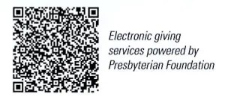
First Presbyterian Church
In the heart of Gardner since 1866 ~ Serving from the heart of God

Sunday, March 23, 2025
Third Sunday of Lent
8:45 AM
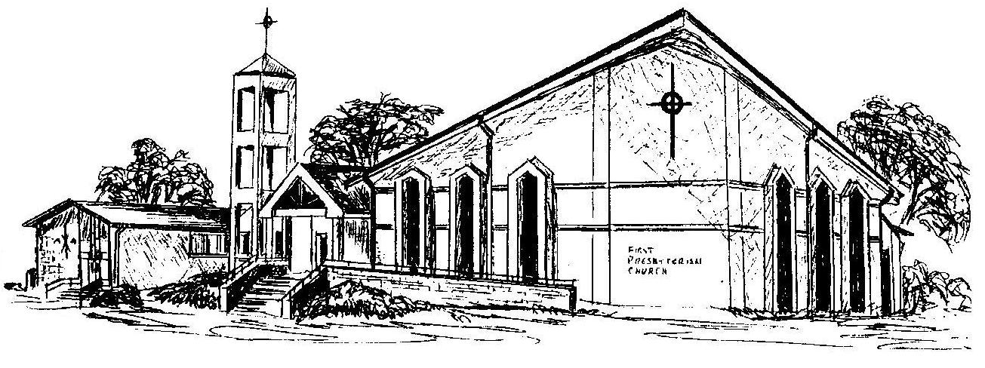

Welcome - Thank you for joining us for worship today. Please fill out a visitor information card found in the pew racks and place those in the offering plate so that we may follow up with you in the future. Your presence with us today has been a blessing to us, we hope that you have felt the presence of God and the welcome of this congregation.

