Welcome

Prelude “It Is Well With My Soul”
written by Philip Bliss, Arr. by M Mier
Let us prepare our hearts and minds for worship.

Call to Worship
Leader: Do you hear the voice of God calling you to come and worship?
People: We hear and we seek to follow Jesus Christ.
Leader: Amid all the noise and distraction in the world, hear the Word of the Lord.
People: We listen and we lift our voices in praise.

*Opening Hymn: “Praise to the Lord, the Almighty” Red Hymnal, #8

*Prayer of Confession (Unison)
Voice of Truth, we hear so many voices demanding our attention. Sometimes it is hard to focus on Your call. We pray, quiet the noise and distraction. Help us to hear You. Give us wisdom to know Your will and courage to follow Your way. Speak to us in ways we will understand. Inspire us to listen and to respond in the name of Jesus who calls each of us by name. Amen.

*Silent Reflection

*Assurance of Pardon

*Gloria Patri (Glory Be to the Father…) Red Hymnal, #623

Children’s Time

Scripture “1 Kings 19:9-13” (page 559)
“John 10:1-18” (page 1666)
“John 10:27” (page 1667)
“Romans 10:14-17” (page 1761)
Leader: The word of the Lord.
People: Thanks be to God.

Anthem “Give Thanks”
Words and Music by Henry Smith, Choral Setting by John F. Wilson
Sermon “Hear God” Rev. Kimby Young

*Profession of Faith The Apostle's Creed Red Hymnal, inside back cover
I Believe in God the Father Almighty, Maker of heaven and earth, And in Jesus Christ his only Son our Lord; who was conceived by the Holy Ghost, born of the Virgin Mary, suffered under Pontius Pilate, was crucified, dead, and buried; he descended into hell; the third day he rose again from the dead; he ascended into heaven, and sitteth on the right hand of God the Father Almighty; from thence he shall come to judge the quick and the dead. I believe in the Holy Ghost; the holy catholic Church; the communion of saints; the forgiveness of sins; the resurrection of the body; and the life everlasting. Amen

*Hymn “Open My Eyes, That I May See” Red Hymnal, #381

Pastoral Prayer & Lord’s Prayer

Offertory Meditation “He Leadeth Me, O Blessed Thought”
Written by Wm. Bradbury, Arr. by Mark Hayes

*Doxology

*Prayer of Dedication

*Closing Hymn: “Dear Lord and Father of Mankind” Red Hymnal, #427

*Benediction

Postlude “This Is My Father’s World” Arr. by Chris Rice
*Those who are comfortably able will please stand.

Rev. Kimby Young, Pastor; Kim Allen, Worship Assistant
Dean Faulk, Music Ministries, Chancel Choir
Harlan Plunkett, Organist; Robyn Forkner, Pianist
Mike McGuire and Brad Cornell, Slide Production, Kim Liu Sound

Childcare is always available in the nursery (off the hall to the west of the sanctuary). Children are welcome to stay in the sanctuary thru the whole service, or to leave at any time. Allison Perry is our primary childcare attendant.

Worship Bags for Children are available outside the north door to the sanctuary. Choose books,
crayons, pencils, Legos, stuffed toys and other items to fill your bag to use during worship.

Offering Plates are at the entrance of each aisle for your contributions to the work of the church.

Gardner Multi Service Center collection is ongoing every week and is always in need of any non-perishable food. Bring something every week or once a month.

Fair Trade Products for Sale on Sundays Coffee, tea, chocolate, nuts, olive oil, dried fruit, baking products, and a few other items are for sale each Sunday at church.

Harvesters Food Distribution is always seeking volunteers. Every 3rd Saturday at Trade Net Parking lot and every 2nd Thursday at Divine Mercy Parish. Distribution begins at 1 p.m.
Note Harvesters has changed the regular distribution day.

A "Suggestion Box" is outside the office for ideas, comments, questions and thoughts. Contents will be reviewed at session meetings on the 2nd Monday of each month.

Joy Closet – Our mission center thrift store provides free clothing to a variety of needs. Our church provides all volunteers on the fourth Saturday of each month.

Presbyterian Women’s Bible Study meets each Thursday in Fellowship Hall at 6:30 p.m. All women welcome.

Men’s Breakfast meets at Perkins on Tuesday, March 11 7:00 a.m.

Black Out Drapes - For Lent each year we raise curtains over the stained glass windows as reminders of the deepening season. As a Lenten discipline we are called to awareness of light and darkness in the world as we seek God's presence in our daily lives, and as we look forward in hope to the celebration of the resurrection of Jesus Christ

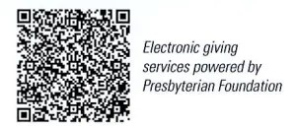
First Presbyterian Church
In the heart of Gardner since 1866 ~ Serving from the heart of God

Sunday, March 16, 2025
Second Sunday of Lent
8:45 AM
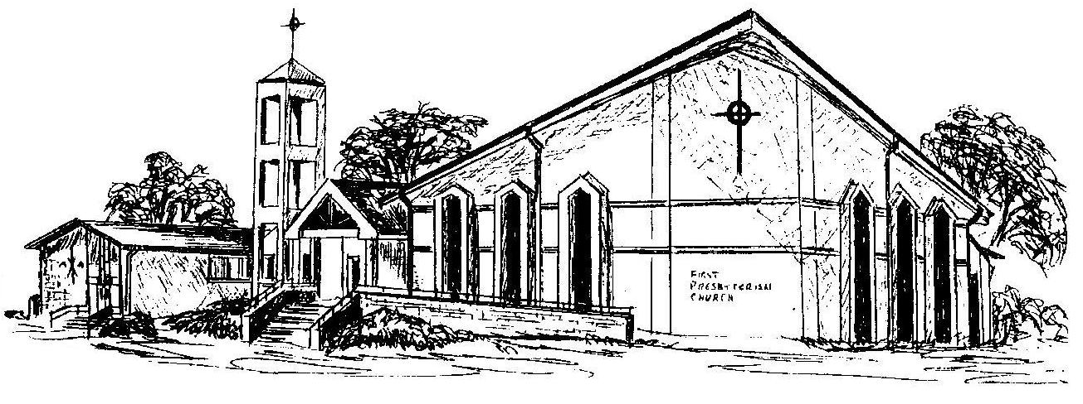

Welcome - Thank you for joining us for worship today. Please fill out a visitor information card found in the pew racks and place those in the offering plate so that we may follow up with you in the future. Your presence with us today has been a blessing to us, we hope that you have felt the presence of God and the welcome of this congregation.

