Welcome
Prelude “Wounded for Me” arr. A.C. Whitworth
Let us prepare our hearts and minds for worship.

Leader: Taste and see that the Lord is good. God’s steadfast love endures forever.
People: We come to the table of Jesus Christ. We receive the gifts of God.
Leader: All are welcome at this table of grace. There is room for everyone.
People: We praise God for bounty and blessing. We delight in worshipping God.

*Opening Hymn: “Come, Thou Fount of Every Blessing” Red Hymnal, #2

*Prayer of Confession (Unison)
God of abundance, sometimes we miss the miracle of moments like this in worship, when you come to us and reveal your grace for us. Forgive us. Open our hearts. Inspire us again. Fill us with all we need to share your love in the world in the name of Jesus Christ. Amen.

* Silent Reflection

* Assurance of Pardon

* Gloria Patri (Glory Be to the Father…) Red Hymnal, #623

Children’s Time

Scripture “Psalm 34:4-8” (page 871)
“Matthew 26:26-30” (page 1543)
“John 2:1-11” (page 1648)
“John 6:47-58” (page 1658)
Leader: The word of the Lord.
People: Thanks be to God.

Anthem “The Whisper” by Craig Courtney

Sermon “Taste” Rev. Kimby Young

*Profession of Faith The Apostle's Creed Red Hymnal, inside back cover
I Believe in God the Father Almighty, Maker of heaven and earth, And in Jesus Christ his only Son our Lord; who was conceived by the Holy Ghost, born of the Virgin Mary, suffered under Pontius Pilate, was crucified, dead, and buried; he descended into hell; the third day he rose again from the dead; he ascended into heaven, and sitteth on the right hand of God the Father Almighty; from thence he shall come to judge the quick and the dead. I believe in the Holy Ghost; the holy catholic Church; the communion of saints; the forgiveness of sins; the resurrection of the body; and the life everlasting. Amen

*Hymn “Jesus, Thou Joy of Loving Hearts” Red Hymnal, #501

Offertory Meditation “God So Loved the World” arr. A.C. Whitworth

*Doxology

The Sacrament of Holy Communion
(All bread is gluten free. Prepacked elements are available in the back.)
Invitation
Great Prayer and The Lord’s Prayer
Words of Institution – Breaking of Bread
Communion of the People
Prayer of Thanksgiving

*Closing Hymn: “When We All Get to Heaven” Red Hymnal, #542

*Benediction

Postlude “Alleluia! Alleluia!” arr. A.C. Whitworth
*Those who are comfortably able will please stand.

Rev. Kimby Young, Pastor; Randy Rieger, Worship Assistant
Dean Faulk, Music Ministries; Chancel Choir
Harlan Plunkett, Organist; Robyn Forkner, Pianist
Mike McGuire and Brad Cornell, Slide Production; Kim Liu, Soun

Childcare is always available in the nursery (off the hall to the west of the sanctuary). Children are welcome to stay in the sanctuary thru the whole service, or to leave at any time.

Worship Bags for Children are available outside the north door to the sanctuary. Choose books,
crayons, pencils, Legos, stuffed toys and other items to fill your bag to use during worship.

Offering Plates are at the entrance of each aisle for your contributions to the work of the church.

Gardner Multi Service Center collection is ongoing every week and is always in need of any non-perishable food. Bring something every week or once a month.

Fair Trade Products for Sale on Sundays Coffee, tea, chocolate, nuts, olive oil, dried fruit, baking products, and a few other items are for sale each Sunday at church.

Harvesters Food Distribution is always seeking volunteers. Every 3rd Saturday at Trade Net Parking lot and every 2nd Thursday at Divine Mercy Parish. Distribution begins at 1 p.m.

Joy Closet – Our mission center thrift store provides free clothing to a variety of needs. Our church provides all volunteers on the fourth Saturday of each month.

Presbyterian Women’s Bible Study meets each Thursday in Fellowship Hall at 6:30 p.m.

Black Out Drapes - For Lent we raise curtains over the stained glass windows as reminders that we are called to awareness of light and darkness in the world as we seek God's presence in our daily lives, and as we look forward in hope to the resurrection of Jesus Christ.

Men’s Breakfast April 8, Perkins at 7:00 a.m.

April 13 – Palm Sunday – Schedule
10 a.m. – One Service with Cantata
11 a.m. – Potluck Brunch
6 p.m. – KC Gospel Big Band Concert

Holy Week Schedule
April 17 7:00 p.m. – Maundy Thursday Communion
April 18 7:00 p.m. – Good Friday
April 20 10:00 a.m. – Celebration of the Resurrection – Easter

Flowering the cross – On Easter Sunday, bring a fresh flower from your garden to flower the cross in memory of a loved one. We will have flowers if you do not have one to bring.

PW Annual Spring Brunch, Saturday, April 26 at 9:30 a.m. Signup sheet in the Narthex.

Presbyterian Youth Fellowship Chicken & Noodle dinner April 27 food served 11:30–1:00 p.m.
First Presbyterian Church
In the heart of Gardner since 1866 ~ Serving from the heart of God

Sunday, April 6, 2025
Fifth Sunday of Lent
8:45 AM
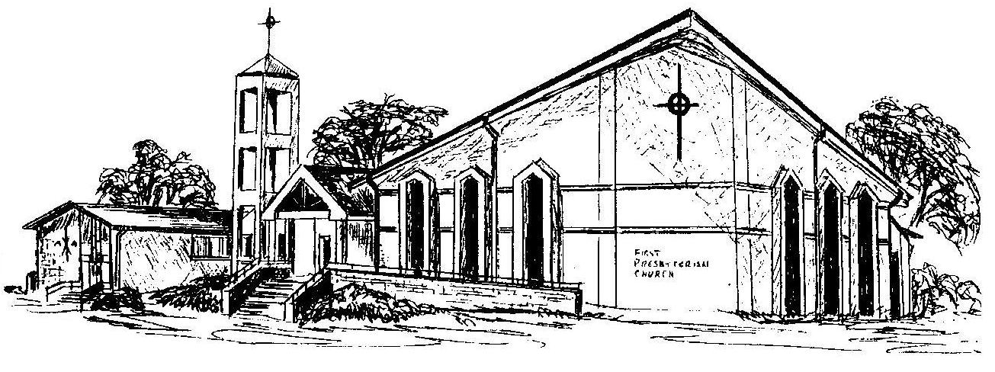

Welcome - Thank you for joining us for worship today. Please fill out a visitor information card found in the pew racks and place those in the offering plate so that we may follow up with you in the future. Your presence with us today has been a blessing to us, we hope that you have felt the presence of God and the welcome of this congregation.

