Welcome

Prelude “Ariosto” Craig Penfield
Let us prepare our hearts and minds for worship.

Call to Worship (from Psalm 8)
Leader: O Lord, our Sovereign, how majestic is your name in all the earth!
People: When I look at your heavens, the work of your fingers, the moon and the stars that you have established; what are humans that you are mindful of them, mortals that you care for them?
Leader: Yet you have made humans a little lower than God and crowned them with glory and honor.
People: We honor our God of glory and lift our hearts in worship.

*Opening Hymn: “How Great Thou Art” Red Hymnal, # 4

*Prayer of Confession (Unison)
We confess that when we pray, we don’t know how to pray. Yet you hear us anyway. We are afraid to speak to you. We are slow to listen. Yet you are ever ready to hear our prayers and to be with us in your love. Give us courage to pray. Give us wisdom to understand. Give us boldness to answer your call. In Jesus Christ our Savior and Lord. Amen.

*Silent Reflection

*Assurance of Pardon

*Gloria Patri (Glory Be to the Father…) Red Hymnal, # 623

Children’s Time

Scripture “Acts 4:23-31” (page 1697)
“Romans 8:24-28” (page 1757)
Leader: The word of the Lord.
People: Thanks be to God.

Music “Holy Ground” by Geron Davis

Sermon: “Prayer for Boldness” Rev. Kimby Young

*Profession of Faith The Apostle's Creed Red Hymnal, inside back cover
I Believe in God the Father Almighty, Maker of heaven and earth, and in Jesus Christ his only Son our Lord; who was conceived by the Holy Ghost, born of the Virgin Mary, suffered under Pontius Pilate, was crucified, dead, and buried; he descended into hell; the third day he rose again from the dead; he ascended into heaven, and sitteth on the right hand of God the Father Almighty; from thence he shall come to judge the quick and the dead. I believe in the Holy Ghost; the holy catholic Church; the communion of saints; the forgiveness of sins; the resurrection of the body; and the life everlasting. Amen

*Hymn “Sweet Hout of Prayer” Red Hymnal, # 433

Pastoral Prayer & Lord’s Prayer

Offertory Meditation: “Jesus, the Very Thought of Thee”
(excerpts from “The Swan”). Arr. Marilyn Arison

*Doxology

*Prayer of Dedication

*Closing Hymn: “Lord, Speak to Me” Red Hymnal, # 450

*Benediction

*Postlude “Hornpipe” G.F. Handel
*Those who are comfortably able will please stand.

Rev. Kimby Young, Pastor; John Forkner, Worship Assistant
Oliver Schwab, Soloist; Dean Faulk, Music Ministries
Harlan Plunkett, Organist; Robyn Forkner, Pianist
Mike McGuire and Brad Cornell, Slide Production; Kim Liu. Sound

Childcare is always available in the nursery (off the hall to the west of the sanctuary). Children are welcome to stay in the sanctuary thru the whole service, or to leave at any time. Allison Perry is our primary childcare attendant.

Worship Bags for Children are available outside the north door to the sanctuary. Choose books, crayons, pencils, Legos, stuffed toys and other items to fill your bag to use during worship.

Offering Plates are at the entrance of each aisle for your contributions to the work of the church.

Gardner Multi Service Center collection is ongoing every week and is always in need of any non-perishable food. Bring something every week or once a month.

Fair Trade Products for Sale on Sundays Coffee, tea, chocolate, nuts, olive oil, dried fruit, baking products, and a few other items are for sale each Sunday at church.

Harvesters Food Distribution is always seeking volunteers. Every 3rd Saturday at Trade Net Parking lot and every 4th Wednesday at Divine Mercy Parish. Distribution begins at about 1 p.m.

A "Suggestion Box" is outside the office for ideas, comments, questions, and thoughts. Contents will be reviewed at session meetings on the 2nd Monday of each month.

Joy Closet – Our mission center thrift store provides free clothing to a variety of needs. Extra items are sold at low cost. Volunteers are trained in a variety of jobs and work at different times. Our church provides all volunteers on the fourth Saturday of each month.

Presbyterian Women’s Bible Study will begin Thursday, Feb 27th - April 10th, each Thursday for 7 sessions. They will be meeting at 6:30 pm in the Fellowship Hall. The study is “Twelve Extraordinary Women.” How God Shaped Women of the Bible and What He Wants to Do With You by John MacArthur. See Paula Waters or Alice Rollf about a book. Signup sheets in narthex. All Ladies are welcome!

Traveling Day Camp Registration is open.

Women’s Fellowship Group will begin on Wednesday, March 5, 2025, at 10:00 a.m. in the Fellowship Hall. Mark your calendar. All women are welcome.

ASH WEDNESDAY March 5 – Two Options
Drive through prayer and sacrament 5:30 – 6:30 p.m.
Worship in the Sanctuary 7:00 – 8:00 p.m.
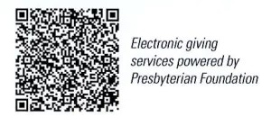
First Presbyterian Church
In the heart of Gardner since 1866 ~ Serving from the heart of God

February 16, 2025
8:45 AM

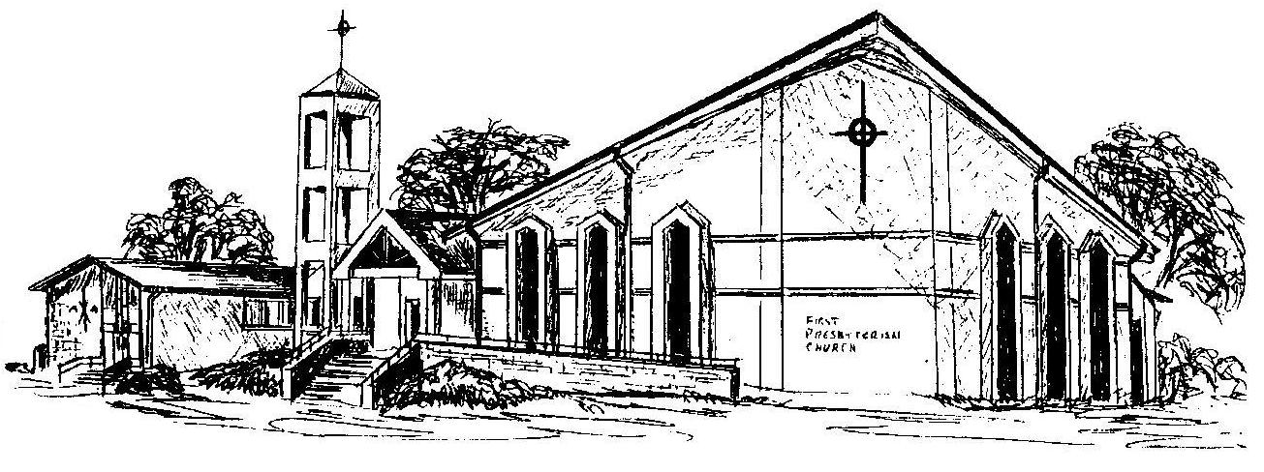

Welcome - Thank you for joining us for worship today. Please fill out a visitor information card found in the pew racks and place those in the offering plate so that we may follow up with you in the future. Your presence with us today has been a blessing to us, we hope that you have felt the presence of God and the welcome of this congregation.

