First Presbyterian Newsletter February 2025

The Early Church and the Modern Church – by Pastor Kimby
I’ve been teaching the book of Acts this year on Thursday mornings. I always learn something new when I study or teach scripture. This year I have been struck by the similarities between the first disciples and current disciples today. We face some of the same issues. Our faith in God offers the same grace today. Yes, the world is different – technology and global connections create a very different way of life. Christianity in America does not face the persecution of the early church. However, the faithfulness of the early disciples and the way they lived their faith in the world, provide a powerful witness for us and a model for living for all who would follow Jesus Christ in the way of love.
During February I will be preaching a series from passages in the book of Acts. Each lesson centers around the life of the early Christians, and at the same time offers a call to us today. The stories remind us of faithfulness and show us how to live our faith in the modern world. Join us each Sunday in February for a glimpse of the church as God calls us to live.

Scripture for Upcoming Worship – Lessons from the book of Acts
February 2 – Matthew 5:13-16; Acts 1:1-9; Acts 8:26-39 – Sharing Our Faith
February 9 – Acts 3:1-10; Acts 4:13-22 – Show and Tell
February 16 – Acts 4:23-31; Romans 8:24-28 – Prayer for Boldness
February 23 – Acts 2:43-47; Acts 4:32-37; Acts 9:36-42 – One in Community

Monthly Financial Report
At the end of December our records indicate:
total income this month is $ 39454.82
total expenses this month is $ 28391.04
December usually has a higher than regular income because of end of year giving. This surplus over expenses allowed us to end the year 2024 slightly ahead. The session thanks each of you for your contributions to the church. A complete line by line expense report is available upon request. We will close finances for January after February 3.

Per Capita – Donations welcome
In the Presbyterian Church USA, each local church makes a payment to the denomination based on the number of members on record in a previous year. This per capita payment emphasizes our connectional nature and our oneness in Christ. These funds go to support costs and ministries of the denomination on the local, regional and national level. Some of these funds pay salaries and operating expenses. Some of these funds pay for maintaining programs and offices, including vocational ministries, committee support, evangelism, new church development, educational ministry, communications, support networks and advocacy programs.
If you would like to contribute to the church the amount, we pay for membership for you or your family, that gift can be designated on your check to First Presbyterian Church as “per capita.” You may also pay an extra per capita membership contribution for someone who cannot afford to pay their own. You may also round your donation up to $45 or $50 if that is easier.
Per Capita for 2025 is $44.98 per person (GA $10.84, Synod $3.15, and Presbytery $30.99). For First Presbyterian Church of Gardner the total for 2025 is $7556.64.

Souper Bowl of Caring Collection on Super Bowl Sunday – Tackle Hunger
Sunday, February 9
We will join millions of people from all across the nation in support of this fundraiser to end hunger. Started by a Presbyterian youth group in 1990, Souper Bowl of Caring has since grown all over the world, collecting more than $100 million donated back into their own communities. “Souper Bowl of Caring” works to mobilize those looking to fight hunger and poverty around the time of the Super Bowl football game. Bring non-perishable food items on or before Sunday, February 9. You may also make a financial contribution designated to "Souper Bowl of Caring." We will have soup pots ready to collect money on Sunday, February 9. Bring your loose change, noisy offering to add. Food Donations will be divided between the Johnson County Multi-Service Center of Gardner and the Joy Closet parking lot outdoor free food pantry. Money will go to the Multi-Service Center. Let’s defeat hunger!!

Noisy Offering – February 9
Our loose change offering for this quarter will fall on Super Bowl Sunday, February 9 and will be given to the Souper Bowl of Caring. This offering which is collected by our children and youth during worship is a fun way to “Make a Joyful Noise to the Lord” and to remember that little gifts add up when shared together. Each noisy offering is designated for a specific cause, usually something that benefits children and youth in our community and world. This month’s offering is for Souper Bowl Sunday – Tackle Hunger. Remember to bring your coins to worship on Sunday, February 9 and help us “make a joyful noise.”

ASH WEDNESDAY – March 5 - Two Options
Drive through prayer and sacrament – 5:30-6:30 p.m.
Worship in the Sanctuary – 7:00-8:00 pm.
Imposition of Ashes and Communion
Come, and invite a friend!
In addition to worship in the sanctuary with music, scripture, prayer and meditation, the Worship Pillar has decided to offer again both communion and imposition of ashes to participants in your car in the parking lot. Join us as we begin this season of reflection and spiritual growth.

Traveling Day Camp - June 16-20, 2025, Register Now!
Registration has just opened for Traveling Day Camp 2025.
Be sure to get your children and grandchildren, neighbors and friends registered. We have limited enrollment through our contract with Heartland Camp and Conference center. We always fill up long before summer.
Students are eligible if they have completed kindergarten through 6th grade. Youth and adult volunteers are welcome. Contact Robin Tropansky or Marsha Cooper to volunteer or for more information.

To register go to the link below,
Heartland Camp TDC link
Gardner First Presbyterian Church — Heartland Christian Camps

Weather Cancellation Policy
Usually, we try to worship if possible. We may modify worship or cancel Sunday school. Even if we don’t cancel. Be smart. Be cautious. Don't take any chances. Even if a church event is not cancelled, if you do not feel comfortable getting out, you are excused. If you have a duty, we will find someone to cover for you.
Generally, midweek if school is cancelled, events are cancelled. But as weather changes during the day, an evening event may not be consistent with school closing. Discretion is given to event leaders to cancel if needed. Check with the event leader to be sure. Check emails, Facebook or the website (www.fpcgardner.church) for announcements about cancellation. Also check KMBC-TV notices. Call Rev. Kimby 913-481-7076, or Connie 913-244-8185.

Prayer Request
The family of Larry Gaston, Beau Foster, Dennis Chambers, the Family of Gary Wittkopf, Jerry Lane, Annette Hatfield, Bayli Waters, People in California, Linda Wolf, Karen Elliott, Rhonda Krehbiel, Poppy Zurcher, Annette Hatfield, Steve Perry, Robert Mashburn, Susan Gash, Susan Wilson – Dierksen, Karl Morrison, Abe Portenier, Michael Judah, Blake McSwane, Jim Applegarth, Rex & Karen Roney, Jon Deiley, Amanda Allen, LeMoyne Zimmerman, Mike Judah, Steve & Laurie Holben, Mike Tilma, Mike Judah, Dozer Reed, Dedra Reed, Trinity D’Autorio, Skyla D’Autorio, Jackson Tijerina, Reagan Barnadt.

Thank you for your Prayers
For all the quiet but powerful prayers we all could hear, we thank you!! Our son has completed all his chemo treatments, has gotten a great report back from yesterday’s CT test and is blessedly released to return to his family and work back in Indonesia, this week!! We thank you from our hearts! God bless you all.
Bob and Poppy Zurcher
PW News
Presbyterian Women’s Book Club will meet Thursday, Feb 6th, at 6:30 pm, at Vera Beach’s home. The book being read is “Bringing Maggie Home.” All Ladies are Welcome!
Presbyterian Women’s Bible Study will begin Thursday, Feb 27th-April 10th, each Thursday for 7 sessions. They will be meeting at 6:30 pm in the Fellowship Hall. The study is “Twelve Extraordinary Women.” How God Shaped Women of the Bible and What He Wants to Do With You by John MacArthur. See Paula Waters or Alice Rolf about a book. All Ladies are welcome!
The Women’s Fellowship Group will not meet in February. THE FELLOWSHIP GROUP WILL BEGAN MEETING AGAIN ON MARCH 5, 2025, MARK IT ON YOUR CALENDER. The Women’s Fellowship Group meets on the first Wednesday of each month, from March through November, in the Fellowship Hall. The Fellowship Group is open to all women of the church.
Ushers for February 2025 8:45 a.m.
Devon & Judy Mason, Karl & Kim Allen

Communion Servers for Sunday, February 2, 2025, 8:45 a.m.
Larry Schick, Karen Elliott, Mitch McSwane, Lynn Moldrup, Randy Rieger, Sandy Rieger

Communion Servers for Sunday, February 2, 2025, 11:00 a.m.
Eric Gourley, Laura Gourley, Seth Cooper

Men’s Breakfast on Tuesday, February 11 at 7:00 a.m. at Perkins. It is an opportunity to get to know one another and build a stronger community of Faith.

Welcome New Organist
Welcome Harlan Plunkett is the new organist. His first Sunday is February 9, 2025.
Harlan was raised in rural Southwest Kansas on a farm. He attended MidAmerica Nazarene University (MNU) in Olathe KS in the 1980’s graduating with a BA in business. He has worked for MNU full-time since 1990 in the Financial Aid Office. He currently is the Associate Director of Operations. He also delivers flowers for HyVee part-time for fun.
He began music lessons with his mother when he was three years old learning to read music before reading or writing. Harlan studied Piano throughout the K-12 years with a local Piano teacher. In college he began private organ lessons with a concert organist in Kansas City, MO who became a dear friend and long-time mentor.
At age 8 he played in a small local church for the first time and soon began to play regularly for the church services because there was no one else to play. With few interruptions he has served as an organist for various churches since.
Harlan has two daughters, Audrey, a junior at UMKC double majoring in Physics and Math, and Devan who is a Senior at Olathe North High School. Harlan loves being a Dad.
My hobbies include travel, photography, and cooking.

To the Congregation of First Presbyterian Church
Words can’t truly express my gratitude and appreciation for the wonderful recognition ceremony for me on December 29.
The tributes and kind words from Pastor Kimby, Dean Faulk, Lois Barber, and Paula Waters were very humbling. Randy Rieger’s history of my early years as organist brought back many memories.
The “Last Supper” picture given in my honor will add to our sanctuary for years to come. The “Music Speaks” plaque has found a home in the music corner of our living room. The monetary donation to PCUSA for world mission is greatly appreciated as it will help many mission co-workers around the world.
The reception was overwhelming with the cards, beautiful table decorations, and the Christmas balls for writing notes. Who could forget those delicious cakes and the amazing organ cake?
Again, thank you for your support and encouragement these past forty years. You are a super church family, and you mean so much to me.
Love in Christ,
Alice Rollf

Geraldine Roberts’ birthday is Saturday, February 1. Hope she has a Happy Birthday.


Store Hours
MONDAY 10 – 7
TUESDAY` 10 – 7
WEDNESDAY 10 – 4
THURSDAY 10 – 7
SATURDAY 10 - 2

February 2025 When to donate
Now is a great time to donate the following items:
Spring clothing, spring sportswear, Royals apparel, back-to-school items.

Items that are used year-round are appreciated at any time. Seasonal items are best donated during the preceding season to allow time for the sorting and making items ready for display.
Thanks to EVERYONE for your donations!
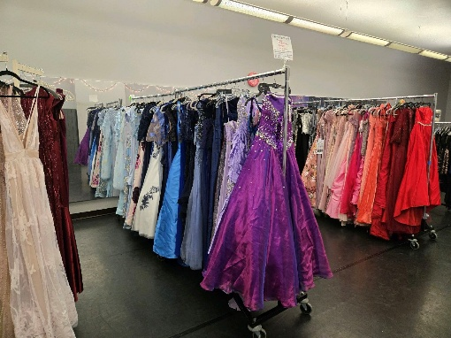
JOY Closet Prom Dress Event was a huge success. Held January 25th at Inspire Dance Academy, it was well-attended.
The following items were given to the young ladies who participated: 76 dresses, 28 pairs of shoes, 27 necklaces, and 35 earrings and bracelets. It was a fun event and we look forward to doing it again.
Thanks to all of the volunteers who worked to prepare the items and special thanks to Inspire Academy for a great venue for our event. It’s great to be able to show our support for this special occasion!
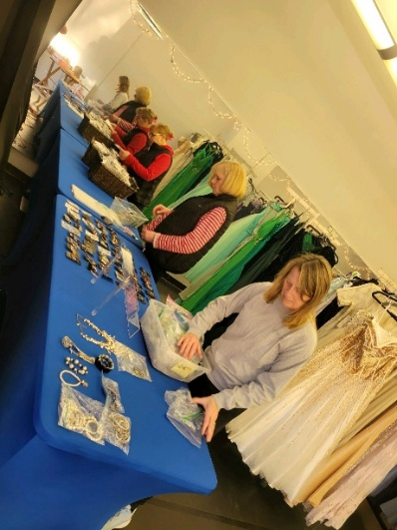
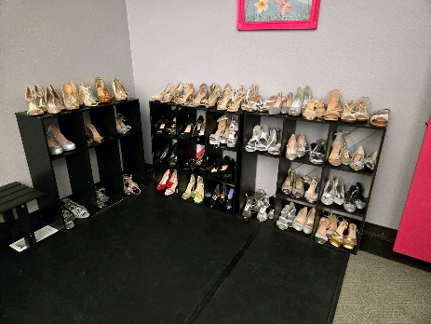


We’re pleased to have new friends volunteering and hope you’ll soon feel like family.
May your volunteer experience enrich your lives and THANK YOU FOR VOLUNTEERING!

This text was recently received:
I wanted to say thank you. Today (Friday) you had people working on things and even though you guys were closed, they were kind enough to help me with unloading items. They didn’t have to do so since you were closed and it really helped this momma out. You have a great staff and I wish I got the lady’s name who was so kind and helpful,
So THANK YOU to our Friday volunteers and to ALL of our volunteers. You cannot imagine the good that you do in our community. You are appreciated beyond words. What a great feeling to make that kind of impression.
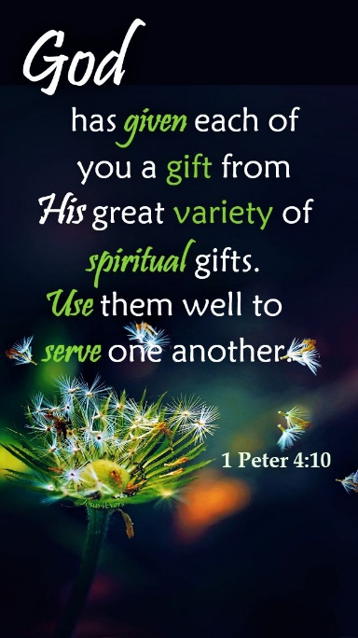
Do you recognize your gifts?
Too often we think gifts have to be the ability to sing beautifully or create a masterpiece. But, the spiritual gifts help you to come closer to God. Can you listen well? Are you good at helping and encouraging others? Do people depend on your wisdom and grace? Think of the gifts that matter most in life. God gave them to us to be used.
Look for quiet moments, pray, and listen.
He may be calling you.
For I was hungry and you gave me something to eat, I was thirsty and you gave me something to drink, I was a stranger and you invited me in, I needed clothes and you clothed me.

Matthew 25:35-36 NIV

JOY Closet Is a ministry of

First Presbyterian Church of Gardner, KS
Serving our community since 2013

