Welcome

Prelude
Let us prepare our hearts and minds for worship.

Call to Worship
Leader: We gather today to worship the God who loves us and loves the world.
People: We are called to serve God and to share God’s love in the world.
Leader: Come, let us be the salt of the earth, adding flavor and goodness, preserving God’s Word and nourishing the world with God’s grace.
People: Come, let us share God’s goodness. Let us join together to worship God.

*Opening Hymn: “Morning Has Broken” Red Hymnal, # 60

*Prayer of Confession (Unison)
(by Iona MacLean, Nova Scotia, Presbyterian World Service)
Merciful God, You call us to be salt of the earth and light of the world. We confess that our witness is often bland and gloomy. Forgive us when we fail to be an influence for good, and when we condone or do what is wrong in Your sight. Help us to flavor the earth with righteousness and to reflect the light of Your love in a dark world; through Jesus Christ, the Light of the world. Amen.

*Silent Reflection

*Assurance of Pardon

*Gloria Patri (Glory Be to the Father…) Red Hymnal, # 623

Children’s Time

Scripture “Matthew 5:13-16” (page 1501)
“Acts 1:1-9” (page 1690)
“Acts 8:26-39” (page 1705)
Leader: The word of the Lord.
People: Thanks be to God.

Music “Here I Am Lord” words & music by Dan Schutte

Sermon: “Pass the Salt” Rev. Kimby Young

*Profession of Faith The Apostle's Creed Red Hymnal, inside back cover
I Believe in God the Father Almighty, Maker of heaven and earth, and in Jesus Christ his only Son our Lord; who was conceived by the Holy Ghost, born of the Virgin Mary, suffered under Pontius Pilate, was crucified, dead, and buried; he descended into hell; the third day he rose again from the dead; he ascended into heaven, and sitteth on the right hand of God the Father Almighty; from thence he shall come to judge the quick and the dead. I believe in the Holy Ghost; the holy catholic Church; the communion of saints; the forgiveness of sins; the resurrection of the body; and the life everlasting. Amen

*Hymn “Pass It On” Red Hymnal, # 309

Offertory Meditation:

*Doxology

The Sacrament of Holy Communion
(All bread is gluten free. Prepacked elements are available in the back)
Invitation
Great Prayer and The Lord’s Prayer
Words of Institution – Breaking of Bread
Communion of the People
Prayer of Thanksgiving

*Closing Hymn: “Break Thou the Bread of Life” Red Hymnal, # 274

*Benediction

*Postlude
*Those who are comfortably able will please stand.

Rev. Kimby Young, Pastor; Larry Schick, Worship Assistant
Chesley Jones, Solo; Dean Faulk, Music Ministries
Robyn Forkner, Pianist
Mike McGuire and Brad Cornell, Slide Production; Kim Liu. Sound

Childcare is always available in the nursery (off the hall to the west of the sanctuary). Children are welcome to stay in the sanctuary thru the whole service, or to leave at any time. Allison Perry is our primary childcare attendant.

Worship Bags for Children are available outside the north door to the sanctuary. Choose books, crayons, pencils, Legos, stuffed toys and other items to fill your bag to use during worship.

Offering Plates are at the entrance of each aisle for your contributions to the work of the church.

Gardner Multi Service Center collection is ongoing every week and is always in need of any non-perishable food. Bring something every week or once a month.

Fair Trade Products for Sale on Sundays Coffee, tea, chocolate, nuts, olive oil, dried fruit, baking products, and a few other items are for sale each Sunday at church.

Harvesters Food Distribution is always seeking volunteers. Every 3rd Saturday at Trade Net Parking lot and every 4th Wednesday at Divine Mercy Parish. Distribution begins at about 1 p.m.

A "Suggestion Box" is outside the office for ideas, comments, questions, and thoughts. Contents will be reviewed at session meetings on the 2nd Monday of each month.

Joy Closet – Our mission center thrift store provides free clothing to a variety of needs. Extra items are sold at low cost. Volunteers are trained in a variety of jobs and work at different times. Our church provides all volunteers on the fourth Saturday of each month.

Scout Sunday – Today we welcome representatives of Troop 88 in celebration of Scouting Anniversary Day. Boy Scouts meet at our church every Tuesday. We recognize the contributions of young people and adults to the various Scouting programs and thank you for your service!

Sunday, February 9, Souper Bowl of caring offering received both services.

Sunday, February 9. Noisy Offering please bring coins to put in the Noisy Offering Can.

Traveling Day Camp Registration is open.

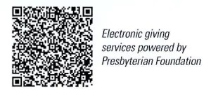
First Presbyterian Church
In the heart of Gardner since 1866 ~ Serving from the heart of God

February 2, 2025
Boy Scout Sunday
8:45 AM

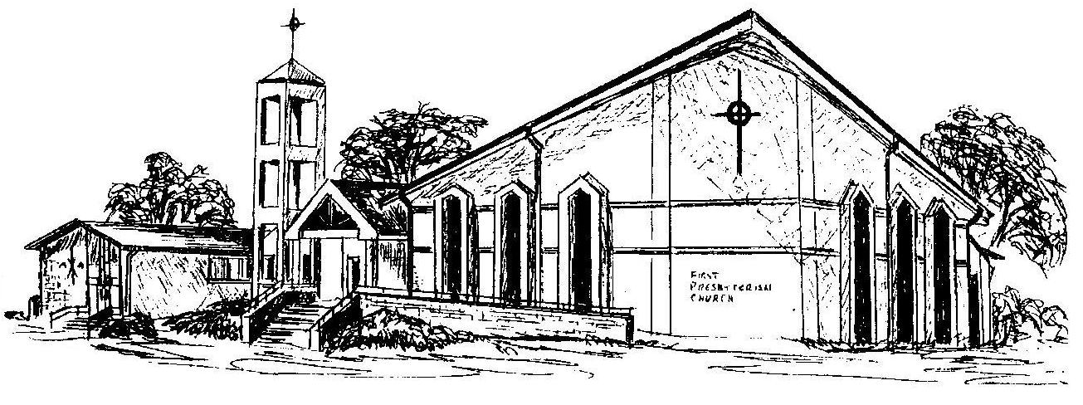
Welcome - Thank you for joining us for worship today. Please fill out a visitor information card found in the pew racks and place those in the offering plate so that we may follow up with you in the future. Your presence with us today has been a blessing to us, we hope that you have felt the presence of God and the welcome of this congregation.

