Welcome

Prelude
Let us prepare our hearts and minds for worship.

Call to Worship (based on 1 Corinthians 12)
Leader: In one Spirit we were all baptized into one body – the body of Jesus Christ.
People: The body does not consist of one member but of many – working together for the common good.
Leader: If one member suffers, all suffer together; if one is honored, all rejoice together.
People: We are the body of Christ and individually members of Christ. Together we serve God. Together we worship God.

*Opening Hymn: “Come Christians Join to Sing” Red Hymnal, #108

*Prayer of Confession (Unison)
God of Mercy, clearly you have called us to follow Jesus. You have invited us to grow up into Christ. We try. We sometimes fail. We don’t always do our best. We are distracted from your way. We forget to listen and look for you. Forgive us and help us. Remind us again. Show us how to grow. Teach us to love as you love. Make us your people. By your grace and in the name of Jesus Christ we pray. Amen

*Silent Reflection

*Assurance of Pardon

*Gloria Patri (Glory Be to the Father…) Red Hymnal, #623

Children’s Time

Ordination and Installation of Officers “Teri Winegar, Julie Sutton, Karl Allen”

Scripture “Psalm 34:1-11” (page 871)
“Ephesians 4:1-8, 11-16” (page 1821)
Leader: The word of the Lord.
People: Thanks be to God.

Music “My Faith Looks Up To Thee”
arr. by Bill Derkson

Sermon: “All Together Now” Rev. Kimby Young

*Profession of Faith The Apostle's Creed Red Hymnal, inside back cover
I Believe in God the Father Almighty, Maker of heaven and earth, And in Jesus Christ his only Son our Lord; who was conceived by the Holy Ghost, born of the Virgin Mary, suffered under Pontius Pilate, was crucified, dead, and buried; he descended into hell; the third day he rose again from the dead; he ascended into heaven, and sitteth on the right hand of God the Father Almighty; from thence he shall come to judge the quick and the dead. I believe in the Holy Ghost; the holy catholic Church; the communion of saints; the forgiveness of sins; the resurrection of the body; and the life everlasting. Amen

*Hymn “They’ll Know We Are Christians by our Love” Red Hymnal, #284

Pastoral Prayer & Lord’s Prayer

Offertory Meditation:

*Doxology

*Prayer of Dedication

*Closing Hymn: “Just a Closer Walk with Thee” Red Hymnal, #380

*Benediction

*Postlude
*Those who are comfortably able will please stand.

Rev. Kimby Young, Pastor; Judy Mason, Worship Assistant
Chancel Choir; Ella Falkner, Flute
Dean Faulk, Music Ministries; Alice Rollf, Organist; Robyn Forkner, Pianist
Mike McGuire and Brad Cornell, Slide Production; Kim Liu. Sound

Childcare is always available in the nursery (off the hall to the west of the sanctuary). Children are welcome to stay in the sanctuary thru the whole service, or to leave at any time. Allison Perry is our primary childcare attendant.

Worship Bags for Children are available outside the north door to the sanctuary. Choose books, crayons, pencils, Legos, stuffed toys and other items to fill your bag to use during worship.

Offering Plates are at the entrance of each aisle for your contributions to the work of the church.

A "Suggestion Box" is outside the office for ideas, comments, questions, and thoughts. Contents will be reviewed at session meetings on the 2nd Monday of each month.

Elder On Call Karen Elliott will be in the narthex this Sunday morning between services to answer questions and hear ideas or concerns.

On-line Bible study group continues - "From Beginning to Forever - A Study of the Grand Narrative of Scripture". Meeting on Tuesday evening at 6:00 p.m. Interested in joining should email Jennifer Waites at jwaitemail@hotmail.com.

Women of Faith Book Club The next book club will be held on Thursday, December 5 at 6:30p.m. at the home of Jennifer Waites. The book is "Two from Galilee" by Marjorie Holmes. All are welcome. Please join us.

Ladies Christmas Luncheon: Saturday, December 7th at 12:00 noon. Mark your calendars!

Presbyterian Women Mitten Tree. Please bring scarves, gloves, mittens, winter items. They will be delivered to different Gardner schools.

Presbyterian Women’s Thank Offering will be on Sunday, November 17.

Stewardship Dedication on Sunday, November 17 return our pledge offerings for 2025.

Operation Christmas Child Packing Party – November 17 – 10:00a.m. You are all invited to a packing party for Operation Christmas Child.

Wednesday Music Rehearsals - Bell Choir is at 6:00 p.m., Christmas Cantata is at 7:00 p.m., Choir is at 8:00 p.m.

PYF Annual Brunch on Sunday, November 24. Food will be served 9:30 –11:00 a.m. Biscuits and gravy, pancakes, sausage, bacon and eggs. Donations accepted for 2025 mission trip.

A square Fiesta Plum in color dish, was taken from the Chili Supper the night of Trunk or Treat. If taken by mistake, please return to the church office please. Thanks Judy Lenehan.

Christmas Poinsettias for Sanctuary cost $13.00 in memory of or in honor of someone special due by Monday, December 2.
First PresbyterianChurch
In the heart of Gardner since 1866 ~ Serving from the heart of God
Sunday, November 10, 2024
8:45 AM

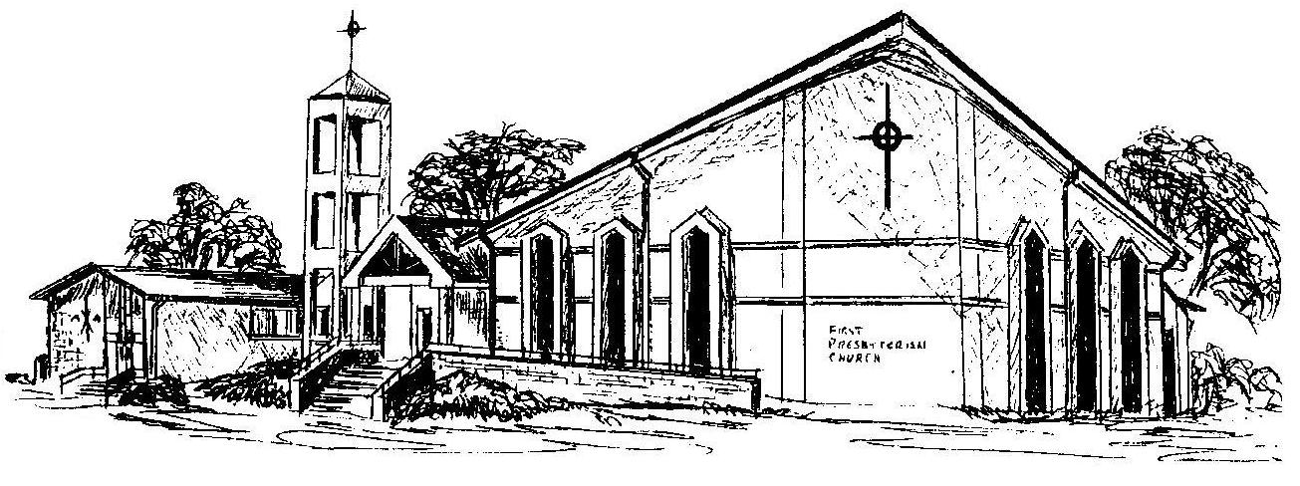

Welcome - Thank you for joining us for worship today. Please fill out a visitor information card found in the pew racks and place those in the offering plate so that we may follow up with you in the future. Your presence with us today has been a blessing to us, we hope that you have felt the presence of God and the welcome of this congregation.

