Welcome

Prelude “
Let us prepare our hearts and minds for worship.

Call to Worship and Lighting of the Advent Wreath -
Leader: Jesus said, “I am the Light of the World,
whoever follows me will not walk in darkness, but will have the light of life.”
People: Today, we light the first candle on our Advent wreath.
Leader: We remember the prophets’ hope based on God’s promise to send a Messiah,
one who would bring peace and love to the world.
People: The first light reminds us that God’s promises are still true for us today.
Leader: Wait and hope, for Jesus Christ is coming.
People: Come Lord Jesus, Light of the World!

*Opening Hymn: “O Come All Ye Faithful” Red Hymnal, # 145

*Prayer of Confession (Unison)
Hope of the World, through long generations, prophets foretold your coming. Those same prophets call us to live in your light and walk in your ways. Again and again you tell us “Do not be afraid.” Yet we fear the darkness, even though your light is stronger. We doubt your presence, even when your Spirit fills us with grace. Make us bold to share the hope you have given in Jesus Christ our Prince of Peace, born to save the world. Amen.

*Silent Reflection

*Assurance of Pardon

*Gloria Patri (Glory Be to the Father…) Red Hymnal, #623

Children’s Time

Scripture “Micah 5:2-5a” (page 1445)
“Luke 1:67-79” (page 1590)
“John 6:32-35” (page 1657)
“John 6:47-58” (page 1658)
Leader: The word of the Lord.
People: Thanks be to God.

Choir Anthem

Sermon: “Bethlehem - House of Bread” Rev. Kimby Young

*Profession of Faith The Apostle's Creed Red Hymnal, inside back cover
I Believe in God the Father Almighty, Maker of heaven and earth, and in Jesus Christ his only Son our Lord; who was conceived by the Holy Ghost, born of the Virgin Mary, suffered under Pontius Pilate, was crucified, dead, and buried; he descended into hell; the third day he rose again from the dead; he ascended into heaven, and sitteth on the right hand of God the Father Almighty; from thence he shall come to judge the quick and the dead. I believe in the Holy Ghost; the holy catholic Church; the communion of saints; the forgiveness of sins; the resurrection of the body; and the life everlasting. Amen

*Hymn “Come, Thou Long Expected Jesus” Red Hymnal, # 124

Offertory Meditation: “

*Doxology

The Sacrament of Holy Communion and Remembrance of Saints
(All bread is gluten free. Prepacked elements are available in the back)
Invitation
Great Prayer and The Lord’s Prayer
Words of Institution – Breaking of Bread
Communion of the People
Prayer of Thanksgiving

*Closing Hymn: “O Little Town of Bethlehem” Red Hymnal, # 141

*Benediction

*Postlude “
*Those who are comfortably able will please stand.

Rev. Kimby Young, Pastor; , Worship Assistant
Chancel Choir; Dean Faulk, Music Ministries;
Alice Rollf, Organist; Robyn Forkner, Pianist
Mike McGuire and Brad Cornell, Slide Production; Kim Liu. Sound

Childcare is always available in the nursery (off the hall to the west of the sanctuary). Children are welcome to stay in the sanctuary thru the whole service, or to leave at any time. Allison Perry is our primary childcare attendant.

Worship Bags for Children are available outside the north door to the sanctuary. Choose books, crayons, pencils, Legos, stuffed toys and other items to fill your bag to use during worship.

Offering Plates are at the entrance of each aisle for your contributions to the work of the church.

A "Suggestion Box" is outside the office for ideas, comments, questions, and thoughts. Contents will be reviewed at session meetings on the 2nd Monday of each month.

Elder On Call Mitch McSwane will be in the narthex this Sunday morning between services to answer questions and hear ideas or concerns.

Women of Faith Book Club The next book club will be held on Thursday, December 5 at 6:30p.m. at the home of Jennifer Waites. The book is "Two from Galilee" by Marjorie Holmes. All are welcome. Please join us.

Ladies Christmas Luncheon: Saturday, December 7th at 12:00 noon. Mark your calendars!

Presbyterian Women Mitten Tree. Please bring scarves, gloves, mittens, winter items. They will be delivered to different Gardner schools.

Wednesday Music Rehearsals - Bell Choir is at 6:00 p.m., Christmas Cantata is at 7:00 p.m., Choir is at 8:00 p.m.

Christmas Poinsettias for Sanctuary cost $13.00 in memory of or in honor of someone special due by Monday, December 2.

Session has called a Congregational Meeting for Sunday, December 8 at 9:45a.m. at the end of the first service for the purpose of electing an Associate Pastor Nominating Committee.

Gardner Children’s Christmas Project gift requests are in. Take a tag from the tree in the narthex and return the gift by December 8.

Sunday Potluck Brunch, December 15, 11:00 a.m. or at the end of the Cantata and Worship.
Bring a main dish, side dish, salad or dessert to share. Bring a friend or family members.

Christmas Caroling - Sunday December 22, 4-6 p.m. with hot chocolate after in fellowship hall.

December 15, December 22 and December 29 - One Worship Service at 10:00 a.m.

Christmas Eve Service, Tuesday, December 24, 4:30 p.m. – Communion and Candlelight Worship
First Presbyterian Church
In the heart of Gardner since 1866 ~ Serving from the heart of God
First Sunday of Advent,
December 1, 2024
8:45 AM

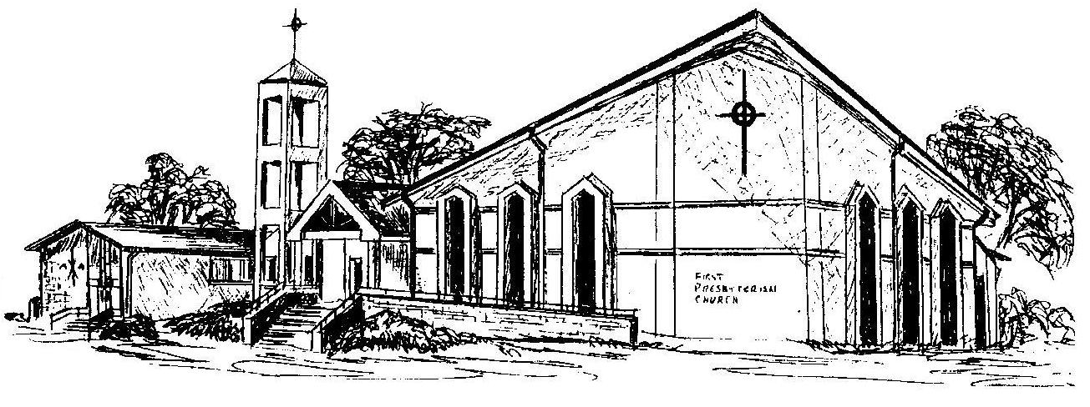
Welcome - Thank you for joining us for worship today. Please fill out a visitor information card found in the pew racks and place those in the offering plate so that we may follow up with you in the future. Your presence with us today has been a blessing to us, we hope that you have felt the presence of God and the welcome of this congregation.

