Welcome
Prelude “Little Prelude in G Minor”
J.S. Bach / arr. by L.N. Porter
Let us prepare our hearts and minds for worship.

Call to Worship:
Leader: Today we gather around God's table from every corner of the earth.
People: We are the People of God!
Leader: Though we differ in many ways, we come together to worship a God who knows and loves us all.
People: We are brothers and sisters in Christ!
Leader: For there is one Lord, one faith, and one baptism.
People: One God and Savior of us all! Let us worship God.

*Opening Hymn: “Guide Me, O Thou Great Jehovah” Red Hymnal, #51

*Prayer of the Confession (Unison)
Great God of all the world, we know that you call us to be one world community, inviting all people into your love and abundance. Help us on this Worldwide Communion Sunday to hear your call to unity and to respond. Help us to be open to your world in all its diversity, and to share generously the gifts you have given, that all may know your mercy and grace, through Jesus Christ our Lord. Amen.

*Silent Reflection

*Assurance of Pardon

* Gloria Patri (Glory Be to the Father…) Red Hymnal, #623

Children’s Time

Scripture “Isaiah 58:6-12” (page 1153)
“Matthew 14:13-21” (page 1520)
“Matthew 15:32-38” (page 1522)
Leader: The word of the Lord.
People: Thanks be to God.

Music “Come to the Table”
Words and music by Ben McDonald, Dave Frey and Ben Glover; arr.by David Wise

Sermon “Feed the World” Rev. Kimby Young

*Profession of Faith The Apostle's Creed Red Hymnal, inside back cover
I Believe in God the Father Almighty, Maker of heaven and earth, And in Jesus Christ his only Son our Lord; who was conceived by the Holy Ghost, born of the Virgin Mary, suffered under Pontius Pilate, was crucified, dead, and buried; he descended into hell; the third day he rose again from the dead; he ascended into heaven, and sitteth on the right hand of God the Father Almighty; from thence he shall come to judge the quick and the dead. I believe in the Holy Ghost; the holy catholic Church; the communion of saints; the forgiveness of sins; the resurrection of the body; and the life everlasting. Amen

*Hymn “In Christ There Is No East or West” Red Hymnal, #285

Offertory Meditation “Bread of the World”
John S.B. Hodges / arr. by Gilbert M. Martin

*Doxology

The Sacrament of Holy Communion
(All bread is gluten free. Prepacked elements are available in the back.)
Invitation
Great Prayer and The Lord’s Prayer
Words of Institution – Breaking of Bread
Communion of the People
Prayer of Thanksgiving

*Closing Hymn: “Let Us Break Bread Together” Red Hymnal, #323

*Benediction

Postlude “A Psalm of Thanksgiving” Roger C. Wilson
*Those who are comfortably able will please stand.

Rev. Kimby Young, Pastor; Larry Schick, Worship Assistant; Chancel Choir
Alice Rollf, Organist; Robyn Forkner, Pianist; Dean Faulk, Music Ministries
Mike McGuire and Brad Cornell, Slide Production; Kim Liu, Sound

The flowers given today are to the “Glory of God” in loving memory of Pastor Emeritus Rev. Charles A. & Mrs. Minnie Ashmore, flowers given by children Karen, Sheryl, Steve.
Childcare is always available in the nursery (off the hall to the west of the sanctuary). Children are welcome to stay in the sanctuary thru the whole service, or to leave at any time. Allison Perry is our primary childcare attendant.

Worship Bags for Children are available outside the north door to the sanctuary. Choose books, crayons, pencils, Legos, stuffed toys and other items to fill your bag to use during worship.

Offering Plates are at the entrance of each aisle for your contributions to the work of the church.

A "Suggestion Box" is outside the office for ideas, comments, questions, and thoughts. Contents will be reviewed at session meetings on the 2nd Monday of each month.

Elder On Call Linda Wolf will be in the narthex this Sunday morning between services to answer questions and hear ideas or concerns.

Womens Fall Book/Bible Study through October 24th at 6:30 p.m. in Fellowship Hall. Study book “The GOD We Can Know” by Rob Fuquay.

On-line Bible study group will start a new study, "From Beginning to Forever - A Study of the Grand Narrative of Scripture", on Oct. 8th. Meeting on Tuesday evening at 6:00 p.m. Interested in joining should email Jennifer Waites at jwaitemail@hotmail.com.

Women of Faith Book Club The next book club will be held on Thursday, December 5 at 6:30p.m. at the home of Jennifer Waites. The book is "Two from Galilee" by Marjorie Holmes. All are welcome. Please join us.

Mitten Tree Watch for the Mitten Tree in early November. New stocking hats, mittens and gloves will be collected for students in need.

Bell Choir will rehearse at 6:00 p.m., Christmas Cantata will rehearse 7:00 p.m., Choir will rehearse 8:00 p.m.

Men’s Breakfast Tuesday, October 8, at Perkins 7:00 a.m. Come and join in the Fellowship. It is an opportunity to get to know one another and to build a stronger community of faith.

Faith and Blue Event – October 13 - 1:00 – 3:00 p.m. at the Gardner Justice Center.

Trunk or Treat and Chili Supper Return! October 27
Halloween All Church Celebration – Sunday, October 27
5-6:00 p.m. – Trick-or-treat and Games – North Parking Lot
5:45-7 p.m. –Chili Supper – Fellowship Hall
Mark your calendar! Save the date.

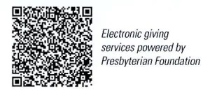
First Presbyterian Church
In the heart of Gardner since 1866 ~ Serving from the heart of God

Sunday, October 6, 2024
8:45 AM
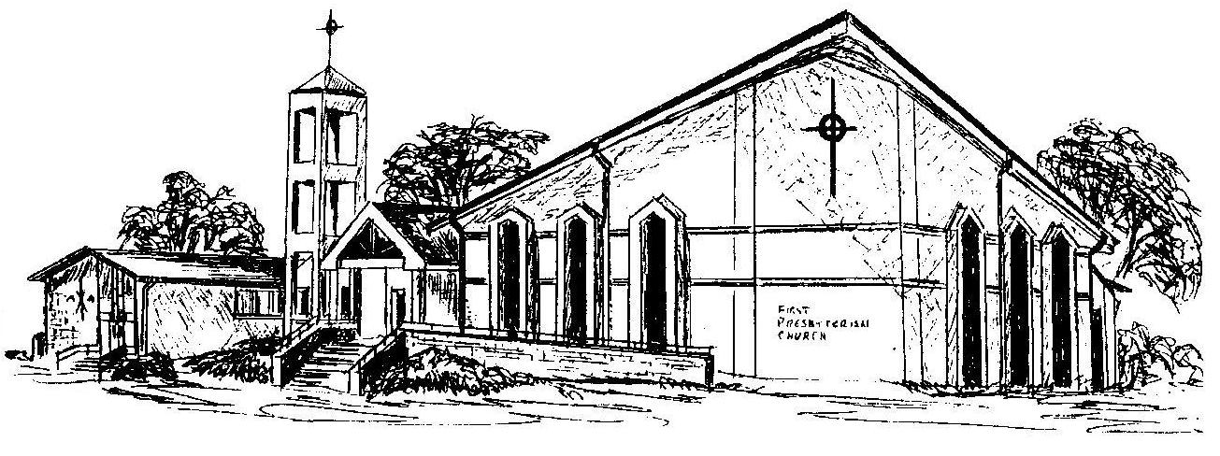

Welcome - Thank you for joining us for worship today. Please fill out a visitor information card found in the pew racks and place those in the offering plate so that we may follow up with you in the future. Your presence with us today has been a blessing to us, we hope that you have felt the presence of God and the welcome of this congregation.

