FIRST PRESBYTERIAN NEWSLETTER JUNE 2024

June is Busting Out All Over – by Kimby Young
The Rodgers and Hammerstein song from the musical “Carousel” keeps rolling through my mind these days. June is a wonderful month as we enter into summer. The church is busting with activities. People are busy. Life is full. Join us for church activities listed below. And if you are traveling, be sure to look for signs of the presence of God with you.
June is also a great time to dig a little deeper into faith. If you are out enjoying God’s creation, be sure to thank God and to listen for God’s voice. If you have a little free time, consider a mission project or a helping hand. Let me know if you need some ideas. Join us each Sunday, or whenever you are available. If you are not able to be here on a Sunday, praise God wherever you are, and know that you are loved. Most of all share that love all summer, any way you are able. Be joyful and generous as you share the love of God.

Scripture for Upcoming Worship
June 2 - communion - Psalm 23; Matthew 26:26-30 - Overflowing Cup
June 9 - Genesis 45:4-13; 50:20 - Gods Plan for good
June 16 - Father's Day - Isaiah 40:28-31; Eph 3:14-21 - Roots and Wings
June 23 – Ecclesiastes 3:1-15; Phil 1:2-11 – Life Goes On
June 30 - guest preacher - Sarah Evans

Upcoming events. (Some of these dates and times are tentative and may change.)
Sunday, June 9 – Scout Pancake breakfast fundraiser 9:30 a.m. – 1:00 p.m.
Friday, June 21 –4:15 p.m. – 6:00 p.m. - Picnic for members and guests at the close of TDC
Sunday, July 7 – 9:45 a.m. - 10:30 a.m. - Ice Cream social between services
Saturday, August 3 – morning - JOCO Fair Parade and FPC entry
Saturday, August 17 – Holy Smokes BBQ and Music

Vacation for Pastor Kimby
Kimby will take a week of vacation from June 24-30. Guest preacher for the week June 30 will be Sarah Evans who has preached here several times. Please plan to come and welcome Sarah.

Elders On Call
Communication is key to any church. As we look to the future, session members are trying to hear and understand congregational perspectives. We are working on listening as well as speaking clearly. To that end, the session has decided to be visibly available each Sunday morning. Beginning in June, at least one currently serving session member will be available in the narthex to hear your thoughts, joys and concerns. Please stop by to visit, to share a little fellowship, and to ask questions or share your thoughts.

Fellowship for All
We are trying to reestablish a “fellowship hour” after the first service and before the second service every Sunday. We are asking various groups and individuals to volunteer to host occasionally. We now have enough volunteers that the rotation is about every other month. If you are willing to help make coffee and set up treats, please contact the church office. If you don’t feel up to hosting but would be willing to help clean up at 11 or noon, please contact the office. If you aren’t able to help physically, but would like to support this opportunity financially, mark your donations, “fellowship”. Whether you can host or not, plan to join us each Sunday in the narthex between services.

Monthly Financial Report
At the end of April 2024 our records indicate:
total income this month is $ 18,375.62
total expenses this month is $ 20,793.99
The session and finance/operations pillar thank each of you for your contributions to the church – financial or any other contribution. A complete line-by-line expense report is available upon request. We will close finances for May after June 3.

Summer Finances and Additional Giving
Giving is always down in the summer, but expenses remain high. This always adds a little stress to the Finance and Operations Pillar and Session as we try to balance the budget. If you plan to be away, consider sending in your pledge early. Also consider giving a little extra in the regular offering to compensate for our expenses. Any extra giving is greatly appreciated. If you are not able to give, please pray for our church and all of our operations and missions. Your session strives to be good stewards of all of God's gifts. We appreciate your partnership in ministry and mission. Thank you for all of your gifts and prayers. May you be blessed.

SAS – Summer Adventures on Sunday
Another Great Year for Learning
Starting June 2 – 10 a.m.
Join us for summer intergenerational class for kids of all ages at 10 a.m. each Sunday. Parents, grandparents, and friends are welcome. We will all be together to sing, pray, play, create and learn. Each week will stand alone, so come when you are able. Leaders and helpers are also needed. You may take one week to plan and lead, or multiple weeks to lead or help. Talk to Kimby Young or Marsha Cooper if you are interested.

Church Family and Friends - End of TDC Picnic – Everyone Welcome!
Friday, June 21, 4:15 – 6:00 p.m.
Just for fellowship and fun!
We are inviting all the families of the Traveling Day Camp to join our church family and friends for a wonderful celebration. Join us on Friday, June 21, 4:15 – 6:00 p.m. We plan to be on the lawn, but will move to fellowship hall if weather requires. Hot dogs, chips, water, and lemonade will be provided. Bring your own lawn chair or blanket for outside.

Teachers for Fall
We are beginning the process of recruiting teachers for next year for Sunday School. Several of our teachers are returning, but we could use a few new teachers. We plan to keep the same age ranges of classes – Preschool, Elementary (1-4) and Middle School (5-8). High School youth will again be invited to help lead and teach. We welcome regular weekly teachers or occasional substitutes. If you would be willing to teach, to assist, or to substitute, please speak to Pastor Kimby Young, Marsha Cooper, or to anyone on the Discipleship Pillar to volunteer.

Nominating Committee
Nominating Committee is about to start the process of looking for elders and deacons for the class of 2027 to begin serving in January 2025. If you have a name to suggest, if you would be interested in serving, or if you would like more information about what is involved in these service positions, please contact the church office or anyone on nominating committee. This year’s committee includes Karen Elliott, Lynn Moldrup, Carl Frahme. Paula Waters, Larry Atwater, Robin Tropansky, Phil Lenahan, Lois Barber, and Pastor Kimby Young.

Multi-Church School Supply Drive
Hope Market
Pocket folders (with out brads)
We are joining several Gardner churches in collecting school supplies for an area giveaway through Hope Market (Food Pantry). We have been assigned to supply 850 pocket folders. You are invited to contribute either cash or folders. With the financial donations we will buy folders in bulk to add to any folders you bring in. Our contribution is due by June 17. Please bring in your donations right away. There will be another opportunity later in the summer to contribute a variety of school supplies for area schools.

Prayer Request Tammy Clark, for the family of Jim Corwin, Marna Miller, Clinton Campbell, Larry Gaston, Jerry Beach, Rhonda Krehbiel, Poppy Zurcher, Jim Applegarth, Karen Erwin, Henry Marrant, Jessic Zahn, Debbie Edmonson, Teresa, Rita Catalona, Nikki Villa, Maureen Hoover, Christine Curran, Susan Gash, Dennis Chambers, Susan Wilson-Dierksen, Karl Morrison Jerry Seim, Abe Portenier, Amanda Allen, LeMoyne Zimmerman, Mike Judah, Dozer Reed. Trinity D’Autorio, Skyla D’Autorio, Jackson Tijerina, Reagan Barnadt, Steve and Laurie Holben
Ushers for Month of June 8:45 a.m.
Gary and Jan Richardson, Linda Wolf, John Forkner
Women Fellowship Group will meet on Wednesday, June 5 at 10:00 am. in Fellowship Hall. We will enjoy a morning of fellowship, devotions by Teri Winegar, and refreshments provided by Paula Waters. The Fellowship group will furnish cookies for the Traveling Day Camp. We are reminding everyone to bring 3 bags/boxes of cookies to the June meeting. We appreciate your contribution. The women’s Fellowship Group meet March – November in Fellowship Hall. This group is open to all women of the church. Our purpose is to provide care and support for the mission and service projects of the church. Please plan to attend!

Women’s Book Club will meet on Thursday, June 20th from 6:00pm-8:00pm at the Gardner Library Meeting Room. The book will be "And the Shofar Blew" by Francine Rivera.

Men’s Fellowship Breakfast at Perkins 7:00 a.m. Tuesday, June 11. All men are welcome for fellowship and good food. We pay for our own food and meet in the closed room on the west side of the restaurant and bring a friend!

Cub Scout Pack 3088 is hosting a Pancake Breakfast/Brunch on Sunday, June 9th, from 9:30 a.m. to 1:00 p.m. here at our church. For $5 per plate you'll receive 2 pancakes, 2 meat (bacon, sausage, or 1 of each), eggs, and coffee or milk. Please help support our local youth in their adventures to learn about citizenship, sportsmanship, outdoor skills, performing service projects, and so much more. Thanks, Ashley Reynolds, Pack 3088 Committee Chair.

Ladies Community Luncheon on Saturday, June 15, 2024, at 11:30 a.m. at Divine Mercy Parish, 555 W. Main, Gardner, KS 66030. Door opens at 11:00 a.m. call the office at 913-856-7781 to make reservations. Theme: Guard your Heart and Your Mind (Philippians 4: 7-9) Speaker Emily Lopez.


Store Hours
MONDAY 10 – 7
TUESDAY` 10 – 7
WEDNESDAY 10 – 4
THURSDAY 10 – 7
SATURDAY 10 - 2
For I was hungry and you gave me something to eat, I was thirsty and you gave me something to drink, I was a stranger and you invited me in,
I needed clothes and you clothed me. Matthew 25:35-36 NIV

This scripture inspires our efforts. Helping others, showing that we care, spreading the love of Christ: whether someone is in need of free basics (clothing, bedding, and shoes) or simply needs a convenient place to shop for bargains, we are there. When people in the community need a donation center, we are honored that they support our mission with goods to give to the needy and to sell so that our mission continues.
Volunteers needed:
- Back-room volunteers needed Tuesday from 5 until closing.
- Back-room volunteers needed Thursday from 10 until 1.
- Sorters specifically for women’s clothing.
- Sorter in bedding to prepare items for the shopping floor.
- Purse sorter needed, Wednesday, Thursday, or Saturday.
Other ways to serve: Take-home Jobs – ways to serve from at home. Did you know that there are ‘take home’ jobs? While much of our donations are sorted on the site, some items need special care. Some things need sorted, taken apart, tied together, checked to see if they function, or polished in some way.  There are many ways to serve. Check with Cindy if you might help! | Donation Greeter during our busiest times: a smile and words of appreciation needed! We are blessed with many donations and want those who contribute to know how greatly we appreciate their contributions. This can be someone who might not do all of the lifting or carrying, just greet the people who bring in donations and let someone inside know that help is needed in getting items inside.  We can provide a chair! Get more info from Cindy.
 | JOY Closet was able to provide five graduating seniors from Gardner Edgerton High School with $1,500 scholarships for the coming year.  Three of the winners are beginning a traditional four-year college program and two of the students have chosen to study a trade in a vo-tech or two-year program.  We share their excitement as they become leaders in our community. Thank you to all who support JOY Closet and its mission of community outreach.
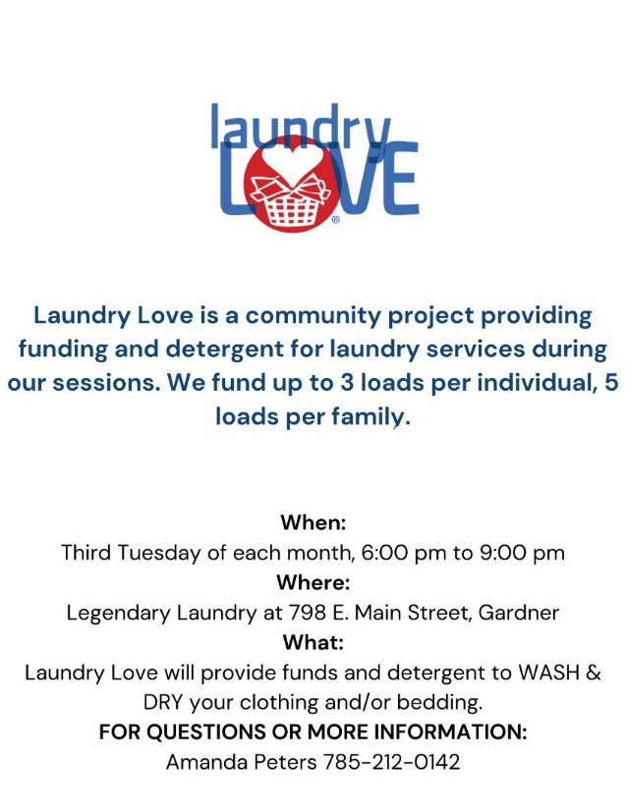
Reminder: Laundry Love
has started!
Laundry Love provides the detergent and JOY Closet will fund the quarters.

The families handle all of the laundry and the volunteers put the quarters in the machine.
Conversations and becoming acquainted are encouraged!

If I had clean clothes, people would treat me like a human being.

Want to help?
JOY Closet Family

The remarkable thing about working with people who give of their time is that you learn so much from them about sharing and caring. It is almost guaranteed to make you feel better. Some things are little: Remarks like, “Here, I can do that for you. Let me help.” But it is the heartfelt moments: someone asking for prayer, sharing that they have lost someone, and seeing the comments on the volunteer group. It touches the heart. Hearing people refer to it as the JOY Closet family lets us know that great things are happening. We are blessed beyond words.

If you haven’t joined us yet, know that you would be welcome.
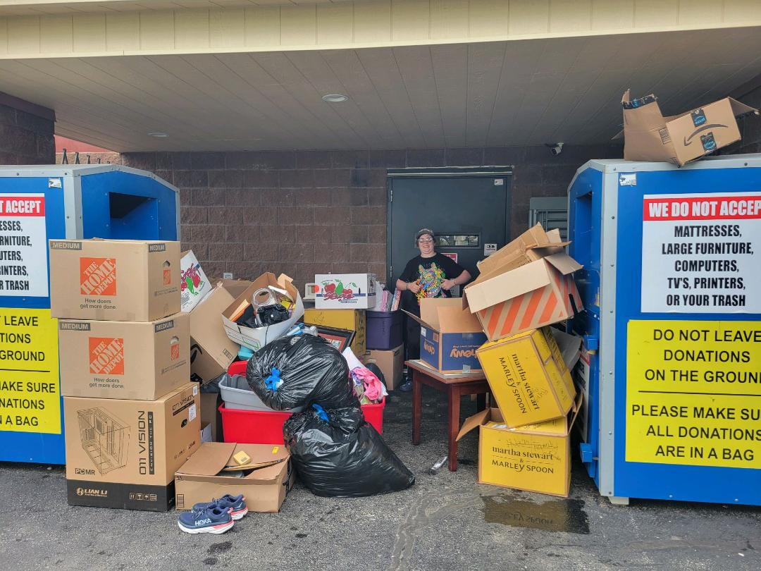
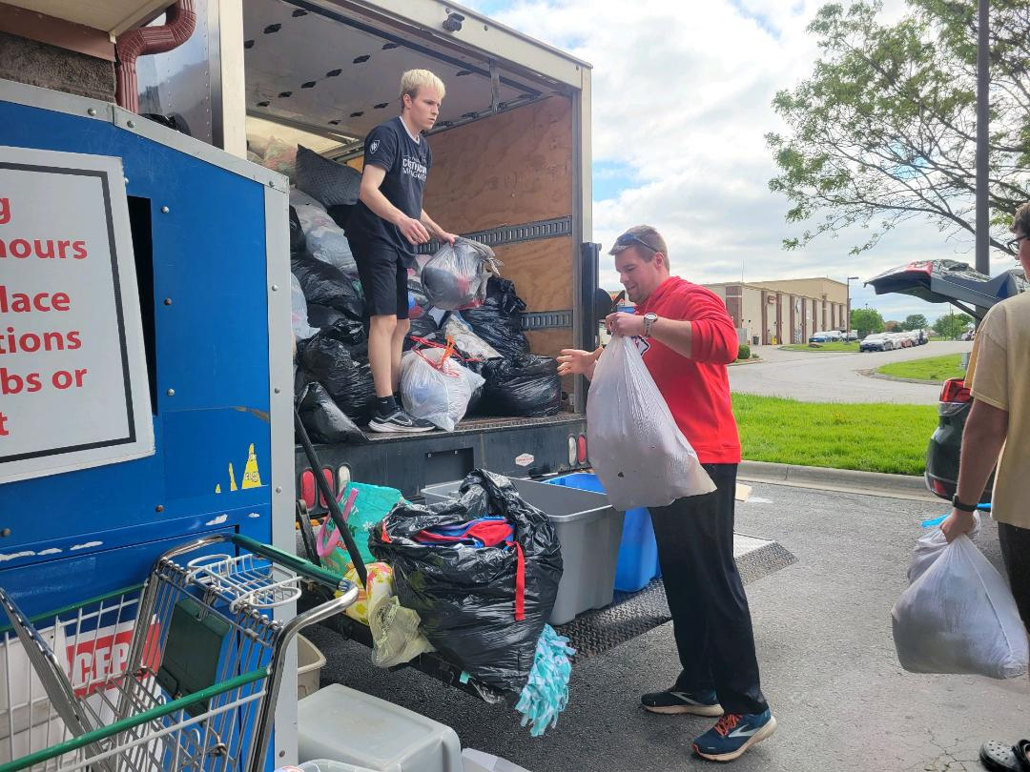
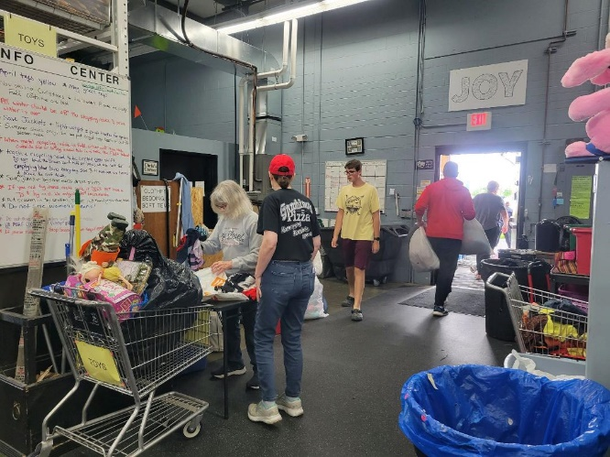
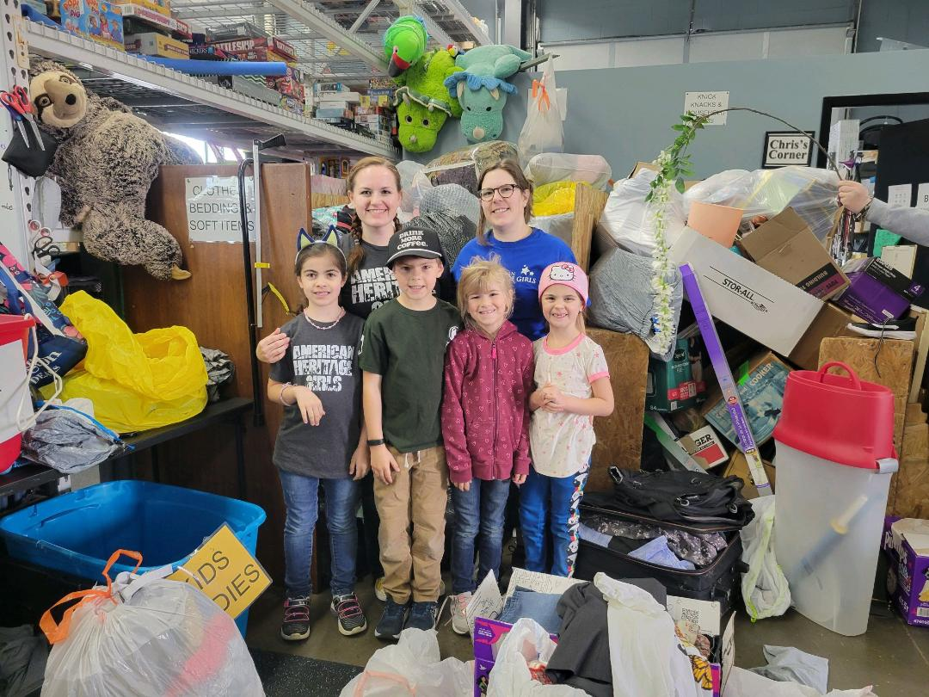
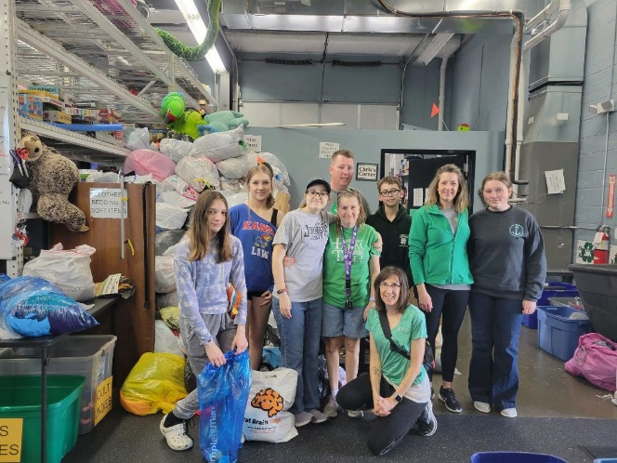
Thanks to our volunteer groups who help: Prairie Moon 4-H, New Life volunteers, American Heritage girls, and the great volunteers of Garage Sale Saturday!
To all of our regular volunteers who show up and put their hearts into helping… you are deeply appreciated!
Many hands accomplish great things! Thank you!
For I was hungry and you gave me something to eat, I was thirsty and you gave me something to drink, I was a stranger and you invited me in, I needed clothes and you clothed me.

Matthew 25:35-36 NIV

JOY Closet Is a ministry of

First Presbyterian Church of Gardner, KS
Serving our community since 2013

