Welcome

Prelude “The Church's One Foundation”
Samuel S. Wesley / arr. Steven Scott
Let us prepare our hearts and minds for worship.

Call to Worship
Leader: This Reformation Sunday, we gather remembering God’s grace for many generations.
People: We remember God’s presence and look forward to the future God has promised.
Leader: We remember that we are one in Christ and it is Christ alone who saves us.
People: We celebrate the Church that was, the Church that is, and the Church that yet will be, to the glory of God.

*Opening Hymn: “A Mighty Fortress Is Our God” Red Hymnal, #26

*Prayer of Confession (Unison)
God of Formation and Reformation, we give thanks for the Church Universal and for this our local church in Gardner. We know that we are not perfect, that we have made mistakes, and that we sometimes have not lived up to your high calling. We pray, forgive us and reshape us again. Help us to make amends for any wrong we have done. Inspire us to be the best that we can be. Open our hearts to your transformation that we may become your grace filled servants, sharing your love and working for your justice, through Jesus Christ our Lord. Amen.

*Silent Reflection

*Assurance of Pardon (from 1 John 1:8-9)
Leader: If we say that we have no sin, we deceive ourselves, and the truth is not in us.
People: If we confess our sins, God, who is faithful and just, will forgive our sins, and cleanse us from all unrighteousness.
Leader: Friends, hear and believe the good news of God’s amazing grace.
People: In Jesus Christ we are forgiven and set free to wholeness and new life.

*Gloria Patri (Glory Be to the Father…) Red Hymnal, #62

Children’s Time

Scripture “Hebrews 11:1-12” (page 1874)
Leader: The Word of the Lord.
People: Thanks be to God.
Anthem “Jesus Loves Me “ arr.by Michael Hassell

Sermon “Looking Back and Looking Forward” Rev. Kimby Young

*Profession of Faith The Apostle's Creed Red Hymnal, inside back cover
I Believe in God the Father Almighty, Maker of heaven and earth,
And in Jesus Christ his only Son our Lord; who was conceived by the Holy Ghost, born of the Virgin Mary, suffered under Pontius Pilate, was crucified, dead, and buried; he descended into hell; the third day he rose again from the dead; he ascended into heaven, and sitteth on the right hand of God the Father Almighty; from thence he shall come to judge the quick and the dead.
I believe in the Holy Ghost; the holy catholic Church; the communion of saints; the forgiveness of sins; the resurrection of the body; and the life everlasting. Amen

*Hymn “Have Thine Own Way” Red Hymnal, #371

Pastoral Prayer & Lord’s Prayer

Offertory Meditation: “My Faith Looks Up to Thee” Lowell Mason

*Doxology

*Prayer of Dedication

*Closing Hymn: “God of Our Fathers” Red Hymnal, #573

*Benediction

Postlude “Go Forth in Triumph” Franklin Ritter
*Those who are comfortably able will please stand.

Rev. Kimby Young; Karl Allen, Worship Assistant
Dean Faulk, Music Ministries, Chancel Choir
Alice Rollf, Organist
Mike McGuire and Brad Cornell, Slide Production
Davis Tropansky & Theo Borge, Tech and Videographer; Kim Liu, Sound

Childcare is available in the nursery (off hall west of the sanctuary). Children are welcome to stay in the sanctuary, or to leave at any time. Allison Perry is our primary childcare attendant.

Offering Plates are at the entrance of each aisle for your contributions to the work of the church.

Gardner Multi Service Center collection is ongoing every week and is always in need of any non-perishable food. Bring something every week or once a month.

Fair Trade Products for Sale on Sundays Coffee, tea, chocolate, nuts, olive oil, dried fruit, baking products, and a few other items are for sale each Sunday at church.

Harvesters Food Distribution is always seeking volunteers. Every 3rd Saturday at Trade Net Parking lot and every 4th Wednesday at Divine Mercy Parish. Distribution begins at about 1 p.m.

Our church is serving at the Joy Closet on the 4th Saturday of every month. Just show up anytime between 10:00 – 2:00 p.m.

Women’s Bible Study meets every Thursday, at 6:30 pm in Westminster Room. We are studying the book Desperate for HOPE by Vaneetha Risner.

Choirs meet on Wednesday’s Bell Choir at 6:00 p.m. in Chapel, Chancel Choir at 7:00 p.m. in Sanctuary, Christmas Cantata at 8:00 p.m.

Sunday School for all ages. 10:00 a.m. Children & Youth classes meet downstairs.

Trunk or Treat – Sunday, October 29 5:00 -7:00 p.m. Sign up in the narthex to help.
5:00 – 5:45 p.m. Trick-or-treat and Games in North Parking Lot
5:45 – 7:00 p.m. Chili Supper in Fellowship Hall

Monday online Bible Study 6 p.m. on October 30, contact Jennifer Waites for login information. jwaitemail@hotmail.com.

Women Fellowship Group meets on Wednesday, November 1 at 10:00 a.m. in Fellowship Hall.

Ladies Night Out hosted by Presbyterian Women Thursday, November 2 at 6:30 p.m. Potluck Bring a salad to share. Making Thanksgiving wreaths for shut ins, friends or yourself.

Daylight Savings Time Ends– Sunday November 5, don’t forget to move your clocks back one hour, so you will make it to church on time.

Give Thanks to the Lord, Stewardship Dedication Sunday, November 12. Financial Support, time, talents, property and prayer.

Operation Christmas Child Packing Party – November 12 – 9:45-11 a.m.
YOU ARE ALL INVITED TO A PACKING PARTY for Operation Christmas Child.
First Presbyterian Church
In the heart of Gardner since 1866 ~ Serving from the heart of God

Sunday, October 29, 2023
Reformation Sunday
8:45 AM

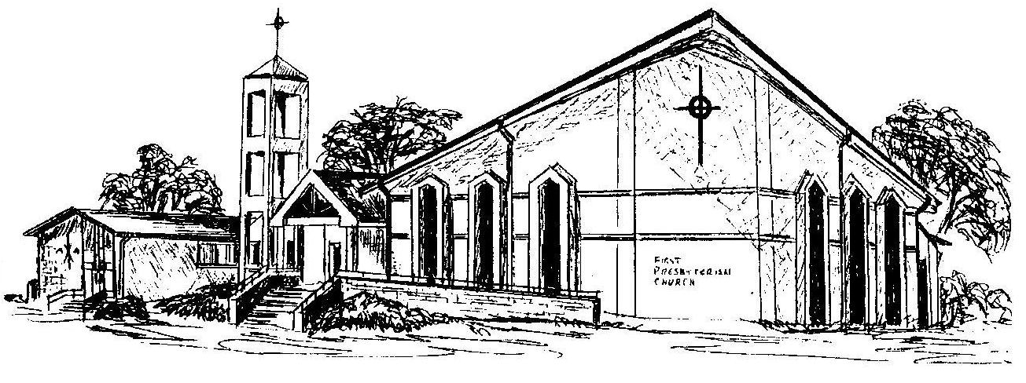

Welcome - Thank you for joining us for worship today. Please fill out a visitor information card found in the pew racks and place those in the offering plate so that we may follow up with you in the future. Your presence with us today has been a blessing to us, we hope that you have felt the presence of God and the welcome of this congregation.

