Welcome

Prelude *“This is My Father's World”*

English  melody/adapted by F.L. Sheppard

*Let us prepare our hearts and minds for worship.*

Call to Worship (inspired by Psalm 46 and 121)

Leader: Our “God is our refuge and strength, our very present help in times of trouble.

**People: Therefore, we will not fear, for God is with us, our help and our redeemer.**

Leader: Be still, and know that God is with us.

Be confident, and know that God loves you.

**People: We trust in the Lord, our help and our hope. We lift our eyes to the Lord.**

*Opening Hymn: *“Come Christians Join to Sing”* Red Hymnal, #108

*Prayer of Confession (Unison)

**Very Present God, we know that you are with us. We know that you love us. But sometimes we forget. We fail to turn to you. We look everywhere else but to your grace. We are slow to trust and quick to fear. Turn our eyes to your will. Turn our hearts to your way. Remind us again of your unfailing mercy. Calm us. Fill us. Inspire us by your Spirit, through Jesus Christ our Savior. Amen.**

*Silent Reflection

*Assurance of Pardon

*Gloria Patri *(Glory Be to the Father…)* Red Hymnal, #623

Children’s Time

Scripture  *“1 Kings 18:25-29”* (page 557)

*“Psalm 121”* (page 965)

Leader: The Word of the Lord.

**People: Thanks be to God.**

Music *“Unseen Blessings”* arr. by Mark Hayes

Sermon*: “Lift My Eyes”* Rev. Kimby Young

*Profession of Faith The Apostle's Creed Red Hymnal, inside back cover

**I Believe in God the Father Almighty, Maker of heaven and earth,**

**And in Jesus Christ his only Son our Lord; who was conceived by the Holy Ghost, born of the Virgin Mary, suffered under Pontius Pilate, was crucified, dead, and buried; he descended into hell; the third day he rose again from the dead; he ascended into heaven, and sitteth on the right hand of God the Father Almighty; from thence he shall come to judge the quick and the dead.**

**I believe in the Holy Ghost; the holy catholic Church; the communion of saints; the forgiveness of sins; the resurrection of the body; and the life everlasting. Amen**

*Hymn *“God Will Take Care of You”* Red Hymnal, #47

Pastoral Prayer & Lord’s Prayer

Offertory Meditation:  *“Unto the Hills”* Velma Russell

*Doxology

*Prayer of Dedication

*Closing Hymn: *“Spirit of God, Descend Upon My Heart”* Red Hymnal, #249

*Benediction

Postlude *“God of Glory”* Gertrude Haupt Richolson

*Those who are comfortably able will please stand.

Rev. Kimby Young, Pastor; Rhonda Atwater, Worship Assistant

Dean Faulk, Music Ministries, Rhonda Atwater, Solo

Alice Rollf, Organist

Mike McGuire and Brad Cornell, Slide Production

Davis Tropansky, Tech and Videographer; Kim Liu, Sound

**Childcare is available in the nursery** (off hall west of the sanctuary).  Children are welcome to stay in the sanctuary, or to leave at any time. Allison Perry is our primary childcare attendant**.**

**Offering Plates** are at the entrance of each aisle for your contributions to the work of the church.

**Scripture for Upcoming Worship**

September 3 - Labor Day Weekend - Call to Justice - Psalm 82

September 10 – Rally Day - -Door Keeper in God's Home- Psalm 84 and 90

September 17 - Be Still and Know God is - Psalm 46

September 24 - In the Shadow of the Most High -Psalm 91

**Gardner Multi Service Center** collection is ongoing every week and is always in need of any non-perishable food. Bring something every week or once a month.

**Fair Trade Products for Sale** on Sundays Coffee, tea, chocolate, nuts, olive oil, dried fruit, baking products, and a few other items are for sale each Sunday at church.

**Harvesters Food Distribution** is always seeking volunteers. Every 3rd Saturday at Trade Net Parking lot and every 4th Wednesday at Divine Mercy Parish. Distribution begins at about 1 p.m.

**SAS – Summer Adventures Sunday, Learning Event for all Ages 10:00 a.m.**.

**Our church is serving at the Joy Closet** on the 4th Saturday of every month. Just show up anytime between 10:00 – 2:00 p.m.

**Thursday Morning Bible Study, 10 – 11:30 a.m.** Starting September 7 for the school year. Pastor Kimby Young will teach the Gospel of John. Please sign up on the sheet in the narthex.

**Grief Support Group** on Thursday, August 31 at 6:30 p.m. at Church. No pre-registration. Meet every other Thursday. See Brenda Jones or Terri Winegar if you have any questions.

**Women’s Book Club August 30, 6:30 p.m.** at Gardner Library “Round the Corner”

**Women’s Bible Study** will begin Thursday, September 14, at 6:00pm in Westminster Room and will meet for 7 sessions. We will be studying the book **Desperate for HOPE** by *Vaneetha Risner*. There is a signup sheet in the Narthex.  Contact Lynn Moldrup for a copy of the book $20.

**The Message in the Hymnal,** Phil Lenahan leading tonight, Aug. 27, 6:30 p.m. in Fellowship Hall.

**Holy Smokes Saturday, September 16 5:00 – 8:00 p.m.** BBQ & music on the lawn.

**Choirs start Sept. 6** Bell Choir at 6:00 p.m. in Chapel, Vocal Choir at 7:00 p.m. in Sanctuary.

**Women Fellowship Group** will meet on Wed., Sept. 6 at 10:00 a.m. at Vintage Park.

First Presbyterian Church

*In the heart of Gardner since 1866 ~ Serving from the heart of God*

*Sunday,* *August 27, 2023*

*8:45 AM*

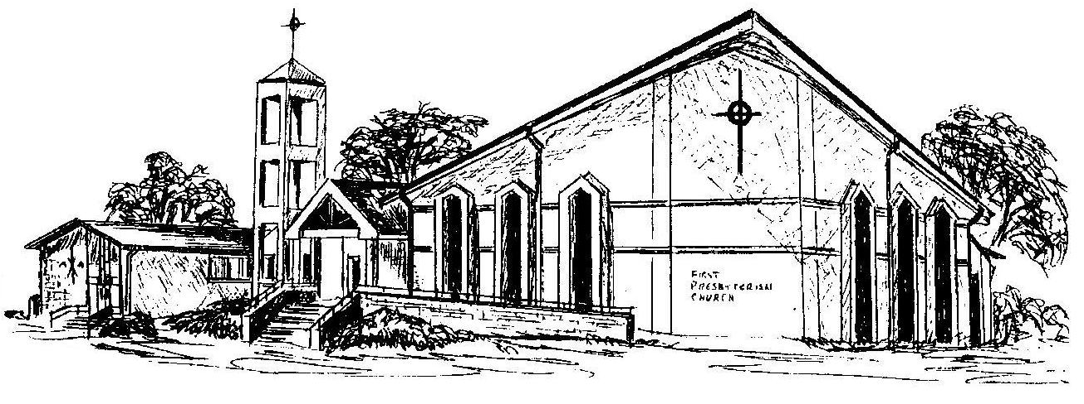

**Welcome -** Thank you for joining us for worship today.  Please fill out a visitor information card found in the pew racks and place those in the offering plate so that we may follow up with you in the future.  Your presence with us today has been a blessing to us, we hope that you have felt the presence of God and the welcome of this congregation.