First Presbyterian Newsletter July 2023

Everything Has Changed – by Kimby Young
Most of you know that my beloved older sister Candy died unexpectedly on June 22. Her passing came as a complete shock. People ask what they can do, and I can’t think of a thing but prayer. I promise to let you know if I think of anything. I will ask for help. I will need help.

There is a song that has been in my head all week. It is from the movie Frozen 2. In the Frozen series, I have always identified with Anna – the ditzy lovable happy little sister of the tremendously powerful and mysterious queen who loved fiercely and protectively, who kept fears and secrets hidden, and who learned that love saves everything. In Frozen 2 there is a point when Anna thinks Elsa has died. She sings a heart rending song that says so much of what I am feeling now.

The Next Right Thing – sung by Kristen Bell. Songwriters: Robert Lopez, Kristen Jane Anderson.
I've seen dark before, but not like this. This is cold, this is empty, this is numb.
The life I knew is over, the light's are out. Hello, darkness, I'm ready to succumb.
I follow you around, I always have. But you've gone to a place I cannot find.
This grief has a gravity. It pulls me down. But a tiny voice whispers in my mind.
"You are lost, hope is gone But you must go on And do the next right thing"
Can there be a day beyond this night?
I don't know anymore what is true. I can't find my direction, I'm all alone
The only star that guided me was you.
How to rise from the floor When it's not you I'm rising for?
Just do the next right thing, take a step, step again.
It is all that I can to do the next right thing.
I won't look too far ahead. It's too much for me to take.
But break it down to this next breath, this next step, This next choice is one that I can make.
So I'll walk through this night Stumbling blindly toward the light. And do the next right thing.
And with the dawn, what comes then?
When it's clear that everything will never be the same again.
Then I'll make the choice To hear that voice And do the next right thing.

One agony that hit me early on was that I would never hear my sister’s voice again – her strong beautiful tender voice. I will never sing with her, never receive her advice, never hear her fantastic laugh. At least in this world I will never hear her voice. The song talks about a voice whispering to move forward. I hear that. My sister was always the voice of encouragement, wisdom and hope. In the days ahead, I will be trying to hear that voice whispering in my mind. I know she would try to give me that grace, even now if she could. I know that God is also pouring out grace. I know all of you will help me find that next right step – whatever it is. I know that you will be patient with me as I stumble and you will help me when I fall. I feel deeply supported and loved right now. Thank you for everything. You are a great blessing to me. For now, I’m just trying to take the next breath, the next choice, the next step. Thank you for walking with me.

Scripture for Upcoming Worship
July 2 – Guest Preacher Jennifer Baer
July 9 – Acrostic Psalms and Hebrew Poetry - Psalm 111, 112, and 119:105
July 16 – Personal Lament - Psalm 6, 13, 142
July 23 - Lament of the community - Psalm 22 band 137.
July 30 - National and Nature Psalms - Psalm 1, 2, 8, and 78.
August 6 – one service at 10 a.m. - PYF: Mission Trip Report

Children’s Ministry and Families of Faith – by Kimby Young
I am writing this during Traveling Day Camp within ear range of 50 delighted children singing praise to God. I marvel at the young helpers and leaders. They have such beautiful hearts for serving God and loving children. Of course, it would not happen without the commitment and leadership of Kim Liu, Karen Liu, Robyn Tropansky and Marsha Cooper. They have a passion for sharing their love of Jesus with the next generation that is marvelous to watch.

I must admit TDC week brings flashbacks from many many years of ministry. I started out in children’s ministry 40 years ago. Before seminary I taught Sunday School, VBS and children’s music. My first job after seminary included organizing the children and youth programs. I still remember fondly some of “my kids” from that first church. Three of them grew up to be church education directors. It makes me wonder which of our campers this week might become ministers or music directors or elders or deacons or teachers or whatever else. I suspect God will continue to spark love in their young hearts that will bloom and flourish for years to come.

Discipleship Pillar (committee) is wrestling with ideas about how best to meet the needs of children, youth and families in our church. Some of our “tried and true” activities from 40 and 50 years ago, don’t work for families today. We may try a few more experiments in the next year or so. If you have some ideas or would like to be a part of the planning, let me know. New members are welcome on the pillar at any time.

We recognize that as our children and youth go, so our church goes. If we grow in faith together, the church will flourish as we reach out in the world to share God’s grace. Pray for inspiration and participation as we move forward together. God has us well in hand. Let us trust God and reach out in love.

Monthly Financial Report
At the end of May our records indicate:
total income this month is $ 19,403.28
total expenses this month is $ 20,887.50
The session and finance/operations pillar thank each of you for your contributions to the church – financial or any other contribution. A complete line by line expense report is available upon request. We will close finances for June after July 6.

Summer Finances and Additional Giving
Giving is always down in the summer, but expenses remain high. This always adds a little stress to the Finance and Operations Pillar and Session as we try to balance the budget. If you plan to be away, consider sending in your pledge early. Also consider giving a little extra in the regular offering to compensate for our expenses. Any extra giving is greatly appreciated. If you are not able to give, please pray for our church and all of our operations and missions. Your session strives to be good stewards of all of God's gifts. We appreciate your partnership in ministry and mission. Thank you for all of your gifts and prayers. May you be blessed.

The Message in the Hymnal, Phil Lenahan, leading, on Sunday, July 16, 2023 6:30 p.m. in the Fellowship Hall. Everyone is welcome. Coffee & cookies
SAS – Summer Adventures on Sunday
Learning Event for All Ages
Every Sunday in July – 10 a.m.
Our Summer Adventures on Sunday at 10 a.m. have been going well thanks to the organization of Marsha Cooper. Join us for an experimental summer intergenerational class for all ages at 10 a.m. each Sunday. We will all be together to sing, pray, play, create and learn together. Each week will stand alone, so come when you are able. Leaders and helpers are also needed. Talk to Kimby Young or Marsha Cooper if you are interested.

PYF Mission Trip Worship Presentation
August 6, 2023 – 10 a.m. Worship
One Worship Service
Our youth will lead worship on Sunday August 6 at 10 a.m. to share their experiences of their mission trip to Columbia, South Carolina from July 8-17 to serve with Next Step Ministries. Mark your calendars for August 6 at 10 a.m. for one service. Please come support our youth as they lead us in worship.

Communion Service – July 2 and July 30 – both services
Because of the PYF presentation on August 6, we will move communion forward one week. Communion will be offered two Sundays in July – July 2 and 30. Communion will not be offered in August.

Teachers for Fall
We are beginning the process of recruiting teachers for next year for Sunday School. We plan to change the age ranges of classes to expand to three age groups – Preschool, Elementary (1-4) and Middle School (5-8). High School youth will be invited to help lead and teach. Our teachers from last year are returning for the youngest and the oldest groups. We need a new regular weekly teacher and a regular weekly helper for the Elementary group. If you would be willing to teach, to assist, or to substitute, please speak to Pastor Kimby Young or to anyone on the Discipleship Pillar to volunteer.

Johnson County Fair Parade – IS BACK!! August 5 10am-noon
Planning meeting for float – Wednesday, July 12 at 7 p.m. at church
After COVID delay and a main street reroute – the parade will be held this year with a new route. This year the parade is on Saturday, August 5. Mark your calendar and plan to join us walking or riding bikes in the parade. We want to be represented again, sharing good will in our neighborhood. It is a great way to get our name out in town. We are still deciding what to give away this year. We will collect candy all month to add to our handouts. If you would like to work on a team to put together an entry for the 2023 parade, please come to the meeting on July 12 or contact Oliver Schwab.

Johnson County Fair Walk About
Friday August 4 2023 – 10a.m. and 1p.m.
Karl Allen and Karen Elliott are offering a Fair Tour for church members and friends during fair week. All ages are welcome. Karl will talk about some of the history and the animal details. Karen will talk about the 4H and extension buildings and shows. They will show and tell around the barns and behind the scenes, so you can get an up close look at the Johnson County Fair. Right now they need a tentative sign up of who might be interested, so they know what kind of preparations to make. (strollers, walkers, seats, interests, etc.) Speak to Karl or Karen or call the office if you are interested.

BBQ and Music Festival Community Event
Planning Volunteers Needed
September 16 – 5-8 p.m.
We are planning a community celebration hosted on our lawn on Saturday, September 16. The plan is to invite all the area churches to bring musicians, so we can enjoy and praise God together. We will provide a stage, a lawn, and outdoor games. We will cook hot dogs and burgers. Bring potluck sides, chairs and lots of friends. If you would like to be a part of the planning group for this event, contact the church office.

New Picture Directory Task Group forming
We want to put together a current picture directory. Currently we are exploring an internet based option that can be updated throughout the year by individual members. There is a great deal of “set up” to start this process. If you would be willing to be a part of a group to move this process along, please contact pastor Kimby or the church office.

Nominating Committee
Nominating Committee has started the process of looking for elders and deacons for the class of 2026 to begin serving in January 2024. We have quite a few openings to fill this year. If you have a name to suggest, if you would be interested, or if you would like more information about what is involved in these service positions, please contact the church office or anyone on nominating committee. Linda Wolf is moderator, working with Larry Atwater, Alice Rollf, Lynn Moldrup, Karen Elliott, Carl Frahme, Robin Tropansky, Paula Waters and Pastor Kimby Young.

Prayer Requests: the family of Candis Lochmann, sister of Kimby Young, the family of Larry Zimmerman, Erin Moore, Mike Fraser, Kelly Johnson, Ashleigh Martin, Linda Rosine, Harold Farren, Gary Richardson, Jon Deiley, Nick McSwane, Larry Gaston, Madelon Browning, Mary Dean, Jim Corwin, Valerie Taylor, Ellie Johnson, Dustin Toman, Arlene Carroll, Skyla D’Autorio, Richard Hatfield, Abe Portenier, Amanda Allen, Steve and Laurie Holben, LeMoyne Zimmerman, Mike Judah, Dozer Reed, Trinity D’Autorio, Jackson Tijerina, Reagan Barnadt.

Women Fellowship Group will meet on Wednesday, July 5 at 10:00 am. in Fellowship Hall. We will enjoy a morning of fellowship and fun. Please bring a pair of scissors to use. Devotions by Paula Waters and refreshments provided by Teri Winegar. Women Fellowship Group meet March – November in Fellowship Hall. This group is open to all women of the church. Our purpose is to provide care and support for the mission and service projects of the church. Please plan to attend.

Women of Faith Book Club
New members are welcome to join anytime. Our first book is The Sister Circle (Book 1) by Nancy Moser and Vonette Bright. There are several ways to participate in the Book Club. Read the book and meet with us on Wednesday, July 26 at 6:30. At Teri Winegar’s home 720 N. Walnut St, Gardner, Ks 66030. The first half of meeting we will discuss the book and 2nd half socialize and eat snacks. Contact Jo Lynn at 913-226-5954 and ask her to send you this link specific for the Women of Faith Book Club. There is no charge. Once a member of the Book club app you will see our members, what we are currently reading, upcoming meetings, Polls for our next book to read, club messages and books we want to read.
Please contact Jo Lynn Clark if you have any questions:
913-226-5953
Jolynn.clark50@gmail.com
Joy Closet is in need of volunteers on Saturdays, once a month, twice a month or weekly, from 12:00 – 2:00 p.m. to help accept and bring in donations. If interested they can contact Joy Closet, Cindy Rollf (913) 638-7989 or Ginger Crist (913) 207-4401. Matthew 25:36 I needed clothes and you clothed me.
Moved - Teresa Rezac we built a house at my family farm between Topeka and Manhattan and moved a couple of weeks ago. I want to thank everyone for the fellowship, support and encouragement that I received during my time with the church.
Thanks You for everything!!! Teresa
Men’s Fellowship Breakfast at Perkins 7:00 a.m. Tuesday, July11. All men are welcome for fellowship and good food. We pay for our own food and meet in the closed room on the west side of the restaurant and bring a friend!

Need Help
Tony and Jennifer Waites are looking for some extra hands to help with projects around their property such as staining pasture fence; cleaning out a small pond; trimming up around trees; moving/stacking wood and branches, etc. No specific skills are necessary but do need to have your own transportation. $20/hour. If interested, please contact Jennifer at jwaitemail@hotmail.com.

The Presbyterian Youth Fellowship will be traveling to Columbia, South Carolina on a ten day mission trip in July. Seven youth and two adults will leave July 8th and return on July 17th. During the week of service with Next Step Ministries the group will join several other youth groups from across the county, working alongside existing helping agencies in the city. The mission team will lead a single worship service on Sunday, August 6th at 10am to share their experience with the congregation and the community. Please pray for the group while they are gone and come celebrate with them upon their return!

Birthday Celebration for Sharon Frahme
There will be a celebration of Sharon’s 80th birthday in the Fellowship Hall of First Presbyterian Church Gardner on Saturday, July 22, 2023 from 2-4 p.m. Come join the family for snacks and fellowship. Please- no gifts. This is not a “surprise” party. Please RSVP to Erin Moore (daughter) at yellowrose98@gmail.com or (913) 424-3771.

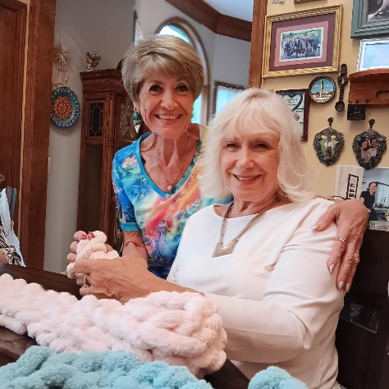
Prayer Shawl Ministry
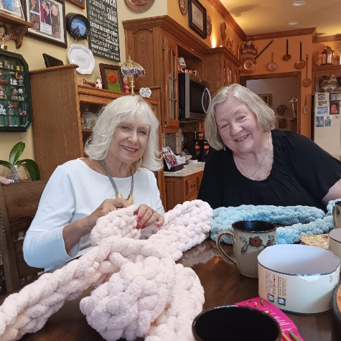
Poppy Zurcher hosted a recent meeting of ladies that are interested in creating prayer shawls. A wonderful time was had by all as we attempted to replicate her skills. Interested in joining us? We’d love to have more in our group. Please contact Poppy at 913-541-1239.

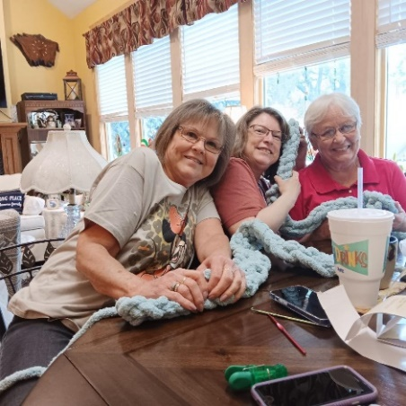
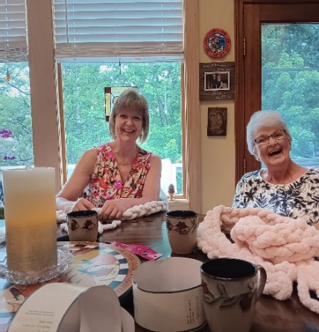
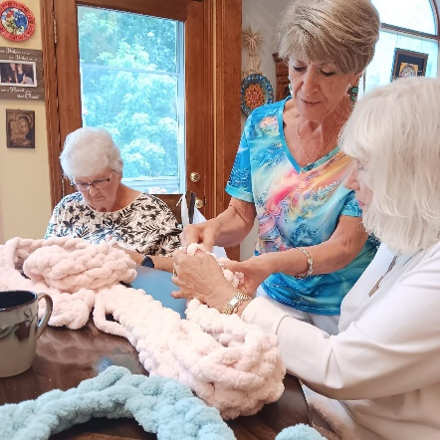

Attention Ladies of Retreat time is approaching for our Retreat, August 18, 2023. The payment is due July 9, 2023. We will gather in Fellowship Hall July 6, 2023 at 6:30 pm. Overview of the happenings and update of what you need to have. Looking forward to seeing all as excitement is building! See you July 6, 2023, 6:30pm. Fellowship Hall. God Bless, Paula, Benda, Alice

Store Hours
MONDAY 10 – 7
TUESDAY` 10 – 7
WEDNESDAY 10 – 4
THURSDAY 10 – 7
SATURDAY 10 - 2
Volunteers Needed!!
- Cashier assistant needed - Monday 4 – 7.

- Wednesday – additional volunteers needed in the back anytime from 10 – 4.

- Saturday - need additonal help from 12 – 2. Saturday is an extremely busy time with shoppers on the store floor and new donations coming in the back.
Our volunteers make a difference.
Come join us!


BTS supplies
–on display soon!
– grab them early!

Attention college students:


Looking for awesome items to outfit your dorm room? Our household goods sell quickly! Check back often as inventory constantly changes. Often our preowned items look like new and you can save money for those other necessary expenses.

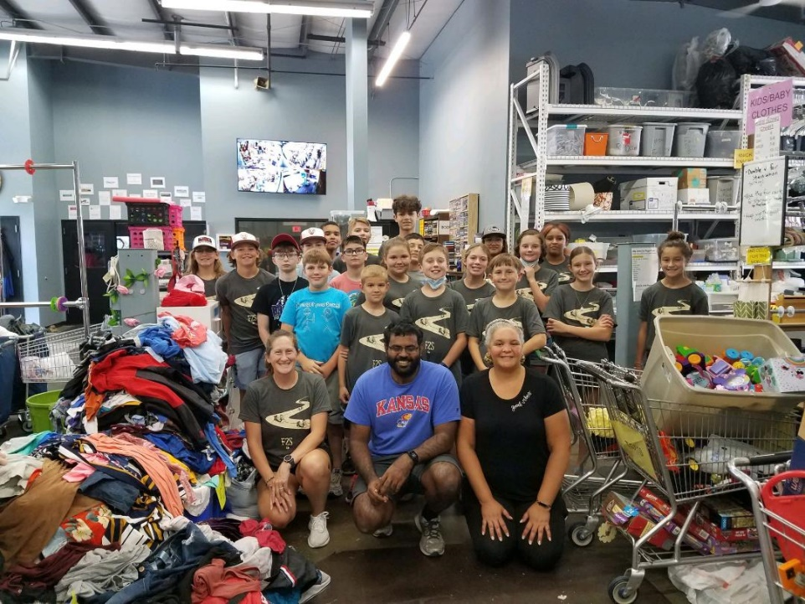
Thanks to the youth from Divine Mercy Catholic Church, who recently brought in donations and sorted under the leadership of Cindy, Nalleli, and Cathy.
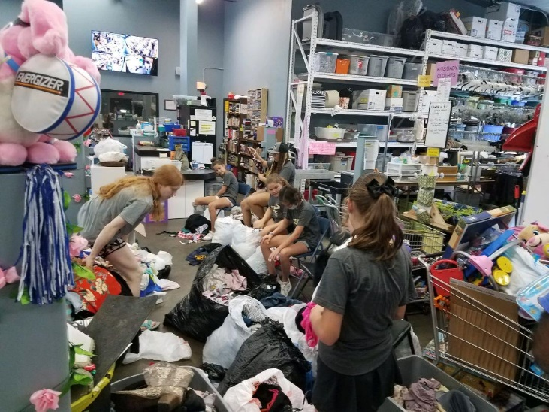

The group accomplished a lot and had fun together.
Thank you!!


Reminder:
4th Saturday of the month- July 22nd-

First Presbyterian Church volunteers!
Mark your calendar!

Moments of JOY:
Recently, a cashier noticed a huge tub of 8-foot burlap-and-lace table runners for sale. A customer came in and shopped awhile, then saw them. She quickly called her relative and became very excited. The person on the phone could be heard and was excited, also. The box was priced at $10. She grabbed it and said ‘SOLD!’
She told the cashier that she was helping her nephew get ready for his wedding, that he lived in California, but the wedding would be in western Kansas, so she was trying to help them out so they could save money and not have to transport everything. The burlap table runners were exactly what they were looking for and they had priced them for $30 a piece! She said her nephew even told her to give us $50 for them! I told her she didn’t need to do that, $10 was fine. She left a very happy customer!!

In contrast to the above story, a recent shopper came in early in the morning, just after being released, and having been given instructions on where to get clothing, bedding, and shoes. The only things he owned was what he was wearing. While we don’t know the beginning of this story or the end of it, we can rest assured that God has put us squarely into the middle of it.
May we continue to bless others as God has blessed us.

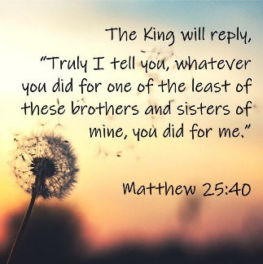
For I was hungry and you gave me something to eat, I was thirsty and you gave me

something to drink, I was a stranger and you invited me in, I needed clothes and you clothed me.

Matthew 25:35-36 NIV

JOY Closet

A ministry of First Presbyterian Church of Gardner, KS

Serving our community since 2013

