Welcome

Prelude *“Love One Another”* Lucaine Clark Fox/arr, Brent Jorgensen

Call to Worship

Leader: Wherever we go God is there; Wherever we are God is here.

**People: We come to worship God, who loved us before we were yet born.**

Leader: We come to worship God, who knows us even better than we know ourselves.

**People: We come to worship God, whose Spirit never leaves us.**

Leader: We come to worship God, whose grace fills us to overflowing.

**People: We come to worship God, whose love for us never ends.**

*Opening Hymn*: “Be Thou My Vision”* Red Hymnal, #382

*Prayer of Confession (Unison)

**Gracious God, we are grateful that you love us. We try to follow where you lead, but often we fail. Forgive us. Call us again. Strengthen us with your presence. Set us on your right path. Help us to recognize justice and to work to make it yours. Embolden our kindness that we may share your grace freely. Walk with us and show us your way of humility. We pray in Jesus’ name and to your glory. Amen.**

*Silent Reflection

*Assurance of Pardon

*Gloria Patri (Glory Be to the Father…) Red Hymnal, #623

Children’s Time

Scripture *“Psalm 139:1-18 and 23-24”* (page 974)

*“Micah 6:8”* (page 1447)

*“1 John 4:7-12*” (page 1902)

Leader: The word of the Lord.

People: Thanks be to God.

Bell Choir *“How Great Thou Art”*

Sermon: *“What Are We Seeking – Seek Jesus; See God”* Rev. Kimby Young

*“We Make the Way By Walking.”*

*Profession of Faith The Apostle's Creed Red Hymnal, inside back cover

**I Believe in God the Father Almighty, Maker of heaven and earth, And in Jesus Christ his only Son our Lord; who was conceived by the Holy Ghost, born of the Virgin Mary, suffered under Pontius Pilate, was crucified, dead, and buried; he descended into hell; the third day he rose again from the dead; he ascended into heaven, and sitteth on the right hand of God the Father Almighty; from thence he shall come to judge the quick and the dead. I believe in the Holy Ghost; the  holy  catholic  Church;  the communion of saints; the forgiveness of sins;**

**the resurrection of the body; and the life everlasting. Amen**

*Hymn *“Just A Closer Walk With Thee”* Red Hymnal, #380

Pastoral Prayer & Lord’s Prayer

Offertory Meditation: *“O, How He Loves You and Me”* Kurt Kaiser

*Prayer of Dedication

*Closing Hymn: *“Jesus Thou Joy of Loving Hearts”* Red Hymnal, #501 verses 1, 2, 5

*Benediction

Postlude: *“Postlude in G”* Gerald Peterson

Annual Congregational Meeting

*Those who are comfortably able will please stand.

*Rev. Kimby Young, Pastor; Paula Waters, Worship Assistant*

*Dean Faulk, Music Ministries; Bell Choir*

*Alice Rollf, Organist, Robyn Forkner, Pianist*

*Mike McGuire and Brad Cornell, Slide Production*

*Davis Tropansky, Tech and Videographer; Kim Liu, Sound*

**Childcare is always available in the nursery** (off the hall to the west of the sanctuary).  Children are welcome to stay in the sanctuary thru the whole service, or to leave at any time.  Allison Perry is our primary childcare attendant.

**Offering Plates** are at the entrance of each aisle for your contributions to the work of the church.

**Gardner Multi Service Center** collection is ongoing every week and is always in need of any non-perishable food. Bring something every week or once a month.

**Souper Bowl of Caring** – Tackle Hunger – bring nonperishable food on or before Souper Bowl, February 12. Food items will be divided between the outdoor food pantry at Joy Closet or the Gardner Multi Service Center. Donations of money will go to the Multi Service Center.

**Fair Trade Products for Sale** on Sundays Coffee, tea, chocolate, nuts, olive oil, dried fruit, baking products, and a few other items are for sale each Sunday at church.

**Harvesters Food Distribution** is always seeking volunteers. Every 3rd Saturday at Trade Net Parking lot and every 4th Wednesday at Divine Mercy Parish. Distribution begins at about 1 p.m.

**Teacher’s Assistant Needed -** for the PreK-2nd Grade Sunday School Class.

**New Membership Class** will be offered on February 12 at 10 a.m. in the chapel. If you would like to learn more about joining the church, you are welcome to join us. You do not have to join to attend the class. If you want to join but that day does not work for you, just let Kimby know and we will find another time.

**Per Capita** - for 2023 is $43.94 per person (GA $9.85, Synod $2.90, and Presbytery $31.19).

**Vacation –** Pastor Kimby Young will have a week of vacation from January 30 to February 5. Jodi Matthews will be filing in the pulpit and for communion on February 5.

**Ash Wednesday worship - February 22** – Two Options for Imposition of Ashes and Communion. Drive through prayer and sacrament – 5:00-6:30 p.m.; Worship in the Sanctuary – 7:00-8:00 p.m.

**Congregational Conversation and Potluck** – February 26 6 p.m., March 25 5 p.m., April 29 5p.m.

**Women’s Fellowship Group;** Join us February 1, 2023, at Teri Winegar’s home 720 N. Walnut Gardner. Enjoy a game of Mexican Train Dominoes. Gather at 11:00 am with a sack lunch! Drinks and dessert will be provided! Please call Teri 785-766-6607, let her know you are coming.

First Presbyterian Church

*In the heart of Gardner since 1866 ~ Serving from the heart of God*

*Sunday,* *January 29, 2023*

*8:45 AM*

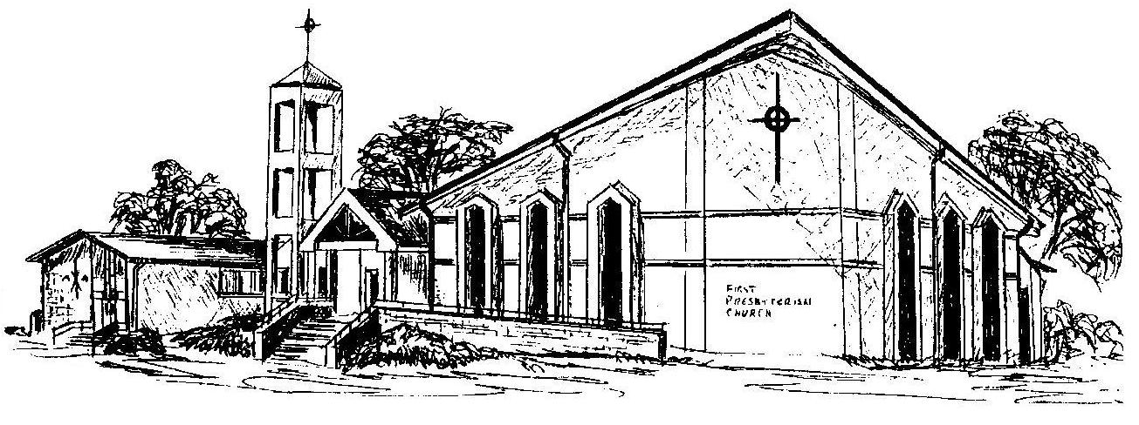

***Welcome -*** *Thank you for joining us for worship today.  Please fill out a visitor information card found in the pew racks and place those in the offering plate so that we may follow up with you in the future.  Your presence with us today has been a blessing to us, we hope that you have felt the presence of God and the welcome of this congregation.*