Welcome & Announcements, Friendship Information, & Sharing Christ’s Peace
Prelude: “Jesu, Joy of Man's Desiring” J. S. Bach

Call to Worship
Leader: For forty years, the people of Israel wandered in the wilderness learning about God’s way.
People: For forty days, Jesus listened in the desert and wrestled with the sin of humanity.
Leader: For forty days of Lent, we intentionally turn toward God, seeking to follow Jesus Christ, to grow in our faith and to live a life of love.
People: We gather to pray and to praise, to sing and to serve, to hear God’s Word and to open our hearts to God’s grace.

*Opening Hymn: “Lord, Who Throughout These Forty Days” Blue Hymnal, #81

* Prayer of Confession (Unison)
God of Love, we get so caught up in our own projects and schemes that we forget to enjoy, or even to notice, the day you have given us. We hold on to righteousness and fail to be right with you and with others. We seek perfection and lose possibility. We try so hard rather than “giving it all to you.” Forgive us. Restore us to the joy of your salvation. Teach us to love and to live as you would have us live, in Jesus Christ our Lord. Amen.

*Silent Confession

*Assurance of Pardon

*Gloria Patri (Glory Be to the Father…) Blue Hymnal, #567

Scripture “Matthew 5:1-10” (page 1501)
“1 Thessalonians 5:9-18” (page 1841)
Leader: The word of the Lord.
People: Thanks be to God.

Bells “What Wondrous Love is This” by Kevin McChesney

Children's Time
Please join in singing one verse of Jesus Loves Me as the children come forward.

Special Music “You Gave Me Love” by Archie Jordan & Clair Clonger

Sermon: “Loving Life: Find Joy” Rev. Kimby Young

*Profession of Faith - from "A Brief Statement of Faith" PCUSA. Book of Confessions.
We trust in God, whom Jesus called Abba, Father.
In sovereign love God created the world good
and makes everyone equally in God’s image,
male and female, of every race and people,
to live as one community.
God acts with justice and mercy to redeem creation.
In everlasting love, the God of Abraham and Sarah
chose a covenant people to bless all families of the earth.
Hearing their cry, God delivered the children of Israel
from the house of bondage.
Loving us still, God makes us heirs
with Christ of the covenant.
Like a mother who will not forsake her nursing child,
like a father who runs to welcome the prodigal home,
God is faithful still.
With believers in every time and place,
we rejoice that nothing in life or in death
can separate us from the love of God in Christ Jesus our Lord.
Amen.

*Hymn “Joy to the World!” Blue Hymnal, #40

Pastoral Prayer & Lord’s Prayer: Please Pray for Rick Marrant, Ed Shank, Lanny John Turner, Debra Murphy Scheumann, Cynthia Miller, Coen Towner, Jeremy Towner, Karen Clark, Karen Elliott, Becky Jones, Leona Faulk, Ruth Chesnut, Mia Volpe, Mary Meinert, Shirley Crane, Lila Orr, Jackie Lang, Chuck Motter, Hudson Inglehart, Glenn Schulz, Reagan Barnadt, Boston DeWald, Brian McManus, David Butler, Margaret Davidson, Roland Jack, Rob Kuhauz, Denny Harris, Richard Hatfield, Jackson Tijerina

Offertory: “Joy of My Desire” J. Randolph

*Doxology Blue Hymnal, #592

*Prayer of Dedication

*Closing Hymn: “Joyful Joyful We Adore Thee” Blue Hymnal, #464

*Benediction

Postlude: “Rejoice, the Lord is King” J. Darwall
*Those who are comfortably able will please stand
Kimby Young, Pastor; Nalleli & Jon Rollf, Worship Assistant; Alice Rollf, Organist
Oliver Schwab, Soloist; Robyn Forkner, Pianist; Dean Faulk, Music Ministries;
Chancel Bells; Heather Rutler, Worship Transcription

Ushers February 2018
Jerry & Paula Waters; Larry Flakus; Kim & Karen Liu; Phil Lenahan

Bible Reading for February 25 is Micah 6:6-8; Matthew 6:33 and Matthew 7:7-12

Monday, February 19: Presbyterian Women Business Meeting 7:00 PM
Tuesday, February 20: Building & Grounds Meeting 7:00 PM
Wednesday, February 21: Bells 6:15 PM; Choir 7:00 PM; Easter Musical 8:00 PM
Thursday, February 22: Women’s Bible Study 7:00 PM
Sunday, February 25: Doughnuts with Deacons in Narthex right after Worship Service

Pastor Kimby's class today at 10:15 in Westminster Room will discuss Heaven and Hell. Next Sunday the topic is suffering and evil.

Ladies’ Thursday Bible Study - Lent and Loving Life
February 22 – March 22 at 7 p.m. Pastor Kimby will teach a five week Bible study for Lent for women. This study will extend the Lenten theme from worship to daily life and explore weekly themes on a deeper level. There is no book required beyond your own Bible. You may miss weeks and not be lost in the study. Guests are welcome. Invite a friend.
February 22 – Lent: Denial vs Abundance – Psalm 51; Matthew 6:25-34

The choir is rehearsing for our Easter Musical on Wednesday evenings at 8:00 p.m. Regular Choir rehearsal will remain at 7:00 p.m. If you would like to join the choir for the Easter Musical please see Dean Faulk for more details.

Ever thought of ringing someone’s bell? Well come on Wednesday evenings at 6:15 p.m. and you can Ring God’s bell with the bell choir. We are looking for new members to enhance the sound of the glorious bells for God. See Dean Faulk for more details.

Sunday Evening Experience (SEE) – begins tonight - with soup at 6 p.m. and worship at 6:30 p.m. Each Sunday during Lent join us for praise and prayer, celebration and discussion.

Confirmation Class – will begin March 5 at 5:30 PM 6th to 12th grade students who would be interested in exploring their faith. Please contact Pastor Kimby.

Financial Report Close of January Income: $28,767.09; Expense: $17,935.97. A full report is available upon request from the treasurer or the Finance & Operations Pillar.

Traveling Day Camp June 18-22 Registration is now open. Sign up soon. Go to: http://www.heartlandcamps.org/traveling-day-camps/#forparents to register campers. When you register your child, remember to fill out the health form also. We do not charge any fees.

Sunday, February 18, 2018
First Sunday of Lent
9:00 AM

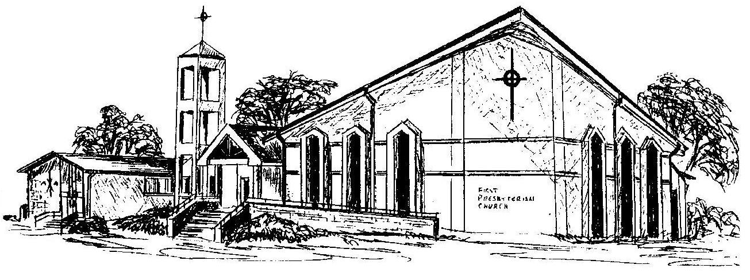

First Presbyterian Church
In the heart of Gardner since 1866 ~ Serving from the heart of God

Welcome - Thank you for joining us for worship today. Please fill out a visitor information card found in the pew racks and place those in the offering plate so that we may follow up with you in the future. Your presence with us today has been a blessing to us, we hope that you have felt the presence of God and the welcome of this congregation.

