Welcome & Announcements, Friendship Information, & Sharing Christ’s Peace
Prelude: “How Great is Our God” Tomlin, Cash, & Reeves

Call to Worship
Leader: Our God appears on the mountain of holiness -
People: Our Awesome God calls us.
Leader: Our God shines in cloud and fire -
People: Our Brilliant God stirs us.
Leader: Our God lives, even among us -
People: Our Gracious God welcomes us.
Leader: People of God, let us respond to God’s movement among us.
People: With confidence in God, we gather to worship and serve.

*Opening Hymn: “Holy, Holy, Holy” Red Hymnal, #262

* Prayer of Confession (Unison)
God of transfiguration and transformation, we seek an experience of your presence. We seek revelation and truth, mystery and power, wisdom and purpose. Stay with us always, as we worship here, and as we go out in the world to share the challenge of living our faith. Turn our fear to courage and our confusion to confidence. Shine in our hearts and in our lives, as your glory shines in the presence of Christ. Amen.

*Silent Confession

*Assurance of Pardon

*Gloria Patri (Glory Be to the Father…) Red Hymnal, #623

Scripture “Psalm 121” (page 965)
“Mark 9:2-9” (page 1567)
Leader: The word of the Lord.
People: Thanks be to God.

Children's Time
Please join in singing one verse of Jesus Loves Me as the children come forward.

Special Music “Higher Ground” arr. by Jeff Wachter

Sermon: “Miracles Reveal: Transformation” Rev. Kimby Young
Imminent, Transcendent

*Profession of Faith The Apostle's Creed Red Hymnal, inside back cover

*Hymn “How Great Thou Art” Red Hymnal, #4

Pastoral Prayer & Lord’s Prayer: Please Pray for the family of Wyona Marksbury, Rick Marrant, Ed Shank, Lanny John Turner, Debra Murphy Scheumann, Cynthia Miller, Coen Towner, Jeremy Towner, Karen Clark, Karen Elliott, Becky Jones, Leona Faulk, Char Bergene, Ruth Chesnut, Mia Volpe, Mary Meinert, Shirley Crane, Lila Orr, Jackie Lang, Chuck Motter, Hudson Inglehart, Glenn Schulz, Reagan Barnadt, Boston DeWald, Brian McManus, David Butler, Margaret Davidson, Roland Jack, Rob Kuhauz, Denny Harris, Richard Hatfield, Jackson Tijerina

Offertory: “Cleanse Me” Maori melody / arr. R. Douglas

*Doxology Red Hymnal, #625

*Prayer of Dedication

*Closing Hymn: “Majesty” Red Hymnal, #74

*Benediction

Postlude: “Awesome God” Rich Mullins
*Those who are comfortably able will please stand

Kimby Young, Pastor; Eric Gourley, Worship Assistant; Alice Rollf, Organist
Chancel Choir; Robyn Forkner, Pianist; Dean Faulk, Music Ministries
Heather Rutler, Worship Transcription

Bible Reading for February 18 Matthew 5:1-10; l Thessalonians 5:9-18

Ushers February 2018
Jerry & Paula Waters; Larry Flakus; Kim & Karen Liu; Phil Lenahan

Lenten Devotion Books are in the Narthex.

Annual Meeting - The session has called for our Annual Congregational Meeting to be held today, with a congregational brunch following the meeting.
Sunday, February 11: No Sunday School
Sunday, February 11: 6:00 PM Concert
Monday, February 12: 6:30 PM Session & Elders Combined Meeting
Tuesday, February 13: 8:00 AM Presbytery 2nd Church, KCMO
Tuesday, February 13: 7:00 AM Men’s Breakfast Perkins

Special Praise Team Concert, tonight, Sunday, February 11, 6 p.m. The Grace Covenant Praise Team, worship band and singers, a fun evening of music and singing. You may sing along or just listen and praise God through music. This will be a wonderful way to spend a midwinter evening. Invite a friend. You will be inspired and blessed by the concert.

Men's Breakfast will meet at Perkin's Restaurant on February 13th at 7:00 AM. Our theme this year is, "Getting to Know You Better". Hope you can be there.

Ash Wednesday Worship, February 14 at 7:00 pm. Join us for prayer, song, impostition of ashes, communion by intinction and reflections with FirstLight.

Lent: Loving Life. February 18 – Find Joy; February 25 – Seek God; March 4 – Share Gifts; March 11 – Spend Time; March 18 – Practice Care; March 25 – Celebrate Life.

The choir is rehearsing for our Easter Musical on Wednesday evenings at 8:00 p.m. Regular Choir rehearsal will remain at 7:00 p.m. If you would like to join the choir for the Easter Musical please see Dean Faulk for more details.

Ever thought of ringing someone’s bell? Well come on Wednesday evenings at 6:15 p.m. and you can Ring God’s bell with the bell choir. We are looking for new members to enhance the sound of the glorious bells for God. See Dean Faulk for more details.

Sunday Evening Experience (SEE) – begins next Sunday, February 18 - with soup at 6 p.m. and worship at 6:30 p.m. Each Sunday during Lent join us for praise and prayer, celebration and discussion.

Confirmation Class - we are gathering names of 6th to 12th grade students who would be interested in exploring their faith. Please contact Pastor Kimby if you are interested or if you have a suggestion of someone to contact.

Financial Report Close of January Income: $22,524.22; Expense: $23,854.09. A full report is available upon request from the treasurer or the Finance & Operations Pillar.

Traveling Day Camp June 18-22 Registration is now open. Sign up soon. Go to: http://www.heartlandcamps.org/traveling-day-camps/#forparents to register campers. When you register your child, remember to fill out the health form also. We do not charge any fees.

Sunday, February 11, 2018
Transfiguration Sunday
9:00 AM

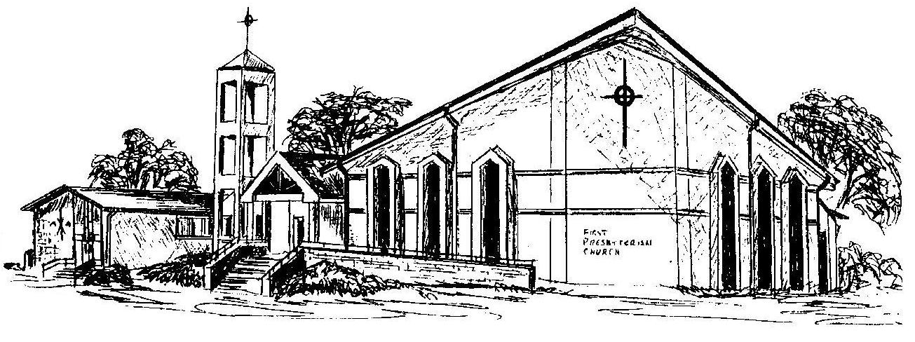

First Presbyterian Church
In the heart of Gardner since 1866 ~ Serving from the heart of God

Welcome - Thank you for joining us for worship today. Please fill out a visitor information card found in the pew racks and place those in the offering plate so that we may follow up with you in the future. Your presence with us today has been a blessing to us, we hope that you have felt the presence of God and the welcome of this congregation.

