Welcome & Announcements, Friendship Information, & Sharing Christ’s Peace
Prelude: “Feed Us Now” R. Mann
Let us prepare our hearts and minds for worship.

Call to Worship
Leader: People will come from east, west, and north and south, to sit at table in the presence of God.
People: We gather – men and women, boys and girls, old and young, feeble and strong – to praise God and to celebrate God’s gifts.
Leader: Come, let us worship God freely and fully together.
People: Let us hear God’s Word and respond to Christ’s call.

Scout Flag Ceremony

*Opening Hymn: “America the Beautiful” Red Hymnal, #572

*Prayer of Confession (Unison)
God of Miracles, we confess that sometimes we fail to believe. We trust what we see and know. We even trust what we fear, more than what you promise. In the presence of your abundance, we still hold back. Forgive us. Nourish us. Fill us again with all that you offer, that we may respond with generosity and joy, in the name of Jesus Christ our Savior. Amen.

*Silent Confession

*Assurance of Pardon

*Gloria Patri (Glory Be to the Father…) Red Hymnal, #623

Scripture “Mark 6:34-44”; “Mark 8:1-8” (page 1562) Leader: The word of the Lord.
People: Thanks be to God.

Children's Time
Please join in singing one verse of Jesus Loves Me as the children come forward.

Special Music “The Work of Christmas” Howard Thurman; by Dan Forrest
When the song of the angels is stilled, When the star in the sky is gone,
When the kings and the princes are home, When the shepherds are back with their flocks,
The work of Christmas begins: To find the lost,
To heal the broken, To feed the hungry,
To release the prisoner, To rebuild the nations,
To bring peace among brothers, To make music from the heart.
Sermon “Miracles: Feeding” Rev. Kimby Young

*Profession of Faith “The Apostle's Creed” Red Hymnal, inside back cover

*Hymn “Break Thou the Bread of Life” Red Hymnal, #274 verses 1, 2, 3

Offertory: “Gentle Shepherd” W. Gaither

*Doxology Red Hymnal, #625

*Prayer of Dedication & Pastoral Prayer Please Pray for Wyona Marksbury, Ed Shank, Lanny John Turner, Debra Murphy Scheumann, Cynthia Miller, Coen Towner, Jeremy Towner, Karen Clark, Karen Elliott, Becky Jones, Leona Faulk, Char Bergene, Ruth Chesnut, Mia Volpe, Mary Meinert, Shirley Crane, Lila Orr, Jackie Lang, Chuck Motter, Hudson Inglehart, Glenn Schulz, Reagan Barnadt, Boston DeWald, , Brian McManus, David Butler, Margaret Davidson, Roland Jack, Rob Kuhauz, Denny Harris, Richard Hatfield, Jackson Tijerina

Communion & Celebration
Invitation
Great Thanksgiving
The Lord’s Prayer
Breaking of Bread
Communion of the People
Prayer of Thanksgiving

*Closing Hymn: “Lord Speak to Me That I May Speak” Red Hymnal, #450

*Benediction

Postlude: “To God be the Glory” Doane / arr. Sergisson
*Those who are comfortably able will please stand

Kimby Young, Pastor; Jessica Brunker, Worship Assistant; Alice Rollf, Organist
Chancel Choir; Robyn Forkner, Pianist; Dean Faulk, Music Ministries
Heather Rutler, Worship Transcription

Bible Reading for February 11, Psalm 121; Mark 9:2-9

Ushers February 2018
Jerry & Paula Waters; Larry Flakus; Kim & Karen Liu; Phil Lenahan

Sunday, February 4: 11:15 AM Discipleship Pillar Meeting
Monday, February 5: 6:30 PM Finance & Operations Pillar Meeting; 6:30 FH Reserved
Wednesday, February 7: 6:15 Bells; 7:00 Choir; 8:00 Easter Musical; 6:30 FH Reserved
Saturday, February 10: 5:00- 9:00 PM Parents Night Out

The 2018 Per Capita is $43.29 is General Assembly $7.73, Synod $2.80, Presbytery $32.76

Annual Meeting - The session has called for our Annual Congregational Meeting to be held next Sunday, February 11 immediately following our regular morning worship service with a congregational brunch following the meeting.

The choir will start rehearsing for our Easter Musical on Wednesday evenings at 8:00 p.m. Regular Choir rehearsal will remain at 7:00 p.m. If you would like to join the choir for the Easter Musical please see Dean Faulk for more details.

Ever thought of ringing someone’s bell? Well come on Wednesday evenings at 6:15 p.m. and you can Ring God’s bell with the bell choir. We are looking for new members to enhance the sound of the glorious bells for God. See Dean Faulk for more details.

Special Praise Team Concert, Sunday, February 11, 6 p.m. The Grace Covenant Praise Team, worship band and singers, have agreed to a special concert. Plan to join us in the sanctuary for a fun evening of music and singing. You may sing along or just listen and praise God through music. This will be a wonderful way to spend a midwinter evening. Invite a friend. You will be inspired and blessed by the concert.

Wednesday, February 14 at 7:00 PM Ash Wednesday Service combined with FirstLight.

Lenten Devotion Books are in the Narthex.

Sunday Evening Experience (SEE) - begins February 18 - with soup at 6 p.m. and worship at 6:30 p.m. Each Sunday during Lent join us for praise and prayer, celebration and discussion. Look for more information in this month's newsletter. Come and SEE.

Confirmation Class - we are gathering names of 6th to 12th grade students who would be interested in exploring their faith during March, April and May. Please contact Pastor Kimby if you are interested or if you have a suggestion of someone to contact.

Financial Report Close of December Income: $22,524.22; Expense: $23,854.09. A full report is available upon request from the treasurer or the Finance & Operations Pillar.

Sunday, February 4, 2018
9:00 AM

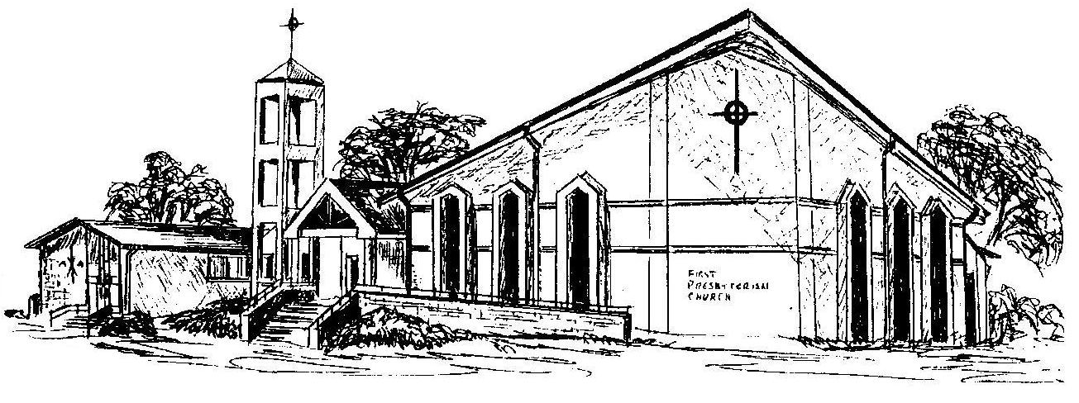

First Presbyterian Church
In the heart of Gardner since 1866 ~ Serving from the heart of God

Welcome - Thank you for joining us for worship today. Please fill out a visitor information card found in the pew racks and place those in the offering plate so that we may follow up with you in the future. Your presence with us today has been a blessing to us, we hope that you have felt the presence of God and the welcome of this congregation.

