Welcome & Announcements, Friendship Information, & Sharing Christ’s Peace
Prelude: “Christians, Awake, Salute the Happy Morn” J. Wainwright
Let us prepare our hearts and minds for worship.

Call to Worship
Leader: Have you heard the glorious news?
People: Jesus Christ is born! Emmanuel, God is with us!
Leader: Wonder of wonders, the Word became flesh and has come to dwell among us.
People: And we have seen Christ’s glory, full of grace and truth!
Leader: Glory to God in the highest,
People: And on Earth peace among all whom God favors!

*Opening Hymn: “Angels We Have Heard on High” Red Hymnal, #132

* Prayer for the day (Unison) (from Bread for the Journey by Ruth Duck)
Amazing God, you have confounded the wisdom of the world by coming to us in the form of a human baby, frail and vulnerable. Help us to comprehend the great love with which you open yourself to our world, that we in turn may risk to open ourselves in love toward all your children, and that we may find the source of our lives in Jesus Christ and the folly of the cross. Amen.

Scripture “Luke 2:21-40” (page 1591)
Leader: The word of the Lord.
People: Thanks be to God.

Children's Time
Please join in singing one verse of Jesus Loves Me as the children come forward.

Sermon: “This Side of Christmas” Rev. Kimby Young

*Profession of Faith The Apostle's Creed Red Hymnal, inside back cover

*Hymn “O Little Town of Bethlehem” Red Hymnal, #141

Pastoral Prayer & Lord’s Prayer: Please Pray for Char Bergene, the family of Christine Chalender, Millard Carlson, Ruth Chesnut, Fred Cox, Mia Volpe, Mary Meinert, Shirley Crane, Aaron Rutler, David Rutler, Vespersia Pennington, Becky Jones, Lila Orr, Jackie Lang, Chuck Motter, Hudson Inglehart, Glenn Schulz, Reagan Barnadt, Boston DeWald, Lanny John Turner, Brian McManus, David Butler, Margaret Davidson, Roland Jack, Rob Kuhauz, Denny Harris, Richard Hatfield, Jackson Tijerina
Offertory: “I Wonder as I Wander” J.J. Niles

*Doxology Red Hymnal, #625

Prayer of Dedication

*Closing Hymn “Good Christian Men Rejoice” Red Hymnal, #151

Benediction

Postlude: “Rise Up, Shepherd, and Follow” Traditional

*Those who are comfortably able will please stand

Kimby Young, Pastor; Bob Bergene, Worship Assistant
Alice Rollf, Organist; Robyn Forkner, Pianist
Dean Faulk, Music Ministries; Heather Rutler, Worship Transcription

Ushers December 2017
Vern & Leone Knabe; Andy & Lois Barber; Corky & Joyce Scarlett

Reading for January 7 is Matthew 2:1-15; Isaiah 60:1-6

Bell Choir and Chancel Choir will resume rehearsals on Wednesday January 10th. Bell choir will rehearse at 6:15 p.m. and the chancel choir will rehearse at 7:00 p.m. New members are always welcome. If you would like to join either choir please see Dean Faulk for more information. We would love to have you.

Wednesday, January 3 Congregational Life Pillar Meeting 6:30 PM.

Financial Report Close of November Income - $24,861.81; Expense - $18,911.69. A full report is available upon request from the treasurer or the Congregational Life Pillar.

Per capita was approved at the stated meeting of the presbytery. Anyone wishing to contribute money to cover expenses for their family or even for additional members who cannot pay, may write a check to First Presbyterian Church and mark it for per capita.
The 2018 Per Capita is $43.29 The allocation breakdown is as follows General Assembly $7.73, Synod $2.80, Presbytery $32.76

Stewardship Pledges - If you have not turned in a pledge card for 2018, please turn one in as soon as possible. Cards are available in the narthex near the name tags. Session will be approving a preliminary budget this week and we would like to have an accurate understanding of possible income. If you would like to talk about your contributions, please contact Pastor Kimby or any member of session.

Church office hours:
January 1 - Church Office Closed

Emergency - If you need Pastor Kimby when the church office is closed, call on cell phone 913-481-7076. Leave a message for call back.

Custodian Leaving - Our church custodian of two years, Steve Winters, has resigned effective December 31. He has served our church well and faithfully. Steve and his wife Karen were a great blessing to our church.

Custodian Needed - If you would be interested in the job of part time custodian, or if you have a name to suggest, please contact Pastor Kimby Young or Phil Lenahan. Hours are flexible and vary from 10-20 hours per week, usually about 12. Some weekend work is needed. Some physical strength and ability are needed. We are considering splitting the job into weekend cleaning and weekday with that is more varied.

Weather Cancellation Policy
Be smart. Be cautious. Don't take any chances. Even if a church event is not cancelled, if you do not feel comfortable getting out, you are excused.
Generally, midweek if school is cancelled, events are cancelled. But discretion is given to event leaders to cancel if needed. Check with the event leader to be sure.
Sunday Worship Service will usually NOT be cancelled (if Pastor Kimby is in town). However, don’t take any chances. If it is very bad, walkways and parking lot may not be cleared. Ushers, musicians and worship leaders are to use their own discretion about attending, and if you don’t feel safe getting out, please stay home. We may modify the service if musicians or other worship leaders cannot make it in or if attendance is very low. Sunday School is more likely to be cancelled if we have a storm.
Check emails, Facebook or the website (www.fpcgardner.church) for announcements about cancellation. Also check KMBC-TV notices. Call Rev. Kimby 913-481-7076, or Connie 913-244-8185.

Noisy Offering Sunday, January 21st. The coins will be collected by our children and youth during worship. This month is to help with Utility Relief for people in our community. Remember to bring your coins to worship on Sunday, January 21, and “make a joyful noise.”

Sunday, December 31, 2017
9:00 AM

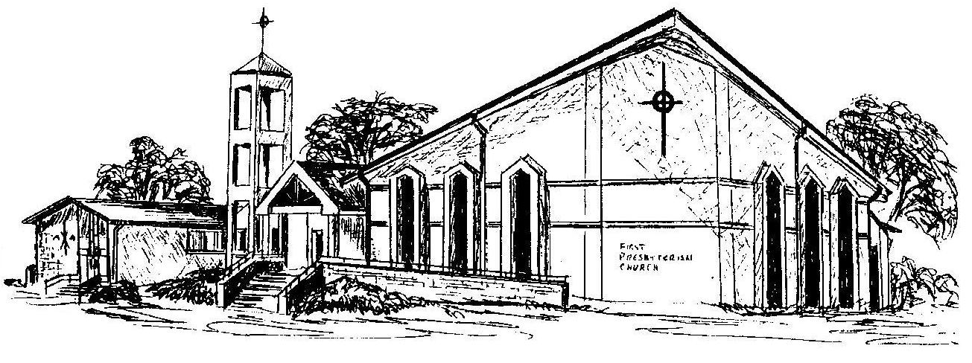

First Presbyterian Church
In the heart of Gardner since 1866 ~ Serving from the heart of God

Welcome - Thank you for joining us for worship today. Please fill out a visitor information card found in the pew racks and place those in the offering plate so that we may follow up with you in the future. Your presence with us today has been a blessing to us, we hope that you have felt the presence of God and the welcome of this congregation.

