Welcome & Announcements, Friendship Information, & Sharing Christ’s Peace
Prelude: “This is My Father's World” Trad. English Melody

Call to Worship
Leader: In the beginning God created the heavens and the earth.
People: And God saw that it was good. Creation was very good.
Leader: In the beginning the Word became flesh and came to dwell among us.
People: Jesus Christ reveals God’s love for us and for all creation.
Leader: We praise God for life and for every day miracles.
People: We praise God with all that we have and all that we are.

*Opening Hymn: “O Sing a Song of Bethlehem” Red Hymnal, #167

* Prayer of Confession (Unison)
God of all creation, we sometimes fail to see your order amid the chaos of our lives. We hear the wind and storm, and do not see YOU standing right before us, coming to be with us. We fear the darkness, rather than turning toward your light. Forgive us. Help us to remember that you can walk on water and calm every storm. Inspire us to step out in faith and to trust in you through Jesus Christ our Savior. Amen.

*Silent Confession

*Assurance of Pardon

*Gloria Patri (Glory Be to the Father…) Red Hymnal, #623

Scripture “Genesis 1:1” (page 1)
“Mark 4:35-41” (page 1558)
“Mark 6:45-51” (page 1563)
Leader: The word of the Lord.
People: Thanks be to God.

Children's Time
Please join in singing one verse of Jesus Loves Me as the children come forward.

Special Music “Cry No More”
Lyrics by Johanna Anderson; Music Dan Forrest

Sermon: “Miracles Reveal: Creation” Rev. Kimby Young

*Profession of Faith The Apostle's Creed Red Hymnal, inside back cover

*Hymn “It is Well With My Soul” Red Hymnal, #493

Pastoral Prayer & Lord’s Prayer: Please Pray for the family of Fred Cox, Debra Murphy Scheumann, Cynthia Miller, Coen Towner, Jeremy Towner, Bob Knoche, Karen Clark, Karen Elliott, Becky Jones, Leona Faulk, Char Bergene, Ruth Chesnut, Mia Volpe, Mary Meinert, Shirley Crane, Lila Orr, Jackie Lang, Chuck Motter, Hudson Inglehart, Glenn Schulz, Reagan Barnadt, Boston DeWald, Lanny John Turner, Brian McManus, David Butler, Margaret Davidson, Roland Jack, Rob Kuhauz, Denny Harris, Richard Hatfield, Jackson Tijerina

Offertory: “The Steadfast Love of the Lord” McNeill
“Great is Thy Faithfulness” Runyan

*Doxology Red Hymnal, #625

*Prayer of Dedication

*Closing Hymn: “Eternal Father Strong to Save” Red Hymnal, #575

*Benediction

Postlude: “He's Got the Whole World in His Hands” Trad. Spiritual / E. Thomas
*Those who are comfortably able will please stand

Kimby Young, Pastor; Cindy Rollf, Worship Assistant; Alice Rollf, Organist
Chancel Choir; Robyn Forkner, Pianist; Dean Faulk, Music Ministries
Heather Rutler, Worship Transcription

Bible Reading for February 4 Isaiah 55:1-3a; Mark 6:30-44

Ushers January 2018
Brad & Amber Cornell, Lynn Moldrup, Debbie Pickell, Bob & Char Bergene

Sunday, January 28: 11:15 AM Worship Pillar Meeting
Wednesday, January 31: 6:15 Bells; 7:00 Choir; 8:00 Easter Musical; 6:30 FH Reserved

The 2018 Per Capita is $43.29 is General Assembly $7.73, Synod $2.80, Presbytery $32.76.

Pastor Kimby's class will meet at 10 a.m. in Westminster room. Upcoming topics: January 28 - faith development theory; February 4 - generational theory; February 11 - no class.
Souper Bowl of Caring is on Sunday, February 4, 2018. Every dollar donated goes to Gardner
Multiservice Center.

The choir will start rehearsing for our Easter Musical on Wednesday January 31, 2018 at 8:00 p.m. Regular Choir rehearsal will remain at 7:00 p.m. If you would like to join the choir for the Easter Musical please see Dean Faulk for more details.

Ever thought of ringing someone’s bell? Well come on Wednesday evenings at 6:15 p.m. and you can Ring God’s bell with the bell choir. We are looking for new members to enhance the sound of the glorious bells for God. See Dean Faulk for more details.

Financial Report Close of December Income: $22,524.22; Expense: $23,854.09. A full report is available upon request from the treasurer or the Finance & Operations Pillar.

Parents Night Out we’ll watch the kiddos while you enjoy a night kid-free on Saturday, February 10th, 5:00 – 9:00 PM. Proceeds benefit EPIC activities, education, and events. Cost is $15.00 per kid or $30.00 per family, RSVP by Friday, February 2nd. Call Nancy Falkner 945-0629 or Amber Cornell 449-5203.

Annual Meeting - The session has called for our Annual Congregational Meeting to be held on Sunday, February 11 immediately following our regular morning worship service with a congregational brunch following the meeting.

Special Praise Team Concert, Sunday, February 11, 6 p.m. The Grace Covenant Praise Team, worship band and singers, have agreed to a special concert. Plan to join us in the sanctuary for a fun evening of music and singing. You may sing along or just listen and praise God through music. This will be a wonderful way to spend a midwinter evening. Invite a friend. You will be inspired and blessed by the concert.

Sunday Evening Experience (SEE) - begins February 18 - with soup at 6 p.m. and worship at 6:30 p.m. Each Sunday during Lent join us for praise and prayer, celebration and discussion. Look for more information in this month's newsletter. Come and SEE.

Weather Cancellation Policy - Sunday Worship Service will usually NOT be cancelled. Sunday school might be cancelled even if church is not. Generally, midweek if school is cancelled, events are cancelled. Even if a church event is not cancelled, if you do not feel comfortable getting out, you are excused. Check emails, Facebook or website, and KMBC-TV notices for announcements about cancellation. Call Rev. Kimby 913-481-7076, or Connie 913-244-8185.

Confirmation Class - we are gathering names of 6th to 12th grade students who would be interested in exploring their faith during March, April and May. Please contact Pastor Kimby if you are interested or if you have a suggestion of someone to contact.

Sunday, January 28, 2018
9:00 AM

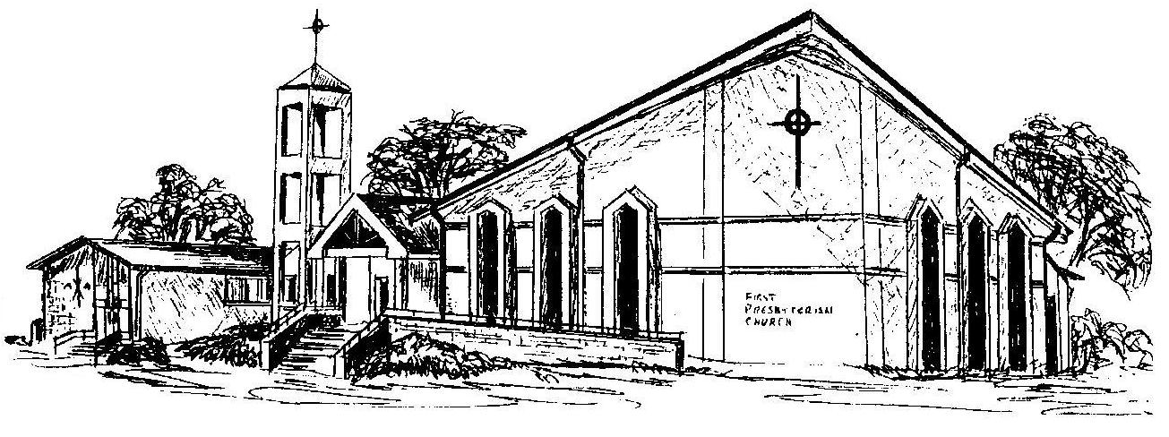

First Presbyterian Church
In the heart of Gardner since 1866 ~ Serving from the heart of God

Welcome - Thank you for joining us for worship today. Please fill out a visitor information card found in the pew racks and place those in the offering plate so that we may follow up with you in the future. Your presence with us today has been a blessing to us, we hope that you have felt the presence of God and the welcome of this congregation.

