Welcome & Announcements, Friendship Information, & Sharing Christ’s Peace
Prelude: “Rise and Be Healed” Milton Bourgeois

Call to Worship
Leader: We gather on this ordinary Sunday, knowing that we come into God’s presence.
People: We come, seeking hope, needing light, asking for grace.
Leader: Into the ordinary, God’s extraordinary love comes.
People: We gather to receive God’s gifts and to praise God for each blessing.

*Opening Hymn: “Sing Praise to God” Red Hymnal, #6

* Prayer of Confession (Unison)
God of Miracles and Mercy, thank you for loving us. Sometimes we come to worship out of habit, not really expecting much to happen. Sometimes we hear the stories from scripture of healing and transformation, and we think that doesn’t happen today. Forgive us. Open our eyes to your miracles all around us. Inspire us to believe all that you can do and bring about through us. Help us to believe and to move forward in faith in the name of Jesus Christ our Healer and Redeemer. Amen.

*Silent Confession

*Assurance of Pardon

*Gloria Patri (Glory Be to the Father…) Red Hymnal, #623

Scripture “Psalm 30:1-5” (page 867)
“Mark 1:21-34” (page 1552)
Leader: The word of the Lord.
People: Thanks be to God.

Children's Time - Noisy Offering
Please join in singing one verse of Jesus Loves Me as the children come forward.

Special Music “Be Still and Know That I am God”
Lyrics by Gene Grier and Music by Davis Lantz III.

Sermon: “Miracles Reveal: Healing” Rev. Kimby Young

*Profession of Faith The Apostle's Creed Red Hymnal, inside back cover

*Hymn “There is a Balm in Gilead” Red Hymnal, #423

Prayers for Healing

Pastoral Prayer & Lord’s Prayer: Please Pray for Coen Towner, Jeremy Towner, the family of Vespersia Pennington, Bob Knoche, Karen Clark, Karen Elliott, Becky Jones, Leona Faulk, Char Bergene, Ruth Chesnut, Fred Cox, Mia Volpe, Mary Meinert, Shirley Crane, Lila Orr, Jackie Lang, Chuck Motter, Hudson Inglehart, Glenn Schulz, Reagan Barnadt, Boston DeWald, Lanny John Turner, Brian McManus, David Butler, Margaret Davidson, Roland Jack, Rob Kuhauz, Denny Harris, Richard Hatfield, Jackson Tijerina

Offertory: “I Am the God That Healeth Thee” Don Moen

*Doxology Red Hymnal, #625

*Prayer of Dedication

*Closing Hymn: “May Jesus Christ Be Praised” Red Hymnal, #87 ver. 1, 3, & 6

*Benediction

Postlude: “He is Jehovah” B. J. Robinson
*Those who are comfortably able will please stand

Kimby Young, Pastor; Brenda Jones, Worship Assistant; Alice Rollf, Organist; Chancel Choir Robyn Forkner, Pianist; Dean Faulk, Music Ministries; Heather Rutler, Worship Transcription

January 23rd, 65th Wedding Anniversary of Glenn & Nancy Schulz; Bob & Donna Knoche

Flowers are given today to the Glory of God in Honor of Glenn & Nancy Schulz 65th Wedding Anniversary by Ginger Crist and Family.

Bible Reading for January 28 Genesis 1:1, Mark 6:45-51; Mark 4:35-41

Ushers January 2018
Brad & Amber Cornell, Lynn Moldrup, Debbie Pickell, Bob & Char Bergene

The 2018 Per Capita is $43.29 is General Assembly $7.73, Synod $2.80, Presbytery $32.76.

Monday, January 22: 6:30 PM Deacons
Monday, January 22: 7:00 PM PW Business Meeting
Wednesday, January 24: 6:15 PM Bells; 7:00 PM Choir; 6:30 PM FH Reserved
Sunday, January 28: 11:15 AM Worship Pillar Meeting

Pastor Kimby's class will meet at 10 a.m. in Westminster room. Upcoming topics: January 21 - miracles; January 28 - faith development theory; February 4 - generational theory; February 11 - no class - Annual meeting.

Annual Meeting - The session has called for our Annual Congregational Meeting to be held on Sunday, February 11 immediately following our regular morning worship service with a congregational brunch following the meeting.

On Wednesday, Bell choir will rehearse at 6:15 p.m. and chancel choir at 7:00 p.m. New members are always welcome. If you would like to join either choir please see Dean Faulk for more information. We would love to have you.

The choir will be preparing for our Easter Musical ‘Celebrate Life’ starting Wednesday, January 31, 2018 at 8:00 p.m. The musical will be presented in its entirety to the congregation on Palm Sunday March 27. Excerpts from the musical will be used throughout holy week leading up to Easter April 1. If you would be interested in singing with the choir please contact Dean Faulk for more details.

Financial Report Close of December Income: $22,524.22; Expense: $23,854.09. A full report is available upon request from the treasurer or the Congregational Life Pillar.

Special Concert - Grace Covenant Praise Team - February 11, 6 p.m. Mark your Calendars! More information soon.

Weather Cancellation Policy - Sunday Worship Service will usually NOT be cancelled. Sunday school might be cancelled even if church is not. Generally, midweek if school is cancelled, events are cancelled. However, as weather changes during the day, discretion is given to event leaders to cancel if needed. Even if a church event is not cancelled, if you do not feel comfortable getting out, you are excused. Check emails, Facebook or website, and KMBC-TV notices for announcements about cancellation. Call Rev. Kimby 913-481-7076, or Connie 913-244-8185.

Confirmation Class - we are gathering names of 6th to 12th grade students who would be interested in exploring their faith during March, April and May. Please contact Pastor Kimby if you are interested or if you have a suggestion of someone to contact.

Sunday, January 21, 2018
9:00 AM

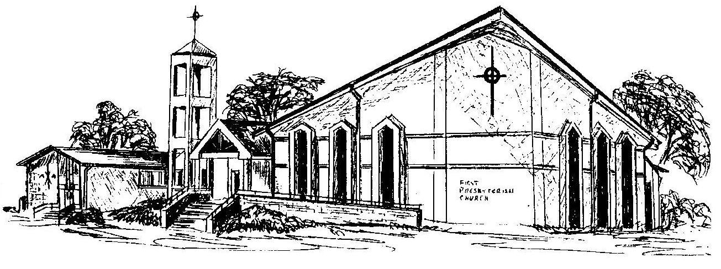

First Presbyterian Church
In the heart of Gardner since 1866 ~ Serving from the heart of God

Welcome - Thank you for joining us for worship today. Please fill out a visitor information card found in the pew racks and place those in the offering plate so that we may follow up with you in the future. Your presence with us today has been a blessing to us, we hope that you have felt the presence of God and the welcome of this congregation.

