Welcome & Announcements, Friendship Information, & Sharing Christ’s Peace
Prelude: “Ceremonial Rondeau” H. Purcell / arr. Parks
Let us prepare our hearts and minds for worship.

Call to Worship
Leader: People of God, rejoice! The Light of the World has come!
People: The light shines in the darkness, and the darkness has not overcome it.
Leader: People of God, give thanks! We have received this Light of life and are called to share that light in the world.
People: Arise, Shine, Our Light has come!

*Opening Hymn: “What Child is This” Red Hymnal, #137

*Prayer of Confession (Unison)
God of light and darkness, we have seen the glimmer of your star-light beckoning to us, but we have turned away and followed other paths. You have given us dreams of possibilities, but we have failed to act on those visions. We have heard the wisdom of prophets and sages, but we have ignored their call. We have experienced the glorious grace of our Savior, but we have neglected to tell the good news. Forgive us. Enlighten us again. Empower us to dream. Inspire us to live the love of Jesus and to be witnesses to your love in the world that all may see your glory and come to worship you. Amen

*Assurance of Pardon

Scripture “Isaiah 60:1-6” (page 1155)
“Matthew 2:1-15” (page 1497)
Leader: The word of the Lord.
People: Thanks be to God.

Children's Time
Please join in singing one verse of Jesus Loves Me as the children come forward.

Special Music

Sermon “Dreams Revealing God” Rev. Kimby Young

*Profession of Faith “The Apostle's Creed” Red Hymnal, inside back cover

*Hymn “We Three Kings” Red Hymnal, #166
Congregation sings verses 1 & 5 and refrain, Soloists sing 2, 3, 4
Offertory: “We Three Kings of Orient Are” J. Hopkins, Jr.

*Doxology Red Hymnal, #625

*Prayer of Dedication & Pastoral Prayer Please Pray for Karen Elliott, Leona Faulk, Char Bergene, Millard Carlson, Ruth Chesnut, Fred Cox, Mia Volpe, Mary Meinert, Shirley Crane, Vespersia Pennington, Becky Jones, Lila Orr, Jackie Lang, Chuck Motter, Hudson Inglehart, Glenn Schulz, Reagan Barnadt, Boston DeWald, Lanny John Turner, Brian McManus, David Butler, Margaret Davidson, Roland Jack, Rob Kuhauz, Denny Harris, Richard Hatfield, Jackson Tijerina

Communion & Celebration
Invitation
Great Thanksgiving
The Lord’s Prayer
Breaking of Bread
Communion of the People
Prayer of Thanksgiving

*Closing Hymn: “The First Noel” Red Hymnal, #136

*Benediction

Postlude: “Ding, Dong, Merrily on High” Trad. French Carol
*Those who are comfortably able will please stand

Kimby Young, Pastor; Paula Waters, Worship Assistant; Alice Rollf, Organist
Robyn Forkner, Pianist; Dean Faulk, Music Ministries; Heather Rutler, Worship Transcription

Ushers January 2018
Brad & Amber Cornell, Lynn Moldrup, Debbie Pickell, Bob & Char Bergene

Bible Reading for January 14 Mark 1:4-11; Acts 19:1-7

Sunday, January 7: 11:15 AM Discipleship Pillar Meeting
Monday, January 8: 6:30 PM Session
Tuesday, January 9:7:00 AM Men’s Breakfast Perkins
Wednesday, January 10: 6:15 PM Bells; 7:00 PM Choir; 6:30 PM FH Reserved
Saturday, January 13: 9:00 AM Session Retreat

The 2018 Per Capita is $43.29 is General Assembly $7.73, Synod $2.80, Presbytery $32.76.

Pastor's Class in Westminster Room will continue the series on Presbyterian beliefs. January 7 - today - Epiphany and Christmas stories - scripture and tradition; January 14 - Baptism; January 21 - Communion; January 28 - other holy rituals and observations; February 4 - Lectionary and Scripture; February 11 - no class.

Annual Meeting - The session has called for our Annual Congregational Meeting to be held on Sunday, February 11 immediately following our regular morning worship service with a congregational brunch following the meeting.

Bell Choir and Chancel Choir will resume rehearsals on Wednesday January 10th. Bell choir will rehearse at 6:15 p.m. and the chancel choir will rehearse at 7:00 p.m. New members are always welcome. If you would like to join either choir please see Dean Faulk for more information. We would love to have you.

Financial Report Close of December Income: $22,524.22; Expense: $23,854.09. A full report is available upon request from the treasurer or the Congregational Life Pillar.

Noisy Offering – January 21 - Mission Pillar continues our quarterly offering of loose change which is collected by our children and youth during worship. This month’s offering is for utility relief through the city of Gardner. Remember to bring your coins to worship on Sunday, January 21, and help us “make a joyful noise to the Lord.”

Stewardship Pledges - If you have not turned in a pledge card for 2018, please turn one in as soon as possible. Cards are available in the narthex near the name tags. Session will be approving a preliminary budget this week and we would like to have an accurate understanding of possible income. If you would like to talk about your contributions, please contact Pastor Kimby or any member of session.

Custodian Needed - If you would be interested in the job of part time custodian, or if you have a name to suggest, please contact Pastor Kimby Young or Phil Lenahan. Hours are flexible and vary from 10-20 hours per week, usually about 12. Some weekend work is needed. Some physical strength and ability are needed. We are considering splitting the job into weekend cleaning and weekday with that is more varied.

Weather Cancellation Policy - Sunday Worship Service will usually NOT be cancelled. Sunday school might be cancelled even if church is not. Generally, midweek if school is cancelled, events are cancelled. However, as weather changes during the day, discretion is given to event leaders to cancel if needed. Even if a church event is not cancelled, if you do not feel comfortable getting out, you are excused. Check emails, Facebook or website, and KMBC-TV notices for announcements about cancellation. Call Rev. Kimby 913-481-7076, or Connie 913-244-8185.

Sunday, January 7, 2018
Celebration of Epiphany
9:00 AM

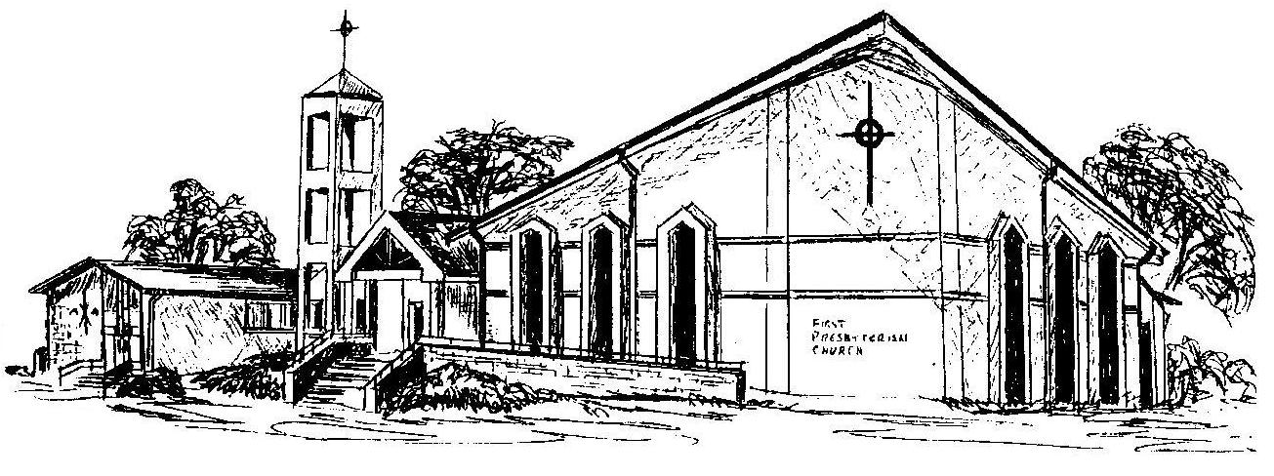

First Presbyterian Church
In the heart of Gardner since 1866 ~ Serving from the heart of God

Welcome - Thank you for joining us for worship today. Please fill out a visitor information card found in the pew racks and place those in the offering plate so that we may follow up with you in the future. Your presence with us today has been a blessing to us, we hope that you have felt the presence of God and the welcome of this congregation.

