Welcome & Announcements, Friendship Information, & Sharing Christ’s Peace
Prelude: “Jesu, Joy of Man's Desiring” J. S. Bach
Let us prepare our hearts and minds for worship.

Call to Worship & Lighting of the Advent Candle: Advent Readers: Mike & Tina Fraser
Leader: Jesus said, “I am the Light of the World, whoever follows me will not walk in darkness, but will have the light of life.”
People: Today, we light the first candle on our Advent wreath.
Leader: We remember the prophets’ hope based on God’s promise to send a Messiah, one who would bring peace and love to the world.
People: The first light reminds us that God’s promises are still true for us today.
Leader: Wait and hope, for Jesus Christ is coming.

*Opening Hymn: “O Come All Ye Faithful” Red Hymnal, #145

*Prayer of Confession (Unison)
God of Light, who shines in deepest darkness, we hear you calling us out of hopelessness into hope. We hear your call to wait and watch, but we lack patience, and we fear what is to come. We do not see all around us the signs of your presence, the gifts of your mercy. Forgive us. Open our eyes. Empower us to shine your light, that all may see your glory and come to worship you, in Jesus Christ, hope of the world. Amen.

*Assurance of Pardon

Scripture “Mark 13:24-37” (page 1578)
“Revelation 21:1-7” (page 1937)
Leader: The word of the Lord.
People: Thanks be to God.

Children's Time
Please join in singing one verse of Jesus Loves Me as the children come forward.

Special Music “All Other Kings Bow Down”
Words and Music by David Noel, Arr by Jay Rouse.

Sermon “Ready for God: Watch!” Rev. Kimby Young

*Profession of Faith “The Apostle's Creed” Red Hymnal, inside back cover
*Hymn “O Come, O Come Emmanuel” Red Hymnal, #123

Offertory: “All Earth is Waiting” A. Taule

*Doxology Red Hymnal, #625

*Prayer of Dedication & Pastoral Prayer Please Pray for Mary Meinert, Leo Pickell, Pam Wilson, Shirley Crane, Aaron Rutler, David Rutler, Vespersia Pennington, Becky Jones, Lila Orr, Jackie Lang, Chuck Motter, Debi Crowell Crist, Hudson Inglehart, Glenn Schulz, Reagan Barnadt, Boston DeWald, Lanny John Turner, Larry Bartel, Brian McManus, David Butler, Margaret Davidson, Roland Jack, Rob Kuhauz, Denny Harris, Richard Hatfield, Jackson Tijerina

Communion & Celebration
Invitation
Great Thanksgiving
The Lord’s Prayer
Breaking of Bread
Communion of the People
Prayer of Thanksgiving

*Closing Hymn: “Come, Thou Long Expected Jesus” Red Hymnal, #124

*Benediction

Postlude: “Emmanuel” B. McGee
*Those who are comfortably able will please stand

Kimby Young, Pastor; Tina Fraser, Worship Assistant; Chancel Choir
Robyn Forkner, Pianist; Dean Faulk, Music Ministries; Alice Rollf, Organist
Heather Rutler, Worship Transcription

Ushers December 2017
Vern & Leone Knabe; Andy & Lois Barber; Corky & Joyce Scarlett

Bible Reading for December 10, Isaiah 40:1-11; Mark 1:1-8

Sunday, December 3: Discipleship Pillar 11:15 AM
Sunday, December 3: Caroling 1:00 PM
Monday, December 4: Congregational Life Pillar 7:00 PM
Wednesday, December 6: Bells 6:00 PM, Cantata 7:00 PM

Join us for Caroling today Sunday, December 3, 2017 at 1:00pm. We will meet at the church and go caroling to our "Shut Ins" who are not able to attend our programs during the Christmas Season. We will return to the Church for Hot Chocolate and Cookies.

Christmas Poinsettias for the sanctuary may be purchased in memory or in honor of someone special. Order by Monday, December 4th. The poinsettias are $11.00 each. You may take them home after the Christmas Eve service, if you wish.

Mayor’s Christmas We have 4 children to purchase presents for by Dec. 10th. Please do not wrap presents. Just take one or more tags from the small tree in the Narthex purchase the items and return them to church. You may also donate cash that can be used by the Mission pillar to purchase items. If you have any questions please contact Eldonna Chesnut.

The Cantata Choir is working on the Christmas Cantata “Comfort & Joy” to be performed on Sunday December 17, 2017. What an exciting time.

Music Ministry Mark your calendar for the 1st Annual Christmas Talent Concert on Wednesday, December 20, 2017 at 7:00 PM. If you are not sharing a talent, please come and enjoy the show. Come learn the hidden talents of your fellow congregant members.

Sunday, Christmas Eve December 24, Morning worship and Christmas Pageant at 9:00 AM, Evening Candlelight and Communion at 4:30 PM.

Substitute Teachers are needed for our Sunday School classes. To volunteer contact Nancy Falkner or Pastor Kimby.

Financial Report Close of October Income - $24,382.41; Expense - $18,541.04. A full report is available upon request from the treasurer or the Congregational Life Pillar.

Offering Envelopes for 2018 on a table in the Narthex, please pick them up.

Sunday, December 3, 2017
1st Sunday of Advent
9:00 AM
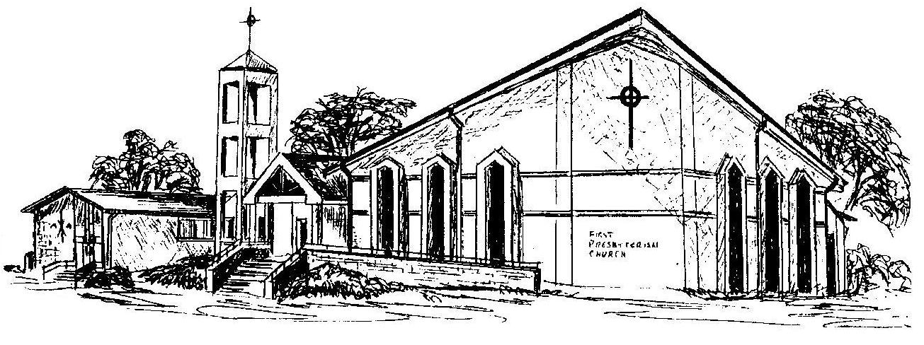

First Presbyterian Church
In the heart of Gardner since 1866 ~ Serving from the heart of God

Welcome - Thank you for joining us for worship today. Please fill out a visitor information card found in the pew racks and place those in the offering plate so that we may follow up with you in the future. Your presence with us today has been a blessing to us, we hope that you have felt the presence of God and the welcome of this congregation.

