Welcome & Announcements, Friendship Information, & Sharing Christ’s Peace
Prelude: “Mary's Little Boy Child” J. Hairston
Let us prepare our hearts and minds for worship.

Call to Worship and Lightening of the Advent Candles: Randy & Sandy Rieger
Leader: Jesus said, “I am the Light of the World, whoever follows me will not walk in darkness, but will have the light of life.”
People: As we light the advent candles again today, we remember the hope, the peace and the joy of all those who have gone before us, all those who have called us and all those who have helped us to prepare for the coming of Christ.
Leader: Today as we light the fourth candle, we remember the love of God as shown most clearly in Jesus Christ our Lord.
People: These candles remind us that this hope, this peace, this joy, and this love are offered to us today.
Leader: Behold, the Light of the World has come!

*Opening Hymn: “Silent Night” Red Hymnal, # 147, all 3 verses
* Prayer of Confession (Unison)
God of Light and Love, as Christmas draws closer, we confess that we are distracted by so many trappings of the season. Remind us again today to focus on Christ and to share your love in the world. We pray in the name of Jesus Christ, Emmanuel, God with us, now and always. Amen.

*Silent Confession

*Assurance of Pardon (Isaiah 9:2)
Leader: The people who walked in darkness have seen a great light.
People: On all living in the land of deep shadows, a light has dawned.
Leader: Friends, hear and believe the Good News of God’s grace.
People: The Light of the world has come! Jesus Christ was born for all!

*Gloria Patri (Glory Be to the Father…) Red Hymnal, #623

Offertory: “One Small Child” D. Meece

Prayer of Dedication, Pastoral Prayer & Lord’s Prayer

The Word in Scripture and Song: Children’s Christmas Pageant
(The congregation will not stand for hymns and will sing only the verses indicated.)
(Children may come forward during this hymn to sit on the front row.)

Hymn “O Come, All Ye Faithful” Red Hymnal, #145, verses 1 & 3
Luke 2:1-7

Hymn “Away in a Manger” Red Hymnal, #157, verses 1 & 2

Luke 2:8

Hymn “While Shepherds Watched” Red Hymnal, #135, verses 1 & 2

Luke 2:9-14

Hymn “Hark! The Herald Angels Sing” Red Hymnal, #133, verses1 & 3

Luke 2:15-20

Hymn “Angels We Have Heard on High” Red Hymnal, #132, verses 1 & 2

Matthew 2:1-9

Hymn “We Three Kings” Red Hymnal, #166, verses 1 & 5

Matthew 2:10-11

Hymn “Joy to the World” Red Hymnal, #125, verses 1 & 4
Meditation

Hymn “Go Tell It On the Mountain” Red Hymnal, #138, all 3 verses

Benediction

Postlude: “Ring, Christmas Bells” J. Parks

Kimby Young, Pastor; Robyn Forkner, Pianist; Alice Rollf, Organist
Dean Faulk, Music Ministries; Heather Rutler, Worship Transcription
Pageant Cast: Readers: Rachel Cornell, Nalleli Rollf, Jon Rollf
Mary: Sydney Wetherington
Joseph: Colby McCabe
Magi: Robert Falkner, Thomas Pacey, Bradley Cornell
Shepherds: Ella Falkner, Tyson Hildreth, Easton Pacey, Kyler Pacey, Dakota Allen, Colby Brunker
Angels: Ashleigh Martin, Zoe Martin, Cheyenne Brunker, Ellie Bockus, Marryn Wolf

Sunday, Christmas Eve December 24, Evening Candlelight and Communion at 4:30 PM.

Substitute Teachers are needed for our Sunday School classes. To volunteer contact Nancy Falkner or Pastor Kimby.

Financial Report Close of November Income - $24,861.81; Expense - $18,911.69. A full report is available upon request from the treasurer or the Congregational Life Pillar.

Stewardship Pledges - If you have not turned in a pledge card for 2018, please turn one in as soon as possible. Cards are available in the narthex near the name tags. Session will be approving a preliminary budget this week and we would like to have an accurate understanding of possible income. If you would like to talk about your contributions, please contact Pastor Kimby or any member of session.

Tree tag blessings are available on the small tree on the table in the narthex by the west entrance to the sanctuary where the Mayor's Christmas Tree Children's Gifts were distributed. Take a tag as a reminder of God's blessings this season. Thank you for supporting the mission and outreach projects of First Presbyterian Church.

If you want to make a donation that is recorded for 2017, it must be in by December 27.

Church office hours:
December 25 and 26 - Church Office Closed
December 27 and 28 - Limited Church Office Hours - Call ahead
December 29 - Church Office Closed
January 1 - Church Office Closed

Emergency - If you need Pastor Kimby when the church office is closed, call on her cell phone 913-481-7076. Leave a message for call back.

Custodian Leaving - Our church custodian of two years, Steve Winters, has resigned effective December 31. He has served our church well and faithfully. Steve and his wife Karen were a great blessing to our church. Tell them thank you as you see them in the next week.

Custodian Needed - If you would be interested in the job of part time custodian, or if you have a name to suggest, please contact Pastor Kimby Young or Phil Lenahan. Hours are flexible and vary from 10-20 hours per week, usually about 12. Some weekend work is needed. Some physical strength and ability are needed.

Sunday, December 24, 2017
4th Sunday in Advent
Christmas Eve Morning
Children's Christmas Pageant
9:00 AM

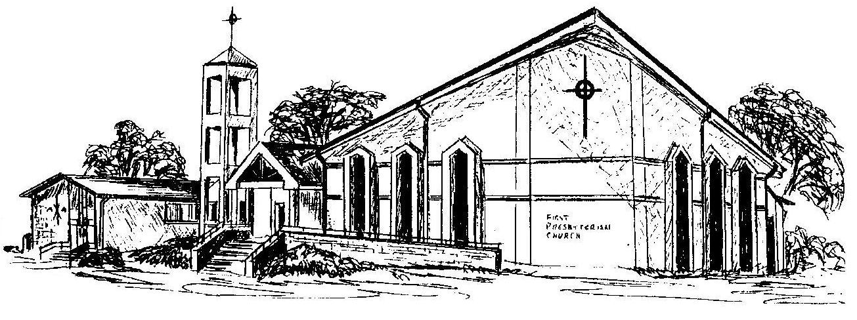

First Presbyterian Church
In the heart of Gardner since 1866 ~ Serving from the heart of God

Welcome - Thank you for joining us for worship today. Please fill out a visitor information card found in the pew racks and place those in the offering plate so that we may follow up with you in the future. Your presence with us today has been a blessing to us, we hope that you have felt the presence of God and the welcome of this congregation.

