Christmas Eve

(Please note: stand only for the 3 hymns indicated with * and sing only the verses listed.)

Welcome:

Prelude: “O Holy Night” A. Adam
Let us prepare our hearts and minds for worship.

Call to Worship
Leader: Do not be afraid; for behold – I bring you good news of great joy.
People: To us is born this day in the city of David a Savior, who is Christ, the Lord.
Leader: This will be a sign for you: you will find a babe wrapped in swaddling cloth and lying in a manger.
People: Glory to God in the highest, and on earth, peace!

Lighting Advent Candles & the Christ Candle
Leader: Tonight, we relight the candles of hope, peace, joy and love. Finally, tonight, we light the Christ Candle, reminding us of the birth of Jesus Christ, Light of the World.
People: “Glory to God in the highest, and on earth peace, good will toward all!”

Bells “Angels We Have Heard on High” arr. by Bisbee

Opening Prayer for Christmas Eve (Unison)
Good and gracious God, on this holy night you gave us your Son, the Lord of the universe, wrapped in swaddling clothes, the Savior of all, lying in a manger. On this holy night draw us into the mystery of your love. Join our voices with the heavenly host that we may sing your glory on high. Illumine our paths with the light of Christ’s presence, that we may clearly see the way before us, the truth to speak, and the life to live for him, our Lord Jesus Christ, who lives and reigns with you in the unity of the Holy Spirit, one God, now and forever. Amen.

*Carol “O Come, All Ye Faithful” verses 1 & 2 Red #145

The First Lesson “Isaiah 9:2, 6-7” (page 1072)

Carol “Angels from the Realms of Glory” verses 1 & 4 Red #131

The Second Lesson “Luke 1:26-38” (page 1588)

Carol “O Come O Come Emmanuel” verses 1 & 4 Red #123

The Third Lesson “Matthew 1:18-24” (page 1497)

Carol “O Little Town of Bethlehem” verses 1 & 2 Red #141

The Fourth Lesson “Luke 2:1-7” (page 1590)

Carol “Away in a Manger” verses 1 & 2 Red #157

The Fifth Lesson “Luke 2:8-14” (page 1591)

Carol “Angels We Have Heard on High” verses 1 & 3 Red #132

The Sixth Lesson “Luke 2:15-20” (page 1591)

Carol “Hark! The Herald Angels Sing” verses 1 & 2 Red #133

The Seventh Lesson “Matthew 2:1-12” (page 1497)

Carol “We Three Kings of Orient Are” verses 1 & 5 Red #166

Offering and Offertory “Jesus, Jesus, Rest Your Head” American Folk Melody

Prayer of Thanksgiving

The Eighth Lesson “Isaiah 11:1-4a” (page 1076)

*Carol “Joy to the World” verses 1 & 4 Red #125

Celebration of The Lord’s Supper -
All are welcome at Christ’s table in the Presbyterian tradition.

Special Music “Midnight Noel” arr. by Mark Hayes

The Ninth Lesson “John 1:1-5, 9-14” (page 1645)

The Distribution of the Candles
(As the light is passed from person to person, hold the lit candle straight, tip the unlit candle into the flame to receive the light of Christ.)

*Carol “Silent Night, Holy Night!” Red #147

*Benediction

Postlude: “He is Born” French Carol

*Those who are comfortably able will please stand

Kimby Young, Pastor; Robyn Forkner, Pianist; Alice Rollf, Organist; Cooper McGuire, Soloist
Chancel Bells; Dean Faulk, Music Ministries; Heather Rutler, Worship Transcription

Sunday, December 31 at 9:00 AM, New Year’s Eve Day

Christmas Eve Readers:
Cooper McGuire
Heather Culbertson
Mike McGuire
Sandy Rieger
Davis Tropansky
Lynn Moldrup
Randy Rieger
Vera Beach
Bill Danner

Communion Servers: Ushers:
Ron Crabbs Vern Knabe
Dave Rollf Leone Knabe
Joyce Scarlett Andy Barber
Lois Barber Lois Barber
Paula Waters Corky Scarlett
Wayne Rollf Joyce Scarlett
Randy Rieger
Sandy Rieger

The Christmas Joy Offering of the PCUSA which is being received tonight is used for two purposes. Half of the offering is distributed through the Board of Pensions for the assistance programs that provide support to church workers facing difficult or unusual circumstances. The other fifty percent supports Presbyterian-related racial ethnic schools and colleges through the Racial Ethnic and Women's Ministries of the Presbyterian Mission Agency.

Tree tag blessings are available on the small tree on the table in the narthex by the west entrance to the sanctuary where the Mayor's Christmas Tree Children's Gifts were distributed. Take a tag as a reminder of God's blessings this season. Thank you for supporting the mission and outreach projects of First Presbyterian Church.

If you want to make a donation that is recorded for 2017, it must be in the office by December 27.

Church office hours:
December 25 and 26 - Church Office Closed.
December 27 and 28 - Limited Church Office Hours - Call ahead.
December 29 - Church Office closed.
January 1 - Church Office Closed

Emergency - If you need Pastor Kimby when the church office is closed, call on cell phone 913-481-7076. Leave a message for call back.

Sunday, December 24, 2017
Christmas Eve Service
Candlelight & Communion Service
4:30 PM

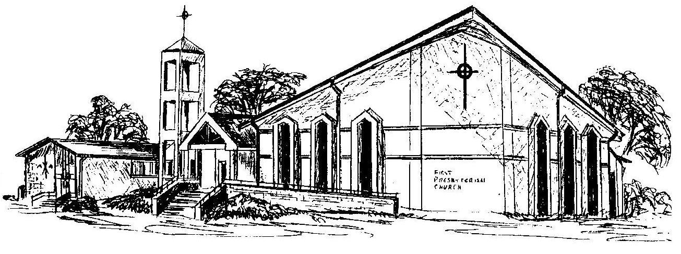

First Presbyterian Church
In the heart of Gardner since 1866 ~ Serving from the heart of God

Welcome - Thank you for joining us for worship today. Please fill out a visitor information card found in the pew racks and place those in the offering plate so that we may follow up with you in the future. Your presence with us today has been a blessing to us, we hope that you have felt the presence of God and the welcome of this congregation.

