Welcome & Announcements, Friendship Information, & Sharing Christ’s Peace
Prelude: “Hymns of Christmas”
Let us prepare our hearts and minds for worship.

Call to Worship & Lighting of the Advent Candles:
Advent Readers: Charlie, Jessica, Cheyenne, Colby & Callen Brunker
Leader: Jesus said, “I am the Light of the World, whoever follows me will not walk in darkness but will have the light if life.”
People: As we light the first candle again on our Advent wreath, we remember the prophet’s hope based on God’s promise: To send a Messiah who would bring peace and love to the world.
Leader: As we light the second candle, we remember the peace of Christ offered to the whole world.
People: As we light the third candle, we remember the joy brought by the angels, who sang their Good News and praised God for all to hear.
Leader: Today our voices ring with theirs as we sing and shout in joyful praise of God’s great Good News. Rejoice, for our Lord comes.

*Opening Hymn: “Joy to the World” Red Hymnal, #125

Opening Prayer (Unison)
God of Joy and Light, today we celebrate your grace poured out to all the world. We give thanks that Jesus has come to us and that our lives are made both whole and holy by Christ’s presence with us today and every day. We pray make us able to share the Good News of your love with everyone we encounter this season. We pray in the name of Jesus Christ, Light of the World, Emmanuel, God with us. Amen.

*Gloria Patri (Glory Be to the Father…) Red Hymnal, #623

Offertory: “Lullaby, Jesus” E. Lorenz

*Doxology Red Hymnal, # 625

Prayer of Dedication , Pastoral Prayer & Lord’s Prayer

The Word in Scripture and Song: “Cantata” See Insert

Benediction

Postlude: “Joyful, Joyful, We Adore You” Beethoven/Hodges

*Those who are comfortably able will please stand

Kimby Young, Pastor; Cantata Choir; Robyn Forkner, Pianist
Dean Faulk, Music Ministries; Alice Rollf, Organist; Heather Rutler, Worship Transcription

Ushers December 2017
Vern & Leone Knabe; Andy & Lois Barber; Corky & Joyce Scarlett

If you have signed up for the Christmas Talent Concert please see Dean Faulk before leaving church today. There will be a run through of the talent show on Tuesday December 19th at 6:30p.m.

We need assistance with Cookies and Desserts for the Christmas Talent Concert on Wednesday December 20th. If you would like to bring cookies or a dessert please see Dean Faulk or Paula Waters.

Sunday, Christmas Eve December 24, Morning worship and Christmas Pageant at 9:00 AM, Evening Candlelight and Communion at 4:30 PM.

Substitute Teachers are needed for our Sunday School classes. To volunteer contact Nancy Falkner or Pastor Kimby.

Financial Report Close of November Income - $24,861.81; Expense - $18,911.69. A full report is available upon request from the treasurer or the Congregational Life Pillar.

Stewardship Pledges - If you have not turned in a pledge card for 2018, please turn one in as soon as possible. Cards are available in the narthex near the name tags. Session will be approving a preliminary budget this week and we would like to have an accurate understanding of possible income. If you would like to talk about your contributions, please contact Pastor Kimby or any member of session.

Tree tag blessings are available on the small tree on the table in the narthex by the west entrance to the sanctuary where the Mayor's Christmas Tree Children's Gifts were distributed. Take a tag as a reminder of God's blessings this season. Thank you for supporting the mission and outreach projects of First Presbyterian Church.

Sunday, December 17, 2017
Comfort & Joy Cantata
3rd Sunday of Advent
9:00 AM
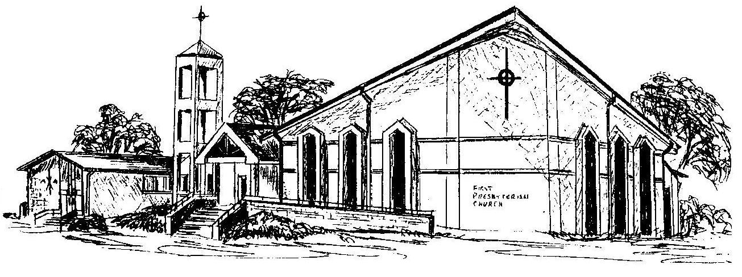

First Presbyterian Church
In the heart of Gardner since 1866 ~ Serving from the heart of God

Welcome - Thank you for joining us for worship today. Please fill out a visitor information card found in the pew racks and place those in the offering plate so that we may follow up with you in the future. Your presence with us today has been a blessing to us, we hope that you have felt the presence of God and the welcome of this congregation.

Comfort and Joy
by Randy Vader and Jay Rouse

Directed by
Dean Faulk – Director of Music Ministries

Choir Accompanist
Robyn Forkner

A Merry Carol of the Bells Overture
Arranged by Richard Kingsmore

Every Valley
Rhonda Atwater - Soloist

Tidings of Comfort and Joy

Only Love
Emmy Hill and Chesley Jones – Soloists

Shining in the Heavens

Adoration

All Other Kings Bow Down
Words and Music by Dave Noel Arranged by Jay Rouse

You Came Into Our Presence
Oliver Schwab - Soloist

In His Presence We Bow
Oliver Schwab – Soloist

A Merry Carol of the Bells
Arranged by Camp Kirkland and Jay Rouse

Tidings of Comfort and Joy Reprise
Narrators
Brenda Jones
Dwain Wallace

Musicians
Joy Covington - Cello
Jack Gerding – Trumpet
Max Levy – Saxophone
Jennifer Mauk – Violin
Jerry Polluck – Drums/Percussion
Patrick Skinner – String Bass
Kurt Wheeler – Clarinet
Cole Wilson – Oboe
Nadia Wright-Morrison - Flute

Sound
Kim Liu

Thank you to everyone who participated in making this happen.
Thank you for sharing your God given talents to glorify the Lord.

‘For Unto Us Is Born This Day, In The City Of David, A Savior, Who Is Christ The Lord.’

