Welcome & Announcements, Friendship Information, & Sharing Christ’s Peace
As you enter, if you have brought a picture of a loved one, please add it to one of the four boards stationed around the sanctuary. If you forgot a picture or did not know to bring one, place any names on a card and add it to a board. Ask an usher for help if you prefer not to walk.

Prelude: “Come and Sing Praises” Massanari and Walker
Let us prepare our hearts and minds for worship.

Call to Worship
Leader: For all the saints who have gone before us, who have spoken to our hearts and touched our lives
People: We praise you, O God!
Leader: For all the saints who live beside us, whose weaknesses and strengths are woven with our own
People: We praise you, O God!
Leader: For all the saints who live beyond us, who challenge us to change the world with them
People: We praise you, O God!

*Opening Hymn: “For All The Saints” Red Hymnal, #546

Remembrance of the Saints and Lighting of the Candles
Unison Prayer
Gracious God, we praise you for the glorious company of the saints who now rest with you. We thank you today for those who have departed from this life over the past year, and remember them in gratitude. We pray your blessing on their loved ones and on all of us who remember. Grant us your peace and confidence in you. We pray in witness to the resurrection of Jesus Christ and in the hope of that eternal union you have promised for all who believe in you.
Amen.

Dean Faulk Solo “To Where You Are” by Josh Grobin

Scripture “Psalm 23” (page 862)
“1 Corinthians 15:12-26” (page 1789)
Leader: The word of the Lord.
People: Thanks be to God.

Children's Time - Please join in singing one verse of Jesus Loves Me as the children come forward.

Special Music “Find Us Faithful” by Jon Mohr; arr by Dennis Allen

"Therefore, since we are surrounded by such a great cloud of witnesses, let us throw off everything that hinders and the sin that so easily entangles. And let us run with perseverance the race marked out for us, fixing our eyes on Jesus, the pioneer and perfecter of faith.” Hebrews 12:1-2
Sermon “Hope in the Resurrection” Rev. Kimby Young

*Profession of Faith “The Apostle's Creed” Red Hymnal, inside back cover

*Hymn “The Day of Resurrection” Red Hymnal, #226

Offertory: “It Is Well With My Soul” P. Bliss

*Doxology Red Hymnal, #625

*Prayer of Dedication & Pastoral Prayer Please Pray for Becky Jones, Lila Orr, Jackie Lang, Chuck Motter, Debi Crowell Crist, Glenn Schulz, Hudson Inglehart, Boston DeWald, Lanny John Turner, Larry Bartel, Brian McManus, Margaret Davidson, Keith W. Smith, Roland Jack, Rob Kuhauz, Denny Harris, Richard Hatfield, Jackson Tijerina

Communion & Celebration of All Saints
Invitation
Great Thanksgiving
The Lord’s Prayer
Breaking of Bread
Communion of the People
Prayer of Thanksgiving

*Closing Hymn: “In Remembrance” Red Hymnal, #322

*Benediction

Postlude: “Therefore the Redeemed of the Lord” R. Lake
*Those who are comfortably able will please stand

Kimby Young, Pastor; Keely McCabe, Worship Assistant; Chancel Choir; Robyn Forkner, Pianist
Dean Faulk, Music Ministries; Alice Rollf, Organist; Heather Rutler, Worship Transcription

Ushers November 2017
Mike & Pat Clark; Brett & Pam Wilson; Karl & Kim Allen

Bible Reading for November 12, Joshua 24:14-25; Matthew 22: 35-46

Sunday, November 12: Mission Pillar 11:15 AM
Monday, November 13: Session 6:30 PM
Sunday, November 19: Stewardship Dedication

Deacons Food Drive Sunday, November 5 – November 12. Bring a non-perishable items.
Congregational “Election” Meeting, today November 5 10:00 AM.
Session has approved the following nominees for Elders, Deacons & Nominating Committee:
Elders class of 2020 - Larry Atwater, Bill Danner, Pat Clark
Deacons class of 2018 - Tom Corwin
Deacons class of 2020 - Lynn Moldrup
Nominating Committee – Randy Rieger, Pam Wilson, Karen Elliott, Alice Rollf

Operation Christmas Child packing party, Saturday, November 11th, 9:00 – 11:00AM. If the packing party isn’t for you, you are welcome to pack your own box and bring it to the church by collection Sunday: November 12th.

Substitute Teachers are needed for our Sunday School classes. To volunteer contact Nancy Falkner or Pastor Kimby.

Men’s Breakfast, Tuesday, November 14 at 7:00 AM at church. A presentation on “Time” by Andy Stanley will be shown. We hope you can make it.

Presbyterian Youth Fellowship would like to invite the congregation, family, friends, and neighbors to brunch on Sunday, November 19th. A wide variety of delicious breakfast food will be served following the 9:00 AM worship service (roughly 10 AM-11AM). There is no set cost, but donations will be accepted to support the 2019 summer mission trip.

Financial Report Close of September Income - $19,703.07; Expense - $22,312.54. A full report is available upon request from the treasurer or the Congregational Life Pillar.

For the choir Thinking about singing the Christmas Cantata Comfort and Joy with the choir? We will have plenty of room for you. Rehearsals for the Christmas Cantata are from 8:00 to 9:00 PM for a few more weeks and then will change to 7:00 PM starting the Wednesday after Thanksgiving.

For the Bell Choir Currently there are 10 individuals committed to the bell choir but we truly need 6 to 8 more individuals to complete the ringing of the 3 full octaves of bells available. The Bell Choir currently is meeting on Wednesday Evenings from 6:15 to 7:00 PM. If you are interested please see Dean Faulk or join us and give it a try.

Christmas Talent Concert Want a break from the holiday hustle and bustle? Do you have a hidden talent you would like to share with our congregation, your family and friends? Then you need to join us for the first annual Christmas Talent Concert to be held on Wednesday, December 20th at 7:00PM with holiday refreshments afterwards. This is meant to be fun for all the family. Please see Dean Faulk for more details and signup information.

Worship at Meadowbrook & Medicalodge –Please volunteer to Pastor Kimby, if you would be willing to help lead. Sunday, November 5: Congregational Life Pillar; Sunday, November 12: Worship Pillar; Sunday, November 19: Discipleship Pillar; Sunday, November 26: Mission Pillar.

Sunday, November 5, 2017
All Saints Day
9:00 AM
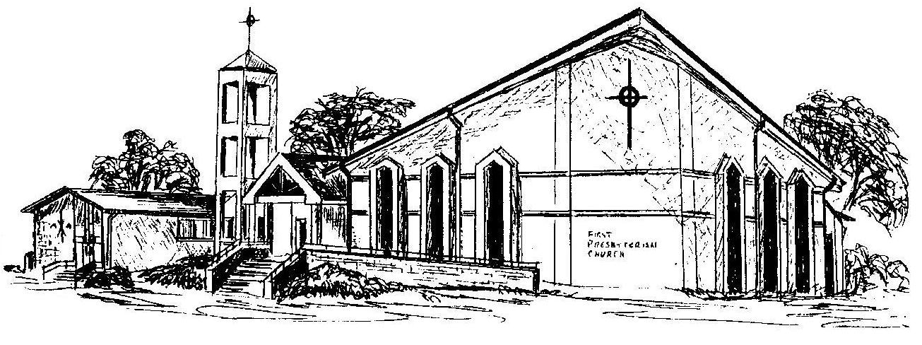

First Presbyterian Church
In the heart of Gardner since 1866 ~ Serving from the heart of God

Welcome - Thank you for joining us for worship today. Please fill out a visitor information card found in the pew racks and place those in the offering plate so that we may follow up with you in the future. Your presence with us today has been a blessing to us, we hope that you have felt the presence of God and the welcome of this congregation.

