Welcome & Announcements, Friendship Information, & Sharing Christ’s Peace
“Channels of Blessings” – Multiply Our Blessings by Sandy Rieger
Prelude: “His Holy Presence” Sergisson
Let us prepare our hearts and minds for worship.

Call to Worship
Leader: We are pulled in many directions with many voices and distractions calling to us.
People: Many duties and tasks seek to claim our lives.
Leader: This day, in this place, let us seek to serve our God.
People: This day, in this place, we open our hearts and spirits to our loving Lord.

*Opening Hymn: “Sing Praise to God Who Reigns Above” Red Hymnal, #6

*Prayer of Confession (Unison)
God of Love, we know that you have chosen us, and we are grateful. We confess that we have sometimes behaved as the “frozen chosen.” We have been stuck in our own ways rather than seeking your way. We hold back from commitment and avoid challenges. We sometimes look for the easy way rather than the best way. We are reluctant to try new things. Forgive us and inspire us again. Help us to choose to serve you today and to follow you tomorrow. We pray in Jesus’ name. Amen.

*Silent Reflection

*Assurance of Pardon

*Gloria Patri (Glory Be to the Father…) Red Hymnal, #623

Scripture “Joshua 24:14-24” (page 369)
“Matthew 22:34-40” (page 1535)
Leader: The word of the Lord.
People: Thanks be to God.

Children's Time
Please join in singing one verse of Jesus Loves Me as the children come forward.

Special Music: “Bring to God the Harvest” arr.by Berta & Sonja Poorman

Sermon: “Choose This Day!” Rev. Kimby Young
*Profession of Faith The Apostle's Creed Red Hymnal, inside back cover

*Hymn “I Have Decided to Follow Jesus” Red Hymnal, #376

Pastoral Prayer & Lord’s Prayer: Please Pray for Aaron Rutler, David Rutler, Vespersia Pennington, Becky Jones, Lila Orr, Jackie Lang, Chuck Motter, Debi Crowell Crist, Hudson Inglehart, Glenn Schulz, Reagan Barnadt, Boston DeWald, Lanny John Turner, Larry Bartel, Brian McManus, David Butler, Margaret Davidson, Roland Jack, Rob Kuhauz, Denny Harris, Richard Hatfield, Jackson Tijerina

Offertory: “With All My Heart” Mason
“I Offer My Life” Cloninger

*Doxology Red Hymnal, #625

Prayer of Dedication

*Closing Hymn: “Have Thine Own Way Lord” Red Hymnal, #371

Benediction

Postlude: “A Salute to Veterans”
*Those who are comfortably able will please stand

Kimby Young, Pastor; Connie Thomas, Worship Assistant;
Alice Rollf, Organist; Robyn Forkner, Pianist; Chancel Choir;
Dean Faulk, Music Ministries; Heather Rutler, Worship Transcription

Ushers November 2017
Mike & Pat Clark; Brett & Pam Wilson; Karl & Kim Allen

Bible Reading for Sunday, November 19 is Ephesians 4: 1-16; Psalm 100

Sunday, November 12: Mission Pillar 11:45 AM
Monday, November 13: Session 6:30 PM
Tuesday, November 14: Men’s Breakfast 7:00 AM; FH Reserved 9:00 -2:00 PM
Wednesday, November 15: Bells 6:00 PM; Choir 7:00 PM; Cantata 8:00 PM
Saturday, November 18: Presbytery at First Presbyterian Church, Liberty, MO
Mitten Tree November till 26th Start collecting hats, gloves, and scarves to give to area children.

Men’s Breakfast, Tuesday, November 14 at 7:00 AM at the church. A presentation on “Time” by Andy Stanley will be shown. We hope you can make it.

Presbyterian Youth Fellowship would like to invite the congregation, family, friends, and neighbors to brunch on Sunday, November 19th. A wide variety of delicious breakfast food will be served following the 9:00 AM worship service (roughly 10 AM-11AM). There is no set cost, but donations will be accepted to support the 2019 summer mission trip.

Stewardship Dedication Sunday, November 19 Pledge cards were mailed this week. Additional cards are available in the office. Please remember to complete this card and to bring it with you to worship next Sunday. We invite you to prayerfully consider your offering of time, talent, prayer and property.

Thank Offering on Sunday, November 19 Our local women's groups have supported national offering for years. The Thank Offering is a national PW offering collected in the fall of each year that gives women a tangible way to express their gratitude for the special blessings in their lives.

Substitute Teachers are needed for our Sunday School classes. To volunteer contact Nancy Falkner or Pastor Kimby.

Financial Report Close of September Income - $19,703.07; Expense - $22,312.54. A full report is available upon request from the treasurer or the Congregational Life Pillar.

Bell Choir Currently there are 10 individuals committed to the bell choir but we truly need 6 to 8 more individuals to complete the ringing of the 3 full octaves of bells available. The Bell Choir currently is meeting on Wednesday Evenings from 6:15 to 7:00 PM. If you are interested please see Dean Faulk or join us and give it a try.

Christmas Talent Concert Want a break from the holiday hustle and bustle? Do you have a hidden talent you would like to share with our congregation, your family and friends? Then you need to join us for the first annual Christmas Talent Concert to be held on Wednesday, December 20th at 7:00PM with holiday refreshments afterwards. This is meant to be fun for all the family. Please see Dean Faulk for more details and signup information.

We would like to invite anyone interested in joining us for Caroling on Sunday December 3, 2017 at 1:00pm. We will meet at the church and go caroling to our "Shut Ins" who are not able to attend our programs during the Christmas Season. We will meet at the church to start our caroling and then return to the Church for Hot Chocolate and Cookies.

Sunday, November 12, 2017
9:00 AM

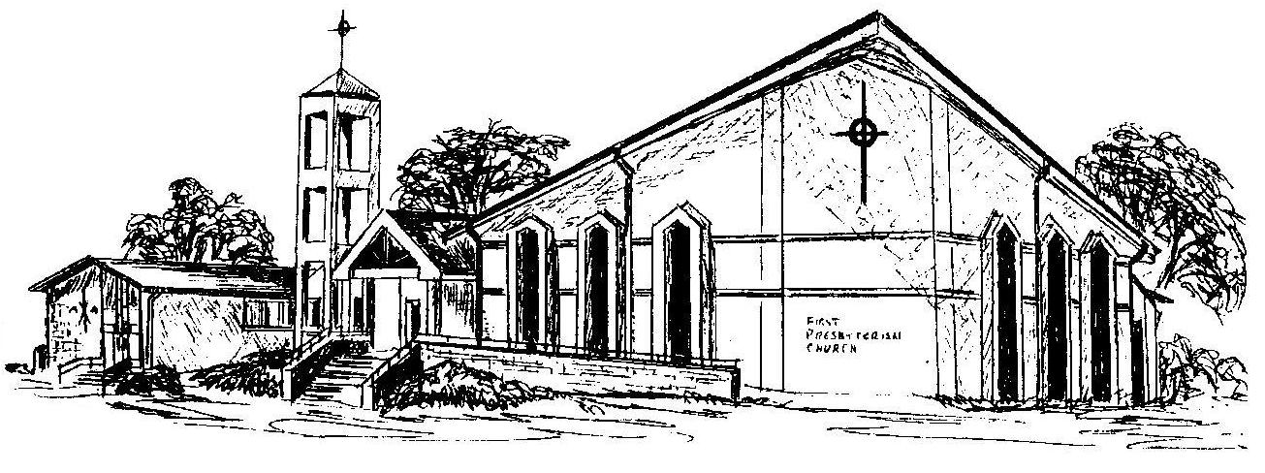

First Presbyterian Church
In the heart of Gardner since 1866 ~ Serving from the heart of God

Welcome - Thank you for joining us for worship today. Please fill out a visitor information card found in the pew racks and place those in the offering plate so that we may follow up with you in the future. Your presence with us today has been a blessing to us, we hope that you have felt the presence of God and the welcome of this congregation.

