Welcome & Announcements, Friendship Information, & Sharing Christ’s Peace
“Channels of Blessings” – Past Blessings by Vera Beach, Kim Allen
Prelude: “Immortal, Invisible” arr. Peterson
Let us prepare our hearts and minds for worship.

Call to Worship
Leader: This Reformation Sunday, we gather remembering God’s grace for generation upon generation.
People: We remember God’s grace and look forward to the future God has promised.
Leader: Built upon this rock of God’s goodness, our faith cannot be shaken.
People: With Christ as our cornerstone, our church continues to grow and become all that God has called us to be. We praise God for this marvelous grace.

*Opening Hymn: “A Mighty Fortress Is Our God” Red Hymnal, #26

*Prayer of Confession (Unison)
God of Formation and Reformation, we give thanks for the Church Universal and for this our local church in Gardner. We know that we are not perfect, that we have made mistakes, and that we sometimes have not lived up to your high calling. We pray, forgive us and reshape us again. Help us to make amends for any wrong we have done. Inspire us to be the best that we can be. Open our hearts to your transformation that we may become your grace filled servants, sharing your love and working for your justice, through Jesus Christ our Lord. Amen.

*Silent Reflection

*Assurance of Pardon
Leader: If we say that we have no sin, we deceive ourselves, and the truth is not in us.
People: If we confess our sins, God, who is faithful and just, will forgive our sins, and cleanse us from all unrighteousness.
Leader: Friends, hear and believe the good news of God’s amazing grace.
People: In Jesus Christ we are forgiven and set free to wholeness and new life.

*Gloria Patri (Glory Be to the Father…) Red Hymnal, #623

Scripture “Matthew 7:24-29” (page 1506)
“Ephesians 2:13-22” (page 1819)
Leader: The word of the Lord.
People: Thanks be to God.

Children's Time
Please join in singing one verse of Jesus Loves Me as the children come forward.
Special Music: “Majesty” arr. Jack W. Hayford

Sermon: “Building Blocks” Rev. Kimby Young
"For I know the plans I have for you,” declares the Lord, “plans to prosper you and not to harm you, plans to give you hope and a future." Jeremiah 29:11

*Profession of Faith The Apostle's Creed Red Hymnal, inside back cover

*Hymn “Christ is Made the Sure Foundation” Red Hymnal, #276

Pastoral Prayer & Lord’s Prayer: Please Pray for the family of Roy Barnett, Jackie Lang, Lila Orr, Chuck Motter, Debi Crowell Crist, Hudson Inglehart, Glenn Schulz, Reagan Barnadt, Boston DeWald, Lanny John Turner, Larry Bartel, Brian McManus, David Butler, Margaret Davidson, Roland Jack, Rob Kuhauz, Denny Harris, Richard Hatfield, Jackson Tijerina

Offertory: “Christ is the Cornerstone” Broughton
*Doxology Red Hymnal, #625

Prayer of Dedication

*Closing Hymn: “The Church’s One Foundation” Red Hymnal #277

Closing Litany
Leader: We celebrate the Church that was, the Church that is and the Church that yet will be.
People: We give thanks for all that God has done among us and all that God continues to do.
Leader: History has proven that we may never be able to predict where our journey through life may take us, but that our journey will always be filled with God’s grace.
People: Let us journey together into the world to share God’s love wherever we go.

Postlude: “How Firm a Foundation” arr. Broughton
*Those who are comfortably able will please stand

Kimby Young, Pastor; Carl Frahme, Worship Assistant; Alice Rollf, Organist;
Chancel Choir; Dean Faulk, Music Ministries; Heather Rutler, Worship Transcription

Ushers October 2017
Sandy Nellor; Joni Meyer; Brian & Denise Bockus; LeMoyne & Donnie Zimmerman

Bible Reading for Sunday, November 5 is 1Corinthians 15: 12-26

Sunday, November 5, Daylight Savings Time ends, be sure and turn your clocks back an hour.
Operation Christmas Child donation is for October: Socks, Underwear, T-Shirts, Shoes.

Deacons Food Drive Sunday, October 29 – November 12. Bring a non-perishable items.

Fall Gathering, Sunday, today October 29 at 6:00 PM. Chili, Food, Fun and Fellowship. Costume Contest for all ages! Games for the little ones.

Ladies Night Thursday, November 2, 6:30 PM, soup supper, with soup being provided. Bring a side dish, (sandwiches, crackers, etc.) and or dessert. Harvesters will be there for a presentation. We ask for food donations of non-perishable food items.

All Saints Sunday – Bring a Picture - On November 5, bring a photo of someone whom you are remembering.

Sunday, November 5 at 10:00 AM Congregational “Election” Meeting to elect Elders, Deacons and Nominating Committee 2018.

Financial Report Close of September Income - $19,703.07; Expense - $22,312.54. Again this month our receipts were lower than expenses, please consider additional giving to help us balance our budget. A full report is available upon request from the treasurer or the Congregational Life Pillar.

The choir will begin working on the Christmas Cantata ‘Comfort and Joy’. We would like to extend an invitation to anyone who would like to join us just for the Cantata. Rehearsals will be held on Wednesday evenings from 8:00 - 9:00 p.m. after normal choir rehearsal.

Worship at Meadowbrook & Medicalodge – During November our church will be responsible for leading worship at 2 of Gardner facilities. Worship is each Sunday starting at 3:15 PM. The most important part of this service is visiting with the residents. Please volunteer to Pastor Kimby or anyone on the Mission Pillar if you would be willing to help lead.

Substitute Teachers are needed for our Sunday School classes occasionally, including November 5 & 12. To volunteer contact Nancy Falkner or Pastor Kimby.

Presbyterian Youth Fellowship would like to invite the congregation, family, friends, and neighbors to brunch on Sunday, November 19th. A wide variety of delicious breakfast food will be served following the 9:00 AM worship service (roughly 10 AM-11AM). There is no set cost, but donations will be accepted to support the 2019 summer mission trip.

Sunday, October 29, 2017
9:00 AM

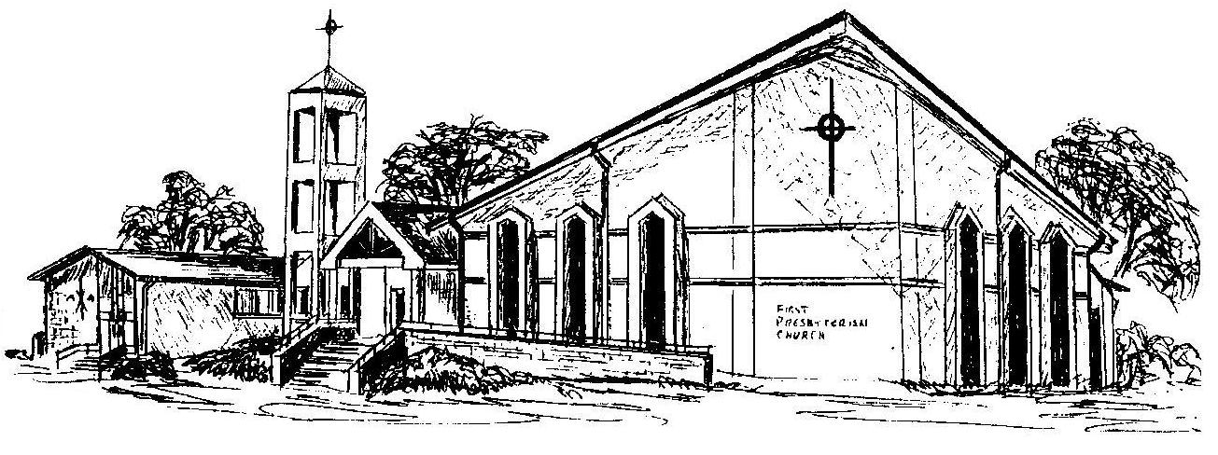

First Presbyterian Church
In the heart of Gardner since 1866 ~ Serving from the heart of God

Welcome - Thank you for joining us for worship today. Please fill out a visitor information card found in the pew racks and place those in the offering plate so that we may follow up with you in the future. Your presence with us today has been a blessing to us, we hope that you have felt the presence of God and the welcome of this congregation.

